**Israeli Super Market Price Comparison**

1. **Overview:**

ISMC system is an application for comparing prices of products of the leading chain stores in Israel. The Application provides to users a catalog of products based on the real products of the chain stores.

The user has the ability to select a shopping cart, compare prices, save and load a shopping cart and data visualization by saving the results as an excel file.

1. **System Architecture:**The application is a Client-Server based system. The UI Layer communicates with the Manager layer using its API. The manager communicates with a REST service called Engine layer using the HTTP protocol. All transferred data are being serialized and DE serialized by JSON serializer.  
   The Engine layer performs the operations which are received from the manager. One of the major roles of the Engine layer is to keep a uniform model of local data by translating the coming in data using a specific Accessor for each chain store XML files. The following chart describes the architecture:

**Server**

**Client**

**Engine**

**(REST service)**

**Manager**

**UI Client**

**Data Access Layer**

**HTTP**

**XML Files of the chain stores**

**Data   
Accessors**

**Uniform XML file of the products catalog**

1. **Components:**

* UI Layer - Windows Forms Application:  
  The UI Layer includes two forms:  
  The Log In Form:  
  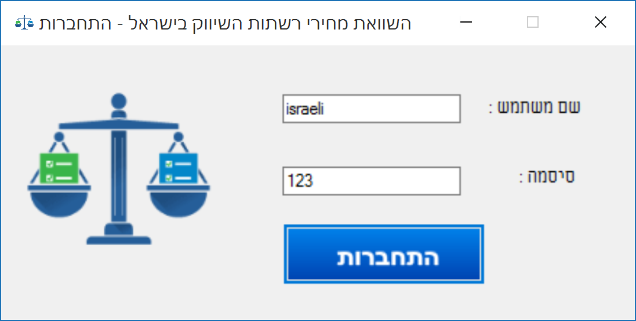  
    
  The Main Form:  
  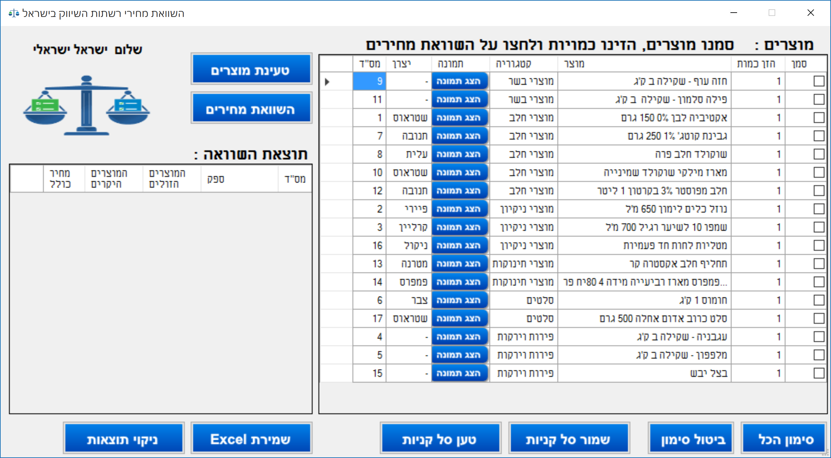
* Manager Layer - API Class Library:  
  This layer provides an API to the UI layer. This API is used by the UI layer to communicate with the Engine layer. All communications are executed asynchronously.
* Engine Layer - REST Service:  
  The Engine Layer is the Core of the system where all the functionality is executed. The major role of the Engine layer is to keep a uniform local data representation. The Engine receives an operation from the Manager to execute, each operation is translated to distributed operations to the accessors of the coming in data (XML files of the chain stores).
* Access Layer - Part of the Engine Layer:  
  The Access layer is a part of the engine where almost all of the functionality is executed. The Access layer locates the Items codes from the local uniform XML file of the products catalog, loads the appropriate Items Prices from the XML files of the chain stores by distributing the operation to an accessor for each chain store XML file. The following chart describes the functionality:

**Engine**

**Data Access Layer**

Local  
Uniform   
XML  
File

Accessor1

XML of   
chain   
Store 1

XML of   
chain   
Store N

AccessorN

* Models Layer - Dependency Class Library:  
  The Models Layer holds the model of the data in the system. This layer is a dependency for all layers. The Models are a collection of classes which represent the data:  
  Product, IProduct.  
  Chain, IChain.  
  User, IUser.  
  **Risk**: The fact that the application is a Client-Server system forces to hold this dependency at both sides of client and server, what makes the need to keep the same version of this layer at the both sides.