

**Software Development Academy**

**Final Project**

**Manual Testing of Website**

[**www.petcity.lt**](http://www.petcity.lt)



|  |  |
| --- | --- |
|  | **Student: Kamilė Guogytė**  **Supervisor: Sandra Budrevičienė**  **Course: Software Tester**  **2020** |

**Contents**

Project Purpose 2

Description of Website 2

Structure of Website and Testing Areas 3

Areas of Testing 4

Testing Checklist 4

Detailed Test Cases 6

Website Bugs and Issues 23

Improvements 30

Test Design Techniques 31

Reflection 31

# **Project Purpose**

The computer and its uses grew very fast throughout the world because it helps to solve people’s problems. Websites are the most important element of the internet and are dedicated to a topic such as news, education, commerce, entertainment, social networking.

E-commerce or electronic commerce refers to a business model that involves sales transactions being done on the web. An e-commerce website, by definition, is a website that allows us to buy and sell goods, digital products or services online. Comparing traditional stores to e-commerce the biggest advantages are that time investment is much smaller, products can be cheaper without taxes of physical stores, it is possible to buy from almost any country in the world, and there is the review blog of users about products.

There are a lot of choices of websites today and the user leaves if it hasn't met the expectations, so the website full of defects is intolerable. Testing is an important part of website creation because it helps to provide a quality product by finding and preventing defects and ensuring that the end result meets user requirements, also makes a website look professional, ensures compatibility with different devices, improves design, boosts security.

The purpose of this project is to perform manual e-commerce website testing and apply testing techniques knowledge. Manual testing is a testing process that is carried out manually in order to find defects without the usage of automation tools.

# **Description of Website**

“PetCity” is an international network of animal products and care services. On the website this company offers pet food, accessories, medicine and body care products for dogs, cats, rodents, birds and exotic animals also offers veterinary clinics, pet hairdressers and pet hostel services. There are products, loyalty programs and blog about pets for owners.

This website is an e-commerce business-to-consumer (B2C) type:

* Online shop;
* Detailed product description;
* Product price comparison;
* Wish list of products;
* High-resolution images;
* Online payment;
* Mobile responsiveness.

Link to the website: <https://www.petcity.lt/>

# **Structure of Website and Testing Areas**

**Website**

**Navigation menu**

**Footer**

**Main content**

**Header**

**Susisiekite su mumis**

**Reklama**

**E-parduotuvė**

**PetCity**

**Prekės gyvūnams**

**Vet. klinikos**

**Apotheca**

**Nuoroda į Instagram**

**Parduotuvės**

**Kontaktai**

**Pravartu žinoti**

**Kirpykla**

**Paslaugos**

**Parduotuvės**

**Viešbutis**

**Skaityti PetCity Blog‘ą**

**Pasiūlymai**

**Blog‘as**

**Gyvūnų tinklaraštis**

**Pagalba ir informacija**

**Blog‘as**

**Registruotis/Prisijungti**

**PetCity lojalumo programa**

**Kontaktai**

**Elektroninė parduotuvė**

**Logotipas**

**Apie PetCity**

**Vartotojo prisijungimas**

**PetCity**

**Paieškos laukelis**

**Populiarūs prekiniai ženklai**

**Veterinarijos klnikos**

**Pirkimo krepšelis**

**Sukurti naują vartotojo paskyrą**

**Pamiršote slaptažodį?**

**Kontaktinė informacija**

**Apie įmonę**

Coloring meanings:

**Main structure of website**

**Main options of website**

**Testing areas of website**

# **Areas of Testing**

Website testing covers the following areas:

* The registration form in the “Sukurti naują vartotojo paskyrą” page;
* The sign in form in the “Vartotojo prisijungimas” page;
* The password reset form in the “Nustatyti naują slaptažodį” page;
* Navigation on mobile devices.

# **Testing Checklist**

|  |  |  |  |
| --- | --- | --- | --- |
| **ID** | **Testing Scenario** | **Status** | **Comments** |
|  | **“Sukurti naują vartotojo paskyrą” page** | | |
| 1.1 | Verify button "Registruotis/Prisijungti" | Pass |  |
| 1.2 | Verify button "Spauskite čia" | Pass |  |
| 1.3 | Verify user registration in the www.petcity.lt system | Pass |  |
| 1.4 | Verify registration form input fields | Pass |  |
| 1.5 | Verify input field "Vardas" | Fail | An error message formulation is in a different language (English) than website language (Lithuanian) when a password does not fulfill the requirements |
| 1.6 | Verify input field "Pavardė" | Fail | An error message formulation is in a different language (English) than website language (Lithuanian) when a password does not fulfill the requirements |
| 1.7 | Verify the drop-down list "Lytis" | Fail | Invalid option in drop-down list |
| 1.8 | Verify input field "El.paštas" | Fail | Syntactically incorrect error message formulation when password do not fulfill requirements |
| 1.9 | Verify input field "Slaptažodis" | Fail | Grammatically incorrect error message formulation when password do not fulfill requirements |
| 1.10 | Verify input field "Pakartoti slaptažodį" | Pass |  |
| 1.11 | Verify input field "Telefono numeris" | Fail | An error message formulation is in a different language (English) than website language (Lithuanian) when a password does not fulfill the requirements |
| 1.12 | Verify input field "Gimimo diena.mėnesis.metai" | Fail | Website system accepts invalid data and allows user registration |
| 1.13 | Verify radio button "Sutinku su Paslaugų teikimo taisyklėmis" | Pass |  |
| 2. | **“Vartotojo prisijungimas” page** | | |
| 2.1 | Verify user sign in | Fail | Syntactically incorrect error message formulation when password do not fulfill requirements |
| 3. | **“Nustatyti naują slaptažodį” page** | | |
| 3.1 | Verify button "Pamiršote slaptažodį?" | Pass |  |
| 3.2 | Verify "Pamiršote slaptažodį" function | Fail | Syntactically incorrect error message formulation when password do not fulfill requirements |
| Fail | Text and input fields place does not match page layout |
| 3.3 | Verify button "Perkrauti ženklų atpažinimo sistemą" | Pass |  |
| 3.4 | Verify "Nustatyti naują slaptažodį" function | Fail | Grammatically incorrect error message formulation when password do not fulfill requirements |
| Fail | Grammatically incorrect error message formulation when password do not fulfill requirements |
| 4. | **Mobile device** | | |
| 4.1 | Verify website design on mobile device | Fail | An incorrect responsive breakpoint that leads to distortion of information in the page |

# **Detailed Test Cases**

|  |  |  |  |  |  |  |  |  |
| --- | --- | --- | --- | --- | --- | --- | --- | --- |
| **Test Case ID** | **Name/Test Title** | **Test Scenario** | **Pre-Condition** | **Dependencies** | **Test Steps** | **Expected Results** | **Actual Results** | **Status Pass/Fail** |
| TC_1.1 | Button "Registruotis/  Prisijungti" | Verify button "Registruotis/  Prisijungti" | website www.petcity.lt is opened in web  browser | TC_1.1 | Click on "Registruotis/Prisijungti" button in the website header | User should be redirected in the "Vartotojo prisijungimas" page | User redirected in the "Vartotojo prisijungimas" page | Pass |
| TC_2.1 | Button "Spauskite čia" | Verify button "Spauskite čia" | • website www.petcity.lt is opened in web browser  • Page "Vartotojo prisijungimas" is opened | TC_2.1 | Text: "Neturite paskyros? Registruoti naują vartotoją su el. paštu" Click on "Spauskite čia" button in the website header | User should be redirected in the "Sukurti naują vartotojo paskyrą" page | User redirected in the "Sukurti naują vartotojo paskyrą" page | Pass |
| TC_3.1 | Registration | Verify user registration in the www.petcity.lt system | • website www.petcity.lt is opened in web browser  • Page "Vartotojo prisijungimas" is opened • Page "Sukurti naują vartotojo paskyrą" is opened | TC_3.1 | Fill in the registration form (all fields required): • Input field "Vardas": Kamilė • Input field "Pavardė": Guogytė • Drop down list "Lytis": Moteris • Input field "El. paštas": kamile.guogyte@gmail.com • Input field "Slaptažodis": 123Suniukai • Input field "Pakartokite slaptažodį": 123Suniukai • Input field "Telefono numeris": 61363253 • Input field "Gimimo diena.menesis.metai": 1984.11.10 • Click on Radio button "Sutinku su paslaugų teikimo taisyklėmis" | • User should receive confirmation email to kamile.guogyte@gmail.com • User should be registered | 1. User received confirmation email to kamile.guogyte@gmail.com:   • Text: "Turite patvirtinti savo kamile.guogyte@gmail.com  el. paštą prieš prisiregistruojant (nuoroda galioja tik kartą)"   • Button "Patvirtinkite savo paskyrą" 2. User clicked on button "Patvirtinkite savo paskyrą"  3. User redirected to page "Vartotojo paskyra":  • Text: "Ačiū, kad registravotės"  4. User succesfully registered | Pass |
| TC_4.1 | Registration form | Verify registration form input fields | • website www.petcity.lt is opened in web browser  • Page "Vartotojo prisijungimas" is opened • Page "Sukurti naują vartotojo paskyrą" is opened | TC_4.1 | Create the account without any data in the input fields of the registration form | An error messages should appear | • An error messages appeared below every required input field • Text of an error messages: "Reikiamas laukelis" | Pass |
| TC_4.2 | TC_4.1 | Create the account when all input fields are filled in except "Vardas" input field | An error message should appear | • An error message appeared below input field "Vardas" • Text of an error message: "Reikiamas laukelis" | Pass |
| TC_4.3 | TC_4.1 | Create the account when all input fields are filled in except "Pavardė" input field | An error message should appear | • Error message appeared below input field "Pavardė" • Text of error message: "Reikiamas laukelis" | Pass |
| TC_4.4 | TC_4.1 | Create the account when all input fields are filled in without "Lytis" selection from drop down list | An error message should appear | • An error message appeared below drop down list "Lytis" • Text of an error message: "Reikiamas laukelis" | Pass |
| TC_4.5 | TC_4.1 | Create the account when all input fields are filled in except "El.paštas" input field | An error message should appear | • An error message appeared below input field "El.paštas" • Text of an error message: "Reikiamas laukelis" | Pass |
| TC_4.6 | TC_4.1 | Create the account when all input fields are filled in except "Slaptažodis" input field | An error message should appear | • An error message appeared below input field "Slaptažodis" • Text of an error message: "Reikiamas laukelis" | Pass |
| TC_4.7 | TC_4.1 | Create the account when all input fields are filled in except "Pakartokite slaptažodį" input field | An error message should appear | • An error message appeared below input field "Pakartokite slaptažodį" • Text of an error message: "Reikiamas laukelis" | Pass |
| TC_4.8 | TC_4.1 | Create the account when all input fields are filled in except "Telefono numeris" input field | An error message should appear | • An error message appeared below input field "Telefono numeris" • Text of an error message: "Reikiamas laukelis" | Pass |
| TC_4.9 | TC_4.1 | Create the account when all input fields are filled in except "Gimimo data" input field | An error message should appear | • An error message appeared below input field "Gimimo data" • Text of an error message: "Reikiamas laukelis" | Pass |
| TC_5.1 | Registration form | Verify input field "Vardas" | • website www.petcity.lt is opened in web browser  • Page "Vartotojo prisijungimas" is opened • Page "Sukurti naują vartotojo paskyrą" is opened | TC_5.1 | Enter one letter in the input field "Vardas" | An error message should appear | • An error message appeared below input field "Vardas" • Text of an error message: "Illegal name, make sure the field does not contain any illegal symbols".  • Bug: an error message formulation is in a different language (English) than website language (Lithuanian) when a password does not fulfill the requirements | Pass |
| TC_5.2 | TC_5.1 | Enter numbers in the input field "Vardas" | An error message should appear | • An error message appeared below input field "Vardas" • Text of an error message: "Illegal name, make sure the field does not contain any illegal symbols".  • Bug: an error message formulation is in a different language (English) than website language (Lithuanian) when a password does not fulfill the requirements | Pass |
| TC_5.3 | TC_5.1 | Enter special characters in the input field "Vardas" | An error message should appear | • An error message appeared below input field "Vardas" • Text of an error message: "Illegal name, make sure the field does not contain any illegal symbols".  • Bug: an error message formulation is in a different language (English) than website language (Lithuanian) when a password does not fulfill the requirements | Pass |
| TC_5.4 | TC_5.1 | Check correctness of an error message | An error message without mistakes | • An error message appeared below input field "Vardas" • Text of an error message: "Illegal name, make sure the field does not contain any illegal symbols".  • Bug: an error message formulation is in a different language (English) than website language (Lithuanian) when a password does not fulfill the requirements | Fail |
| TC_6.1 | Registration form | Verify input field "Pavardė" | • website www.petcity.lt is opened in web browser  • Page "Vartotojo prisijungimas" is opened • Page "Sukurti naują vartotojo paskyrą" is opened | TC_6.1 | Enter one letter in the input field "Pavardė" | An error message should appear | • An error message appeared below input field "Pavardė" • Text of an error message: "Illegal name, make sure the field does not contain any illegal symbols".  • Bug: an error message formulation is in a different language (English) than website language (Lithuanian) when a password does not fulfill the requirements | Pass |
| TC_6.2 | TC_6.1 | Enter numbers in the input field "Pavardė" | An error message should appear | • An error message appeared below input field "Pavardė" • Text of an error message: "Illegal name, make sure the field does not contain any illegal symbols".  • Bug: an error message formulation is in a different language (English) than website language (Lithuanian) when a password does not fulfill the requirements | Pass |
| TC_6.3 | TC_6.1 | Enter special characters in the input field "Pavardė" | An error message should appear | • An error message appeared below input field "Pavardė" • Text of an error message: "Illegal name, make sure the field does not contain any illegal symbols".  • Bug: an error message formulation is in a different language (English) than website language (Lithuanian) when a password does not fulfill the requirements | Pass |
| TC_6.4 | TC_6.1 | Check correctness of an error message | An error message without mistakes | • An error message appeared below input field "Pavardė" • Text of an error message: "Illegal name, make sure the field does not contain any illegal symbols".  • Bug: an error message formulation is in a different language (English) than website language (Lithuanian) when a password does not fulfill the requirements | Fail |
| TC_7.1 | Registration form | Verify the drop down list "Lytis" | • website www.petcity.lt is opened in web browser  • Page "Vartotojo prisijungimas" is opened • Page "Sukurti naują vartotojo paskyrą" is opened | TC_7.1 | Select the option "Pasirinkite lytį" from drop down list "Lytis" | User select option "Pasirinkite lytį" | • An error message appeared below drop down list "Lytis" • Text of an error message: "Reikiamas laukelis"  • Bug: invalid option in drop down list | Fail |
| TC_7.2 | TC_7.1 | Select the option "Vyras" from drop down list "Lytis" | User select option "Vyras" | User selected option "Vyras" | Pass |
| TC_7.3 | TC_7.1 | Select the option "Vyras" from drop down list "Lytis" | User select option "Moteris" | User selected option "Moteris" | Pass |
| TC_8.1 | Registration form | Verify input field "El.paštas" | • website www.petcity.lt is opened in web browser  • Page "Vartotojo prisijungimas" is opened • Page "Sukurti naują vartotojo paskyrą" is opened | TC_8.1 | Enter random string in the input field "El. paštas" | An error message should appear | • An error message appeared below input field "El.paštas" • Text of an error message: "Suveskite galiojantį el.pašto adresą  (pvz: [johndoe@domain.com](mailto:johndoe@domain.com)"  • Bug: syntactically incorrect error message formulation when password do not fulfill requirements: symbol “)” is missing | Pass |
| TC_8.2 | TC_8.1 | Enter email address without "@"symbol | An error message should appear | • An error message appeared below input field "El.paštas" • Text of an error message: "Suveskite galiojantį el.pašto adresą  (pvz: [johndoe@domain.com](mailto:johndoe@domain.com)"  • Bug: syntactically incorrect error message formulation when password do not fulfill requirements: symbol “)” is missing | Pass |
| TC_8.3 | TC_8.1 | Enter email address with "eta" insted of "@" symbol | An error message should appear | • An error message appeared below input field "El.paštas" • Text of an error message: "Suveskite galiojantį el.pašto adresą  (pvz: [johndoe@domain.com](mailto:johndoe@domain.com)"  • Bug: syntactically incorrect error message formulation when password do not fulfill requirements: symbol “)” is missing | Pass |
| TC_8.4 | TC_8.1 | Enter email address with missing dot | An error message should appear | • An error message appeared below input field "El.paštas" • Text of an error message: "Suveskite galiojantį el.pašto adresą  (pvz: [johndoe@domain.com](mailto:johndoe@domain.com)"  • Bug: syntactically incorrect error message formulation when password do not fulfill requirements: symbol “)” is missing | Pass |
| TC_8.5 | TC_8.1 | Enter “@gmail" in the input field "El. paštas" | An error message should appear | • An error message appeared below input field "El.paštas" • Text of an error message: "Suveskite galiojantį el.pašto adresą  (pvz: [johndoe@domain.com](mailto:johndoe@domain.com)"  • Bug: syntactically incorrect error message formulation when password do not fulfill requirements: symbol “)” is missing | Pass |
| TC_8.6 | TC_8.1 | Enter “name@gmail..com" in the input field "El. paštas" | An error message should appear | • An error message appeared below input field "El.paštas" • Text of an error message: "Suveskite galiojantį el.pašto adresą  (pvz: [johndoe@domain.com](mailto:johndoe@domain.com)"  • Bug: syntactically incorrect error message formulation when password do not fulfill requirements: symbol “)” is missing | Pass |
| TC_8.7 | TC_8.1 | Enter “name.. @gmail.com" in the input field "El. paštas" | An error message should appear | • An error message appeared below input field "El.paštas" • Text of an error message: "Suveskite galiojantį el.pašto adresą  (pvz: [johndoe@domain.com](mailto:johndoe@domain.com)"  • Bug: syntactically incorrect error message formulation when password do not fulfill requirements: symbol “)” is missing | Pass |
| TC_8.8 | TC_8.1 | Enter “name@192.168.1.1.0" in the input field "El. paštas" | An error message should appear | • An error message appeared below input field "El.paštas" • Text of an error message: "Suveskite galiojantį el.pašto adresą  (pvz: [johndoe@domain.com](mailto:johndoe@domain.com)"  • Bug: syntactically incorrect error message formulation when password do not fulfill requirements: symbol “)” is missing | Pass |
| TC_8.9 | TC_8.1 | Enter “name@gmail" in the input field "El. paštas" | An error message should appear | • An error message appeared below input field "El.paštas" • Text of an error message: "Suveskite galiojantį el.pašto adresą  (pvz: [johndoe@domain.com](mailto:johndoe@domain.com)"  • Bug: syntactically incorrect error message formulation when password do not fulfill requirements: symbol “)” is missing | Pass |
| TC_8.10 | TC_8.1 | Check correctness of an error message | An error message without mistakes | • An error message appeared below input field "El.paštas" • Text of an error message: "Suveskite galiojantį el.pašto adresą  (pvz: [johndoe@domain.com](mailto:johndoe@domain.com)"  • Bug: syntactically incorrect error message formulation when password do not fulfill requirements: symbol “)” is missing | Fail |
| TC_9.1 | Registration form | Verify input field "Slaptažodis" | • website www.petcity.lt is opened in web browser  • Page "Vartotojo prisijungimas" is opened • Page "Sukurti naują vartotojo paskyrą" is opened | TC_9.1 | Check the password with less than 8 symbols | An error message should appear | • An error message appeared below input field "Slaptažodis" • Text of an error message: "Minimalus laukelio ilgis turi didesnis arba lygus 8 simboliams. Prieky ir gale naudojami tarpai bus ignoruojami"  • Bug: grammatically incorrect error message formulation when password do not fulfill requirements: word “būti” is missing between words “turi” and “didesnis” | Pass |
| TC_9.2 | TC_9.1 | Check correctness of an error message after check the password with less than 8 symbols | An error message without mistakes | • An error message appeared below input field "Slaptažodis" • Text of an error message: "Minimalus laukelio ilgis turi didesnis arba lygus 8 simboliams. Prieky ir gale naudojami tarpai bus ignoruojami"  • Bug: grammatically incorrect error message formulation when password do not fulfill requirements: word “būti” is missing between words “turi” and “didesnis” | Fail |
| TC_9.3 | TC_9.1 | Check the password with only numbers | An error message should appear | • An error message appeared below input field "Slaptažodis" • Text of an error message: "Minimalus simbolių tipų skaičius slaptažodyje yra 3. Simbolių tipai: mažosios raidės, didžiosios raidės, skaičiai, specialūs simboliai" | Pass |
| TC_9.4 | TC_9.1 | Check the password with valid data | Password accepted | Password accepted | Pass |
| TC_9.5 | TC_9.1 | Enter password to check if it is hidden | Password should be hidden | Every simbol of password is hidden by dots | Pass |
| TC_10.1 | Registration form | Verify input field "Pakartoti slaptažodį" | • website www.petcity.lt is opened in web browser  • Page "Vartotojo prisijungimas" is opened • Page "Sukurti naują vartotojo paskyrą" is opened | TC_10.1 | Repeated password does not match the password | An error message should appear | • An error message appeared below input field "Pakartoti slaptažodį" • Text of an error message: "Slaptažodžiai nesutampa.  Prašome pakartoti" | Pass |
| TC_10.2 | TC_10.1 | Enter repeated password to check if it is hidden | Repeated password should be hidden | Every simbol of repeated password is hidden by dots | Pass |
| TC_11.1 | Registration form | Verify input field "Telefono numeris" | • website www.petcity.lt is opened in web browser  • Page "Vartotojo prisijungimas" is opened • Page "Sukurti naują vartotojo paskyrą" is opened | TC_11.1 | Enter string instead of numbers in the input field | An error message should appear | • An error message appeared below input field "Telefono numeris" • Text of an error message: "Please enter a valid number in this field"  • Bug: an error message formulation is in a different language (English) than website language (Lithuanian) when a password does not fulfill the requirements | Pass |
| TC_11.2 | TC_11.1 | Type in special characters instead of numbers in the input field | An error message should appear | • An error message appeared below input field "Telefono numeris" • Text of an error message: "Please enter a valid number in this field"  • Bug: an error message formulation is in a different language (English) than website language (Lithuanian) when a password does not fulfill the requirements | Pass |
| TC_11.3 | TC_11.1 | Check correctness of an error message after when invalid data in numbers input field | An error message without mistakes | • An error message appeared below input field "Telefono numeris" • Text of an error message: "Please enter a valid number in this field"  • Bug: an error message formulation is in a different language (English) than website language (Lithuanian) when a password does not fulfill the requirements | Fail |
| TC_11.4 | TC_11.1 | Select phone code from drop down list 6 options | User should select one option from drop down list | User selected one option from drop down list | Pass |
| TC_12.1 | Registration form | Verify input field "Gimimo diena.mėnesis.metai" | • website www.petcity.lt is opened in web browser  • Page "Vartotojo prisijungimas" is opened • Page "Sukurti naują vartotojo paskyrą" is opened | TC_12.1 | Enter birthday number ≥ 32 | An error message should appear | • An error message appeared below input field "Gimimo diena.mėnesis.metai" • Text of an error message: "Netinkamai nurodyta gimimo data" | Pass |
| TC_12.2 | TC_12.1 | Enter birth month number ≥ 13 | An error message should appear | • An error message appeared below input field "Gimimo diena.mėnesis.metai" • Text of an error message: "Netinkamai nurodyta gimimo data" | Pass |
| TC_12.3 | TC_12.1 | Enter birth year numner ≤ 2020 | An error message should appear | • System registered invalid birth year until today date  • Bug: website system accepts invalid data and allows user registration | Fail |
| TC_13.1 | Registration form | Verify radio button "Sutinku su Paslaugų teikimo taisyklėmis" | • website www.petcity.lt is opened in web browser  • Page "Vartotojo prisijungimas" is opened • Page "Sukurti naują vartotojo paskyrą" is opened | TC_13.1 | Create the account when all input fields are filled in and radio button "Sutinku su paslaugų teikimo taisyklėmis" unmarked | An error message should appear | • An error message appeared below radio button" • Text of an error message: "Reikiamas laukelis" | Pass |
| TC_13.2 | TC_13.1 |
| TC_13.3 | TC_13.1 |
| TC_14.1 | Sign in form | Verify user sign in | • website www.petcity.lt is opened in web browser  • Page "Vartotojo prisijungimas" is opened | TC_14.1 | Fill the sign in form: • Input field "El.paštas": kamile.guogyte@gmail.com • Input field "Slaptažodis": 123Suniukai | User should sign in | User signed in and redirected in the page "Vartotojo paskyra" | Pass |
| TC_14.2 | TC_14.1 | Sigh in without any data in the input fields of the sigh in form | An error message should appear | • An error messages appears below both input fields • Text of an error messages: "Reikiamas laukelis" | Pass |
| TC_14.3 | TC_14.1 | Enter random data in the input fields | An error message should appear | • An error message appears below "El.paštas" text field • Text of an error message: "Suveskite galiojantį el.pašto adresą (pvz: [johndoe@domain.com](mailto:johndoe@domain.com)"  • Bug: syntactically incorrect error message formulation when password do not fulfill requirements: symbol “)” is missing | Pass |
| TC_14.4 | TC_14.1 | Check correctness of an error message after enter random data in the input fields | An error message without mistakes | • An error message appears below "El.paštas" text field • Text of an error message: "Suveskite galiojantį el.pašto adresą (pvz: [johndoe@domain.com](mailto:johndoe@domain.com)"  • Bug: syntactically incorrect error message formulation when password do not fulfill requirements: symbol “)” is missing | Fail |
| TC_14.5 | TC_14.1 | Enter invalid email adress and password | An error message should appear | • An error messages appears: "Prisijungimas prie paskyros buvo neteisingas arba jūsų paskyra laikinai yra nepasiekiama. Prašome palaukti ir pabandyti vėliau" | Pass |
| TC_14.6 | TC_14.1 | Enter invalid email adress and valid password | An error message should appear | • An error messages appears: "Prisijungimas prie paskyros buvo neteisingas arba jūsų paskyra laikinai yra nepasiekiama. Prašome palaukti ir pabandyti vėliau" | Pass |
| TC_14.7 | TC_14.1 | Enter valid email adress and invalid password | An error message should appear | • An error messages appears: "Prisijungimas prie paskyros buvo neteisingas arba jūsų paskyra laikinai yra nepasiekiama. Prašome palaukti ir pabandyti vėliau" | Pass |
| TC_15.1 | Button "Pamiršote slaptažodį?" | Verify button "Pamiršote slaptažodį?" | • website www.petcity.lt is opened in web browser  • Page "Vartotojo prisijungimas" is opened | TC_15.1 | Click on "Pamiršote slaptažodį?" button | User should be redirected in the "Pamiršote slaptažodį?" page | User redirected in the "Pamiršote slaptažodį?" page | Pass |
| TC_16.1 | "Pamiršote slaptažodį" form | Verify "Pamiršote slaptažodį" function | • website www.petcity.lt is opened in web browser  • Page "Vartotojo prisijungimas" is opened • Page "Pamiršote slaptažodį" is opened | TC_16.1 | Fill in the form: • Input field "El.paštas": kamile.guogyte@gmail.com • Captcha field: symbols | User should receive email to kamile.guogyte@gmail.com | • User redirected to "Vartotojo prisijungimas" page with information message • Text of information message: "Jei paskyrą susijusią su kamile.guogyte@gmail.com jau turite, gausite el.laišką su nuoroda naujo slaptažodžio sukūrimui" • User received email and clicked the button "Nustatyti naują slaptažodį" • User redirected to "Nustatyti naują slaptažodį" page | Pass |
| TC_16.2 | TC_16.1 | Enter captcha input field and no data in email input field | An error message should appear | • An error message appeared below "El.paštas" input field • Text of an error message: "Reikiamas laukelis" | Pass |
| TC_16.3 | TC_16.1 | Enter valid email adress and no data in captcha input field | An error message should appear | • An error message appeared below "Captcha" input field • Text of an error message: "Reikiamas laukelis" | Pass |
| TC_16.4 | TC_16.1 | Enter valid email adress and wrong data in captcha input field | An error message should appear | • An error message appeared in the "Pamiršote slaptažodį" page • Text of an error message: "Neteisingai suvestas ženklų atpažinimo tekstas" | Pass |
| TC_16.5 | TC_16.1 | Enter invalid email adress and valid data in the captcha input field | An error message should appear | • An error message appeared below input field "El.paštas" • Text of an error message: "Suveskite galiojantį el.pašto adresą  (pvz: [johndoe@domain.com](mailto:johndoe@domain.com)"  • Bug: syntactically incorrect error message formulation when password do not fulfill requirements: symbol “)” is missing | Pass |
| TC_16.6 | TC_16.1 | Page design view | Text and input fields match page layout | • Bug: text and input field place does not match page layout | Fail |
| TC_16.7 | TC_16.1 | Check correctness of an error message after enter invalid email adress and valid data in the captcha input field | An error message without mistakes | • An error message appeared below input field "El.paštas" • Text of an error message: "Suveskite galiojantį el.pašto adresą  (pvz: [johndoe@domain.com](mailto:johndoe@domain.com)"  • Bug: syntactically incorrect error message formulation when password do not fulfill requirements: symbol “)” is missing | Fail |
| TC_17.1 | "Perkrauti ženklų atpažinimo sistemą" button | Verify button "Perkrauti ženklų atpažinimo sistemą" | • website www.petcity.lt is opened in web browser  • Page "Vartotojo prisijungimas" is opened • Page "Pamiršote slaptažodį" is opened | TC_17.1 | Click button "Perkrauti ženklų atpažinimo sistemą" | Captcha data change after click of the button | After every button clicked captcha data changed | Pass |
| TC_18.1 | "Nustatyti naują slaptažodį" form | Verify "Nustatyti naują slaptažodį" function | • website www.petcity.lt is opened in web browser  • Page "Nustatyti naują slaptažodį" is opened | TC_18.1 | Fill in the input fields: • Input field "Naujas slaptažodis": 124Suniukai • Input field "Patvirtinti naują": 124Suniukai | User should be redirected to "Vartotojo prisijungimas" page | • User redirected to "Vartotojo prisijungimas" page with the  information message.  • Text of information message: "Atnaujinote slaptažodį" | Pass |
| TC_18.2 | TC_18.1 | Enter new password | Information text about number of password symbols | • An error message appeared below input field "Naujas slaptažodis" when typing password symbols  • Text of an error message: "Minimalus laukelio ilgis turi didesnis arba lygus 8 simboliams. Prieky ir gale naudojami tarpai bus ignoruojami"  • Bug: grammatically incorrect error message formulation when password do not fulfill requirements: word “būti” is missing between words “turi” and “didesnis” | Pass |
| TC_18.3 | TC_18.1 | Enter new password and confirmed new password to check if it is hidden | New password and confirm password  should be hidden | Every symbol of new password and confirm password  is hidden by dots | Pass |
| TC_18.4 | TC_18.1 | Enter weak new password and weak confirmed new password | An error message should appear | • An error message appeared below input field "Naujas slaptažodis" when typing password symbols  • Text of an error message: "Minimalus laukelio ilgis turi didesnis arba lygus 8 simboliams. Prieky ir gale naudojami tarpai bus ignoruojami" • Button "Nustatyti naują slaptažodį was inactive"  • Bug: grammatically incorrect error message formulation when password do not fulfill requirements: word “būti” is missing between words “turi” and “didesnis” | Pass |
| TC_18.5 | TC_18.5 | Check correctness of an error message when password do not fulfill requirements: | An error message without mistakes | • An error message appeared below input field "Naujas slaptažodis" when typing password symbols  • Text of an error message: "Minimalus laukelio ilgis turi didesnis arba lygus 8 simboliams. Prieky ir gale naudojami tarpai bus ignoruojami" • Button "Nustatyti naują slaptažodį was inactive"  • Bug: grammatically incorrect error message formulation when password do not fulfill requirements: word “būti” is missing between words “turi” and “didesnis” | Fail |
| TC_18.6 | TC_18.1 | Enter new password and confirmed new password which doesn’t match | An error message should appear | • An error message appeared below input field "Patvirtinti naują slaptažodį" • Text of an error message: "Slaptažodžiai nesutampa. Prašome pakartoti" | Pass |
| **Responsive web design: verify website design on mobile device (375 x 812)** | | | | | | | | |
| TC_19.1 | Button “Meniu” | Verify drop-down list button “Meniu” | • website www.petcity.lt is opened | TC_19.1 | Click on "Meniu" button in the website header | User should see drop-down list options | User sees drop-down list options | Pass |
| TC_19.2 | TC_19.1 | Check the drop-down list responsive design | The information in drop-down list should be without disortion | • One of the drop-down list options “Turite klausimų? Susisiekite: +37061479498” divided in to two rows in the middle of phone number on screen  • Bug: an incorrect breakpoint that leads to distortion of information in the page | Fail |
| TC_19.3 | Button “Ieškoti” | Verify drop-down list button “Ieškoti” | TC_19.1 | Click on “Ieškoti” button in the website header | Input field for search should appear | Input field for search appears | Pass |
| TC_19.4 | TC_19.1 | • Click on “Ieškoti” button in the website header  • Check the drop-down list responsive design | The information in drop-down list should be without disortion | The information in drop-down list without disortion | Pass |
| TC_19.5 | Button “Prisijungti” | Verify drop-down list button “Prisijungti” | TC_19.1 | Click on “Prisijungti” button in the website header | User should be redirected in the “Vartotojo prisijungimas” page | User redirected in the "Vartotojo prisijungimas"page | Pass |
| TC_19.6 | TC_19.1 | • Click on “Prisijungti” button in the website header  • Check the drop-down list responsive design | The information in drop-down list should be without disortion | The information in drop-down list without disortion | Pass |
| TC_19.7 | Button “Mano krepšelis” | Verify drop-down list button “Mano krepšelis” | TC_19.1 | Click on “Mano krepšelis” button in the website header | User should be redirected in the "Mano krepšelis" page | User redirected in the "Mano krepšelis"page | Pass |
| TC_19.8 | TC_19.1 | • Click on “Mano krepšelis” button in the website header  • Check the drop-down list responsive design | The information in drop-down list should be without disortion | The information in drop-down list without disortion | Pass |

# **Website Bugs and Issues**

Testing of website [www.petcity.lt](http://www.petcity.lt) covers user registration form page “Sukurti naują vartotojo paskyrą” page, user sign in form “Vartotojo prisijungimas” page and user password reset form “Nustatyti naują slaptažodį” areas. In all test cases 12 bugs/issues were detected and reports of bugs/issues with detailed description were entered in “Backlog by nulab” (online project management software) platform:

* 11 test cases could be recognized as low severity, low priority, user interface (UI) bugs/issues (Figures 2 - 12);
* 1 test case could be recognized as medium severity, medium priority, functionality bug (Figure 1).

Figure 13 shows all the bugs/issues found in this project.

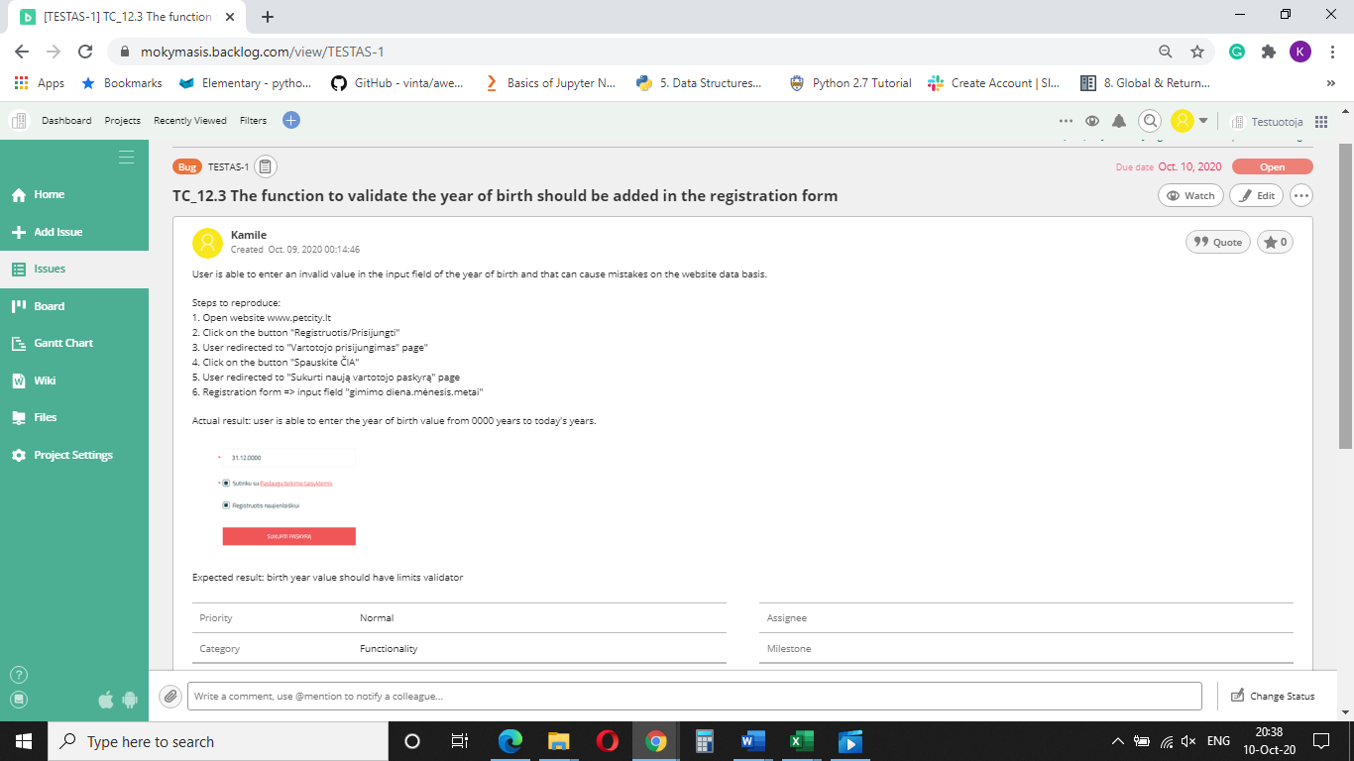

Figure 1.

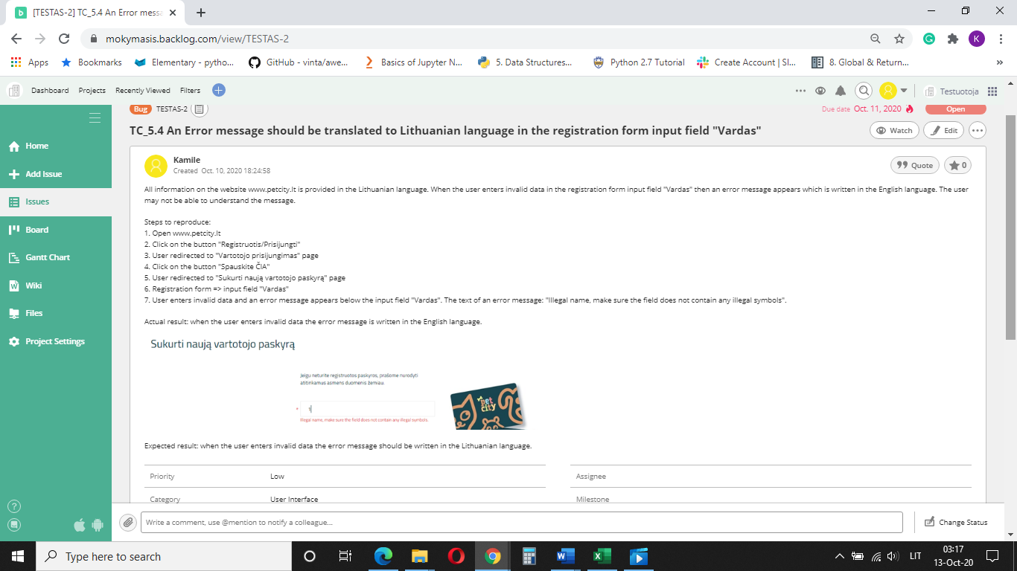

Figure 2.

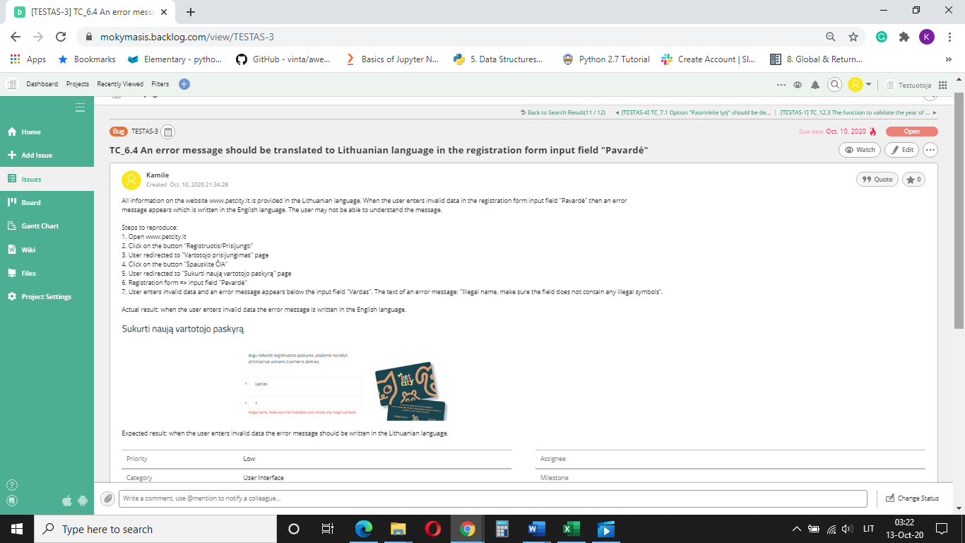

Figure 3.

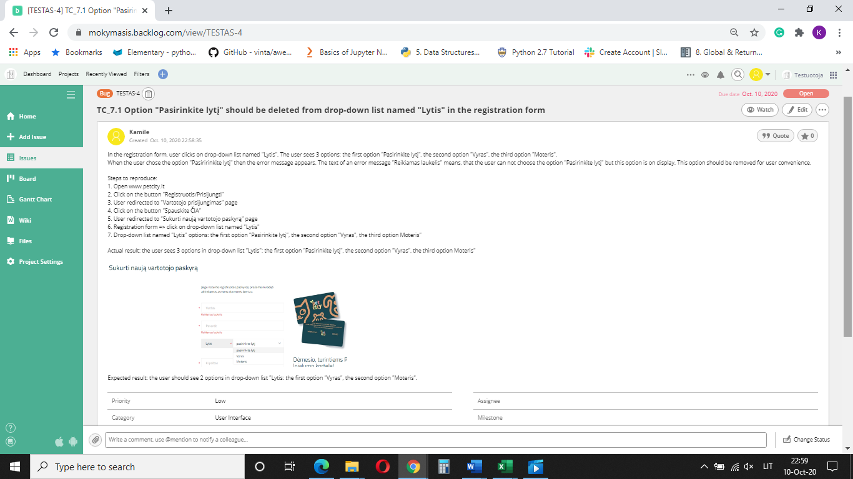

Figure 4.

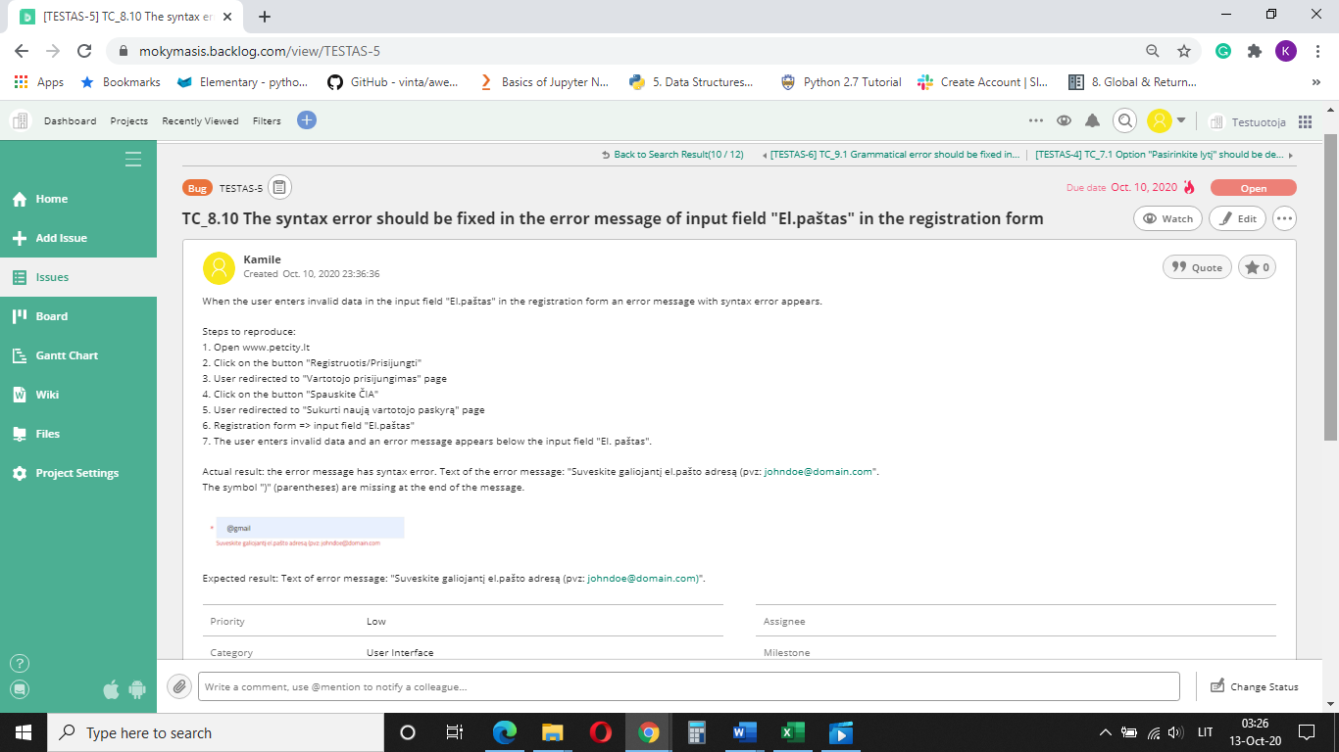

Figure 5.

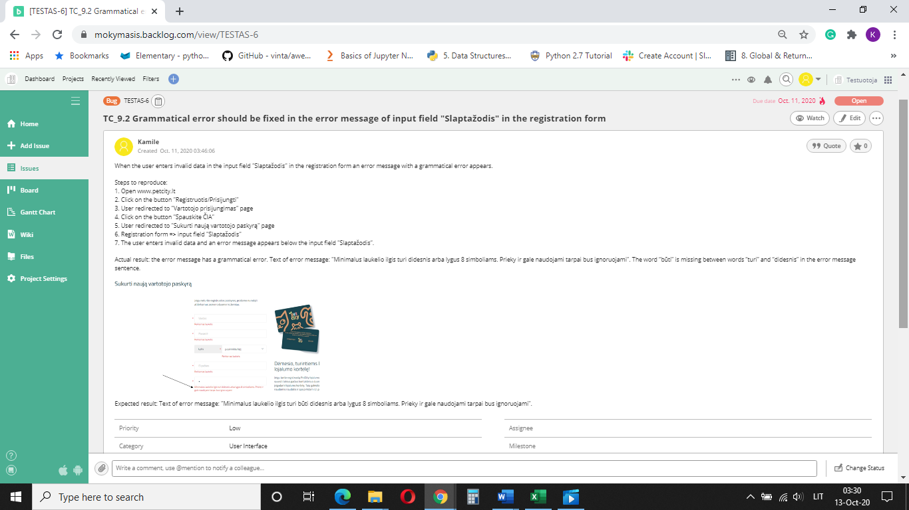

Figure 6.

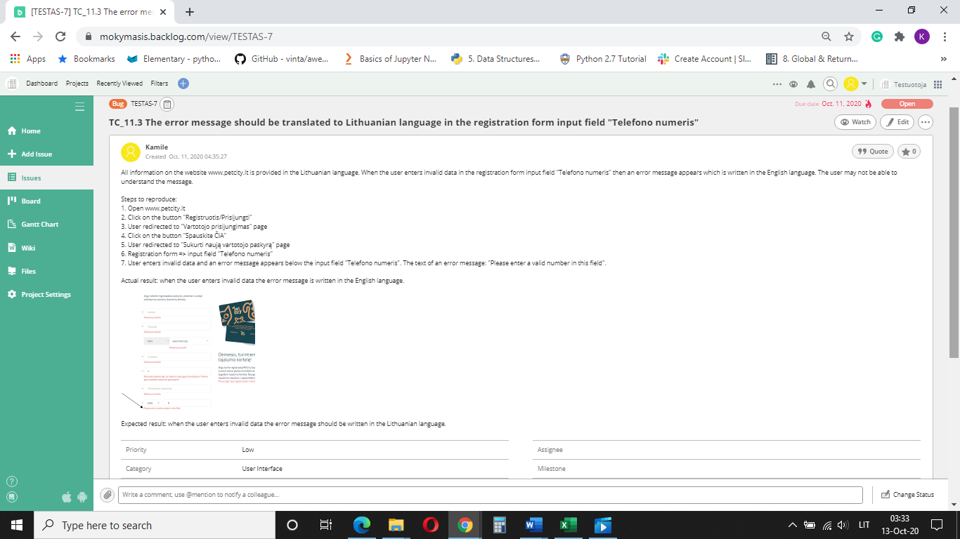

Figure 7.

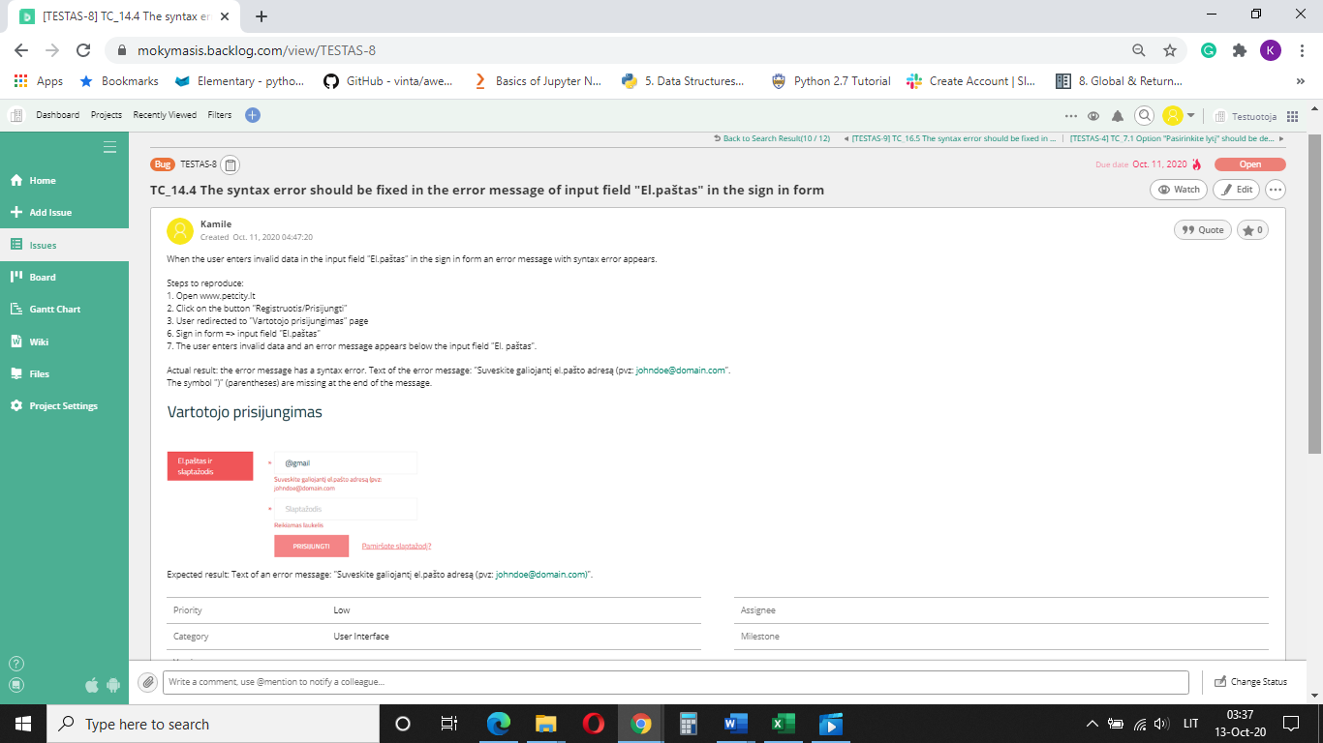

Figure 8.

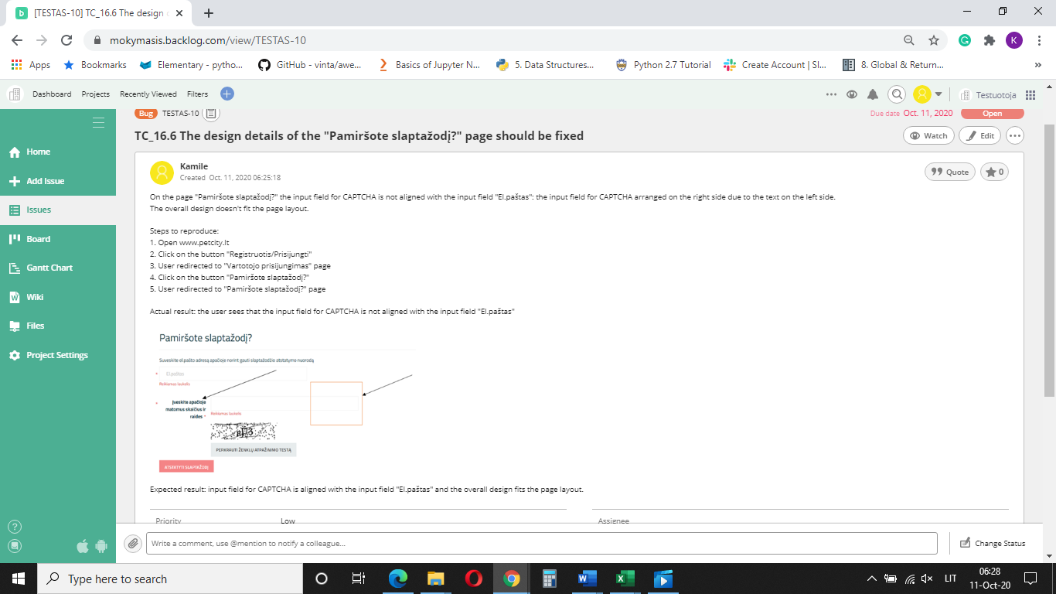

Figure 9.

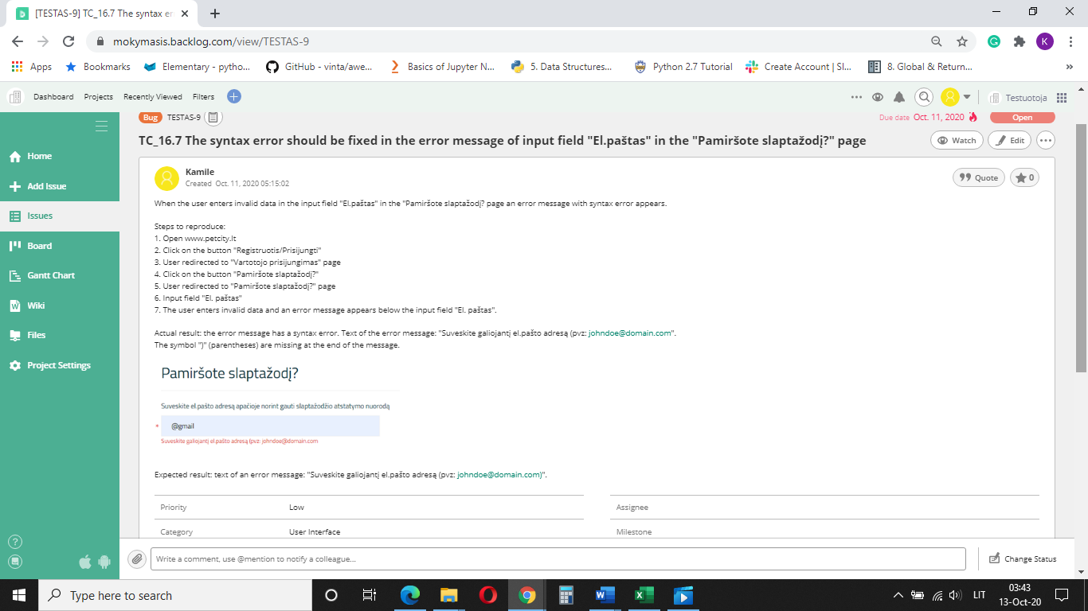

Figure 10.

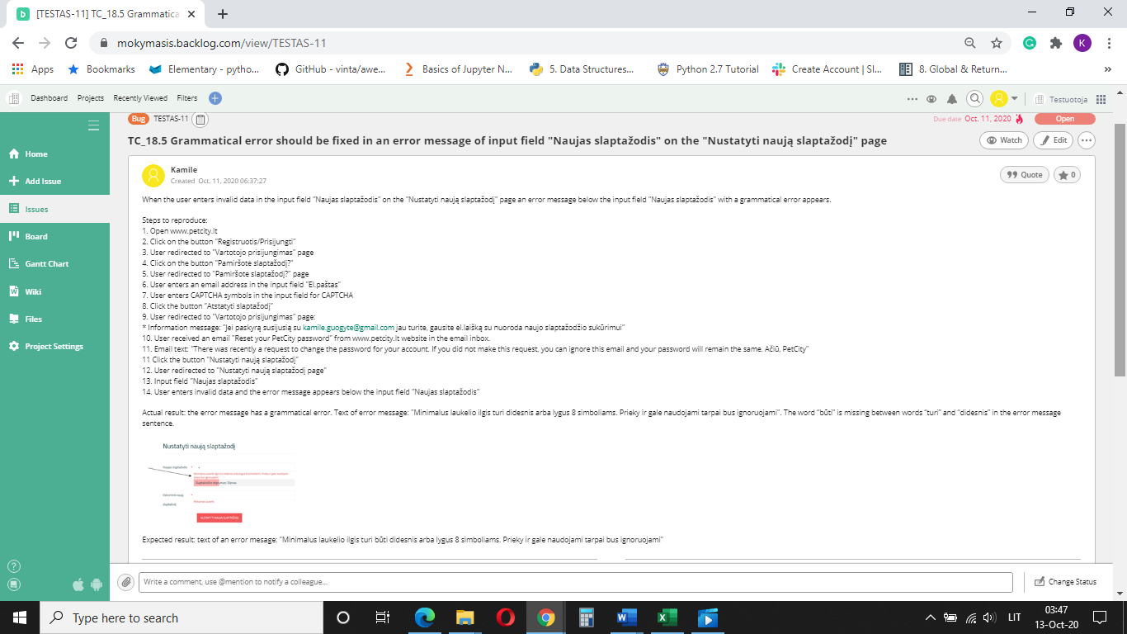

Figure 11.

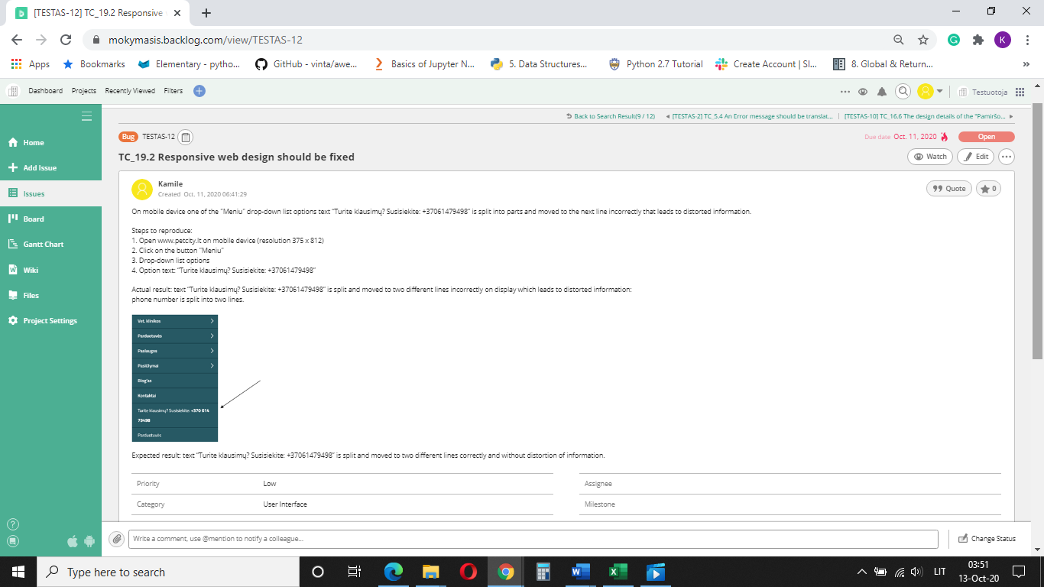

Figure 12.

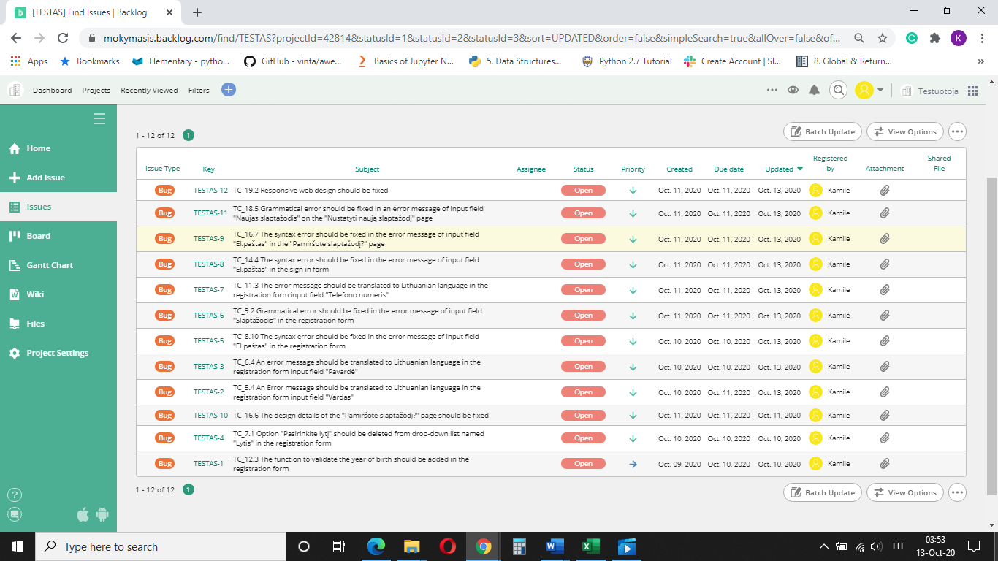

Figure 13.

# **Improvements**

TC_5.4, TC_6.4, TC_11.3 test cases reveal that validation error messages which appear when input data does not fulfill the requirements are formulated in a different language (English) than website language (Lithuanian) (Figure 14, arrow 2).

TC_8.10, TC_14.4, TC_16.7 test cases reveal, that validation error messages are incorrect syntactically (Figure 14, arrow 4) and TC_9.2, TC_18.5. test cases reveal, that validation error messages incorrect grammatically (Figure 15, arrow 1).

In the TC_7.1 test case the user clicks on drop-down list named "Lytis” in the registration form. The user sees 3 options: the first option "Pasirinkite lytį", the second option "Vyras", the third option "Moteris". When the user chose the option "Pasiririnkite lytį" then the error message appears. The text of an error message "Reikiamas laukelis" means, that the user can not choose the option "Pasirinkite lytį" but this option is on display. This option should be removed for user convenience (Figure 14, arrow 3).

TC_12.3 test case shows that user is able to enter the year of birth value from 0000 years to today's years in the registration form. The website system accepts invalid data and allows user registration. In this case programming function to validate the year of birth should be added (Figure 15, arrow 4).

|  |  |  |  |  |  |  |  |  |  |
| --- | --- | --- | --- | --- | --- | --- | --- | --- | --- |
| |  | | --- | | 1 | | 2 | | 3 | | 4 |       Figure 14. | |  | | --- | | 1 | | 2 | | 3 | | 4 |     Figure 15. |

TC_16.6 test case shows, that on the page "Pamiršote slaptažodį?" the input field for CAPTCHA is not aligned with the input field "El.paštas": the input field for CAPTCHA arranged on the right side due to the text on the left side. The overall design doesn't fit the page layout. (Figure 16).

TC_19.2 test case shows, on the mobile device one of the "Meniu" drop-down list options text “Turite klausimų? Susisiekite: +37061479498” split and moved to two different lines incorrectly on display which leads to distorted information: phone number is split into two lines. Text “Turite klausimų? Susisiekite: +37061479498” should be split and moved to two different lines correctly and without distortion of information. Responsive web design should be fixed (Figure 17).

|  |  |  |  |
| --- | --- | --- | --- |
| Figure 16. | |  | | --- | |  | |  |     Figure 17. |

High priority and severity bugs were not found in this project, but low priority and severity bugs although, do not affect the processing of the website, but can have an impact in some contexts.

TC_12.3 test case shows, that the user is able to enter an invalid value in the input field of the year of birth and that can cause mistakes on the website data basis. If birth date is required field for user in registration form but has no birth year date limitation it can lead to a lot of invalid data in the data basis of webpage and will be unuseful in statistical analysis. When capturing information for insertion into a database, or use in other processing, it's important to control what the user can enter. Otherwise, you can end up with values in the database that have no relation to reality.

Grammar and spelling mistakes, text mixed in different languages can create a negative impact on the user. While designing, development and testing phase these points should be considered as well.

# **Test Design Techniques**

The target testing areas in this project are forms of webpage www.petcity.lt: user registration form, user sign in form, user password reset form. According to the rules of form testing:

* Parts of field validation table (FVT) test design technique was used;
* Test cases were formulated on each form object in the combination of both [negative and positive test cases](https://www.softwaretestinghelp.com/positive-and-negative-test-scenarios/);
* Functional test cases positive and negative were used;
* Non-functional security test cases positive and negative were used;
* User interface, usability, compatibility test cases were used.

# **Reflection**

Website testing is a specific area of testing that requires knowledge and practical experience. Often it is impossible to find all bugs in the product according to the time frame, therefore, a tester must know the most important targets for testing. The e-commerce website should be not just functional but also attractive to the user and some not functional issues can be very important for the professional image.

The hardest part in this project as for the inexperienced tester was to prioritize test areas, determine if it is a bug or issue, a priority of it, how this particular bug/issue can affect e-commerce website functionality and how it will affect in the future and user attractiveness. Also lack of experience about specific exceptional target points, most sensitive areas that tester should now look for. Wider knowledge about the relation between front-end parts and back-end programming code areas also important.

After this final project I learned about important points in e-commerce testing and in which areas tester should pay more attention and that each primary issue associated with testing has the potential to branch into uncountable related issues, all of which can be solved if properly identified.