**DEPARTMENT OF COMPUTER SCIENCE**

MACHINE LEARNING

HEART DISEASE PREDICTION **GROUP_2**

TEAM MEMBERS

NAME ID CONTRIBUTION %

KAMILE SEIDU 10822436 25%

DANIEL ANSAH DELADEM 10712655 20%

FREDA OWUSUAA BAAH 10808851 10%

HELENA AMISSAH 10821309 20%

AKUA OSEI-NKWANTABISA 10%

BERTHA ABENA JONES 10844150 15%

GITHUB REPOSITORY LINK:

<https://github.com/KamileSeidu/Group_2_Heart_Disease_Prediction>

INTRODUCTON

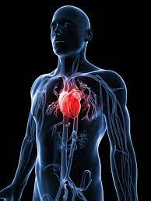

The term "heart disease" refers to a variety of diseases and ailments that affect the heart and circulatory system. Cardiovascular illnesses are another name for them. It is one of the leading causes of disability all around the world. Because the heart is one of the most important organs in the body, illnesses of the heart can impact other organs and parts of the body. Heart disorders come in a variety of shapes and sizes. The most frequent ones involve coronary artery narrowing or blockage, heart valve malfunction, heart enlargement, and a variety of other problems that contribute to heart failure and heart attacks.

According to the Centers for Disease Control and Prevention (CDC), heart disease is one of the major causes of mortality in the World. High blood pressure, high cholesterol, and smoking are three important risk factors for heart disease that affect over half of all Americans (47 percent). Diabetic status, obesity (high BMI), lack of physical exercise, and excessive alcohol use are all important indicators. In healthcare, detecting and avoiding the variables that have the greatest influence on heart disease is critical. As a result of computational advancements, machine learning methods may be used to find "patterns" in data that can be used to forecast a patient's status.

**OBJECTIVES OF THE NOTEBOOK**

This notebook aims at predicting heart diseases base on the data set given. We will be comparing models to see which one performs better than the other. We will be using some common Python libraries, such as pandas, numpy, matplotlib and Seaborn.

**DATASET CURATION**

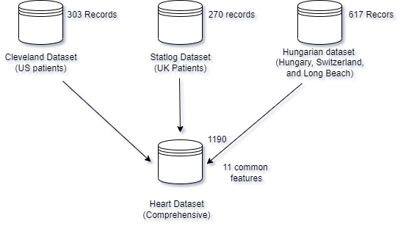

**EXPLANATION OF THE VARIABLES OF THE DATASET**

|  |  |  |  |
| --- | --- | --- | --- |
| S. NO | Feature | Description | Data type |
| 1. | Age | Patients Age in years | Numeric |
| 2. | Sex | Gender of Patient (Male - 1, Female - 0) | Normal |
| 3. | Chest pain type | Type | Nominal |
| 4. | Resting BP | Level of blood pressure at resting mode in mm/HG | Numerical |
| 5. | Cholesterol | Serum cholesterol in mg/dl | Numeric |
| 6. | Fasting blood sugar | Blood sugar levels on fasting > 120 mg/dl represents as 1 in case of true and 0 as false | Nominal |
| 7. | Resting ECG | Result of electrocardiogram while at rest are represented in 3 distinct values | Normal, Wave, Nominal |
| 8. | Max Heart rate | Maximum heart rate achieved | Numeric |
| 9. | Exercise angina | Angina induced by exercise 0 depicting NO 1 depicting Yes | Nominal |
| 10. | Old peak | Exercise induced ST-depression in comparison with the state of rest | Numeric |
| 11. | ST slope | segment measured in terms of slope during peak exercise | Normal, Flat, Nominal |
| **TARGET VARIABLE** | | | |
| 12. | Target | It is the target variable which we have to predict 1 means patient is suffering from heart risk and 0 means patient is normal. | Heart Risk, Normal |

**ST SEGMENT DEPRESSION**

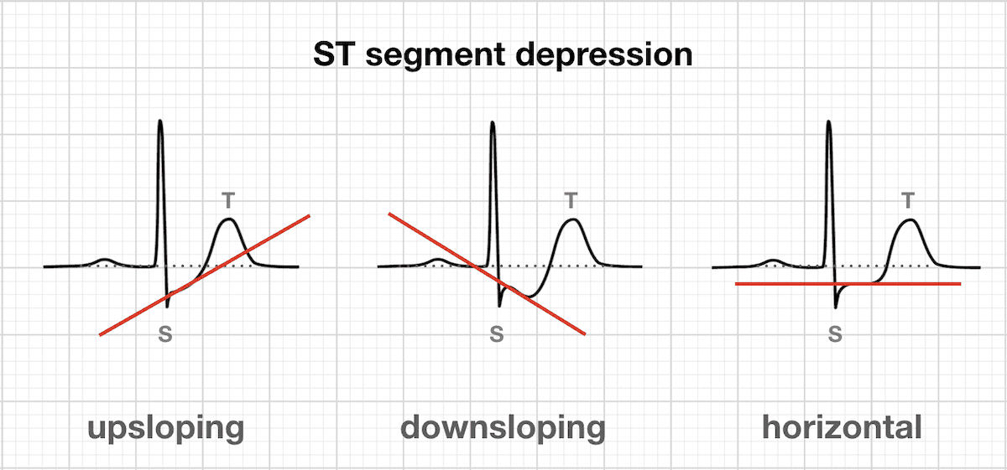

GITHUB LINK:

<https://github.com/KamileSeidu/Group_2_Heart_Disease_Prediction>