# Ice Cream Game

Project Group : **AC**

Group Members :

* **Calista Butera** : start/end Screen; soundEffect.
* **Huanrui Cao** : mainCode; Brief Paper.
* **Duong Tran** : Graphics; Layout; orderGenerater.
* **Nhat Tin Tran** : flavourCheck; mouseFunction.

This is a small game to run a Ice cream parlor.

Players should follow the instructions of the order and click on the different objects in the right order to make ice cream.

After clicking "Start Game" on the launch screen, an ice cream order will be generated.

Players need to use the mouse to click on the corresponding holder, flavor, frosting and topping in order to make ice cream according to the display on the order form.

When finished, click on the delivery button to check if the order is correct.

If the player has correctly made the ice cream as indicated by the order, a success screen will appear on the end screen and a cheerful sound effect will be played.

Conversely, the failure screen and muffled sound effects will be played.

## Reference:

**Purble Place Game** :

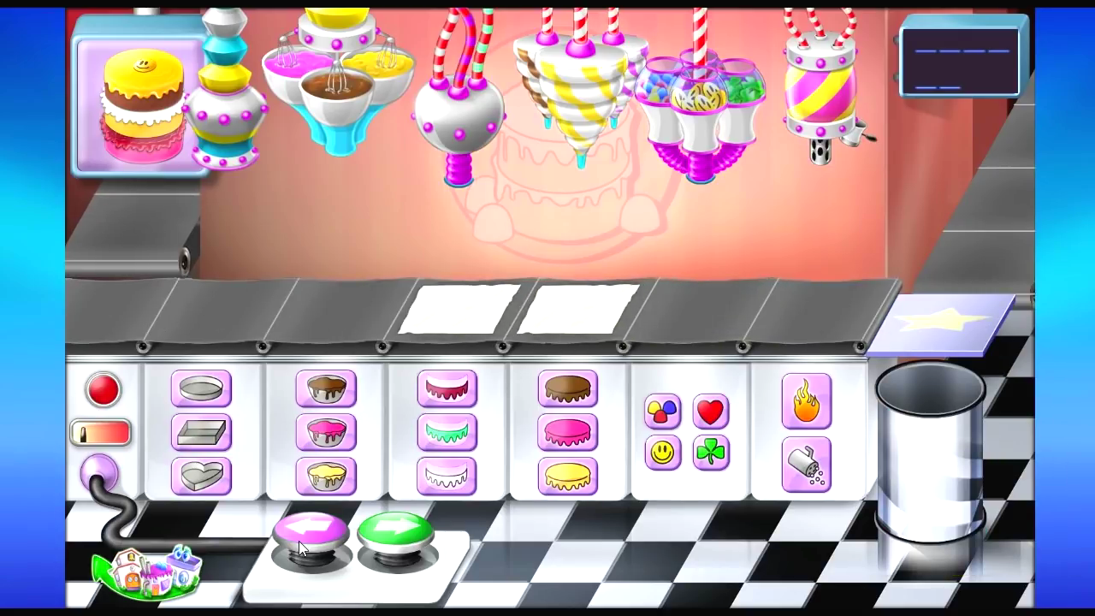 *Childhood game :”)*