|  |  |
| --- | --- |
|  | **FPT ACADEMY INTERNATIONAL**  **FPT – APTECH COMPUTER EDUCATION** |

**Centre Name: ACE-THUDUC-1-FPT.**

**Address: 391A Nam Ky Khoi Nghia, District 3, Ho Chi Minh City, Vietnam.**

HairCare

|  |  |  |
| --- | --- | --- |
| **Supervisor.** | Mr. Nguyen Phat Tai | |
| **Batch.** | T3.2307.E1 | |
| **Group.** | Group 6 | |
| **Serial No.** | **Enrollment Number** | **Student Name** |
| 1. | Student1491492 | Nguyen Minh Tri |
| 2. | Student1491731 | Nguyen Dinh Minh Hien |
| 3. | Student1491485 | Nguyen Hung Dung |

14-Nov-2023

**This is to certify that**

**Mr.:**

Nguyen Minh Tri

Nguyen Dinh Minh Hien

Nguyen Hung Dung

**has successfully designed & developed**

eProject: HairCare

**Submitted by: Nguyen Minh Tri**

**Date of issue: 14-Nov-2023**

**Authorized Signature: Tri**

**TABLE OF CONTENTS**

ACKNOWLEDGEMENT 3

SYNOPSIS 3

PROBLEM DEFINITION 3

CUSTOMER'S REQUIREMENTS SPECIFICATIONS (CRS) 3

Business/Project Objective: 4

Hardware/ Software Requirements: 4

SCOPE OF THE WORK (IN BRIEF) 6

ARCHITECTURE AND DESIGN OF THE SYSTEM 7

MAP OF THE WEBSITE 8

TASK SHEET REVIEW 1 9

# ACKNOWLEDGEMENT

On behalf of myself, I would like to thank all members of group 6 for your hard work and contribution towards the completion of this eProject. I would also like to show my gratitude for Mr. Nguyen Phat Tai for his valuable assistance during both the planning and development phase. Finally, I would like to thank Aptech for allowing us the opportunity to hone our programming skills and test ourselves on real-life problems.

# SYNOPSIS

Proper hair care is vital, as beautiful and shiny hair makes a positive impression, particularly for women. It contributes to overall hair health and prevents damage and hair loss. Ordinary shampoo and conditioner use is insufficient; daily care knowledge is crucial. To address this, there is a need for a comprehensive platform providing complete hair care information, this is where the HairCare website steps in.

# PROBLEM DEFINITION

The Web site is to be created based on the following requirements.

1. Home page with suitable logo and images, making use of sections.

2. Categorized menu which will include various categories as type of treatments

available for various different hair problems like

a. Hair loss

b. Graying

c. Growth related

d. Premature baldness etc

3. The site should also include the various easy home remedies that can be

helpful in dealing with various hair related issues

4. There should be a section which will provide the details of hair care equipments like

a. Dryers

b. Straightners

c. Spray bottles

d. Steamers

e. Massagers

f. Spa caps

5. There should also be a section for hair care products as

a. Hair cream

b. Shampoo

c. Conditioners

d. Masks

e. Serums

f. Hairsprays

g. Various hair oils

6. Along with the various equipments, there should also be user

manual/guidelines for ease of its use and maintenance.

7. The site should also include the details as of which companies provide which

equipments

8. Comparison among the same equipment of different companies should be

possible based on availability, cost major features

9. Gallery section should include most common instruments along with their

necessary details.

10. There should be a section which will enable user to know latest developments

in the field

11. Contact us page: contact us details with location should be displayed using

GeoLocation API (eg. GoogleMaps).

12. Navigation needs to be smoother.

13. The look and feel of the project must be made user friendly and uniformity in

the color combination must be maintained.

# CUSTOMER'S REQUIREMENTS SPECIFICATIONS (CRS)

**Client: HairCare**

### Business/Project Objective:

The Objective of this program is to give a sample project to work on real life projects. These applications help you build a larger more robust application.

The objective is not to teach you JavaScript/Dreamweaver but to provide you with a real life scenario and help you create basic applications using the tools.

You can revise the chapters before you start with the project.

This project is meant for students who have completed the module of ***HTML5.*** These programs should be done in the Lab sessions with assistance of the faculty if required.

It is very essential that a student has a clear understanding of the subject. Students should go through the project and solve the assignments as per requirements given.

Kindly get back at [eprojects@aptech.ac.in](mailto:eprojects@aptech.ac.in) in case of any doubts regarding the application or its objectives.

**Input to the system:**

* + - * Browsing products based on brands, type of equipments…

**Output from the system:**

* A menu that will categorize all the functions of the site.
* Display the list of available products category wisely.
* Perform the brief comparison by showing 2 products of the same type with their details.
* Site should be able to provide brief introduction/history about the company under About Us page.
* The location of the company is in Contact Us page.
* Besides the above requirements, the site should have look and feel as per the industry standards.

**Expected delivery date:** 14-Nov-2023.

**List of deliverables:**

* + - * Document Word.
      * User Guide.
      * Source code.

### Hardware/ Software Requirements:

**Hardware**

* + A minimum computer system that will help you access all the tools in the courses is a Pentium 166 or better.
  + 64 Megabytes of RAM or better.

**Software**

* + Notepad/HTML editor.
  + Dreamweaver, VisualStudioCode.
  + IE 5.0/ Netscape 6.0.

# SCOPE OF THE WORK (IN BRIEF)

**I have discussed with myself and agreed upon the website layout shown as below:**

1. **Homepage**: A brief overview about the company, its mission and services offered. The page includes suitable logos and images with a sensible layout, making use of sections. The homepage will also include a section on the latest development in the field.
2. **Common Hair Problems**: A categorized menu containing many different types of hair problems. Clicking on a hair problem will bring up a few home remedies and products suggested by the company to combat the problem.
3. **Home Remedies**: A categorized collection of home remedies useful for combatting hair related issues.
4. **Products**: Comprehensive list of products we are selling along with their details, images. Filtering, sorting, categorization functionality is available for enhanced user experience. The products offered include hair care equipments and hair care products. Clicking on any product will also bring up its corresponding user manuals/guidelines. User can also sort by their functionality and brand on this page.
5. **Brands**: List of products categorized by brands
6. **Compare**: Compare the same equipment of different companies based on availability, cost major features
7. **Contact Us**: Information on the company, including but not limited to address, location, contact details.
8. **About Us**: History, archievements and further information on the company.

# ARCHITECTURE AND DESIGN OF THE SYSTEM

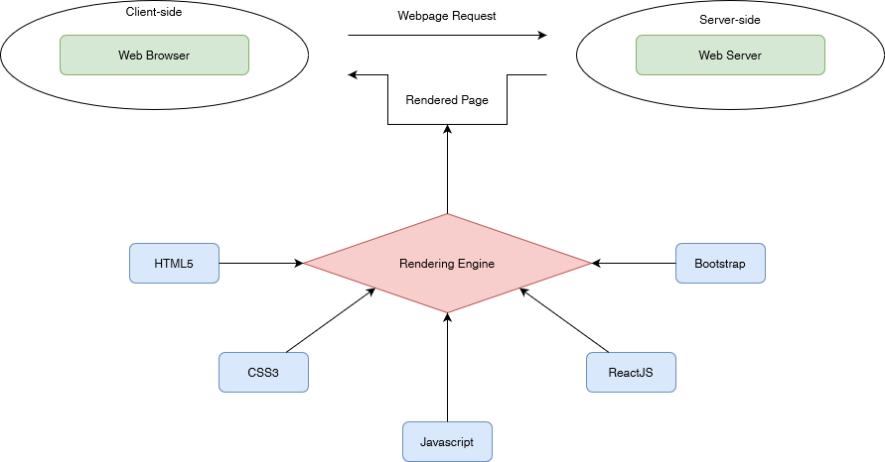

# MAP OF THE WEBSITE

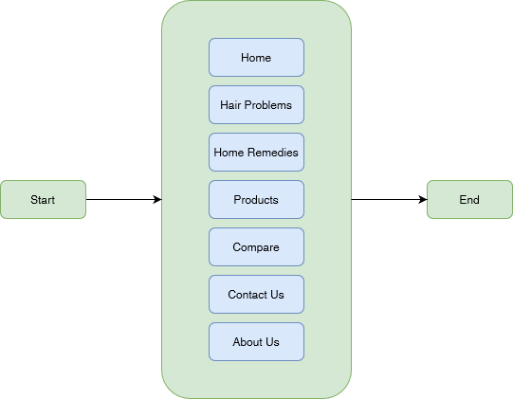



# TASK SHEET REVIEW 1

|  |  |  |  |  |  |  |  |
| --- | --- | --- | --- | --- | --- | --- | --- |
| **Project Ref. No.:**  **eP/Advertisement Portal Management**  **System/01** | | **Project Title:** | **Activity Plan Prepared By:** | **Date of Preparation of Activity Plan:** | | | |
| **Sr.**  **No.** | **Task** | **Actual**  **Start Date** | **Actual Days** | **Team**  **Mate Names** | **Status** |
| 1 | Problem Statement | Durable Furnitures | Tri | 19-Oct-2023 | 1 | Tri | Completed |
| 2 | Analysis of the requirements about the website | 19-Oct-2023 | 1 | Tri | Completed |
| 3 | The scope of the work (in brief) | 19-Oct-2023 | 1 | Tri | Completed |
| 4 | Architecture and design of the system | 19-Oct-2023 | 1 | Tri | Completed |
| 5 | Diagram of the website | 19-Oct-2023 | 1 | Tri | Completed |
| 6 | Task Sheet | 19-Oct-2023 | 1 | Tri | Completed |

|  |  |
| --- | --- |
| **Date: 21/10/2023** | |
| Signature of Instructor:  **Mr. Nguyen Phat Tai** | Signature of Team Leader:    **Mr. Nguyen Minh Tri** |