ACADEMIC TASK - 2
(PROJECT)
INT375
DATA SCIENCE TOOLBOX: PYTHON PROGRAMMING


Lovely Professional University
School of Computer Science and Engineering
Report
on
Analyzing COVID-19 Trends

Submitted by:
Kamlesh Muwal
Reg. No: 12311068
INT375
Under the Guidance of:
Dr. Dhiraj Kapila
Designation: Assistant Professor
Date:10th April 2025

Declaration
I, Kamlesh, hereby declare that the project report titled “Analyzing COVID-19 Trends Using Python” is the outcome of my independent work under the guidance of Dr. Dhiraj Kapila. This report represents my original analysis and interpretation of the COVID-19 dataset, conducted with academic integrity and proper citation of all sources.

Certificate

This is to certify that the project report titled “Analyzing COVID-19 Trends Using Python” submitted by Kamlesh is an original work carried out under my supervision. The candidate has demonstrated diligence and proficiency in data analysis and visualization techniques throughout the project.
Supervisor:
Dr. Dhiraj Kapila
10 April 2025

Acknowledgement

I extend my heartfelt gratitude to Dr. Dhiraj Kapila for their unwavering guidance, constructive feedback, and encouragement throughout this project. I am also thankful to Lovely Professional University for providing the necessary resources and infrastructure. Special thanks to my peers, family, and friends who offered support and motivation during this endeavor.

Table of Contents
- Introduction

- Source of Dataset

- Dataset Preprocessing

- Analysis on Dataset

- Conclusion

- Future Scope

- References

1. Introduction
The COVID-19 pandemic, caused by the SARS-CoV-2 virus, has been one of the most significant global health crises of the 21st century, affecting millions of lives and economies worldwide. This project aims to analyze the trends and patterns of COVID-19 spread, mortality, and vaccination efforts using Python programming language. Leveraging a comprehensive dataset, the analysis employs advanced data visualization techniques to provide insights into the progression of the pandemic across different countries and continents. The study focuses on key metrics such as new cases, total cases, new deaths, total deaths, and vaccination rates, utilizing libraries like Matplotlib, Seaborn, and Pandas. The visualizations include line charts, scatter plots, bar charts, heatmaps, boxplots, and pair plots, offering a multi-dimensional view of the pandemic's impact. This report is designed to assist policymakers, healthcare professionals, and researchers in understanding the dynamics of the pandemic and formulating evidence-based strategies.

2. Source of Dataset
The dataset utilized in this project is the COVID-19 dataset provided by Our World in Data (OWID), a renowned organization dedicated to making data on global issues accessible and understandable. This dataset is available for download at https://ourworldindata.org/coronavirus and is updated regularly to reflect the latest statistics. The CSV file contains a wide range of variables, including daily and cumulative counts of confirmed cases and deaths, vaccination rates, testing data, hospitalization figures, reproduction rates, and government stringency indices. The data spans multiple countries and continents, covering the period from the onset of the pandemic in 2020 through April 2025, providing a robust foundation for longitudinal analysis.

3. Dataset Preprocessing

To ensure the accuracy and usability of the dataset, several preprocessing steps were undertaken:
- Data Loading and Type Conversion: The dataset was loaded using the Pandas library, and the "date" column was converted to datetime format to facilitate time-series analysis.
- Metric Selection: Key metrics were identified for analysis, including new cases per million, total cases per million, new deaths per million, total deaths per million, total vaccinations per hundred, total vaccinations, new tests, Hosp patients per million, reproduction rate, total tests, new cases, new deaths, and stringency index. These metrics were chosen based on their relevance to understanding pandemic trends.
- Handling Missing Values: Missing values were a common issue in the dataset. To maintain consistency, null values in numerical columns were filled with 0, assuming no reported data indicates zero activity for that metric on a given day. Warnings were printed for any missing columns to ensure transparency.
- Data Filtering: The dataset was filtered to focus on five countries—India, United States, Brazil, United Kingdom, and South Africa—selected for their diverse demographic, economic, and healthcare contexts.
- Data Export: A cleaned version of the dataset was saved as "Cleaned_Covid_Dataset.csv" for future reference and reproducibility.
These preprocessing steps ensured the dataset was ready for in-depth analysis and visualization.

4. Analysis on Dataset (5 Objective)
Objective 1: Line Charts - Country-Wise Trends for Per-Million Metrics
This objective involved creating line charts to visualize the temporal trends of COVID-19 metrics across the selected countries. Four key metrics were analyzed:
Total Cases per Million:
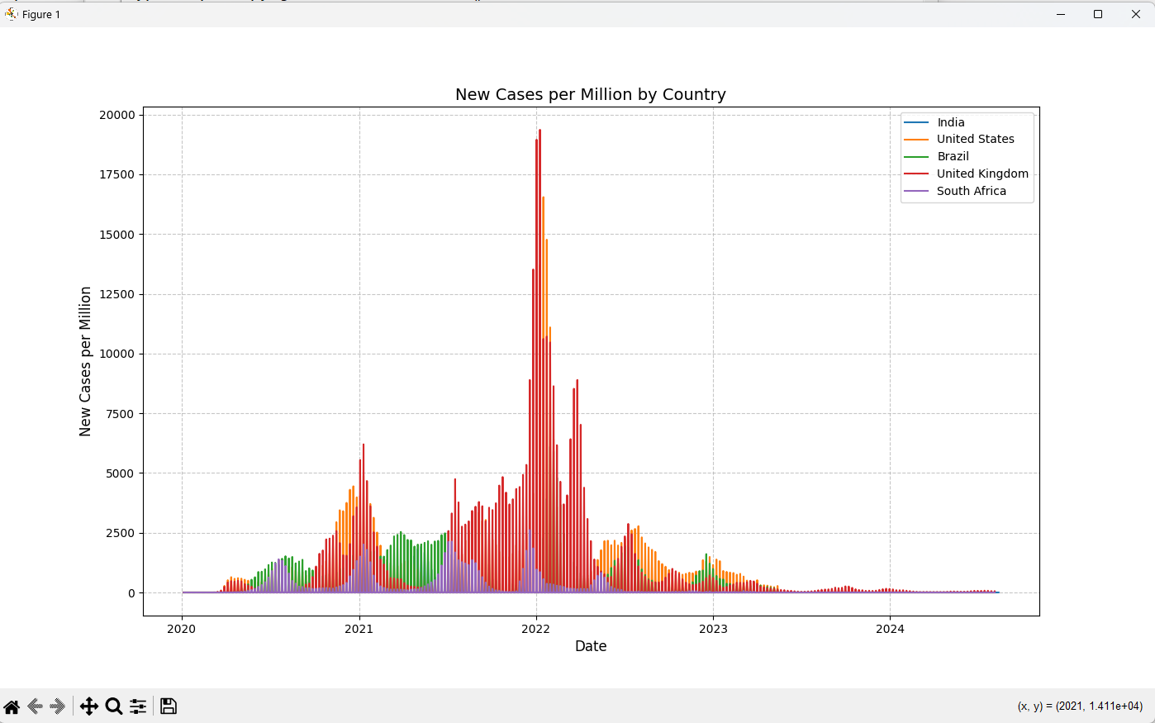

Figure 1 illustrates the cumulative total cases per million, showing the United States and Brazil with the highest values, reflecting their large population sizes and early pandemic waves. India exhibits a sharp rise followed by stabilization, while the United Kingdom and South Africa show moderate increases, indicating varying containment measures.
New Cases per Million:
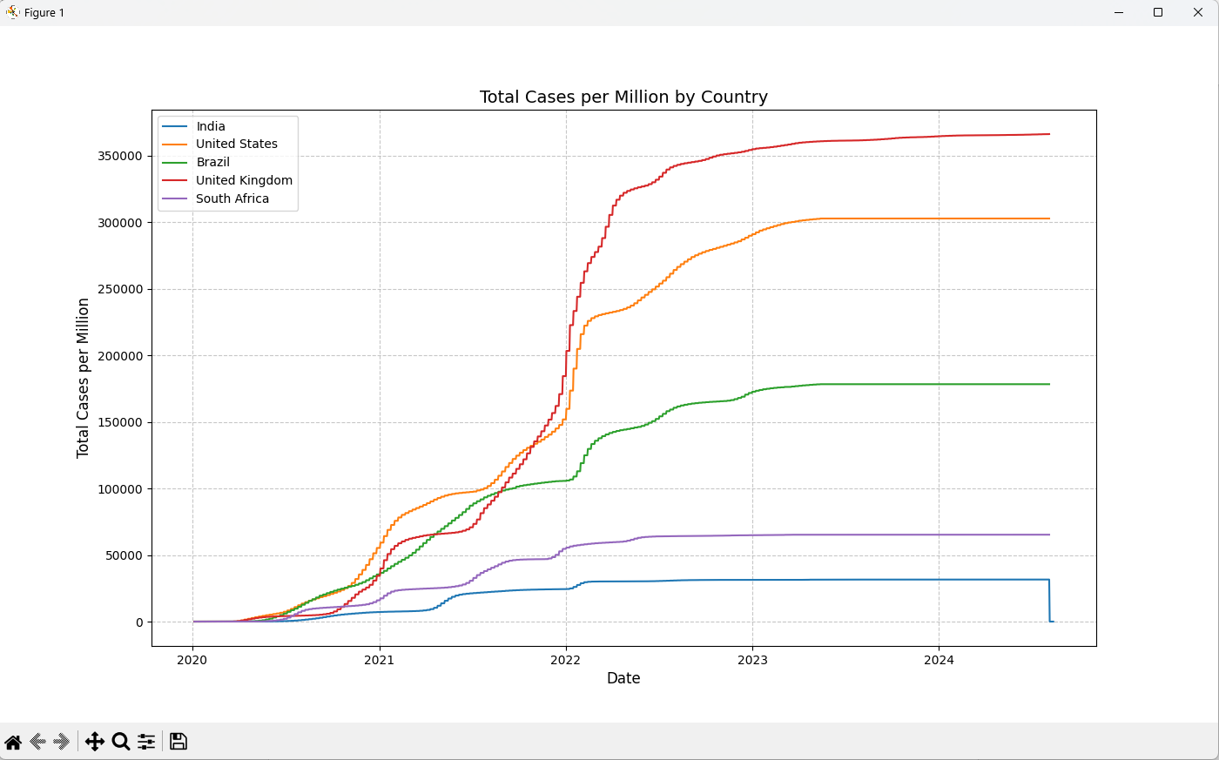

Figure 2 highlights peak waves, with United Kingdom and the United States experiencing significant surges in 2021, likely due to the Delta variant, followed by a decline as vaccination efforts intensified. South Africa and Brazil also show notable peaks, while India remains relatively lower.

New Deaths per Million:
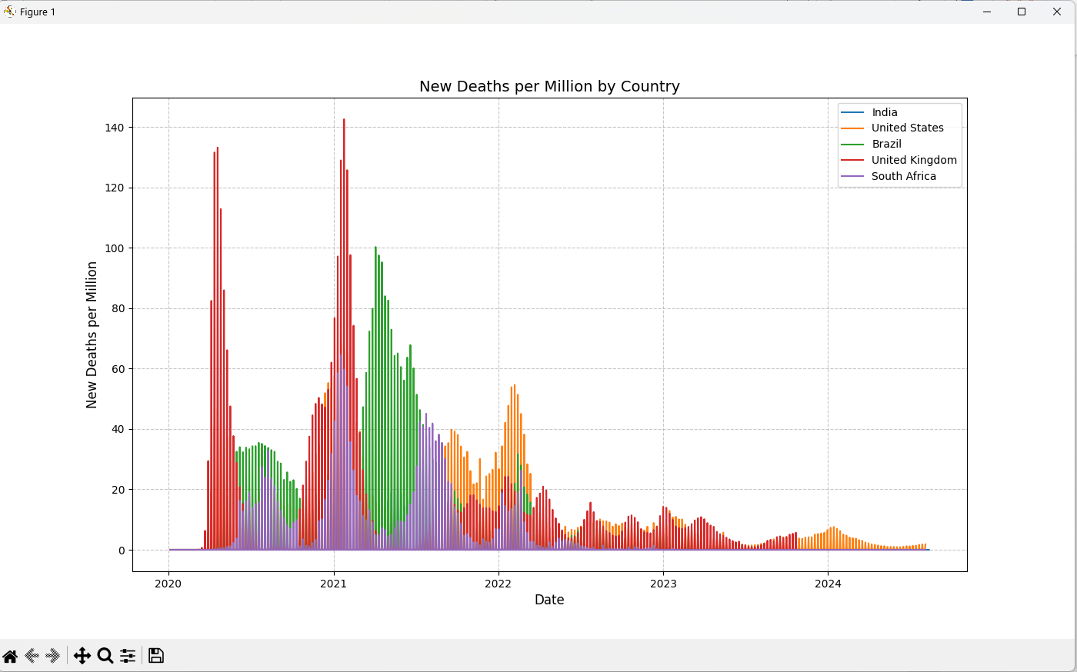

New Deaths per Million: Figure 3 reveals mortality peaks in Brazil and the United States in 2021, correlating with high case loads, while the United Kingdom and India show significant but less intense spikes. South Africa maintains a lower trend.

Total Deaths per Million:
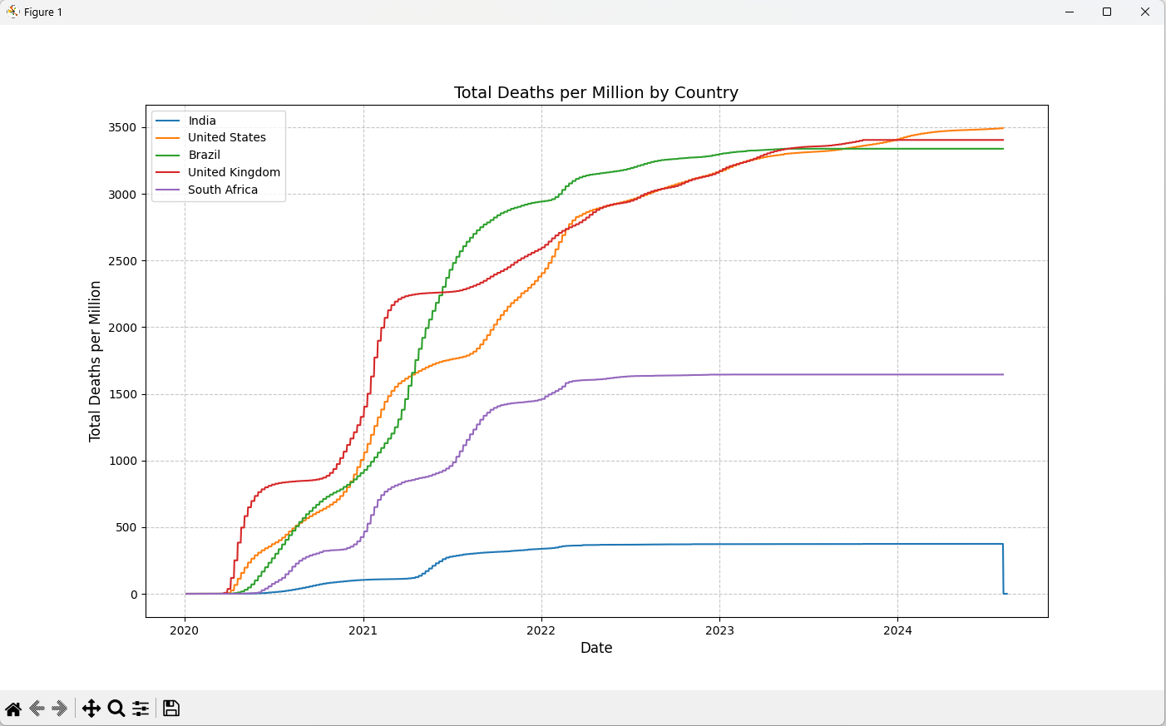

Total Deaths per Million: Figure 4 depicts a steady increase, with the United States and Brazil leading, underscoring the long-term impact of the pandemic on these nations. The United Kingdom, India, and South Africa follow with progressively lower cumulative deaths.
Objective 2: Scatter Plot - Vaccination vs. Mortality (India)
A scatter plot was generated to explore the relationship between vaccination coverage and mortality in India. Figure 5 (see below) shows that as total_vaccinations_per_hundred increased beyond 100, new_deaths_per_million declined significantly, suggesting a strong correlation between vaccination rollout and reduced mortality, particularly after mid-2021.

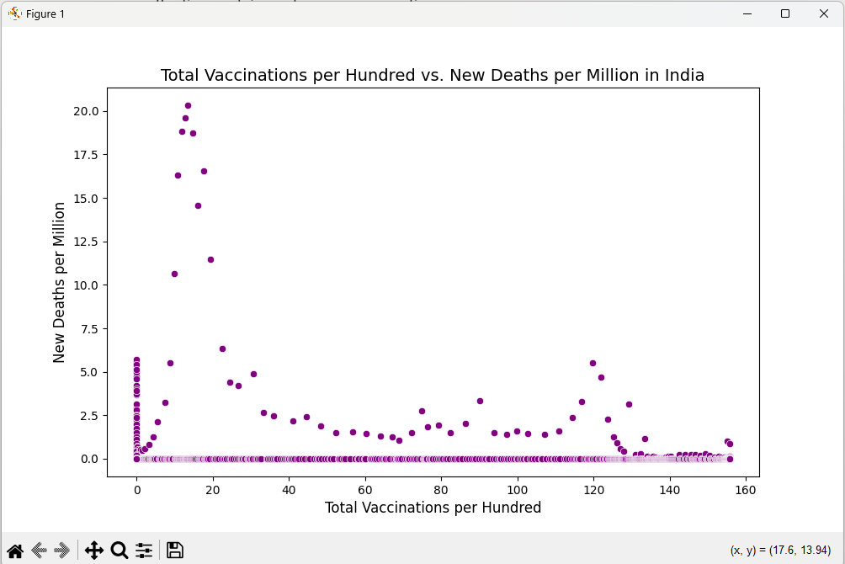
Objective 3: Heatmap - Factors Influencing Spread
A correlation heatmap was created to assess the relationships between factors influencing COVID-19 spread. Figure 6 (see below) indicates a perfect correlation (1.0) between new_cases_per_million and new_deaths_per_million, reflecting the direct link between infections and mortality. A moderate correlation (0.17) with hosp_patients_per_million suggests that hospitalizations play a role in case dynamics, while the stringency_index shows a weaker influence (0.16), indicating that policy measures had varying effectiveness.
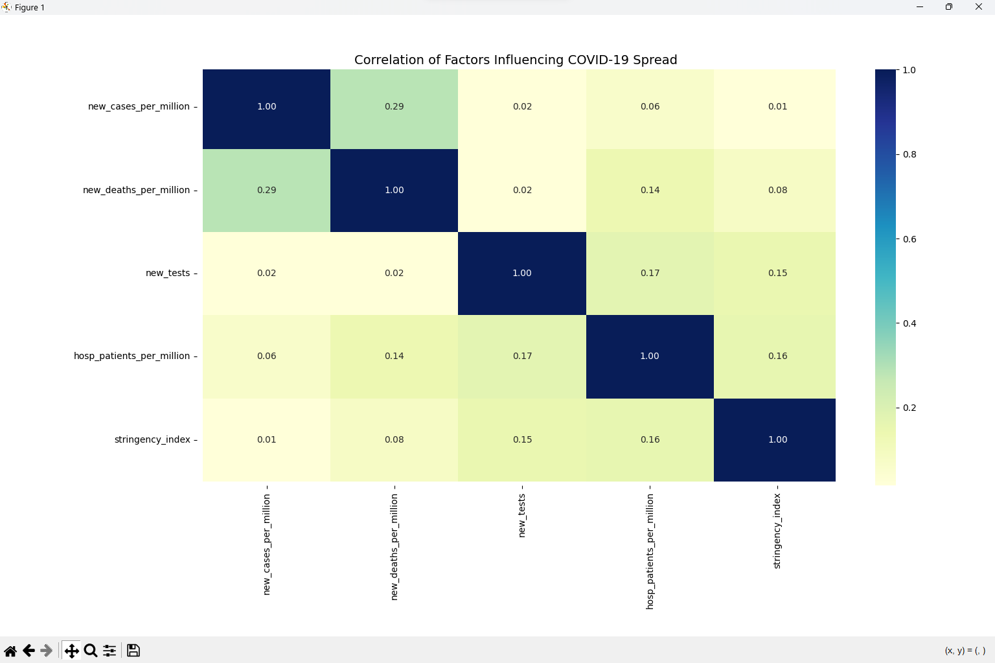
Objective 4: Bar Charts - Regional Differences
Bar charts were used to compare average COVID-19 metrics across continents:
- Average Total Cases per Million: Figure 7 (see below) shows Europe with the highest average, driven by dense populations and early outbreaks, while Africa reports the lowest, possibly due to underreporting or lower testing rates.

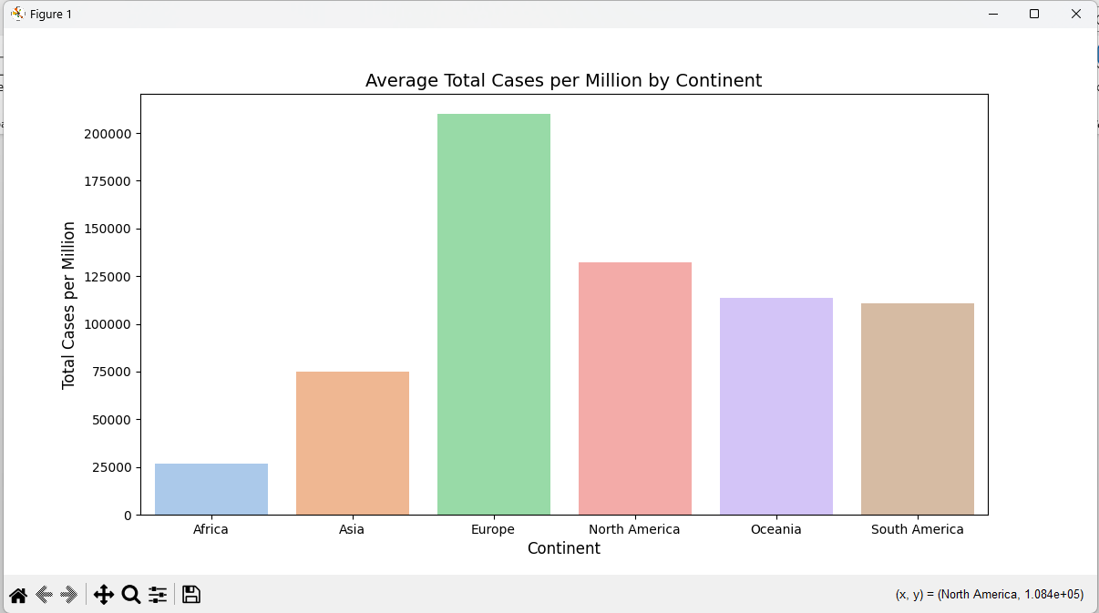

Average Total Deaths per Million:
Figure 8 (see below) highlights South America and Europe with the highest mortality rates, reflecting severe pandemic waves, whereas Africa shows the lowest due to its isolated geography and strict border controls.

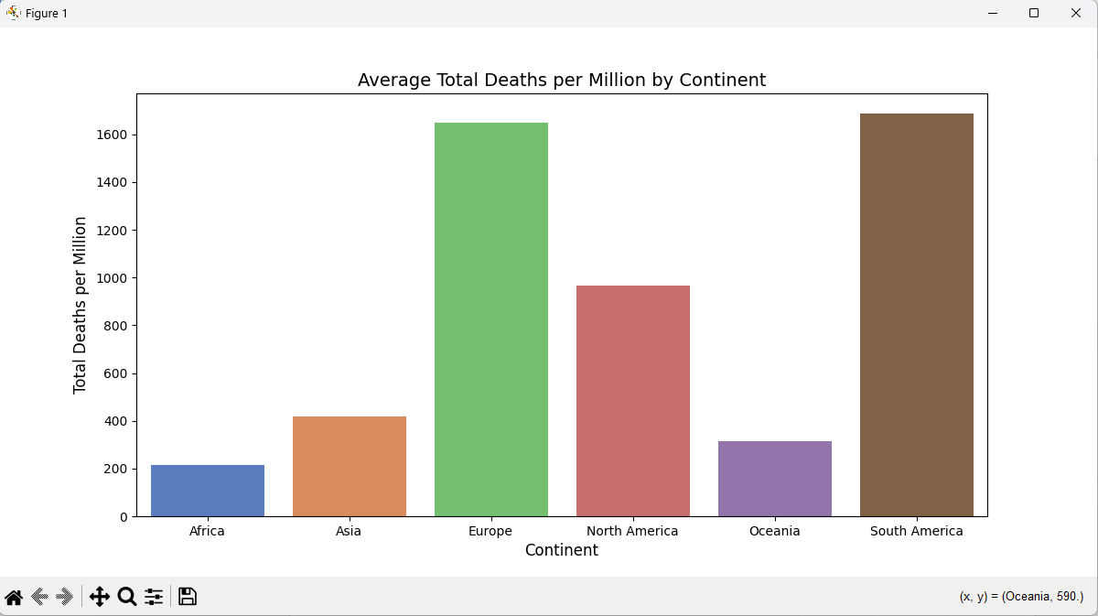

Objective 5: Boxplot - Outlier Detection
A boxplot with a logarithmic scale was used to detect outliers in new_cases across continents. Figure 9 (see below) reveals numerous outliers, especially in Asia and Europe, corresponding to peak waves driven by variants like Delta and Omicron. This suggests significant variability in case reporting and outbreak severity.
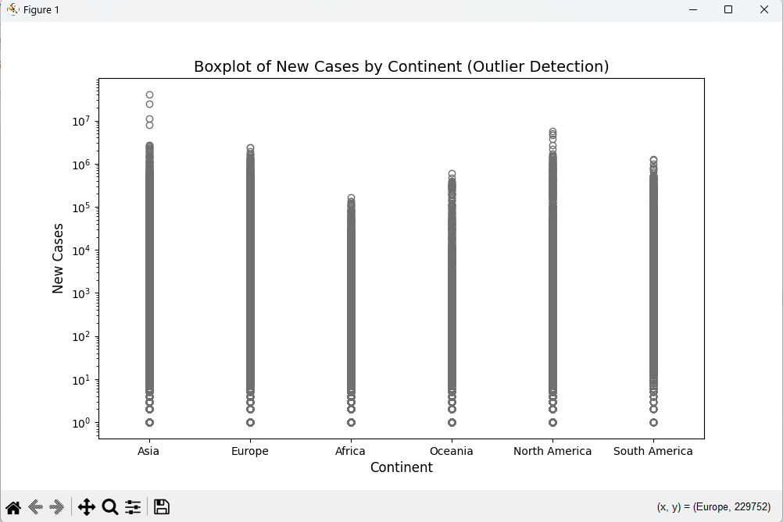

Objective 6: Pairplot - Metric Relationships
A pairplot was generated to explore pairwise relationships between new_cases_per_million, new_deaths_per_million, total_vaccinations_per_hundred, and stringency_index, colored by country. Figure 10 (see below) shows distinct patterns: vaccinations exhibit a negative trend with deaths over time, while stringency_index shows limited impact on case reductions, providing a holistic view of pandemic dynamics.
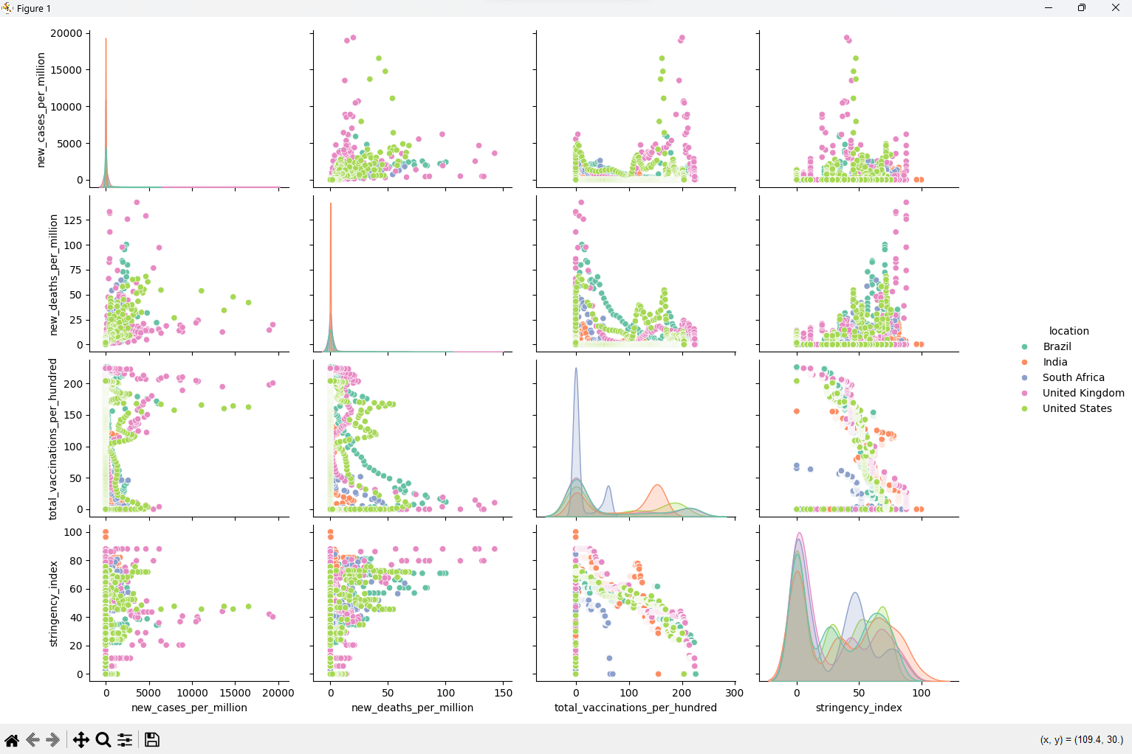

Additional Analysis
- Summary Statistics: Descriptive statistics for new_cases_per_million were computed, offering insights into central tendency and variability.
- Outlier Identification: The top 5 outliers in new_cases_per_million were identified, with corresponding locations and dates, highlighting extreme events such as the Indian Delta wave in 2021.
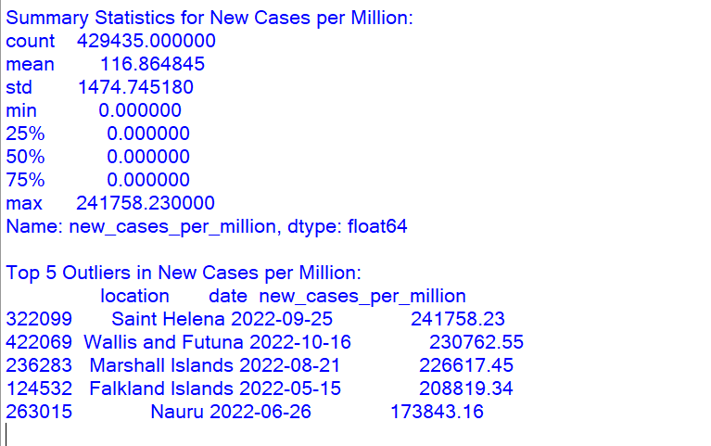

5. Conclusion
The Python-based analysis provided a comprehensive overview of COVID-19 trends from 2020 to 2025. Key findings include:
- The United States and Europe were the hardest hit in terms of per-million cases and deaths, reflecting high population density and healthcare challenges.
- India’s vaccination campaign, as depicted in the scatter plot, significantly reduced mortality rates post-2021, showcasing the effectiveness of public health interventions.
- The heatmap revealed that hospitalizations and case numbers were closely linked, while stringency measures had a moderate impact, suggesting the need for multifaceted strategies.
- Regional disparities, as shown in bar charts, underscored the influence of geography, healthcare infrastructure, and policy responses.
- Visualizations like heatmaps and pairplots offered actionable insights, making this analysis a valuable tool for policymakers and researchers aiming to mitigate future pandemics.

6. Future Scope
This project lays the foundation for further exploration:
- Real-Time Data Integration: Incorporating live data feeds to provide up-to-date insights.
- Interactive Dashboards: Transitioning to tools like Plotly or Dash for dynamic visualizations.
- Predictive Modeling: Developing machine learning models to forecast case and death trends based on historical data.
- Additional Metrics: Analyzing recovery rates, variant-specific data, and socioeconomic factors like poverty and healthcare access to provide a more nuanced understanding.

7. References
- Our World in Data COVID-19 Dataset (https://ourworldindata.org/coronavirus)
- Pandas Documentation (https://pandas.pydata.org/docs/)
- Matplotlib and Seaborn Visualization Guides (https://matplotlib.org/, https://seaborn.pydata.org/)

Link of the post:- https://www.linkedin.com/posts/kamlesh-muwal-36a9b02ab_python-datascience-covid19-activity-7317597169971068928-8kif?utm_source=social_share_send&utm_medium=member_desktop_web&rcm=ACoAAEq4WQIBLSTyeOHLUFrSojNWU0PzuTaknGY

Github Link:

