Certainly! Here’s a comprehensive innovation idea presentation outline for your Gamification Platform, now integrating business, technical, and management/financial benefits.
You can use this as a slide deck structure or executive summary.

Slide 1: Title
Enterprise Gamification Platform for Onboarding & Adoption
Innovation for Engagement, Productivity, and Measurable Success

Slide 2: The Challenge
- Onboarding and adoption are often tedious, inconsistent, and hard to measure.
- Teams lack motivation and managers lack visibility into progress and resource commitment.

Slide 3: The Innovation
- Modular, plugin-based gamification platform built with Python and Streamlit.
- Drives engagement with badges, progress bars, milestones, and instant feedback.
- Empowers any team (DevOps, DataOps, HR, Developers, Managers) to create their own onboarding/adoption journeys.

Slide 4: Key Business & Management Benefits
- Faster Time-to-Productivity: New hires and teams contribute value sooner.
- Resource Planning: Managers see progress, identify bottlenecks, and allocate support.
- Financial Efficiency: Automated onboarding reduces training costs and attrition.
- Goal Alignment: Ensures every employee is aligned with company objectives and compliance.
- Audit & Compliance: Full audit trails and certification tracking for regulatory needs.
- Motivation & Accountability: Automated reminders, recognition, and certification push.
- Strategic Alignment: Standardizes onboarding/adoption with company-wide goals.
- Real-Time Reporting: Dashboards for executives and managers.

Slide 5: Example Use Cases
- New joiner onboarding (company/team)
- DevOps CI/CD adoption
- DataOps onboarding
- GitHub Copilot adoption
- Cloud platform enablement
- Security & compliance training
- HR benefits and compliance
- API/integration onboarding
- Agile/Scrum process adoption

Slide 6: Technical Highlights
- Plugin Architecture:
  - Core engine + hot-pluggable roadmaps for any business process.
- Scalability:
  - Stateless, container-ready, external DB support.
- Metrics & Observability:
  - Built-in dashboards, audit logs, health checks, and monitoring endpoints.
- RBAC:
  - Role-based access for users and admins.
- Automation:
  - CI/CD pipelines, Ansible deployment, self-healing services.
- Authorization:
  - RBAC with SSO/OAuth2 integration for secure, enterprise-grade access control.

Slide 7: Architecture Overview
- Core engine manages users, progress, badges, notifications, and plugins.
- Plugins define milestones and UI for each onboarding/adoption journey.
- Admin UI for importing/creating milestones and managing users.
- Logging, monitoring, and audit trails for compliance and troubleshooting.
(Insert UML/component diagram here)

Slide 8: Management Features
- Timelines & Deadlines: Assign due dates to milestones and certifications.
- Automated Reminders: Email or in-app notifications for pending steps.
- Certification Push: Ensure all required certifications/badges are completed.
- Recognition: Highlight top performers and teams.
- Customizable Roadmaps: Management can define/update goals and milestones as business needs evolve.

Slide 9: Why This Is Innovative
- Moves beyond static checklists to interactive, gamified experiences.
- Enables rapid rollout of new onboarding/adoption journeys as business needs evolve.
- Bridges technical and non-technical domains with a unified, engaging platform.
- Delivers measurable business value, supports compliance, and empowers management with actionable insights and control.

Slide 10: Next Steps
- Pilot with select teams (e.g., DevOps, HR, DataOps).
- Gather feedback, iterate, and expand plugin library.
- Integrate with enterprise systems (HRIS, ITSM, etc.).
- Scale company-wide for all onboarding and adoption needs.

Slide 11: Q&A
Thank you! Questions?

Tips:
- Use screenshots, diagrams, and real examples for maximum impact.
- Keep slides concise; elaborate verbally on each point.
- Be ready to demo or show a short video if possible.

Let me know if you want this as a formatted slide deck, with sample visuals, or further tailored for your audience!

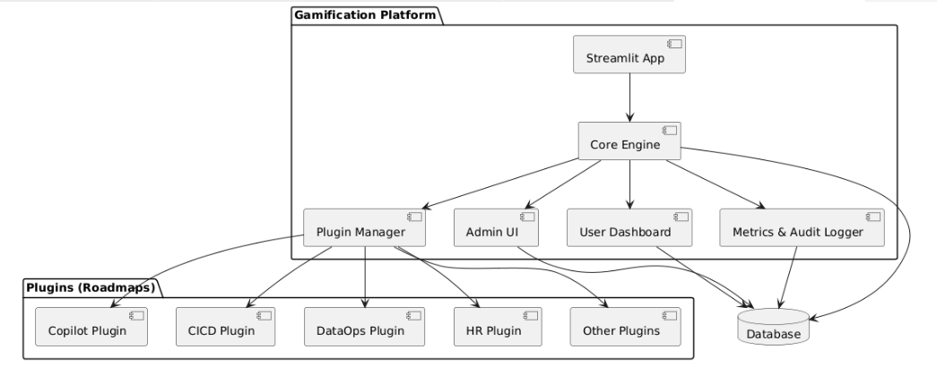
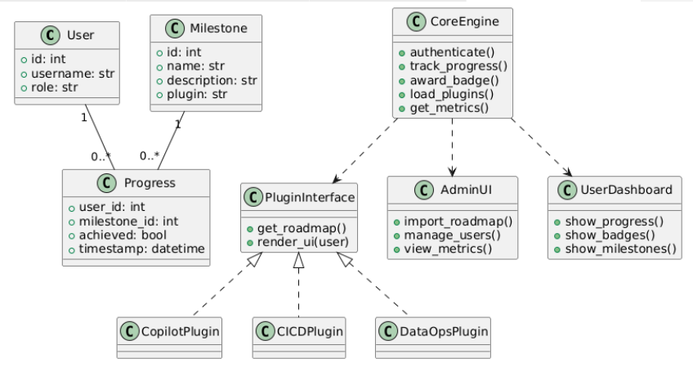
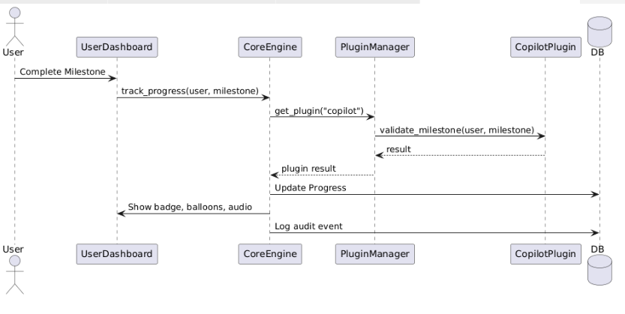
Absolutely! Here’s a sample JSON format for defining a plugin roadmap, which you can use to introduce new onboarding/adoption journeys as plugins in your gamification platform.

Sample Plugin Roadmap JSON Format
{
"roadmap_name": "DevOps CI/CD Adoption",
"description": "Milestones to onboard users to CI/CD best practices.",
"milestones": [
{
"id": 1,
"name": "Setup CI/CD Repo",
"description": "Create and initialize your first CI/CD-enabled repository.",
"badge": "setup_repo.png"
},
{
"id": 2,
"name": "Configure Pipeline",
"description": "Configure your first CI/CD pipeline using company standards.",
"badge": "pipeline_config.png"
},
{
"id": 3,
"name": "First Successful Build",
"description": "Achieve your first green build in the pipeline.",
"badge": "green_build.png"
},
{
"id": 4,
"name": "Deploy to Staging",
"description": "Deploy an application to the staging environment using CI/CD.",
"badge": "deploy_staging.png"
},
{
"id": 5,
"name": "Automated Test Integration",
"description": "Integrate automated tests into your CI/CD pipeline.",
"badge": "test_integration.png"
}
]
}

How to Use
- Place this JSON file in your plugin folder, e.g., plugins/cicd/roadmap.json.
- The platform’s core engine/plugin loader will read this file to dynamically create milestones, badges, and progress tracking for the roadmap.
- You can create similar JSON files for other roadmaps (e.g., Copilot, DataOps, HR, New Joiner, etc.).

Benefits
- No code changes needed to introduce new roadmaps—just add a new JSON file.
- Admins or power users can create or edit roadmaps easily.
- Badges can be mapped to images in your assets folder for visual feedback.

Let me know if you want a template for other use cases or a CSV format as well!

Absolutely! Here’s how you can highlight management-related benefits and strategic value in your innovation idea presentation:

Management & Financial Benefits
1. Resource Commitment & Visibility
- Clear Progress Tracking:
Managers can see exactly where each team member stands in their onboarding/adoption journey.
- Resource Planning:
Identify bottlenecks and allocate support/resources where needed.
- Goal Alignment:
Ensure every employee is aligned with company objectives and compliance requirements.

2. Financial Impact
- Faster Time-to-Productivity:
Accelerated onboarding means new hires and teams contribute value sooner.
- Reduced Training Costs:
Automated, self-service onboarding reduces the need for repeated manual training sessions.
- Lower Attrition:
Engaged, well-onboarded employees are more likely to stay, reducing recruitment and ramp-up costs.

3. Management Control & Reporting
- Dashboards for Executives:
Real-time metrics on adoption, certification, and compliance rates.
- Audit Trails:
Full visibility for compliance and regulatory reporting.
- Customizable Roadmaps:
Management can define and update goals, milestones, and required certifications as business needs evolve.

4. Motivation & Accountability
- Automated Reminders:
Scheduled emails or notifications for pending steps, nudging users to complete milestones.
- Certification Push:
Ensure everyone completes required certifications or badges, supporting compliance and upskilling.
- Recognition:
Publicly recognize top performers or teams, fostering a culture of achievement.

5. Strategic Alignment
- Company-wide Objectives:
Align onboarding/adoption with strategic goals (e.g., cloud migration, security compliance, digital transformation).
- Cross-Departmental Consistency:
Standardize onboarding and adoption across all business units.

6. Timelines & Milestone Management
- Set Deadlines:
Assign due dates to milestones and certifications.
- Track Delays:
Management can quickly identify overdue tasks and intervene proactively.

Summary Table
Benefit Area | Impact for Management/Finance
Resource Planning | Better allocation, reduced bottlenecks
Financial Efficiency | Faster ramp-up, lower training costs
Compliance | Audit trails, certification tracking
Motivation | Reminders, recognition, accountability
Strategic Alignment | Company goals embedded in onboarding
Reporting | Real-time dashboards for leadership

By integrating these features, the platform not only drives user engagement but also delivers measurable business value, supports compliance, and empowers management with actionable insights and control.
Let me know if you want these points formatted for a slide or executive summary!

Certainly! Here’s a streamlined presentation outline that combines both the innovation/business and technical perspectives for your Gamification Platform. You can use this as a slide deck structure or talking points for your innovation pitch.

Slide 1: Title
Enterprise Gamification Platform for Onboarding & Adoption
Innovation for Engagement, Productivity, and Measurable Success

Slide 2: The Challenge
- Onboarding and adoption are often tedious, inconsistent, and hard to measure.
- Teams lack motivation and admins lack visibility into progress.

Slide 3: The Innovation
- Modular, plugin-based gamification platform built with Python and Streamlit.
- Drives engagement with badges, progress bars, milestones, and instant feedback.
- Empowers any team (DevOps, DataOps, HR, Developers, Managers) to create their own onboarding/adoption journeys.

Slide 4: Key Business Benefits
- Faster, more consistent onboarding and adoption.
- Higher engagement and completion rates.
- Actionable insights for managers and admins.
- Scalable across any process or department.

Slide 5: Example Use Cases
- New joiner onboarding (company/team)
- DevOps CI/CD adoption
- DataOps onboarding
- GitHub Copilot adoption
- Cloud platform enablement
- Security & compliance training
- HR benefits and compliance
- API/integration onboarding
- Agile/Scrum process adoption

Slide 6: Technical Highlights
- Plugin Architecture:
  - Core engine + hot-pluggable roadmaps for any business process.
- Scalability:
  - Stateless, container-ready, external DB support.
- Metrics & Observability:
  - Built-in dashboards, audit logs, health checks, and monitoring endpoints.
- RBAC:
  - Role-based access for users and admins.
- Automation:
  - CI/CD pipelines, Ansible deployment, self-healing services.

Slide 7: Architecture Overview
- Core engine manages users, progress, badges, notifications, and plugins.
- Plugins define milestones and UI for each onboarding/adoption journey.
- Admin UI for importing/creating milestones and managing users.
- Logging, monitoring, and audit trails for compliance and troubleshooting.
(Insert UML/component diagram here)

Slide 8: Why This Is Innovative
- Moves beyond static checklists to interactive, gamified experiences.
- Enables rapid rollout of new onboarding/adoption journeys as business needs evolve.
- Bridges technical and non-technical domains with a unified, engaging platform.

Slide 9: Next Steps
- Pilot with select teams (e.g., DevOps, HR, DataOps).
- Gather feedback, iterate, and expand plugin library.
- Integrate with enterprise systems (HRIS, ITSM, etc.).
- Scale company-wide for all onboarding and adoption needs.

Slide 10: Q&A
Thank you! Questions?

Tips:
- Use screenshots, diagrams, and real examples for maximum impact.
- Keep slides concise; elaborate verbally on each point.
- Be ready to demo or show a short video if possible.
Let me know if you want a sample slide deck or further customization!
Absolutely! Here’s a technical summary you can use to explain your innovation idea to architects, engineers, or technical management:

Technical Innovation: Gamification Platform
1. Plugin Architecture
- Design:
  - Core engine exposes a standard plugin interface.
  - Each onboarding/adoption journey (e.g., Copilot, CI/CD, HR) is a self-contained plugin (roadmap) with its own milestones, logic, and UI.
- Benefits:
  - New journeys can be added/removed without touching the core.
  - Teams can develop and test plugins independently.
  - Enables rapid scaling across business domains.

2. Scalability
- Horizontal scaling:
  - Stateless Streamlit app can be containerized (Docker) and deployed behind a load balancer.
  - Database can be externalized (Postgres, MySQL, or managed DB) for multi-instance support.
- Plugin extensibility:
  - Any number of plugins/roadmaps can be added as business needs grow.

3. Metrics & Observability
- User Progress Metrics:
  - Track milestone completion, badge acquisition, and engagement per user/team/department.
- Admin Dashboards:
  - Visualize adoption rates, bottlenecks, and completion trends.
- Audit Logging:
  - All user actions (login, milestone completion, feedback) are logged for compliance and troubleshooting.
- Observability:
  - Centralized logging (file, ELK, or cloud logging).
  - Health checks and monitoring endpoints for integration with Prometheus/Grafana or similar tools.

4. RBAC (Role-Based Access Control)
- User Roles:
  - Users: See only their own progress and assigned roadmaps.
  - Admins: Manage users, create/import roadmaps, view all metrics, and audit logs.
- Access Enforcement:
  - All sensitive actions and data are protected by role checks in the backend and UI.

5. Audit & Compliance
- Audit Trails:
  - Every significant action (milestone completion, badge award, admin changes) is timestamped and user-attributed.
- Compliance:
  - Data retention and export features for audits.
  - Can be extended to integrate with enterprise SIEM or compliance tools.

6. Deployment & Automation
- CI/CD Integration:
  - Automated build, test, and deployment pipelines (Bitbucket/Jenkins/GitHub Actions).
- Ansible Automation:
  - Infrastructure provisioning, app deployment, service management, and health checks.
- Self-Healing:
  - Systemd or container orchestrators auto-restart on failure.

7. Security
- Service Account Integration:
  - Use of service IDs for deployment and automation.
- Secrets Management:
  - Environment variables or vault integration for sensitive configs.

8. Extensibility & Maintainability
- Data-driven configuration:
  - Roadmaps and milestones defined in JSON/CSV—no code changes needed for updates.
- Admin UI:
  - Non-developers can manage and customize journeys.

Summary Table
Feature | How It’s Addressed
Plugin Arch | Modular, hot-pluggable roadmaps
Scalability | Stateless app, external DB, container-ready
Metrics | Built-in dashboards, user/team analytics
Audit | Full action logging, exportable audit trails
Observability | Logging, health checks, monitoring endpoints
RBAC | User/admin roles, enforced in code and UI
Automation | CI/CD, Ansible, systemd, self-healing
Security | Service accounts, secrets management

This architecture ensures the platform is robust, secure, scalable, and ready for enterprise adoption—while remaining flexible and easy to extend for future needs.
Let me know if you want this as a technical one-pager or architecture diagram!

Certainly! Here’s a streamlined Innovation Idea presentation summary for your Gamification Platform, incorporating all key points discussed:

Title:
Enterprise Gamification Platform for Onboarding & Adoption

The Challenge
- Traditional onboarding and adoption processes are often tedious, inconsistent, and lack engagement.
- Teams struggle to track progress, measure adoption, and motivate users across technical and business domains.

The Innovation
- A modular, plugin-based gamification platform built with Python and Streamlit.
- Empowers any team (DevOps, DataOps, HR, Developers, Managers) to create engaging, measurable onboarding/adoption journeys.
- Uses badges, progress bars, milestones, and instant feedback (balloons, audio, messages) to drive engagement.

Key Features
- Core Engine: Handles authentication, user progress, badges, notifications, and plugin management.
- Plugin Architecture: Each onboarding/adoption journey (e.g., Copilot, CI/CD, HR, Cloud) is a plugin/roadmap—easy to add, update, or remove.
- Admin UI: Import, create, and manage milestones via CSV/JSON or forms.
- Role-Based Access: Users see their own progress; admins see team/enterprise-wide metrics.
- Automated Deployment: Uses Ansible and CI/CD for seamless, scalable rollout.
- Logging & Monitoring: Centralized logs, health checks, and auto-restart for reliability.

Enterprise Use Cases
- New joiner onboarding (company/team)
- DevOps CI/CD adoption
- DataOps/data engineering onboarding
- GitHub Copilot adoption
- Cloud platform enablement
- Security & compliance training
- HR benefits and compliance
- API/integration onboarding
- Agile/Scrum process adoption
- Custom team/department journeys

Technical Highlights
- Modular folder structure: Core + plugins for easy extensibility
- Data-driven: Roadmaps/milestones defined in JSON/CSV
- Production-ready: Docker, systemd, Ansible, and CI/CD integration
- Error handling: Logging, monitoring, and self-healing services

Business Impact
- Faster, more consistent onboarding and adoption
- Higher engagement and completion rates
- Actionable insights for managers and admins
- Scalable across any process or department
- Empowers teams to innovate and own their journeys

Why This Is Innovative
- Moves beyond static checklists to interactive, gamified experiences
- Enables rapid rollout of new onboarding/adoption journeys as business needs evolve
- Bridges technical and non-technical domains with a unified, engaging platform

Next Steps
- Pilot with select teams (e.g., DevOps, HR, DataOps)
- Gather feedback, iterate, and expand plugin library
- Integrate with enterprise systems (HRIS, ITSM, etc.)
- Scale company-wide for all onboarding and adoption needs

Summary
This platform transforms onboarding and adoption into a fun, measurable, and scalable experience—driving engagement, accelerating productivity, and empowering every team to succeed.

Let me know if you want this as a slide deck, one-pager, or with visuals!

Certainly! Here are 10 enterprise-wide gamified onboarding/adoption use cases (mostly tech-related) that you can implement as “roadmaps” or plugins in your platform:

1. New Company Joiner Onboarding
- Complete digital paperwork
- Read and acknowledge company values and code of conduct
- Attend orientation session
- Set up email, Slack, and VPN

2. New Team Member Onboarding
- Meet your team (virtual coffee, intro call)
- Review team’s documentation and best practices
- Clone and run the team’s main repo/project
- Complete your first team ticket or task

3. DevOps CI/CD Adoption
- Set up your first CI/CD pipeline
- Pass your first automated build/test
- Deploy to staging using the pipeline
- Fix a failed build and redeploy

4. DataOps/Data Engineering Onboarding
- Connect to the company data warehouse
- Run your first ETL job
- Set up a data quality check
- Create a dashboard/report using company BI tools

5. GitHub Copilot Adoption
- Enable Copilot in your IDE
- Accept your first Copilot suggestion
- Complete a function using Copilot
- Provide feedback on Copilot suggestions

6. Cloud Platform Onboarding (AWS/Azure/GCP)
- Log in to the cloud console
- Launch your first VM or container
- Set up IAM roles and permissions
- Deploy a sample app using cloud-native tools

7. Security Awareness & Compliance
- Complete security training modules
- Pass a phishing simulation test
- Set up 2FA/MFA on all accounts
- Review and acknowledge security policies

8. HR Benefits & Compliance
- Enroll in health and retirement benefits
- Complete annual compliance training
- Submit emergency contact info
- Review and accept employee handbook

9. API/Integration Platform Onboarding
- Register and get API keys
- Make your first API call
- Build and test a simple integration
- Monitor API usage and handle errors

10. Agile/Scrum Process Adoption
- Attend your first daily standup
- Complete a user story in a sprint
- Participate in a sprint retrospective
- Use the team’s agile project management tool

Each of these can be a plugin/roadmap in your gamification platform, with milestones, badges, and progress tracking!
Let me know if you want a CSV/JSON template for any of these use cases.

