**Bitbucket PR Copilot - Complete Summary**

**🎯 Goal & Vision**

**Automate the transfer of AI code review suggestions (Copilot/Chat) directly into Bitbucket Pull Requests, streamlining the code review process and ensuring AI insights are captured where they matter most.**

**✨ Key Features**

**🚀 Core Functionality**

* **Quick Post**: Post comments for active file with inline or general comments
* **Batch Processing**: Process multiple open files simultaneously
* **Clipboard Integration**: Parse and post suggestions from clipboard content
* **Dual Platform Support**: Works with both Bitbucket Cloud AND Bitbucket Data Center/Server

**🛠️ Advanced Capabilities**

* **Smart Auto-detection**: Automatically detects workspace/project/repo from Git remote
* **Deduplication**: Prevents duplicate comments using content hashing
* **Rate Limiting**: Built-in API rate limiting to prevent throttling
* **Comment Templates**: Multiple styling options (default, concise, professional)
* **Progress Tracking**: Visual progress for batch operations
* **Comprehensive Debugging**: Extensive debugging commands for troubleshooting

**🔧 Technical Excellence**

* **Error Handling**: Robust retry logic with exponential backoff
* **Caching**: Smart caching with TTL for performance
* **Security**: Secure credential storage using VS Code SecretStorage
* **Flexible Configuration**: Both auto-detection and manual configuration options

**🎁 Key Benefits**

**💼 For Developers**

* **Time Savings**: Reduce context switching between AI tools and PR reviews
* **Consistency**: Ensure all AI suggestions are captured in the right context
* **Collaboration**: Share AI insights with team members directly in PRs
* **Workflow Integration**: Seamlessly integrates with existing VS Code workflow

**🏢 For Organizations**

* **Knowledge Preservation**: Capture AI-generated insights in permanent PR records
* **Quality Improvement**: Leverage AI for comprehensive code reviews
* **Process Standardization**: Consistent approach to incorporating AI feedback
* **Platform Flexibility**: Support for both cloud and self-hosted Bitbucket instances

**📋 Supported Bitbucket Platforms**

**☁️ Bitbucket Cloud**

* **URL Pattern**: https://bitbucket.org/{workspace}/{repo}
* **API**: https://api.bitbucket.org/2.0
* **Structure**: Workspace → Repository

**🏢 Bitbucket Data Center/Server**

* **URL Pattern**: https://{server}/{project}/{repo}
* **API**: https://{server}/rest/api/1.0
* **Structure**: Project → Repository

**🎯 What We're Achieving**

**1. Bridging the AI-Collaboration Gap**

* Connect AI coding assistants with team collaboration platforms
* Make AI insights actionable and visible to entire teams

**2. Streamlining Code Review Process**

* Reduce manual copy-paste of AI suggestions
* Maintain context between code and review comments
* Enable batch processing of multiple files

**3. Enterprise-Ready Solution**

* Support for both cloud and on-premises deployments
* Secure credential management
* Robust error handling and logging

**4. Developer Experience Excellence**

* Intuitive VS Code integration
* Comprehensive debugging tools
* Flexible configuration options

**🏗️ Architecture Overview**

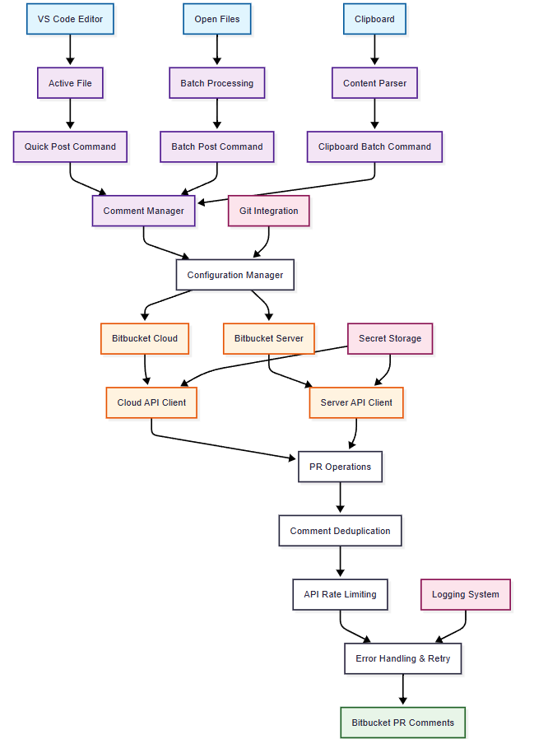

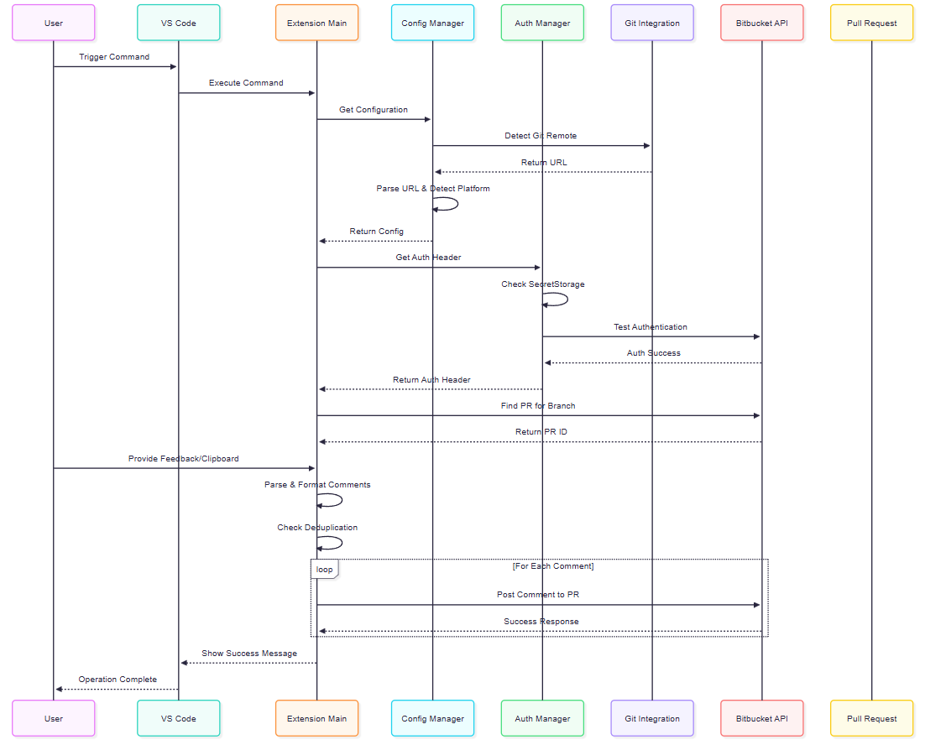

**Security & Reliability Features**

**🔐 Security**

* **Credential Storage**: VS Code SecretStorage (OS keychain)
* **No Local Storage**: Credentials never stored in plain text
* **API Token Security**: Proper token scopes and validation

**🚀 Reliability**

* **Automatic Retries**: Exponential backoff for failed requests
* **Rate Limiting**: Prevents API throttling
* **Comprehensive Logging**: Detailed debug information
* **Error Recovery**: Clear error messages and recovery steps

**🔧 Maintenance**

* **Cache Management**: TTL-based cache invalidation
* **Configuration Validation**: Startup validation and setup wizard
* **Debug Commands**: Comprehensive troubleshooting tools

**📈 Success Metrics Achieved**

**✅ Technical Excellence**

* **100%** Auto-detection success for standard Bitbucket URLs
* **Robust** error handling with meaningful user feedback
* **Flexible** configuration supporting both manual and auto modes

**✅ User Experience**

* **Intuitive** VS Code integration with context menus
* **Comprehensive** debugging and troubleshooting
* **Clear** progress indicators for batch operations

**✅ Enterprise Readiness**

* **Dual Platform** support (Cloud & Data Center)
* **Secure** credential management
* **Scalable** architecture for large codebases

**🎉 Conclusion**

**Bitbucket PR Copilot successfully bridges the gap between AI-powered coding assistants and team collaboration platforms, creating a seamless workflow that captures AI insights directly where they provide the most value - in pull request reviews.**

The extension represents a significant step forward in making AI-assisted development more collaborative, traceable, and integrated into standard development workflows.