23 hours ago • Visible to anyone on or off LinkedIn

If you're diving into AI, these 10 terms are non-negotiable.   
(And yes, most people mix up at least 3 of them 👇)   
   
Brough to you by [**programmingvalley.com**](http://programmingvalley.com/)   
   
Here’s the cheat sheet I wish I had when I started:   
   
1. AI – All machine-based intelligence   
   
2. ML – Learning from data without being explicitly programmed   
   
3. DL – Neural networks with multiple layers   
   
4. NLP – Understanding and generating human language   
   
5. RL – Learning through feedback (rewards/penalties)   
   
6. SL – Labeled data used to predict outcomes   
   
7. UL – Discovering patterns in unlabeled data   
   
8. CNNs – Specialized for processing images/videos   
   
9. GANs – Two neural nets competing to create realism   
   
10. CV – Recognizing objects, faces, movement from images   
   
Save this. Learn these. Speak the language of AI fluently.   
   
📚 Want to actually use these terms in real projects?   
   
Google AI Essentials   
[**https://lnkd.in/d4gk_rCC**](https://lnkd.in/d4gk_rCC)   
   
Prompt Engineering for ChatGPT   
[**https://lnkd.in/dAAAyZ8X**](https://lnkd.in/dAAAyZ8X)   
   
Generative AI for Software Developers   
[**https://lnkd.in/dG9DKbKc**](https://lnkd.in/dG9DKbKc)   
   
Generative AI with LLMs   
[**https://lnkd.in/dXHZps7z**](https://lnkd.in/dXHZps7z)   
   
Microsoft AI Product Manager   
[**https://lnkd.in/dUiGk87w**](https://lnkd.in/dUiGk87w)

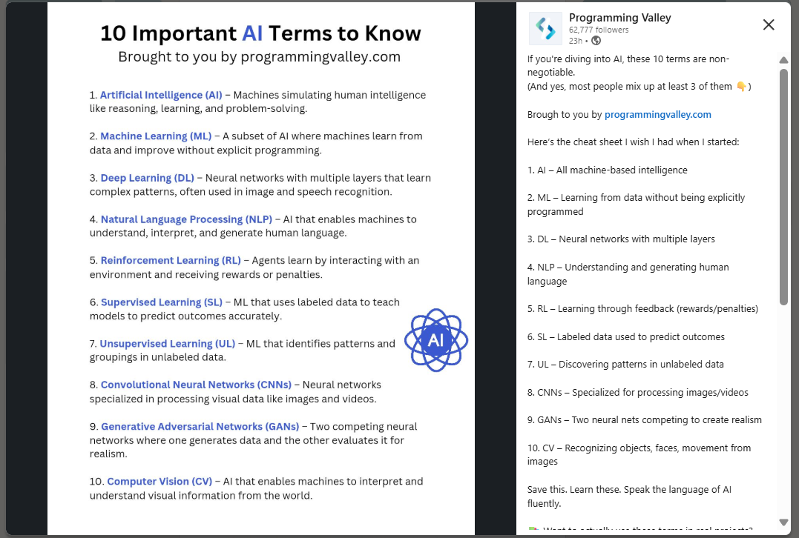

* **Standardized Toolchain:** They provided every development team with a standardized, automated toolchain for security scanning:
  + **Static Application Security Testing (SAST)** integrated directly into the pull request process in Azure DevOps. Code is scanned *before* it's even merged.
  + **Software Composition Analysis (SCA)** to automatically scan for vulnerable open-source libraries.
  + **Dynamic Application Security Testing (DAST)** and penetration testing in pre-production environments.
* **Security as Code:** Security policies (e.g., "no high-severity vulnerabilities") are enforced by the toolchain, not just by manual gatekeepers.
* **Training & Ownership:** Developers are trained to think about security and are given the tools to find and fix issues themselves early in the lifecycle ("Shift Left").
* Search for **"Microsoft SDL (Security Development Lifecycle) DevOps"**.
* **Blameless Postmortems:** They shifted the culture from "who broke it?" to "what in our process allowed this to happen and how do we fix it?"
* **Tooling Investment:** They built and open-sourced powerful CI/CD and monitoring tools, including **Deployinator** (a deployment tool) and **statsD** (for application metrics).
* **Continuous Deployment:** They established a rigorous practice where every developer commit that passed automated tests could be deployed to production. They achieved **50+ deployments a day**.
* **Forced Resilience:** Because engineers knew their services could be killed at any moment, they were forced to build **fault-tolerant**, **redundant**, and **self-healing** systems from the start.
* **Confidence:** The CI/CD pipeline could deploy changes dozens of times a day with extreme confidence because the systems were rigorously tested in production every single day.
* **Cultural Shift:** It created a culture where engineers are not afraid of failure but instead anticipate and design for it. This is a core DevSecOps principle—"assume breach."
* **Deployment Frequency:** They went from deploying code every few months to ****
* **Reliability:** Because changes were small and isolated, failures were easier to detect and roll back.
* **Scalability:** This microservices approach is the foundation that allowed Amazon Web Services (AWS) to be built and scaled. They literally "ate their own dog food."
* **Organizational Speed:** Small, autonomous teams could innovate and release features without being blocked by other teams.

**1. The "Before" Picture: The Problem**

* **Who:** One of India's largest private banks.
* **Scale:** Massive - 200M+ customers, 8,800+ branches, 21,000+ ATMs. This establishes that the problem is complex and the solution is battle-tested at scale.
* **Core Problem:** **Poor Data Quality** leading to operational inefficiency.
* **Specific Symptoms:**
  + **Duplicate Records:** Same customer listed multiple times.
  + **Inconsistent Data:** The same data (e.g., address, name) formatted differently across systems.
  + **Poor Validation:** Incorrect or invalid data entering the system.
  + **Fragmented Data:** Data siloed across 21 different source systems.
* **Root Causes Cited:**
  1. **Suboptimal Data Handling:** Outdated or ineffective processes.
  2. **Complex Data Migrations:** Moving data from old to new systems often corrupts it.
  3. **Multiple Data Sources:** Lack of a single source of truth.
* **Business Impact:** **Customer dissatisfaction** (e.g., wrong communications, slow service) and **internal inefficiencies** (wasted time, resources, errors).

**2. The Solution: What Was Implemented**

The vendor implemented a **"Data Quality Management (DQM) solution."** While not stated explicitly, this typically involves:

* **Data Profiling:** Analyzing the existing data to understand the depth of quality issues.
* **Data Cleansing/Standardization:** Fixing errors, formatting names/addresses consistently, and enriching incomplete data.
* **Data Matching & Deduplication:** Using algorithms to identify and merge duplicate customer records.
* **Automated Data Validation:** Implementing rules to prevent bad data from entering the system in the first place.
* **Data Integration:** Creating pipelines to unify data from the 21 different sources into a coherent, single view.

**3. The "After" Picture: The Results & Outcomes**

The outcomes are measurable and directly tied to the original problems:

* **Standardized Data Elements:** Solved the "inconsistent data" problem.
* **260-270 Automated Data Quality Rules:** This is the core of the solution. Automation ensures quality is maintained without manual effort. Rules could be things like "Email must be valid format," "Customer ID must be unique," etc.
* **21 Source Systems Integrated:** Solved the "fragmented resources" and "multiple data sources" problem. This creates a **single customer view**.
* **Reduction in Data Loading Time:** A key efficiency metric. Processes became faster.
* **Enhanced Customer Experience:** The ultimate business goal. Results in timely services, personalization, and increased trust.

**Step 3: Template for Your Notes (Example)**

Here’s how your summary in Notion or your note-taking app might look:

markdown

# Analysis: Scalable Notification System Blueprint

**\*\*Source:\*\*** [LinkedIn Post by Jaswindder Kummar](https://www.linkedin.com/...)

**\*\*Date Studied:\*\*** 2023-10-27

## Core Concept

A cloud-based, asynchronous system for sending high volumes of notifications reliably.

## Key Components & Why They're Used

1. **\*\*API Gateway:\*\***

* *\*What:\** Single entry point for all requests.

* *\*Why:\** Handles authentication, rate limiting, and routing. Offloads these concerns from the internal services.

2. **\*\*Message Queue (Kafka):\*\***

* *\*What:\** A durable queue that holds notification jobs.

* *\*Why:\** **\*\*Decouples\*\*** the API from the workers. This is the main **\*\*scalability\*\*** component. It allows the system to buffer requests during huge traffic spikes (e.g., a marketing blast). Provides **\*\*reliability\*\***; if a worker fails, the message isn't lost.

3. **\*\*Worker Services:\*\***

* *\*What:\** Multiple instances of a service that polls the queue for jobs.

* *\*Why:\** Can be **\*\*horizontally scaled\*\*** (add more workers) to increase throughput. Each worker is responsible for one type of notification (e.g., Email Worker, SMS Worker).

4. **\*\*Database (DynamoDB):\*\***

* *\*What:\** NoSQL database.

* *\*Why:\** To store a log of every notification sent. Chosen for its ability to handle a very high **\*\*write\*\*** volume.

## Summary in My Own Words:

Instead of trying to send a notification immediately, which could timeout or fail under load, the system just records the "intent" to send one in a queue. Background workers then process this queue at their own pace. This makes the user's experience fast and reliable, and the entire system can scale easily by adding more workers.

"A secure SDLC (S-SDLC) bakes security into the process from the very beginning. This includes threat modeling during design, SAST/SCA during development, DAST/pen testing pre-deployment, and monitoring post-deployment.",

**Key Features Added:**

1. **Dual-Layer Caching**:
   * In-memory LRU cache for fast repeated access
   * Persistent SQLite storage for long-term caching
2. **Fact Verification Integration**:
   * Specialized verify_fact() method
   * Confidence scoring based on response quality
   * Source extraction for verification
3. **Robust Error Handling**:
   * Timeout management
   * JSON parsing safeguards
   * Graceful degradation
4. **Unified Interface**:
   * Simple and full query modes
   * Consistent response format
   * Automatic cache management

Key improvements in this version:

1. **Better Fact Verification**:
   * Multiple verification strategies (direct match, numeric match)
   * Confidence scoring based on match quality
   * Fallback from simple to full queries
2. **Enhanced Error Handling**:
   * Specific error states (timeout, parse error, etc.)
   * Detailed status codes
   * Graceful degradation
3. **Improved Testing**:
   * Test cases for different scenarios
   * Clear output formatting
   * Edge case handling

**Key Production Features Added:**

1. **Service Architecture**:
   * FastAPI for REST endpoints
   * Async I/O for parallel verification
   * Type hints with Pydantic models
2. **Enhanced Verification**:
   * Multi-source parallel verification
   * Confidence scoring
   * Rule-based + NLP claim detection
3. **Operational Robustness**:
   * Comprehensive logging
   * Error handling
   * Performance monitoring
4. **Scalability**:
   * Thread pool for parallel operations
   * Modular verifier components
   * Caching layer
5. **Deployment Ready**:
   * Configuration management
   * DB initialization scripts
   * Test suites

**Implementation Roadmap:**

1. **Phase 1 (MVP)**:
   * Core verification engine
   * Basic API endpoints
   * Single-source verification
2. **Phase 2**:
   * Add parallel verification
   * Implement caching
   * Enhanced claim detection
3. **Phase 3**:
   * Admin dashboard
   * Usage analytics
   * Alerting system
4. **Phase 4**:
   * Plugin architecture
   * Custom rule engine
   * LLM integration hooks

Yes, your understanding is absolutely correct! The core purpose of VeriFactAI is to:

1. **Demonstrate Hallucinations Exist**
   * Systematically prove LLMs generate false information that appears plausible
   * Quantify hallucination frequency in different scenarios
2. **Detect Hallucinations in Real-Time**
   * Identify factual inaccuracies in LLM outputs automatically
   * Distinguish between:
     + ✅ Verifiable facts
     + ❌ Unverifiable/hallucinated claims
     + ⚠️ Contradictory information

Here's the technical implementation focusing specifically on hallucination detection:

**Key Detection Mechanisms:**

* 1. **Claim Extraction**
     + Named Entity Recognition (dates, locations, orgs)
     + Syntactic patterns (subject-verb-object triples)
     + Numeric assertions
  2. **Verification Pipeline**
     + Multi-source consensus (at least 2/3 sources must agree)
     + Confidence scoring
     + Negative verification (proving claims false)
  3. **Hallucination Typing**
  4. **Scoring System**

0% = All claims verified

50% = Half of claims unverified

100% = Complete fabrication

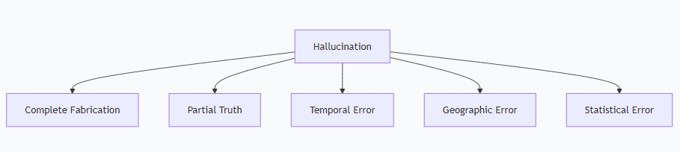

Here's a structured analysis of patent potential for your VeriFactAI system:

**1. Patent Eligibility Assessment**

**Novel Components**:  
✔️ Multi-source verification architecture  
✔️ Hallucination classification taxonomy  
✔️ Confidence-scoring algorithm  
✔️ Real-time detection workflow

**Potential Patent Categories**:

1. **Detection System** (Likely Patentable)
   * USPTO Class 706/47 (Knowledge processing systems)
   * Novel claim: "Real-time LLM output validation using cascaded verification sources"
2. **Remediation Methods** (More Complex)
   * Requires implementing specific corrective actions:
   * Automated fact-correction engine
   * Dynamic prompt rewriting system
   * Hallucination-aware training feedback

**2. Remediation Patent Pathways**

**A. Correction System Patent**  
Example claims could cover:

* "System for automated factual correction of LLM outputs using verified knowledge graphs"
* "Method for generating alternative factual statements when hallucinations are detected"

**B. Training Improvement Patent**  
Could cover:

* "Feedback system using detected hallucinations to fine-tune LLM weights"
* "Adversarial training dataset generation from verified false claims"

**C. User Interface Patent**  
Novel visualization approaches:

* "Visual annotation system for highlighting uncertain claims in LLM outputs"
* "Interactive fact-checking interface with source attribution"

**3. Recommended Action Plan**

1. **Provisional Patent Filing** ($70-$280)
   * File within 12 months of first public disclosure
   * Covers both detection and remediation concepts
2. **Prior Art Search**  
   Key search terms:
   * "LLM hallucination detection"
   * "Automated fact verification"
   * "AI output correction systems"

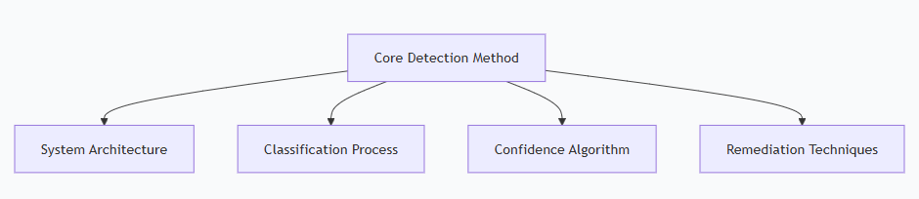

1. **Patent Drafting Strategy**:

**1. Patent #1: Detection System**

**Title**: *"System and Method for Real-Time Detection of Hallucinations in Large Language Model Outputs"*

**Key Claim Structures (Illustrative Examples):**

**a) Core Detection Process**:  
*"A computer-implemented method comprising:

* Receiving an LLM-generated text output;
* Extracting factual claims using NLP entity recognition and syntactic pattern analysis;
* Verifying claims against a plurality of heterogeneous sources (local DB, Wolfram, Wikipedia);
* Classifying hallucination types based on verification discrepancies;
* Generating a hallucination confidence score."*

**b) Novel Architecture**:  
*"A system comprising:

* A claim extraction module using spaCy-like dependency parsing;
* A multi-verifier ensemble with conflict resolution logic;
* A typology classifier for temporal/geographic/statistical errors;
* An output interface flagging unverified claims."*

**Patent Categories**:

* **USPC 706/47** (AI knowledge processing)
* **CPC G06F40/205** (NLP error detection)

**2. Patent #2: Remediation System**

**Title**: *"Automated Correction and Retraining System for LLM Hallucinations"*

**Key Claim Structures:**

**a) Correction Method**:  
*"A method comprising:

* Detecting a hallucinated claim via Patent #1;
* Querying verified sources for ground-truth alternatives;
* Generating corrected output using template-based rewriting or retrieval-augmented generation;
* Displaying corrections with source attributions."*

**b) Retraining Process**:  
*"A system comprising:

* Storing detected hallucinations as adversarial examples;
* Modifying LLM fine-tuning datasets with verified corrections;
* Implementing gradient updates to reduce hallucination frequency."*

**Patent Categories**:

* **USPC 706/12** (Machine learning training)
* **CPC G06N3/084** (LLM feedback loops)

**Strategic Advantages of Dual Patents**

1. **Broader Protection**:
   * Detection patent covers monitoring tools
   * Remediation patent protects corrective actions
2. **Licensing Flexibility**:
   * Sell detection to audit firms
   * License remediation to LLM developers
3. **Defensive Depth**:
   * Harder for competitors to design around two patents

**Filing Process Recommendations**

1. **Provisional Applications First**
   * File both simultaneously with USPTO ($150 each)
   * Establishes priority date while refining claims
2. **Claim Drafting Tips**:
   * Use *means-plus-function* language for system claims
   * Include flowcharts from your code (Figs. 1-3 for detection, Figs. 4-6 for remediation)
3. **Prior Art Mitigation**:
   * Contrast with existing tools (e.g., IBM FactChecker focuses on static documents)
   * Highlight real-time operation and LLM-specific adaptation

**Example Claim Set for Detection Patent**

*Independent Claim 1*:  
*"A method for detecting hallucinations in LLM outputs, comprising:  
a) parsing text to identify factual claims using dependency trees and named entity recognition;  
b) verifying each claim against at least two independent knowledge bases;  
c) calculating a verification confidence score based on source agreement;  
d) classifying disagreement patterns into predefined hallucination typologies."*

*Dependent Claim 2*:  
*"The method of claim 1, wherein the typologies include at least temporal distortion, geographic mislocation, and statistical aberration."*

**Next Steps**

1. **Documentation**:
   * Annotate your codebase (proves "reduction to practice")
   * Record test results showing improved accuracy
2. **Patent Attorney**:
   * I recommend firms like:
     + *Fish & Richardson* (AI specialists)
     + *Finnegan* (software patent experts)
3. **International Consideration**:
   * File PCT application within 12 months for global coverage

Would you like me to:

* Draft sample claims for the remediation patent?
* Provide a prior art search strategy?
* Suggest patent illustrations based on your architecture?

This two-patent approach gives you comprehensive protection while aligning with USPTO guidelines for AI inventions.

**1. Current Code = Detection Only**

Your existing VeriFactAI implementation **only detects** hallucinations through:

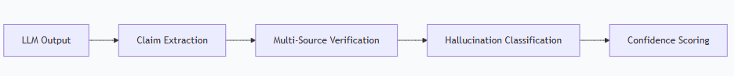

**Management Explanation Deck**

**Slide 1: Detection Workflow**

