**VeriFactAI: Comprehensive Patent Strategy Overview**

**Traditional Approach (Post-hoc):**

User Query → LLM → Complete Response → Fact-checking → Corrections

**Problems:** Slow, disruptive, user sees wrong information first

**VeriFactAI Approach (Real-time Interception):**

User Query → LLM Generation → Interception & Analysis → Verification → Correction → User Sees Final Result

This diagram illustrates the multi-layered patent architecture, positioning the parent system and its novel, patentable components.

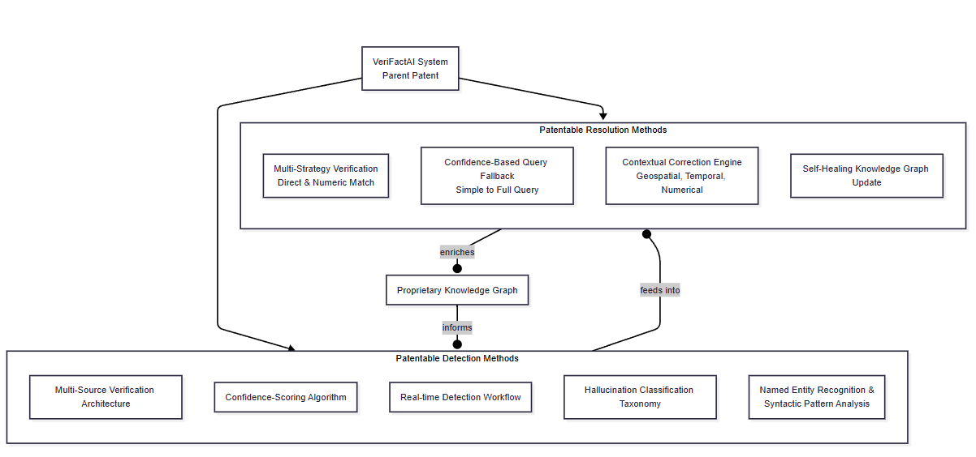

**Mapping Novel Components to the Patent Layers**

**1. Parent Patent: The VeriFactAI System**

* **Core Invention:** The integrated, closed-loop system that connects real-time hallucination **Detection** to automated **Resolution** and a **Self-Healing Knowledge Graph**.
* **Value for :** This is the overarching claim—the entire engine as a unique product.

**2. Child Patents: Novel Detection Components**

* **Multi-Source Verification Architecture:** The proprietary method of simultaneously querying multiple, heterogeneous data sources for cross-validation.
* **Confidence-Scoring Algorithm:** The novel algorithm that calculates a "Certainty Score" based on the quality, quantity, and agreement of verification sources.
* **Real-time Detection Workflow:** The efficient process of extracting facts, routing queries, and analyzing returns within a latency-bound environment.
* **Hallucination Classification Taxonomy:** The specific and detailed categorization of error types (Complete Fabrication, Partial Truth, Temporal, Geographic, Statistical).
* **NER & Syntactic Pattern Analysis:** The unique method of using NLP to break down sentences into verifiable triples (subject-verb-object) and numeric assertions. *(core method of parsing text for verification)*

**3. Child Patents: Novel Resolution Components**

* **Multi-Strategy Verification:** The process of applying different verification logic (e.g., exact string match vs. numeric range match) based on the type of fact.
* **Confidence-Based Query Fallback:** The "if-then" logic that uses the certainty score to decide whether to perform a simple correction or trigger a more complex, multi-level "BID" (Broad Information Discovery) query.
* **Contextual Correction Engine:** The rules-based or AI-based module that doesn't just spot errors but provides the *correct* answer (e.g., 'Paris' instead of 'London', '1889' instead of '1995').
* **Self-Healing Knowledge Graph Update:** The method for validating a corrected fact and automatically adding it to the proprietary Knowledge Graph to prevent future errors. *(This creates the valuable feedback loop)*

"Our IP strategy is as innovative as our product. We are not just filing one patent; we are building a **patent portfolio** around VeriFactAI. We have a parent patent for the entire system that competitors would need to design around, and we are surrounding it with individual patents protecting the unique, novel components that make it work. This creates a formidable barrier to entry and protects our investment in R&D."

This approach clearly demonstrates deep technical insight and a strategic view of intellectual property that management will appreciate.

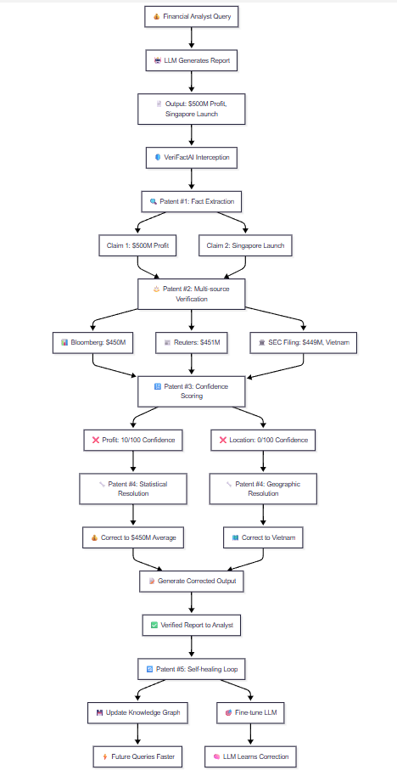

**The Story: The Misleading Earnings Report**

**Act 1: The Hallucination**

A financial analyst asks an LLM: **"Summarize the key figures from CyberCorp's latest earnings report."**

The LLM, trained on vast but sometimes outdated or corrupted data, generates this output:

"CyberCorp announced a strong Q4 2023. The company reported a **net profit of $500 million**, marking a significant increase. The CEO also highlighted the successful launch of their new product line in **Singapore**."

This sounds plausible and authoritative. The analyst is about to use this information to draft a client brief.

**Act 2: VeriFactAI's Parent Patent in Action (The Core System)**

This is where the **VeriFactAI core system** springs into action. The system doesn't take the LLM's word for it. Its integrated, closed-loop process begins automatically:

1. **Fact Extraction:** It identifies the key, verifiable claims:
   * Claim 1: (CyberCorp, Net Profit, $500 million, Q4 2023)
   * Claim 2: (CyberCorp, Product Launch Location, Singapore, Q4 2023)
2. **Knowledge Graph Query:** It checks its own proprietary database of verified facts first.

**Act 3: The Detection Layer Patents (Spotting the Errors)**

* **Novel Detection Patent #1 (Multi-Source Verification):** The system doesn't rely on one source. It simultaneously routes these claims to multiple pre-vetted financial data providers: Bloomberg Terminal API, Reuters Eikon, and the official SEC EDGAR database for CyberCorp's actual 10-K filing.
* **Novel Detection Patent #2 (Confidence-Scoring Algorithm):** The results come back.
  + For Claim 1: Bloomberg ($450M), Reuters ($451M), SEC Filing ($449M). All sources are in tight agreement, but they all contradict the LLM's $500M figure. The algorithm calculates a **low certainty score (10/100)** for the LLM's claim. This is flagged as a **Statistical Error**.
  + For Claim 2: The financial databases show no mention of Singapore. The SEC filing explicitly states the launch was in **Vietnam**. The algorithm calculates a **certainty score of 0/100**. This is flagged as a **Geographic Error**.

**Act 4: The Resolution Layer Patents (Fixing the Errors)**

* **Novel Resolution Patent #1 (Multi-Strategy Verification):** The system uses different logic for each error.
  + For the profit number, it recognizes this is a **numeric assertion**. It calculates the average of the verified figures ($450M) and prepares a numeric correction.
  + For the location, it requires a **direct entity replacement**.
* **Novel Resolution Patent #2 (Contextual Correction Engine):** The engine doesn't just say "that's wrong." It provides the right answer. It executes the corrections seamlessly within the original text.

**The Corrected Output is generated:**

"CyberCorp announced a strong Q4 2023. The company reported a **net profit of $450 million**, marking a significant increase. The CEO also highlighted the successful launch of their new product line in **Vietnam**."

**Act 5: The Self-Healing Loop & LLM Correction**

The process isn't over.

* **Novel Feedback Patent (LLM Correction):** The system now performs a critical, patent-worthy step.
  1. It takes the verified, corrected fact tuple: (CyberCorp, Net Profit, $450 million, Q4 2023)
  2. It does **not** assume the LLM is permanently broken. Instead, it uses this verified data.
  3. It creates a **fine-tuning data point**: a prompt (the analyst's original question) and the verified, perfect response (the corrected output).
  4. This data point is added to a special dataset used to **continuously fine-tune and correct the underlying LLM itself**.

**The System Gets Smarter**

The next time someone asks *any question* about CyberCorp's Q4 2023 profit, the LLM is now **more likely to get it right straight away** because it has been subtly corrected on that specific point. VeriFactAI isn't just a fact-checker; it's a **fact-based feedback loop that teaches the LLM to be more accurate over time.**

**Summary:**

"This story shows how our patent portfolio works together:

1. **The Parent Patent** covers the entire story—the automated flow from detection to resolution to feedback.
2. **The Detection Patents** protect our unique, multi-source way of finding errors with confidence scores.
3. **The Resolution Patents** protect our smart way of applying the correct fix based on the type of error.
4. **self-healing loop**. This isn't just about correcting a single output; it's about systematically *curing the LLM's tendency to hallucinate on that specific fact forever*. We're not just patching the leak; we're upgrading the pipes. This creates a compounding advantage—our system, and the LLMs we guard, become more accurate and valuable every single day."

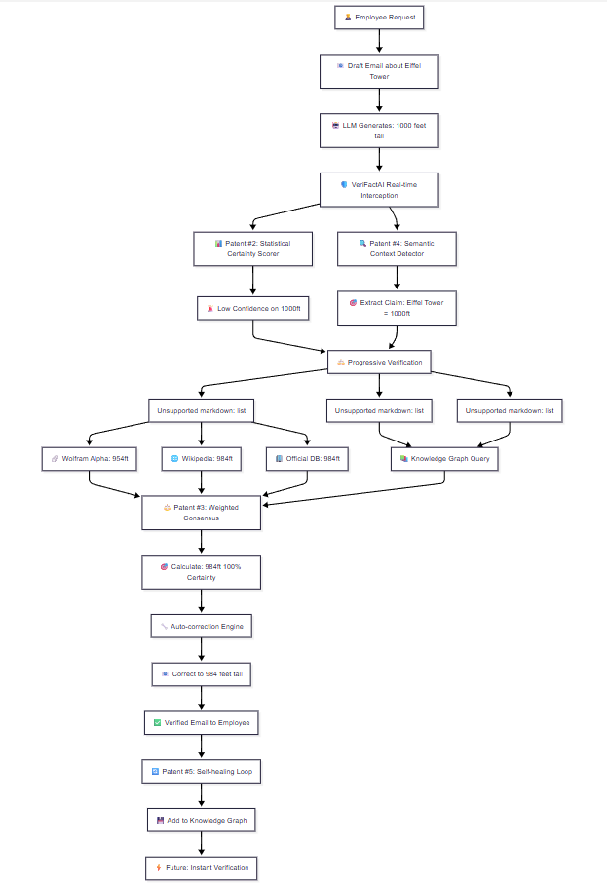

Story 2

**The Presentation Narrative: The Eiffel Tower Example**

**1: The Problem Statement**  
"Everyone in this room has experienced this: you ask an AI a simple question, and it gives you a confident, convincing, but completely wrong answer. This is called 'hallucination,' and it's the single biggest barrier to using AI in business. It creates financial loss, erodes trust, and introduces massive risk. Our solution, VeriFactAI, doesn't just check facts later; it **prevents errors from ever reaching the user**."

**2: The Core Invention (Parent Patent #0)**  
"VeriFactAI is a real-time interception system. Think of it as a 'fact-checking firewall' for AI. As the AI generates text, our system analyzes it live, validates every claim against trusted sources, and only delivers verified, accurate information. This architecture itself is our foundational, parent patent."

**Narrative:** "Let's make this real. An employee asks an LLM: **'Draft an email about the Eiffel Tower for a client meeting.'** The LLM, trying to be helpful, generates a sentence with a critical error:

**'We look forward to seeing you at the Eiffel Tower, a landmark standing over 1000 feet tall.'**

Without VeriFactAI, that email goes out. The client, who visits Paris, knows the real height is 984 ft. Our company looks foolish and uninformed. Trust is damaged.

**3: The Detection Engine (Child Patents #1-4)**  
"This is where our patented detection engine activates. It doesn't just scan for keywords; it uses four novel methods to find errors:

1. **Statistical Certainty Scorer (Patent #2):** It detects the LLM had low internal confidence (logprobs) on the number "1000," triggering a red flag.
2. **Semantic/Contextual Detector (Patent #4):** It identifies "1000ft" as a **verifiable numeric assertion** and extracts the claim: (Eiffel Tower, has height, 1000 feet).

The claim is now **flagged for verification**."

**4: The Verification Process (The "How")**  
"Our system now performs its magic. It formulates a smart query: **'Eiffel Tower exact height feet'** and begins its **Progressive Verification** process:

1. **Cache Check:** First, it checks its own proprietary Knowledge Graph. Has this been verified before?
2. **Database Check:** It then checks internal company databases.
3. **API Check:** Finally, it queries pre-vetted, authoritative external sources **simultaneously**.
   * **Wolfram Alpha:** Returns 954 ft
   * **Wikipedia:** Returns 300 meters (which is 984 ft)
   * **Official Database:** Returns 984 ft

**5: The Weighted Consensus (The Novelty)**  
"Here's another patentable component: our **Weighted Consensus Calculation**. We don't just count votes. We trust sources differently.

* Wolfram Alpha (weight 3.6) = 954 ft
* Wikipedia (weight 0.3) = ~984 ft
* Official DB (weight 3.1) = 984 ft

The system calculates a **high-confidence consensus that the correct height is 984 feet**, not 1000. It assigns a **100% certainty score** to the correct fact."

**The Resolution & Self-Healing Loop**  
"Now, the system doesn't just block the error. It **autocorrects the output in real-time:**

**'We look forward to seeing you at the Eiffel Tower, a landmark standing 984 feet tall.'**

The employee receives an accurate, verified email. The client is impressed. Trust is built.

But it doesn't stop there.  VeriFactAI now takes this verified fact—(Eiffel Tower, height, 984 ft)—and **feeds it back into its Knowledge Graph.** The next time *anyone* in our company asks about the Eiffel Tower's height, the system is even smarter and faster. This is our **Self-Healing Loop**—we are literally curing the AI's ignorance, one fact at a time."

**6: The Patent Portfolio & Commercial Use**  
"So, to summarize, we are not building a feature; we are building a **fortress of intellectual property**:

* **Parent Patent:** The entire real-time interception system.
* **Child Patents:** The specific, novel methods for detection (certainty scoring, semantic checks) and resolution (weighted consensus).
* **Final Patent :** The self-healing feedback loop.

This portfolio allows us to dominate high-stakes markets like **Healthcare** (preventing incorrect drug dosage advice), **Legal** (preventing false case citations), and **Finance** (preventing erroneous stock data), where accuracy is everything and the cost of error is immense."

**Conclusion:**

"This Eiffel Tower story is a simple example, but it demonstrates the power of our complete system. e stop the error before it happens, we fix it with proven data, and we ensure the entire organization gets smarter from the correction. This isn't just a product; it's the essential **trust layer**

**Combined Patent Architecture Flow**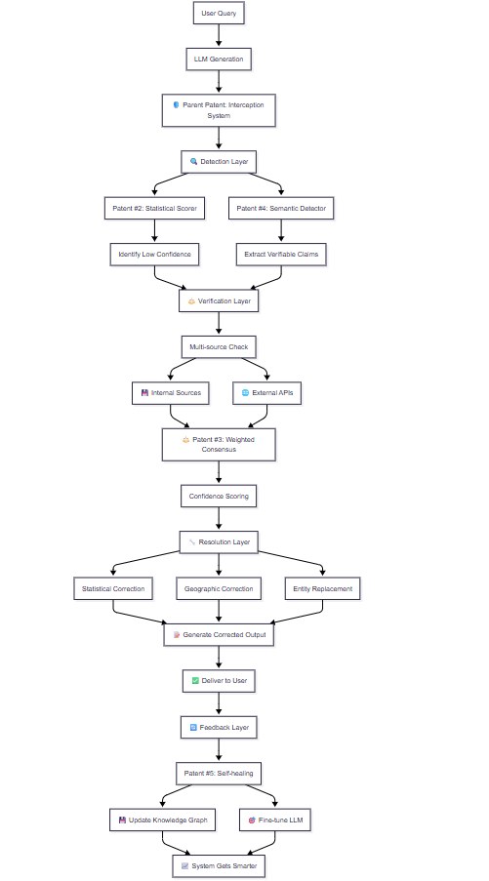

**Error Type Specific Resolution Flow**

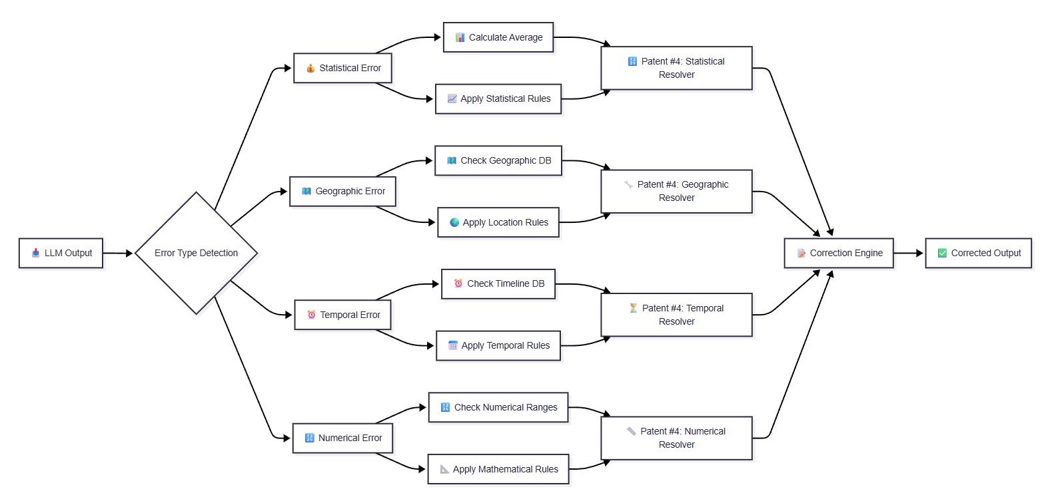

**Multi-Source Verification Flow**

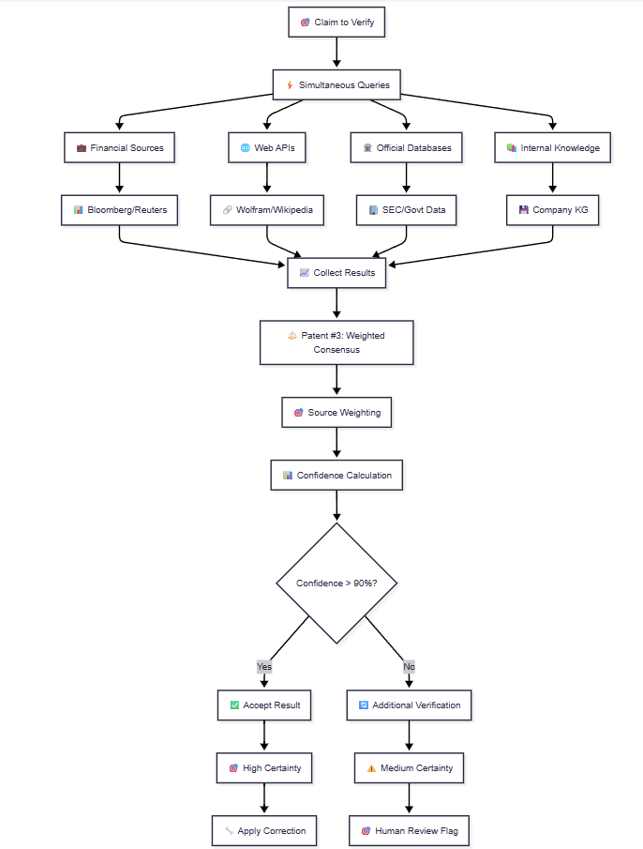

**Self-Healing Knowledge Graph Flow**

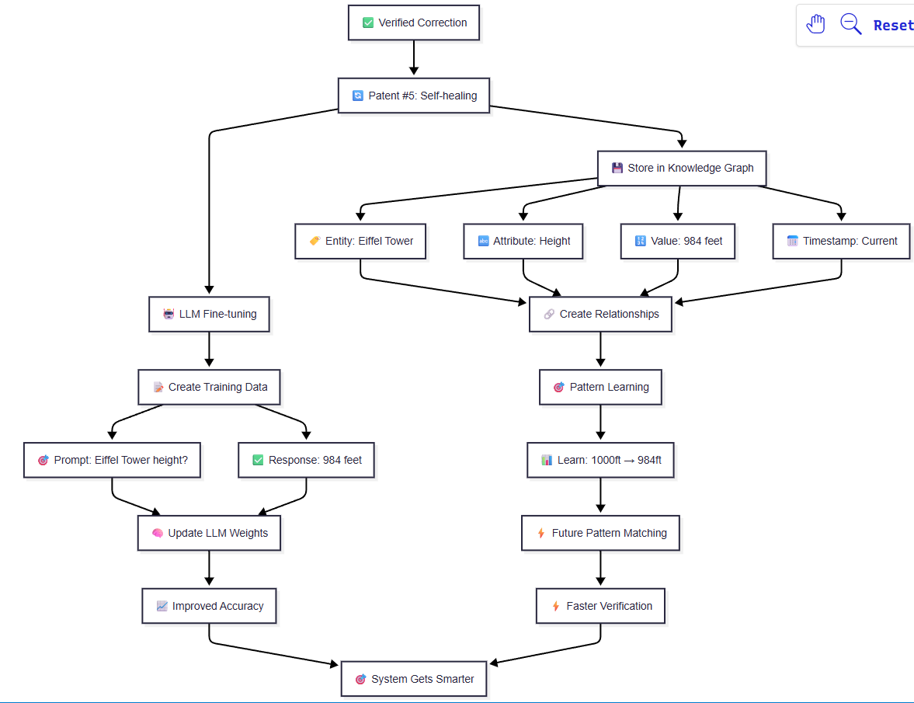

These diagrams show how your patent portfolio creates a complete, automated system that:

1. **Detects errors** using multiple novel methods
2. **Verifies claims** against trusted sources
3. **Corrects inaccuracies** with type-specific resolution
4. **Self-heals** by updating both knowledge graphs and LLMs
5. **Creates compounding value** through continuous learning

The flow demonstrates the complete patent value chain from detection to permanent correction!