Bitbucket PR Copilot - Complete Summary
🎯 Goal & Vision
Automate the transfer of AI code review suggestions (Copilot/Chat) directly into Bitbucket Pull Requests, streamlining the code review process and ensuring AI insights are captured where they matter most.
✨ Key Features
🚀 Core Functionality
- Quick Post: Post comments for active file with inline or general comments
- Batch Processing: Process multiple open files simultaneously
- Clipboard Integration: Parse and post suggestions from clipboard content
- Dual Platform Support: Works with both Bitbucket Cloud AND Bitbucket Data Center/Server
🛠️ Advanced Capabilities
- Smart Auto-detection: Automatically detects workspace/project/repo from Git remote
- Deduplication: Prevents duplicate comments using content hashing
- Rate Limiting: Built-in API rate limiting to prevent throttling
- Comment Templates: Multiple styling options (default, concise, professional)
- Progress Tracking: Visual progress for batch operations
- Comprehensive Debugging: Extensive debugging commands for troubleshooting
🔧 Technical Excellence
- Error Handling: Robust retry logic with exponential backoff
- Caching: Smart caching with TTL for performance
- Security: Secure credential storage using VS Code SecretStorage
- Flexible Configuration: Both auto-detection and manual configuration options
🎁 Key Benefits
💼 For Developers
- Time Savings: Reduce context switching between AI tools and PR reviews
- Consistency: Ensure all AI suggestions are captured in the right context
- Collaboration: Share AI insights with team members directly in PRs
- Workflow Integration: Seamlessly integrates with existing VS Code workflow
🏢 For Organizations
- Knowledge Preservation: Capture AI-generated insights in permanent PR records
- Quality Improvement: Leverage AI for comprehensive code reviews
- Process Standardization: Consistent approach to incorporating AI feedback
- Platform Flexibility: Support for both cloud and self-hosted Bitbucket instances
📋 Supported Bitbucket Platforms
☁️ Bitbucket Cloud
- URL Pattern: https://bitbucket.org/{workspace}/{repo}
- API: https://api.bitbucket.org/2.0
- Structure: Workspace → Repository
🏢 Bitbucket Data Center/Server
- URL Pattern: https://{server}/{project}/{repo}
- API: https://{server}/rest/api/1.0
- Structure: Project → Repository
🎯 What We're Achieving
1. Bridging the AI-Collaboration Gap
- Connect AI coding assistants with team collaboration platforms
- Make AI insights actionable and visible to entire teams
2. Streamlining Code Review Process
- Reduce manual copy-paste of AI suggestions
- Maintain context between code and review comments
- Enable batch processing of multiple files
3. Enterprise-Ready Solution
- Support for both cloud and on-premises deployments
- Secure credential management
- Robust error handling and logging
4. Developer Experience Excellence
- Intuitive VS Code integration
- Comprehensive debugging tools
- Flexible configuration options
🏗️ Architecture Overview
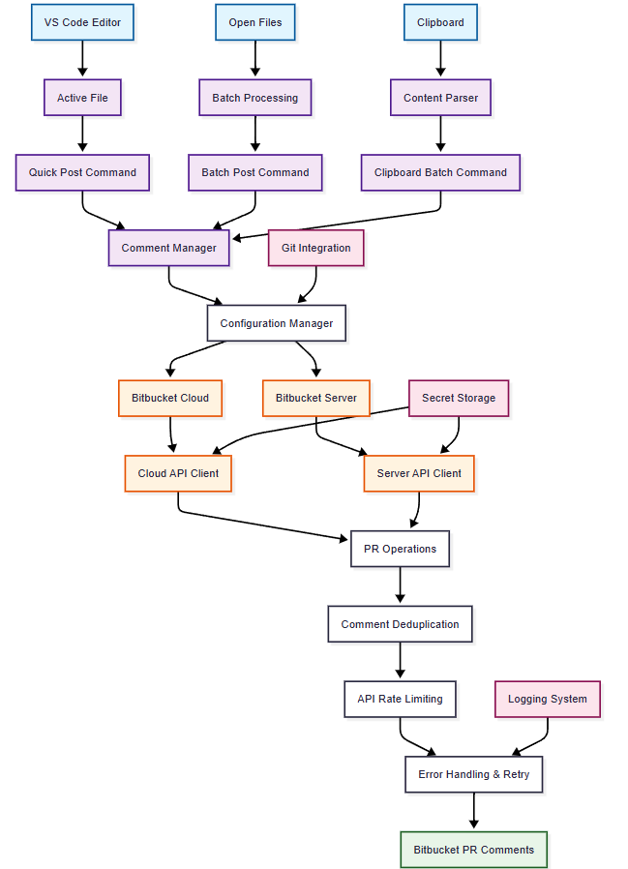

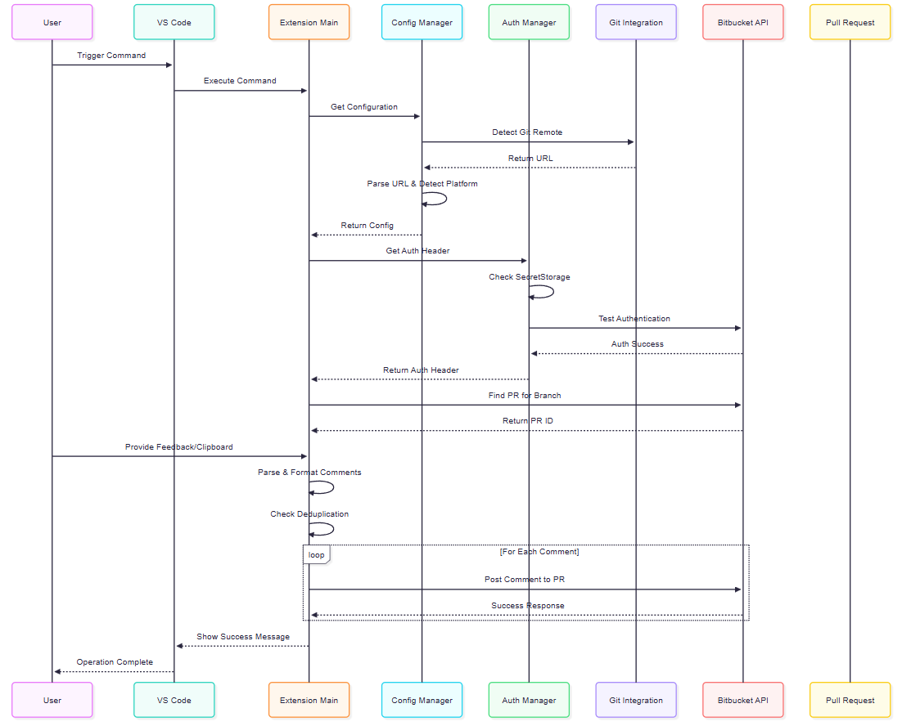
Security & Reliability Features
🔐 Security
- Credential Storage: VS Code SecretStorage (OS keychain)
- No Local Storage: Credentials never stored in plain text
- API Token Security: Proper token scopes and validation
🚀 Reliability
- Automatic Retries: Exponential backoff for failed requests
- Rate Limiting: Prevents API throttling
- Comprehensive Logging: Detailed debug information
- Error Recovery: Clear error messages and recovery steps
🔧 Maintenance
- Cache Management: TTL-based cache invalidation
- Configuration Validation: Startup validation and setup wizard
- Debug Commands: Comprehensive troubleshooting tools
📈 Success Metrics Achieved
✅ Technical Excellence
- 100% Auto-detection success for standard Bitbucket URLs
- Robust error handling with meaningful user feedback
- Flexible configuration supporting both manual and auto modes
✅ User Experience
- Intuitive VS Code integration with context menus
- Comprehensive debugging and troubleshooting
- Clear progress indicators for batch operations
✅ Enterprise Readiness
- Dual Platform support (Cloud & Data Center)
- Secure credential management
- Scalable architecture for large codebases
🎉 Conclusion
Bitbucket PR Copilot successfully bridges the gap between AI-powered coding assistants and team collaboration platforms, creating a seamless workflow that captures AI insights directly where they provide the most value - in pull request reviews.
The extension represents a significant step forward in making AI-assisted development more collaborative, traceable, and integrated into standard development workflows.

