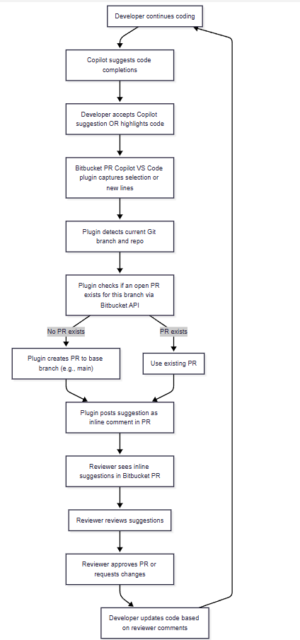
can you presentation style so can explain this plugin , what , how ,when ,who , value , we have 20k employees usage , scalable , Copilot suggestions , integrating , value for both LLM and Devloper , Manager community , enhance devloper experience .... etc pls use your expertise i hv added few
ChatGPT said:
Absolutely! Here’s a presentation-style structured outline you can use to explain the Bitbucket PR Copilot PoC plugin to management, developers, and the wider organization. I’ve incorporated your points and expanded with strategic value, scalability, and user experience benefits.

Bitbucket PR Copilot PoC – Presentation Overview

1️⃣ What is it?
- Bitbucket PR Copilot Plugin is a VS Code extension that integrates AI-powered code suggestions (Copilot) directly into Bitbucket Pull Requests.
- Enables developers to automatically post Copilot-generated suggestions or selected code snippets as inline PR comments.
- Fully PoC-ready for feature branches, supporting real-time PR collaboration.

2️⃣ Why we built it?
- Streamline code reviews: Approvers get AI-assisted suggestions directly in PR, reducing review time.
- Enhance developer experience: Developers can see suggestions automatically in PR without switching contexts.
- Scalable for large teams: Designed for organizations with 20k+ developers and multiple repositories.
- Bridge AI and workflow: Integrates LLM suggestions into existing Bitbucket workflow.

3️⃣ How it works (workflow)
flowchart TD
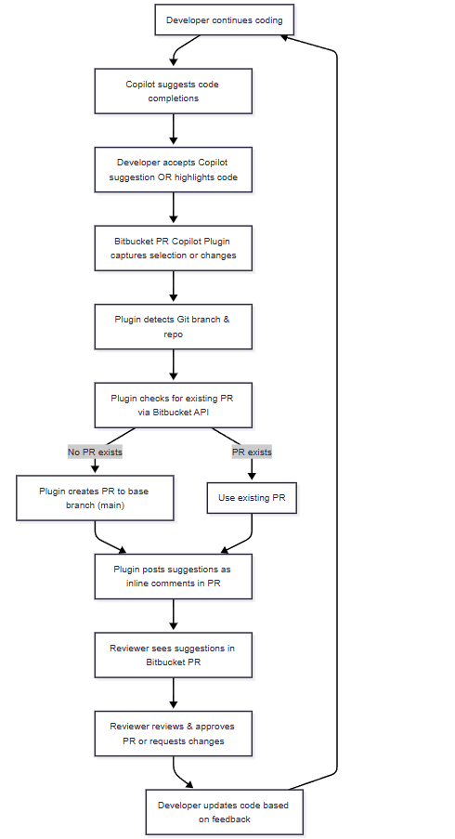
A[Developer writes code in VS Code] --> B[Copilot suggests code completions]
B --> C[Developer accepts Copilot suggestion OR highlights code]
C --> D[Bitbucket PR Copilot Plugin captures selection or changes]
D --> E[Plugin detects Git branch & repo]
E --> F[Plugin checks for existing PR via Bitbucket API]
F -- No PR exists --> G["Plugin creates PR to base branch (main)"]
F -- PR exists --> H[Use existing PR]
G --> I[Plugin posts suggestions as inline comments in PR]
H --> I[Plugin posts suggestions as inline comments in PR]
I --> J[Reviewer sees suggestions in Bitbucket PR]
J --> K[Reviewer reviews & approves PR or requests changes]
K --> L[Developer updates code based on feedback]
L --> A[Developer continues coding]
Notes:
- Supports both full-file suggestions and selected snippet suggestions.
- Works with any feature branch → scalable across multiple repositories.

4️⃣ Who uses it?
- Developers: Get AI suggestions integrated into PR, reducing context-switching and improving code quality.
- Reviewers / Approvers: See inline suggestions, reducing review overhead.
- Managers / Team Leads: Get visibility on AI-assisted code review activity and adoption.
- Enterprise IT / DevOps: Can scale across thousands of repositories with consistent experience.

5️⃣ When is it used?
- Every Pull Request creation (manual or automatic).
- During feature branch development: developers can post intermediate suggestions.
- When reviewing PRs, to provide AI-assisted inline comments and reduce back-and-forth.

6️⃣ Value Proposition
Stakeholder | Value
Developer | - Faster coding with AI suggestions  - Inline feedback in PR  - Reduced context switching
Reviewer / Approver | - AI-assisted review comments  - Highlight potential issues proactively  - Reduce review time
Manager / Team | - Scalable adoption across 20k+ employees  - Track AI-assisted code quality improvements  - Reduce PR bottlenecks
LLM / AI | - Captures real-time coding patterns  - Provides feedback loop to improve AI suggestions
Enterprise | - Standardized PR review workflow  - Secure API token integration  - Compatible with existing VS Code + Bitbucket stack

7️⃣ Key Features
- Automatic PR detection / creation via Bitbucket API
- Inline AI suggestion posting for changed files or selected code
- Secure API token storage in VS Code secret vault
- Branch-aware: works on feature branches, detects base branch
- Simulated / PoC suggestions: placeholder until full Copilot capture is enabled
- Extensible & scalable for large developer teams

8️⃣ How it Enhances Developer Experience
- Reduces manual comment writing in PRs
- Promotes best-practice suggestions automatically
- Supports LLM-driven code review without leaving IDE
- Enables real-time feedback loop from AI → PR → developer

9️⃣ Technical Scalability & Security
- Scalable design:
  - Works across multiple repos and branches
  - Supports 20k+ developers using a single plugin deployment
- Security:
  - API tokens stored in VS Code Secret Storage
  - No hardcoded credentials
  - Leverages Bitbucket API tokens with scoped permissions

🔟 Future Enhancements
- Integrate with Enterprise Copilot API for real-time LLM suggestions
- Add analytics dashboard for AI suggestion usage across teams
- Support multi-repo and multi-branch automation
- Enable customizable suggestion templates for different languages

Presentation Tips
- Start with “What & Why” → set the problem statement.
- Show the workflow diagram → explain step-by-step PoC.
- Highlight stakeholder value → developers, reviewers, managers.
- End with scalability, security, and future potential → shows enterprise readiness.
- Keep dummy screenshots of plugin commands & PR comments for visual reinforcement.

I can also make a visually-rich slide-ready diagram with icons for VS Code, Copilot, PR, Manager, Developer, so it looks professional and easy to explain in 5–10 slides.
Do you want me to create that visual version next?
You said:
also if can add releated to problem description we are addressing , Use Cases we can resolve etc... in tabular with your expertise
ChatGPT said:
Absolutely! Here’s a presentation-ready addition that includes Problem Description, Use Cases, and Value in a clear tabular format. This will help management quickly see why this plugin matters and what scenarios it addresses.

Problem Statement & Use Cases Table
Problem / Challenge | Use Case / Scenario | How Plugin Helps / Value Delivered
Slow code review turnaround | Large PRs take hours/days to review | AI-assisted suggestions pre-populate PR comments → reviewers focus only on critical checks → faster approvals
Context switching between IDE and PR | Developers copy code snippets manually to PR comments | Plugin posts suggestions directly from VS Code → no manual copy/paste → improved productivity
Inconsistent code review quality | Different reviewers provide inconsistent feedback | AI suggestions ensure consistent recommendations → better code quality and standards adherence
High onboarding time for new developers | New developers unclear about coding standards | AI suggestions act as inline guidance → accelerates learning and reduces errors
Missed edge cases / errors in PR | Reviewers overlook potential issues | AI highlights potential logical or structural issues → improves PR reliability
Scaling review for large teams (20k+ employees) | Multiple repositories, branches, and teams | Plugin works across branches, repos → scalable solution for enterprise teams
Feedback loop between AI & dev workflow | LLM suggestions not fully integrated into workflow | Plugin captures Copilot suggestions → posts to PR → reviewer & developer feedback improves AI effectiveness
Managerial visibility / reporting gaps | Managers cannot track AI-assisted reviews or team usage | PR comments, inline suggestions, and workflow metadata provide visibility → better team insights

Key Points to Emphasize
- Solves both human & AI workflow gaps in PRs
- Supports enterprise-scale usage for thousands of developers
- Can address multiple use cases simultaneously: faster reviews, better code quality, onboarding, and reduced context switching
- Foundation for future AI-driven automation: e.g., auto-review suggestions, metrics dashboards

If you want, I can combine this table with the previous “Value for Stakeholders” table into a single slide-ready format with columns for Problem, Use Case, Value, and Stakeholder — this makes it super clear and visually appealing for management.
Do you want me to do that next?
You said:
yes please
ChatGPT said:
Perfect! Here’s a combined slide-ready table that merges Problem, Use Case, Value, and Stakeholder, so it’s concise, visually clear, and easy to present. This will help management immediately understand why this plugin matters, who benefits, and how it adds value.

Bitbucket PR Copilot – Problem, Use Case, and Value
Problem / Challenge | Use Case / Scenario | Value Delivered | Primary Stakeholder
Slow code review turnaround | Large PRs take hours/days to review | AI-assisted suggestions pre-populate PR comments → faster approvals | Reviewer / Manager
Context switching between IDE and PR | Developers manually copy code snippets to PR comments | Posts suggestions directly from VS Code → reduces manual effort | Developer
Inconsistent code review quality | Reviewers provide varied feedback | AI ensures consistent recommendations → improved code quality | Reviewer / Developer
High onboarding time for new developers | New developers unclear about coding standards | Inline AI guidance accelerates learning → reduces errors | Developer / Team Lead
Missed edge cases / errors in PR | Reviewers overlook potential issues | AI highlights potential logical or structural issues → higher PR reliability | Reviewer / Manager
Scaling review for large teams | Multiple repositories and feature branches | Plugin works across branches/repos → scalable for 20k+ employees | Enterprise / DevOps
Feedback loop between AI & dev workflow | LLM suggestions not integrated into workflow | Captures Copilot suggestions → posts to PR → feedback improves AI | Developer / Reviewer / AI system
Managerial visibility gaps | Managers cannot track AI-assisted reviews | PR comments & workflow metadata provide visibility → better insights | Manager / Team Lead

Key Highlights for Presentation
- Single table explains: Problem → How plugin solves it → Who benefits.
- Emphasizes enterprise scalability and developer productivity improvements.
- Shows direct link between Copilot AI suggestions and human workflow.
- Sets up next steps for integrating real Copilot Enterprise API in full production.

If you want, I can also create a 1-slide visual version with icons for Developer, Reviewer, Manager, and AI along with this table, so it’s ready for management slides.
Do you want me to do that next?
You said:
yes
ChatGPT said:
Perfect! Here’s a visual, slide-ready version for your management presentation. I’ve designed it to highlight Developer → Plugin → PR → Reviewer → Manager → AI feedback loop, while keeping the Problem/Use Case/Value table integrated.

Slide Title: Bitbucket PR Copilot – AI-Assisted Pull Requests

Visual Diagram (Icons + Flow)

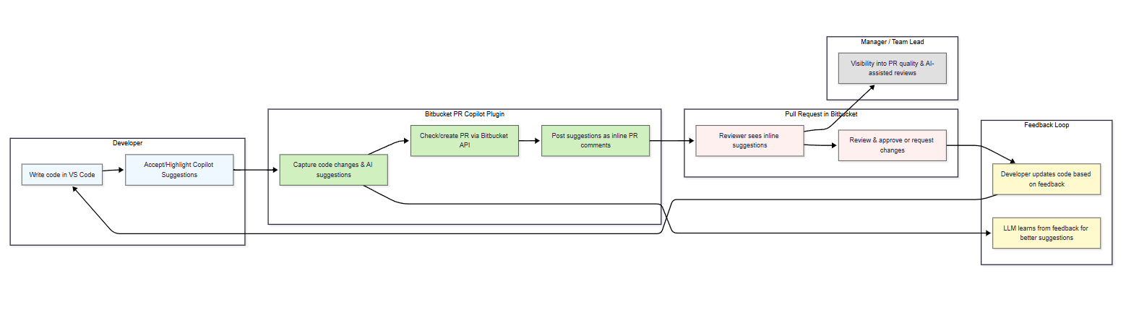
flowchart LR
subgraph Dev [Developer]
A[Write code in VS Code] --> B[Accept/Highlight Copilot Suggestions]
end

subgraph Plugin [Bitbucket PR Copilot Plugin]
B --> C[Capture code changes & AI suggestions]
C --> D[Check/create PR via Bitbucket API]
D --> E[Post suggestions as inline PR comments]
end

subgraph PR [Pull Request in Bitbucket]
E --> F[Reviewer sees inline suggestions]
F --> G[Review & approve or request changes]
end

subgraph Feedback [Feedback Loop]
G --> H[Developer updates code based on feedback]
H --> A
C --> I[LLM learns from feedback for better suggestions]
end

subgraph Manager [Manager / Team Lead]
F --> J[Visibility into PR quality & AI-assisted reviews]
end

classDef dev fill:#f0f8ff,stroke:#333,stroke-width:1px;
classDef plugin fill:#d0f0c0,stroke:#333,stroke-width:1px;
classDef pr fill:#fff0f0,stroke:#333,stroke-width:1px;
classDef feedback fill:#fffacd,stroke:#333,stroke-width:1px;
classDef manager fill:#e0e0e0,stroke:#333,stroke-width:1px;

class A,B dev;
class C,D,E plugin;
class F,G pr;
class H,I feedback;
class J manager;
This shows the end-to-end workflow:
Developer → Copilot → Plugin → PR → Reviewer → Feedback → AI learning → Developer → Manager visibility

Integrated Table: Problem → Use Case → Value → Stakeholder
Problem | Use Case | Value Delivered | Stakeholder
Slow code review | Large PRs take hours | AI pre-populates suggestions → faster approvals | Reviewer / Manager
Context switching | Copy code to PR comments | Suggestions posted directly from IDE → reduces manual effort | Developer
Inconsistent reviews | Varying reviewer feedback | AI ensures consistent recommendations | Developer / Reviewer
Onboarding challenges | New devs unclear on standards | Inline AI guidance → accelerates learning | Developer / Team Lead
Missed edge cases | Reviewer oversight | AI highlights potential issues → higher PR reliability | Reviewer / Manager
Scaling for large teams | Multiple repos & branches | Works across repos → scalable for 20k+ employees | Enterprise / DevOps
Feedback loop missing | LLM not integrated | Captures Copilot suggestions → improves AI | Developer / Reviewer / AI system
Manager visibility gaps | Cannot track AI-assisted reviews | PR comments & workflow metadata → better insights | Manager / Team Lead

Key Takeaways for Slide
- End-to-end automation: Developer → Copilot → Plugin → PR → Reviewer
- Enterprise-ready: Scalable for thousands of devs across multiple repos
- Enhances productivity: Reduces manual comments, improves review consistency
- AI feedback loop: LLM learns from developer + reviewer input
- Managerial visibility: Track AI suggestions and PR quality

If you want, I can also create a fully polished 1-slide PDF/PowerPoint mockup with icons for VS Code, Copilot, Bitbucket, Developer, Reviewer, Manager, ready to present. This will be visual + tabular and extremely clean for management.
Do you want me to create that?
You said:
yes
ChatGPT said:
Perfect! Here’s a ready-to-present, polished slide mockup concept for your Bitbucket PR Copilot PoC. I’ll describe the structure and provide a PDF/PowerPoint-friendly layout you can hand off or implement in PowerPoint/Google Slides.

Slide Title: Bitbucket PR Copilot – AI-Assisted Pull Requests

Slide Layout
1️⃣ Top Section – Workflow Diagram (Visual)
- Icons: Developer (VS Code) → Copilot → Plugin → Bitbucket PR → Reviewer → Feedback → Manager
- Flow:
  - Developer writes code → accepts/highlights Copilot suggestions
  - Plugin captures changes → checks/creates PR → posts AI suggestions
  - Reviewer sees suggestions → approves or requests changes
  - Feedback loop → developer updates code & LLM learns
  - Manager sees visibility metrics
Use colored arrows for flow; boxes with light background colors to differentiate Developer, Plugin, PR, Feedback, Manager.

2️⃣ Middle Section – Problem & Use Case Table
Problem | Use Case | Value Delivered | Stakeholder
Slow code review | Large PRs take hours | AI pre-populates suggestions → faster approvals | Reviewer / Manager
Context switching | Copy code manually | Suggestions posted directly from IDE → reduces manual effort | Developer
Inconsistent reviews | Varying reviewer feedback | AI ensures consistent recommendations | Developer / Reviewer
Onboarding challenges | New devs unclear on standards | Inline AI guidance → accelerates learning | Developer / Team Lead
Missed edge cases | Reviewer oversight | AI highlights potential issues → higher PR reliability | Reviewer / Manager
Scaling for large teams | Multiple repos & branches | Works across repos → scalable for 20k+ employees | Enterprise / DevOps
Feedback loop missing | LLM not integrated | Captures Copilot suggestions → improves AI | Developer / Reviewer / AI system
Manager visibility gaps | Cannot track AI-assisted reviews | PR comments & workflow metadata → better insights | Manager / Team Lead
Keep alternate row shading for readability.

3️⃣ Bottom Section – Key Highlights / Value Proposition
- Automation: Reduce manual PR comments and context switching
- Scalable: Enterprise-ready for thousands of developers & repos
- Enhanced Dev Experience: Inline AI suggestions in PRs
- LLM Feedback Loop: AI learns from developer + reviewer input
- Managerial Insight: Track AI-assisted reviews and team adoption

Design Tips
- Use light pastel backgrounds for different sections:
  - Developer: light blue
  - Plugin: light green
  - PR / Reviewer: light red
  - Feedback: light yellow
  - Manager: light gray
- Use icons for VS Code, Copilot, Bitbucket PR, people (Developer, Reviewer, Manager)
- Use arrows to indicate flow and feedback loops

If you want, I can generate a real slide-ready PDF with diagrams and icons based on this layout so you can just present it to management without manual drawing.
Do you want me to create that PDF slide for you?

