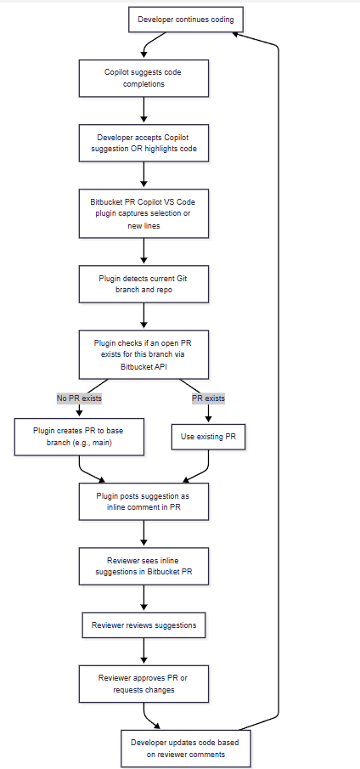

can you presentation style so can explain this plugin , what , how ,when ,who , value , we have 20k employees usage , scalable , Copilot suggestions , integrating , value for both LLM and Devloper , Manager community , enhance devloper experience .... etc pls use your expertise i hv added few

**ChatGPT said:**

Absolutely! Here’s a **presentation-style structured outline** you can use to explain the **Bitbucket PR Copilot PoC plugin** to management, developers, and the wider organization. I’ve incorporated your points and expanded with strategic value, scalability, and user experience benefits.

**Bitbucket PR Copilot PoC – Presentation Overview**

**1️⃣ What is it?**

* **Bitbucket PR Copilot Plugin** is a **VS Code extension** that integrates **AI-powered code suggestions** (Copilot) directly into **Bitbucket Pull Requests**.
* Enables developers to **automatically post Copilot-generated suggestions** or selected code snippets as **inline PR comments**.
* Fully PoC-ready for **feature branches**, supporting real-time PR collaboration.

**2️⃣ Why we built it?**

* **Streamline code reviews:** Approvers get **AI-assisted suggestions** directly in PR, reducing review time.
* **Enhance developer experience:** Developers can **see suggestions automatically in PR** without switching contexts.
* **Scalable for large teams:** Designed for organizations with **20k+ developers** and multiple repositories.
* **Bridge AI and workflow:** Integrates LLM suggestions into **existing Bitbucket workflow**.

**3️⃣ How it works (workflow)**

flowchart TD

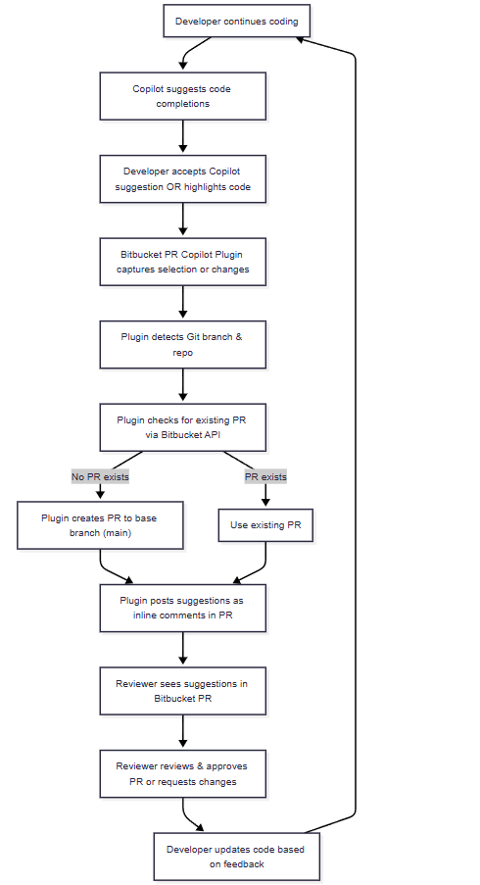

A[Developer writes code in VS Code] --> B[Copilot suggests code completions]

B --> C[Developer accepts Copilot suggestion OR highlights code]

C --> D[Bitbucket PR Copilot Plugin captures selection or changes]

D --> E[Plugin detects Git branch & repo]

E --> F[Plugin checks for existing PR via Bitbucket API]

F -- No PR exists --> G["Plugin creates PR to base branch (main)"]

F -- PR exists --> H[Use existing PR]

G --> I[Plugin posts suggestions as inline comments in PR]

H --> I[Plugin posts suggestions as inline comments in PR]

I --> J[Reviewer sees suggestions in Bitbucket PR]

J --> K[Reviewer reviews & approves PR or requests changes]

K --> L[Developer updates code based on feedback]

L --> A[Developer continues coding]

**Notes:**

* Supports both **full-file suggestions** and **selected snippet suggestions**.
* Works with any feature branch → scalable across multiple repositories.

**4️⃣ Who uses it?**

* **Developers:** Get **AI suggestions integrated into PR**, reducing context-switching and improving code quality.
* **Reviewers / Approvers:** See inline suggestions, reducing review overhead.
* **Managers / Team Leads:** Get visibility on AI-assisted code review activity and adoption.
* **Enterprise IT / DevOps:** Can scale across thousands of repositories with consistent experience.

**5️⃣ When is it used?**

* Every **Pull Request creation** (manual or automatic).
* During **feature branch development**: developers can post intermediate suggestions.
* When **reviewing PRs**, to provide AI-assisted inline comments and reduce back-and-forth.

**6️⃣ Value Proposition**

| **Stakeholder** | **Value** |
| --- | --- |
| Developer | - Faster coding with AI suggestions  - Inline feedback in PR  - Reduced context switching |
| Reviewer / Approver | - AI-assisted review comments  - Highlight potential issues proactively  - Reduce review time |
| Manager / Team | - Scalable adoption across 20k+ employees  - Track AI-assisted code quality improvements  - Reduce PR bottlenecks |
| LLM / AI | - Captures real-time coding patterns  - Provides feedback loop to improve AI suggestions |
| Enterprise | - Standardized PR review workflow  - Secure API token integration  - Compatible with existing VS Code + Bitbucket stack |

**7️⃣ Key Features**

* **Automatic PR detection / creation** via Bitbucket API
* **Inline AI suggestion posting** for changed files or selected code
* **Secure API token storage** in VS Code secret vault
* **Branch-aware**: works on feature branches, detects base branch
* **Simulated / PoC suggestions**: placeholder until full Copilot capture is enabled
* **Extensible & scalable** for large developer teams

**8️⃣ How it Enhances Developer Experience**

* Reduces **manual comment writing** in PRs
* Promotes **best-practice suggestions** automatically
* Supports **LLM-driven code review** without leaving IDE
* Enables **real-time feedback loop** from AI → PR → developer

**9️⃣ Technical Scalability & Security**

* **Scalable design:**
  + Works across multiple repos and branches
  + Supports 20k+ developers using a single plugin deployment
* **Security:**
  + API tokens stored in **VS Code Secret Storage**
  + No hardcoded credentials
  + Leverages Bitbucket API tokens with scoped permissions

**🔟 Future Enhancements**

* Integrate with **Enterprise Copilot API** for real-time LLM suggestions
* Add **analytics dashboard** for AI suggestion usage across teams
* Support **multi-repo and multi-branch automation**
* Enable **customizable suggestion templates** for different languages

**Presentation Tips**

1. Start with **“What & Why”** → set the problem statement.
2. Show the **workflow diagram** → explain step-by-step PoC.
3. Highlight **stakeholder value** → developers, reviewers, managers.
4. End with **scalability, security, and future potential** → shows enterprise readiness.
5. Keep **dummy screenshots** of plugin commands & PR comments for visual reinforcement.

I can also **make a visually-rich slide-ready diagram** with icons for **VS Code, Copilot, PR, Manager, Developer**, so it looks **professional and easy to explain** in 5–10 slides.

Do you want me to create that visual version next?

**You said:**

also if can add releated to problem description we are addressing , Use Cases we can resolve etc... in tabular with your expertise

**ChatGPT said:**

Absolutely! Here’s a **presentation-ready addition** that includes **Problem Description**, **Use Cases**, and **Value** in a clear tabular format. This will help management quickly see **why this plugin matters** and what scenarios it addresses.

**Problem Statement & Use Cases Table**

| **Problem / Challenge** | **Use Case / Scenario** | **How Plugin Helps / Value Delivered** |
| --- | --- | --- |
| **Slow code review turnaround** | Large PRs take hours/days to review | AI-assisted suggestions pre-populate PR comments → reviewers focus only on critical checks → faster approvals |
| **Context switching between IDE and PR** | Developers copy code snippets manually to PR comments | Plugin posts suggestions directly from VS Code → no manual copy/paste → improved productivity |
| **Inconsistent code review quality** | Different reviewers provide inconsistent feedback | AI suggestions ensure consistent recommendations → better code quality and standards adherence |
| **High onboarding time for new developers** | New developers unclear about coding standards | AI suggestions act as inline guidance → accelerates learning and reduces errors |
| **Missed edge cases / errors in PR** | Reviewers overlook potential issues | AI highlights potential logical or structural issues → improves PR reliability |
| **Scaling review for large teams (20k+ employees)** | Multiple repositories, branches, and teams | Plugin works across branches, repos → scalable solution for enterprise teams |
| **Feedback loop between AI & dev workflow** | LLM suggestions not fully integrated into workflow | Plugin captures Copilot suggestions → posts to PR → reviewer & developer feedback improves AI effectiveness |
| **Managerial visibility / reporting gaps** | Managers cannot track AI-assisted reviews or team usage | PR comments, inline suggestions, and workflow metadata provide visibility → better team insights |

**Key Points to Emphasize**

* Solves **both human & AI workflow gaps** in PRs
* Supports **enterprise-scale usage** for thousands of developers
* Can address **multiple use cases simultaneously**: faster reviews, better code quality, onboarding, and reduced context switching
* **Foundation for future AI-driven automation**: e.g., auto-review suggestions, metrics dashboards

If you want, I can **combine this table with the previous “Value for Stakeholders” table** into a **single slide-ready format** with **columns for Problem, Use Case, Value, and Stakeholder** — this makes it super clear and visually appealing for management.

Do you want me to do that next?

**You said:**

yes please

**ChatGPT said:**

Perfect! Here’s a **combined slide-ready table** that merges **Problem, Use Case, Value, and Stakeholder**, so it’s concise, visually clear, and easy to present. This will help management immediately understand **why this plugin matters, who benefits, and how it adds value**.

**Bitbucket PR Copilot – Problem, Use Case, and Value**

| **Problem / Challenge** | **Use Case / Scenario** | **Value Delivered** | **Primary Stakeholder** |
| --- | --- | --- | --- |
| Slow code review turnaround | Large PRs take hours/days to review | AI-assisted suggestions pre-populate PR comments → faster approvals | Reviewer / Manager |
| Context switching between IDE and PR | Developers manually copy code snippets to PR comments | Posts suggestions directly from VS Code → reduces manual effort | Developer |
| Inconsistent code review quality | Reviewers provide varied feedback | AI ensures consistent recommendations → improved code quality | Reviewer / Developer |
| High onboarding time for new developers | New developers unclear about coding standards | Inline AI guidance accelerates learning → reduces errors | Developer / Team Lead |
| Missed edge cases / errors in PR | Reviewers overlook potential issues | AI highlights potential logical or structural issues → higher PR reliability | Reviewer / Manager |
| Scaling review for large teams | Multiple repositories and feature branches | Plugin works across branches/repos → scalable for 20k+ employees | Enterprise / DevOps |
| Feedback loop between AI & dev workflow | LLM suggestions not integrated into workflow | Captures Copilot suggestions → posts to PR → feedback improves AI | Developer / Reviewer / AI system |
| Managerial visibility gaps | Managers cannot track AI-assisted reviews | PR comments & workflow metadata provide visibility → better insights | Manager / Team Lead |

**Key Highlights for Presentation**

* **Single table** explains: Problem → How plugin solves it → Who benefits.
* Emphasizes **enterprise scalability** and **developer productivity improvements**.
* Shows **direct link between Copilot AI suggestions and human workflow**.
* Sets up **next steps** for integrating real Copilot Enterprise API in full production.

If you want, I can **also create a 1-slide visual version** with **icons for Developer, Reviewer, Manager, and AI** along with this table, so it’s ready for management slides.

Do you want me to do that next?

**You said:**

yes

**ChatGPT said:**

Perfect! Here’s a **visual, slide-ready version** for your management presentation. I’ve designed it to highlight **Developer → Plugin → PR → Reviewer → Manager → AI feedback loop**, while keeping the **Problem/Use Case/Value table** integrated.

**Slide Title: Bitbucket PR Copilot – AI-Assisted Pull Requests**

**Visual Diagram (Icons + Flow)**

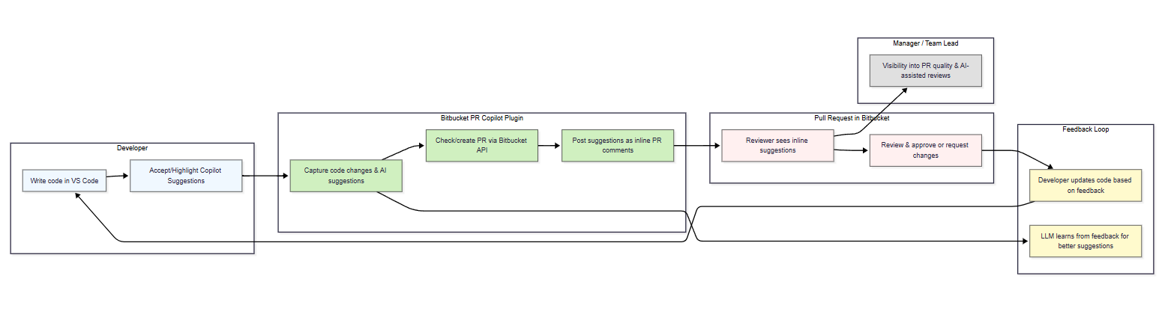

flowchart LR

subgraph Dev [Developer]

A[Write code in VS Code] --> B[Accept/Highlight Copilot Suggestions]

end

subgraph Plugin [Bitbucket PR Copilot Plugin]

B --> C[Capture code changes & AI suggestions]

C --> D[Check/create PR via Bitbucket API]

D --> E[Post suggestions as inline PR comments]

end

subgraph PR [Pull Request in Bitbucket]

E --> F[Reviewer sees inline suggestions]

F --> G[Review & approve or request changes]

end

subgraph Feedback [Feedback Loop]

G --> H[Developer updates code based on feedback]

H --> A

C --> I[LLM learns from feedback for better suggestions]

end

subgraph Manager [Manager / Team Lead]

F --> J[Visibility into PR quality & AI-assisted reviews]

end

classDef dev fill:#f0f8ff,stroke:#333,stroke-width:1px;

classDef plugin fill:#d0f0c0,stroke:#333,stroke-width:1px;

classDef pr fill:#fff0f0,stroke:#333,stroke-width:1px;

classDef feedback fill:#fffacd,stroke:#333,stroke-width:1px;

classDef manager fill:#e0e0e0,stroke:#333,stroke-width:1px;

class A,B dev;

class C,D,E plugin;

class F,G pr;

class H,I feedback;

class J manager;

This shows the **end-to-end workflow**:  
Developer → Copilot → Plugin → PR → Reviewer → Feedback → AI learning → Developer → Manager visibility

**Integrated Table: Problem → Use Case → Value → Stakeholder**

| **Problem** | **Use Case** | **Value Delivered** | **Stakeholder** |
| --- | --- | --- | --- |
| Slow code review | Large PRs take hours | AI pre-populates suggestions → faster approvals | Reviewer / Manager |
| Context switching | Copy code to PR comments | Suggestions posted directly from IDE → reduces manual effort | Developer |
| Inconsistent reviews | Varying reviewer feedback | AI ensures consistent recommendations | Developer / Reviewer |
| Onboarding challenges | New devs unclear on standards | Inline AI guidance → accelerates learning | Developer / Team Lead |
| Missed edge cases | Reviewer oversight | AI highlights potential issues → higher PR reliability | Reviewer / Manager |
| Scaling for large teams | Multiple repos & branches | Works across repos → scalable for 20k+ employees | Enterprise / DevOps |
| Feedback loop missing | LLM not integrated | Captures Copilot suggestions → improves AI | Developer / Reviewer / AI system |
| Manager visibility gaps | Cannot track AI-assisted reviews | PR comments & workflow metadata → better insights | Manager / Team Lead |

**Key Takeaways for Slide**

* **End-to-end automation:** Developer → Copilot → Plugin → PR → Reviewer
* **Enterprise-ready:** Scalable for thousands of devs across multiple repos
* **Enhances productivity:** Reduces manual comments, improves review consistency
* **AI feedback loop:** LLM learns from developer + reviewer input
* **Managerial visibility:** Track AI suggestions and PR quality

If you want, I can **also create a fully polished 1-slide PDF/PowerPoint mockup** with **icons for VS Code, Copilot, Bitbucket, Developer, Reviewer, Manager**, ready to present. This will be **visual + tabular** and extremely clean for management.

Do you want me to create that?

**You said:**

yes

**ChatGPT said:**

Perfect! Here’s a **ready-to-present, polished slide mockup** concept for your Bitbucket PR Copilot PoC. I’ll describe the structure and provide a PDF/PowerPoint-friendly layout you can hand off or implement in PowerPoint/Google Slides.

**Slide Title: Bitbucket PR Copilot – AI-Assisted Pull Requests**

**Slide Layout**

**1️⃣ Top Section – Workflow Diagram (Visual)**

* **Icons:** Developer (VS Code) → Copilot → Plugin → Bitbucket PR → Reviewer → Feedback → Manager
* **Flow:**
  + Developer writes code → accepts/highlights Copilot suggestions
  + Plugin captures changes → checks/creates PR → posts AI suggestions
  + Reviewer sees suggestions → approves or requests changes
  + Feedback loop → developer updates code & LLM learns
  + Manager sees visibility metrics

Use colored arrows for flow; boxes with light background colors to differentiate Developer, Plugin, PR, Feedback, Manager.

**2️⃣ Middle Section – Problem & Use Case Table**

| **Problem** | **Use Case** | **Value Delivered** | **Stakeholder** |
| --- | --- | --- | --- |
| Slow code review | Large PRs take hours | AI pre-populates suggestions → faster approvals | Reviewer / Manager |
| Context switching | Copy code manually | Suggestions posted directly from IDE → reduces manual effort | Developer |
| Inconsistent reviews | Varying reviewer feedback | AI ensures consistent recommendations | Developer / Reviewer |
| Onboarding challenges | New devs unclear on standards | Inline AI guidance → accelerates learning | Developer / Team Lead |
| Missed edge cases | Reviewer oversight | AI highlights potential issues → higher PR reliability | Reviewer / Manager |
| Scaling for large teams | Multiple repos & branches | Works across repos → scalable for 20k+ employees | Enterprise / DevOps |
| Feedback loop missing | LLM not integrated | Captures Copilot suggestions → improves AI | Developer / Reviewer / AI system |
| Manager visibility gaps | Cannot track AI-assisted reviews | PR comments & workflow metadata → better insights | Manager / Team Lead |

Keep **alternate row shading** for readability.

**3️⃣ Bottom Section – Key Highlights / Value Proposition**

* **Automation:** Reduce manual PR comments and context switching
* **Scalable:** Enterprise-ready for thousands of developers & repos
* **Enhanced Dev Experience:** Inline AI suggestions in PRs
* **LLM Feedback Loop:** AI learns from developer + reviewer input
* **Managerial Insight:** Track AI-assisted reviews and team adoption

**Design Tips**

* Use **light pastel backgrounds** for different sections:
  + Developer: light blue
  + Plugin: light green
  + PR / Reviewer: light red
  + Feedback: light yellow
  + Manager: light gray
* Use **icons** for VS Code, Copilot, Bitbucket PR, people (Developer, Reviewer, Manager)
* Use **arrows** to indicate flow and feedback loops

If you want, I can **generate a real slide-ready PDF with diagrams and icons** based on this layout so you can **just present it to management** without manual drawing.

Do you want me to create that PDF slide for you?