EchoROI: U-Net-based ROI Segmentation and De-identification for Echocardiography
3 March 2026

Summary
Echocardiography is the most widely performed cardiac imaging modality, yet large-scale computational analysis of echocardiogram videos is hindered by protected health information (PHI) and vendor-specific overlays that are frequently burned into the pixel data (Madani et al. 2018). EchoROI is an open-source Python package that uses a U-Net convolutional neural network (Ronneberger et al. 2015) to segment the fan-shaped ultrasound scan sector—the region of interest (ROI)—in each frame, and to mask out non-ROI content (e.g., identifiers, ECG traces, calipers, measurement readouts, and vendor logos). The resulting frames preserve the native scan-sector resolution while removing distracting background elements, facilitating dataset preprocessing for machine learning and enabling safer sharing of examples for teaching.
EchoROI is distributed as an installable Python package with both a command-line interface (CLI) and a Python API. Users can apply the pretrained model, fine- tune it on site-specific annotations, and export models to ONNX for deployment outside TensorFlow.
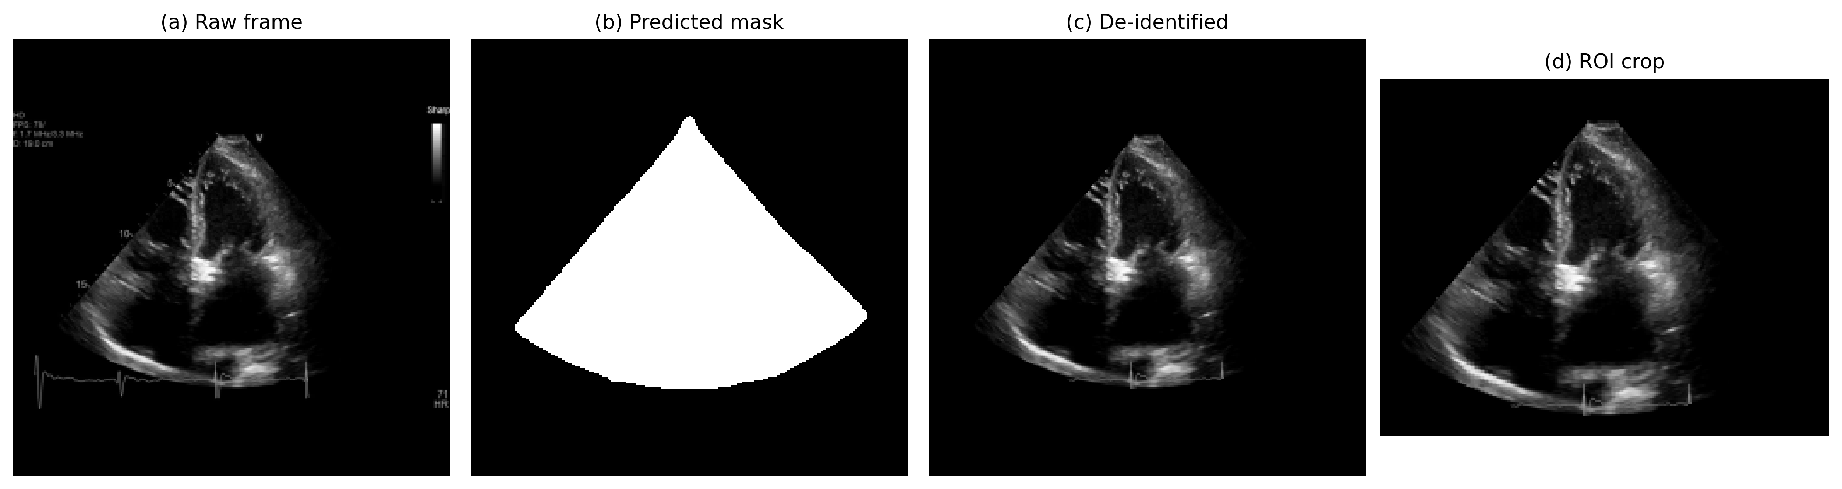
EchoROI processing pipeline: raw input, predicted scan-sector mask, masked/de-identified output, and optional ROI extraction.

Statement of Need
Many echocardiography files contain PHI and vendor overlays rendered directly into pixel data, restricting data sharing and introducing confounders for computer-vision models (Panhuis et al. 2014). Public datasets such as MIMIC-IV-ECHO (Gow et al. 2023) contain identifiers and overlays that must be removed to support privacy- preserving research workflows; manual anonymisation is impractical for modern- scale collections. In prior work (Ekambaram et al. 2026), the authors manually segmented and cropped roughly 1,000 apical four-chamber echocardiograms from MIMIC-IV-ECHO using LabelMe (Russell et al. 2008)—a mandatory preprocessing step before the data could be used for machine-learning analysis. That labour-intensive experience motivated the development of EchoROI as a general-purpose, learned alternative that scales to diverse echocardiography datasets without manual intervention.
Existing tools address related subproblems. OCR-based pipelines can remove textual overlays but may fail when display layouts vary across vendors or when overlays appear in low-contrast regions (Monteiro et al. 2017). Heuristic ROI detection approaches work well for fixed imaging layouts but may not generalise across vendors, zoom levels, or probe orientations (Kline et al. 2023).
Public datasets such as EchoNet-Dynamic distribute pre-cropped videos (Ouyang et al. 2020), simplifying modelling but discarding the original pixel geometry and assuming stable display conventions. These heuristics were tuned for specific acquisition settings and may leave residual overlays or remove non-ventricular anatomy relevant for downstream tasks.
EchoROI provides an end-to-end, open-source workflow for learning the true scan-sector boundary with deep segmentation and using that boundary to standardise frames for downstream analysis. By explicitly modelling the curved sector edges, EchoROI avoids fragile cropping heuristics, supporting diverse acquisition layouts. Including frames from both EchoNet-Dynamic and EchoNet-Paediatric in the training set (alongside six other heterogeneous sources) ensures the learned mask captures the full scan sector regardless of fan angle, depth, or vendor, and removes distracting overlay elements that heuristic methods miss. Standardising the field of view also reduces wasted model capacity on static overlays, which is particularly relevant for representation-learning approaches such as masked autoencoders (He et al. 2022; Tong et al. 2022).
Recent benchmarking work has shown that heterogeneous preprocessing and residual overlays can induce shortcut learning in echocardiography foundation models, harming cross-dataset generalisation (Taratynova et al. 2025). By providing consistent sector masking across vendors and acquisition settings, EchoROI can help stabilise benchmarks and mitigate acquisition-artifact confounds. Emerging multimodal pipelines that integrate cardiac imaging with transcriptomic and clinical data similarly depend on clean, standardised imaging inputs (Le et al. 2026), further motivating robust automated preprocessing.

Usage
EchoROI can be used from the command line for batch preprocessing or as a Python library within research pipelines.
For typical echocardiography acquisitions, the scan sector (ROI) is static over the duration of a cine loop: it is determined by probe geometry (most commonly a phased-array sector), the selected field of view (fan angle/depth), and user-controlled placement/orientation. EchoROI exploits this by predicting a mask on a single representative frame and then applying the same mask (and the resulting crop window) to all frames in the sequence.
By default, the representative frame is selected automatically as the highest-entropy frame among the first few frames (to avoid blank/transition frames). Users can alternatively specify the representative frame index. This design reduces compute cost for large datasets while enforcing consistent preprocessing within each clip.
# De-identify: black out everything outside the scan sector
echoroi predict \
--model-path models/echoroi_unified.keras \
--input video_frames/ \
--output clean/ \
--deidentify
# Fine-tune on site-specific annotations
echoroi train \
--image-dir data/images \
--mask-dir data/masks \
--model-path models/echoroi_finetuned.keras \
--epochs 50 \
--batch-size 8 \
--learning-rate 1e-4 \
--results-dir training_results
from echoroi import UNetPredictor
predictor = UNetPredictor("models/echoroi_unified.keras")
mask = predictor.predict_single_image("frame.png")
result = predictor.process_image_with_visualization(
"frame.png", save_path="output.png"
)

Implementation

Architecture
EchoROI uses a standard U-Net (Ronneberger et al. 2015) with four encoder and four decoder blocks (31 million parameters). Encoder blocks apply 3x3 convolutions with ReLU activation, He-normal initialisation, and spatial dropout (0.1–0.3), followed by 2x2 max-pooling. The decoder mirrors this structure using transposed convolutions and skip connections. A final 1x1 convolution with sigmoid activation produces a single-channel binary mask. Input and output are 256x256x1 grayscale images.
Training uses binary cross-entropy loss and is monitored with Dice and intersection-over-union (IoU). Optimisation uses Adam with an initial learning rate of $1×{10}^{−4}$ and a reduce-on-plateau schedule (factor 0.5, patience 5 epochs). The reference implementation is built in TensorFlow/Keras and was trained and evaluated on an Apple Mac mini with an M2 Pro (CPU/GPU).
Modified U-Net architecture for echocardiographic ROI segmentation with same-padding, dropout regularisation, and binary sigmoid output. Feature map spatial dimensions are shown below each block; channel counts are shown above. Dashed boxes indicate dropout layers (p = 0.1–0.3, increasing with depth).

Training Data
The model was trained on 1,355 manually annotated echocardiogram frame/mask pairs drawn from multiple sources:
Dataset | Frames | Access
MIMIC-IV-ECHO | 403 | PhysioNet
EchoNet-Dynamic | 145 | Stanford
EchoNet-Paediatric | 263 | Stanford
CACTUS (A4C subset) | 38 | Open access
EchoCP | 60 | Kaggle
Private dataset (consented) | 50 | Institutional
CardiacUDC | 247 | Kaggle
HMC-QU | 149 | By request
Total | 1,355
Sources: MIMIC-IV-ECHO (Gow et al. 2023; Goldberger et al. 2000; Ekambaram et al. 2026), EchoNet-Dynamic (Ouyang et al. 2020), EchoNet-Paediatric (Reddy et al. 2023), CACTUS (Elmekki et al. 2025), EchoCP (Wang et al. 2021), CardiacUDC (Yang et al. 2023), HMC-QU (Degerli et al. 2024). The MIMIC-IV-ECHO annotations include frames drawn from the manually segmented A4C subset (Ekambaram et al. 2026). The private dataset comprises consented samples from Mindray and Samsung devices.
Ground-truth masks were created in LabelMe (Russell et al. 2008) by outlining the scan-sector boundary. For consistency, sector ROIs were annotated as polygons with a virtual apex (triangular sector) even for some curved-probe images where the true near-field boundary is an arc. Linear-probe (rectangular) ultrasound layouts were not included in training.
Annotations included all visible diagnostic content while excluding padding, borders, and overlay graphics. Only one frame per input video sequence was included for training.
Training used a single 80/20 train–validation split created once at training start by randomly shuffling the full dataset with a fixed seed. The split was not stratified by dataset source. Batch size was 16 and training ran for 50 epochs.

Software Design
EchoROI is distributed as a pip-installable package (echoroi) with modular components for preprocessing, model definition, training, and inference. The CLI provides subcommands for training, prediction, evaluation, and benchmarking. Models can also be exported to ONNX for framework-agnostic deployment.

Validation
On the validation split (20% of the 1,355 annotated frames), EchoROI achieves:
Metric | Value
Dice coefficient | 0.9880
IoU (Jaccard) | 0.9763
Pixel accuracy | 0.9906
Sensitivity | 0.9894
Specificity | 0.9914
These segmentation results meet or exceed prior open approaches. PyLogik reported 0.976 Dice on 50 images using heuristic morphological operations (Kline et al. 2023); fixed sector-template methods can achieve comparable accuracy on single-vendor data but degrade when fan angle, depth, or display layout varies across vendors. EchoROI’s learned segmentation generalises across the eight heterogeneous sources in the training set without vendor-specific tuning. No separate held-out test set was used; the final metrics are reported on the same validation split used for model selection (best checkpoint by val_dice_coefficient), and may modestly overestimate generalisation performance.
De-identification quality was assessed by manual spot-checking of model outputs on the validation split. During LabelMe annotation, frames were also reviewed to ensure that PHI was not present within the scan-sector ground-truth masks used for training.
On a consumer Apple M2 Pro (CPU/GPU), inference takes approximately 25 ms per 256x256 frame, enabling real-time preprocessing of short echo clips.
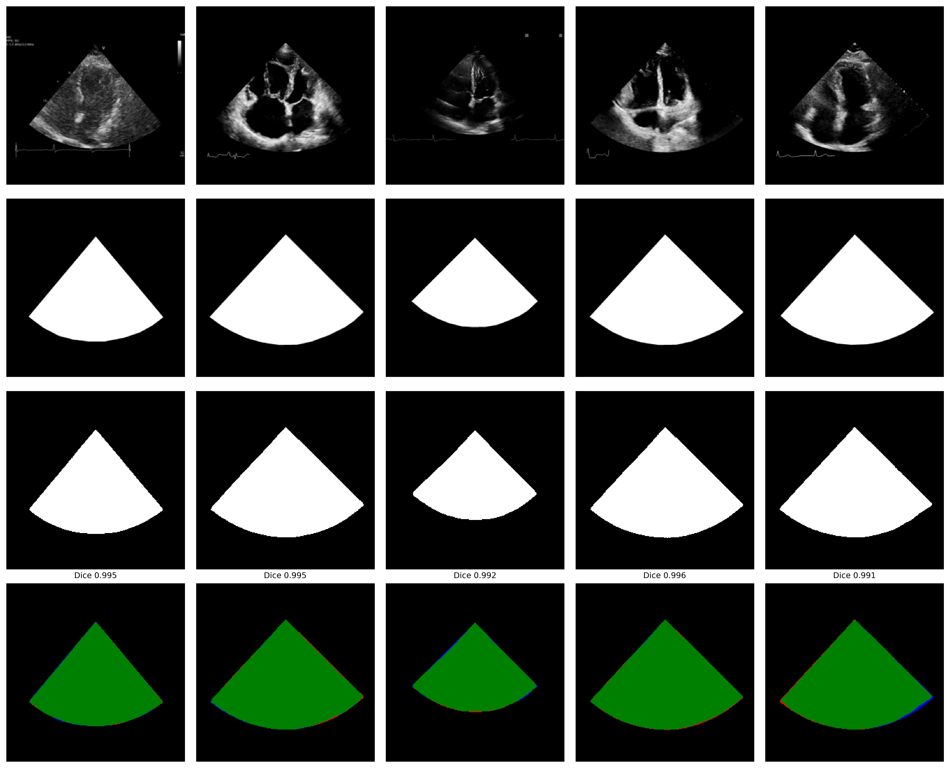
Sample predictions on held-out validation frames.

Limitations
EchoROI should be treated as a preprocessing and de-identification aid rather than a guarantee of complete PHI removal. Masking may fail for atypical layouts, low contrast, extreme zoom, handheld/POCUS devices, or when identifiers overlap or traverse the scan sector.
EchoROI is designed primarily for sector-shaped echocardiography views (most commonly phased-array probes). Curved-probe acquisitions may be approximated by a virtual-apex (triangular) sector mask, which can introduce boundary error near the probe face. Linear-probe (rectangular) ultrasound layouts were not included in training and are not expected to perform reliably.
Because PHI can appear inside the ROI, users should apply human-in-the-loop review and follow local governance procedures before external sharing of derived images or cine loops.
To support responsible use, the repository includes a model card documenting intended use, dataset composition, known failure modes, and performance limitations. Users are encouraged to inspect low-confidence masks (e.g., peak prediction probability below 0.5), atypical aspect ratios, or predicted ROIs with implausible geometry as indicators of potential masking failures.

Reproducibility
A minimal reproduction of the reported segmentation metrics can be performed using the built-in evaluation command on a directory of images and masks:
echoroi evaluate \
--model-path models/echoroi_unified.keras \
--image-dir <IMAGE_DIR> \
--mask-dir <MASK_DIR> \
--output <EVAL_DIR>
For end-to-end dataset preprocessing, the repository includes a worked example notebook (04_dataset_preprocessing.ipynb) demonstrating a DICOM-to-NPZ workflow using the exported ONNX model:
- Recursively discover DICOM files and load cine frames.
- Optionally normalise clip length to a fixed frame count (e.g., 32) using an adaptive stride: evenly downsample when frames > target, or linearly interpolate when frames < target.
- Resize to 256x256 with aspect-ratio preservation and zero-padding; convert to float32 and normalise pixel intensities to [0, 1].
- Apply optional orientation transforms (horizontal/vertical flips and 90-degree rotations) for dataset-specific DICOM compatibility.
- Select a representative frame automatically (highest Shannon entropy among the first few frames) and run ONNX EchoROI inference to obtain an ROI mask.
- Broadcast the ROI mask across the full clip and compute an LV-focused square crop from the representative-frame mask (threshold 0.5; square side length set by the mask height and centred on the mask bounding box).
- Apply the crop to all frames, resize to 112x112, and save as compressed NPZ arrays shaped (32, 112, 112).
Training data are not redistributed; users can retrain by providing matched image/mask pairs derived from their permitted datasets and/or site-specific LabelMe annotations.

Availability and Reuse
EchoROI is released under the MIT licence. Source code, pretrained weights, example notebooks, and a test suite are available at https://github.com/Kamlin-MD/UNET-Echocardiography-ROI-segmentation.
The primary use case is research preprocessing of large echocardiography collections: standardising frames by removing non-diagnostic background content while preserving scan-sector resolution. A secondary use case is education (e.g., sharing de-identified stills or cine loops for teaching and FOAMed), subject to user responsibility and local policy.
Users working with devices or layouts not represented in the training set can fine-tune the model on 50–100 annotated frames using the CLI or Python API. EchoROI is not a substitute for institutional de-identification procedures; governance review and human-in-the-loop workflows are recommended before any external data sharing.

Acknowledgements
This work was supported by the University of Stellenbosch Institute of Biomedical Engineering. The manual A4C segmentation effort described in (Ekambaram et al. 2026) directly motivated the development of EchoROI. We gratefully acknowledge the following dataset providers whose data made the training of EchoROI possible: the PhysioNet team and Beth Israel Deaconess Medical Center for MIMIC-IV-ECHO (Gow et al. 2023; Goldberger et al. 2000); the Stanford Artificial Intelligence in Medicine and Imaging (AIMI) Center for EchoNet-Dynamic (Ouyang et al. 2020) and EchoNet-Paediatric (Reddy et al. 2023); the authors of the CACTUS dataset (Elmekki et al. 2025); the EchoCP contributors (Wang et al. 2021); the CardiacUDC team (Yang et al. 2023); and the HMC-QU research group (Degerli et al. 2024). EchoROI is built on TensorFlow/Keras, OpenCV, and the Python scientific computing ecosystem.

References
Degerli, Aysen, Serkan Kiranyaz, Tahir Hamid, Rashid Mazhar, and Moncef Gabbouj. 2024. “Early Myocardial Infarction Detection over Multi-View Echocardiography.” Biomedical Signal Processing and Control 87. https://doi.org/10.1016/j.bspc.2023.105448.
Ekambaram, Kamlin, Anurag Arnab, Philip Herbst, and Rensu Theart. 2026. “MIMIC-IV-ECHO-Ext-LVVOLUMES-A4C-ROI: Annotated Subset of Apical Four-Chamber Echocardiography for PoCUS-Style LV Volume and Function Analysis.” PhysioNet, ahead of print, February. https://doi.org/10.13026/713s-z339.
Elmekki, Hanae, Ahmed Alagha, Hani Sami, et al. 2025. “CACTUS: An Open Dataset and Framework for Automated Cardiac Assessment and Classification of Ultrasound Images Using Deep Transfer Learning.” Computers in Biology and Medicine 190: 110003. https://doi.org/10.1016/j.compbiomed.2025.110003.
Goldberger, Ary L., Luı́s A. Nunes Amaral, Leon Glass, et al. 2000. “PhysioBank, PhysioToolkit, and PhysioNet: Components of a New Research Resource for Complex Physiologic Signals.” Circulation 101 (23): e215–20. https://doi.org/10.1161/01.CIR.101.23.e215.
Gow, Brian, Tom Pollard, Larry A. Nathanson, et al. 2023. MIMIC-IV-Echo: Echocardiogram Matched Subset. PhysioNet. https://doi.org/10.13026/ef48-v217.
He, Kaiming, Xinlei Chen, Saining Xie, Yanghao Li, Piotr Dollár, and Ross Girshick. 2022. “Masked Autoencoders Are Scalable Vision Learners.” Proceedings of the IEEE/CVF Conference on Computer Vision and Pattern Recognition (CVPR), 16000–16009. https://doi.org/10.1109/CVPR52688.2022.01554.
Kline, Adrienne, Shiyuan Zhou, Chi-Chun Liu, and William K. Thompson. 2023. Medical Image de-Identification, Cleaning and Compression Using PyLogik. https://doi.org/10.48550/arXiv.2302.13905.
Le, Minh H. N., Tuan Vinh, Thanh-Huy Nguyen, et al. 2026. Imaging-Anchored Multiomics in Cardiovascular Disease: Integrating Cardiac Imaging, Bulk, Single-Cell, and Spatial Transcriptomics. https://arxiv.org/abs/2601.07871.
Madani, Ali, Ramy Arnaout, Mohammad Mofrad, and Rima Arnaout. 2018. “Fast and Accurate View Classification of Echocardiograms Using Deep Learning.” Npj Digital Medicine 1 (1): 6. https://doi.org/10.1038/s41746-017-0013-1.
Monteiro, Erin Eriksson, Javier Andreu-Perez, Marcus Larsson, Krister Boman, Panagiotis Papapetrou, and Theo Kyriacou. 2017. “A de-Identification Pipeline for Ultrasound Medical Images in DICOM Format.” Journal of Medical Systems 41 (6): 97. https://doi.org/10.1007/s10916-017-0747-6.
Ouyang, David, Bryan He, Amirata Ghorbani, et al. 2020. “Video-Based AI for Beat-to-Beat Assessment of Cardiac Function.” Nature 580 (7802): 252–56. https://doi.org/10.1038/s41586-020-2145-8.
Panhuis, Willem G van, Proma Paul, Claudia Emerson, et al. 2014. “A Systematic Review of Barriers to Data Sharing in Public Health.” BMC Public Health 14 (1): 1144. https://doi.org/10.1186/1471-2458-14-1144.
Reddy, Charitha, Leo Lopez, David Ouyang, James Y. Zou, and Bryan He. 2023. “Video-Based Deep Learning for Automated Assessment of Left Ventricular Ejection Fraction in Pediatric Patients.” Journal of the American Society of Echocardiography 36 (5): 482–89. https://doi.org/10.1016/j.echo.2023.01.015.
Ronneberger, Olaf, Philipp Fischer, and Thomas Brox. 2015. “U-Net: Convolutional Networks for Biomedical Image Segmentation.” Medical Image Computing and Computer-Assisted Intervention (MICCAI), 234–41. https://doi.org/10.1007/978-3-319-24574-4_28.
Russell, Bryan C., Antonio Torralba, Kevin P. Murphy, and William T. Freeman. 2008. “LabelMe: A Database and Web-Based Tool for Image Annotation.” International Journal of Computer Vision 77 (1-3): 157–73. https://doi.org/10.1007/s11263-007-0090-8.
Taratynova, Darya, Ahmed Aly, Numan Saeed, and Mohammad Yaqub. 2025. CardioBench: Do Echocardiography Foundation Models Generalize Beyond the Lab? https://arxiv.org/abs/2510.00520.
Tong, Zhan, Yibing Song, Jue Wang, and Limin Wang. 2022. “VideoMAE: Masked Autoencoders are Data-Efficient Learners for Self-Supervised Video Pre-Training.” arXiv abs/2203.12602 (1): 10. https://doi.org/10.48550/arxiv.2203.12602.
Wang, Tianchen et al. 2021. “EchoCP: An Echocardiography Dataset in Contrast Transthoracic Echocardiography for Patent Foramen Ovale Diagnosis.” Medical Image Computing and Computer Assisted Intervention (MICCAI 2021), Lecture notes in computer science, vol. 12906. https://doi.org/10.1007/978-3-030-87231-1_49.
Yang, Jiewen, Xinpeng Ding, Ziyang Zheng, Xiaowei Xu, and Xiaomeng Li. 2023. GraphEcho: Graph-Driven Unsupervised Domain Adaptation for Echocardiogram Video Segmentation. https://arxiv.org/abs/2309.11145.

