**Current student looking to join the workforce to gain real-world experience. Ability to complete tasks on time in both individual and team settings with excellent communication and interpersonal skills. Team player,** **dependable and reliable, ready to learn and grow with your company.** **Seeking to maintain full-time position that offers professional challenges utilizing interpersonal skills, excellent time management and problem-solving skills.**

# Skills



Kamogelo

**Phiri**

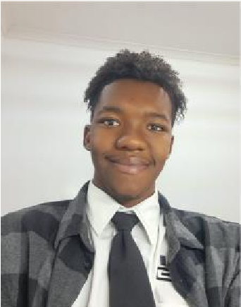

Intern



**Address**



Pretoria, GP 0002



**Phone**



0848957292



**E**

**-**

**mail**



kamophiri0@gmail.com



Cultural Awareness



Collaborative Teamwork



Written Communication



Adaptability

**S**

**oft**

**S**

**kills**

**Technical**

**Skills**



Web Architecture

(

HTML, CSS, JavaScript

)



Database programming

(

MongoDB

,

Pos

tGre, MySQL

)



Agile development methodologies



Project Management



Object

-

Oriented Programming

(

C#, Java

)



**Ma**

**nagement**

**Skills**

# Interests

The passion I feel for gaming fuels my interest in interactive design, game and systems mechanics, and the potential of AI to transform user experiences through advanced, adaptable environments. I keep up with the newest trends in AI advancement, eager to understand how machine learning, neural networks, and data-driven technologies are transforming industries outside of entertainment, such as automation and customized solutions. I am passionate about technology because I want to constantly be updated on the latest developments in areas such as blockchain, virtual reality, and cloud computing. These interests drive both my personal projects and my career goals to help in advancing futuristic technologies that improve everyday life.

# Education

**2022-02 - Current Bachelor of Science: Computer and Information Sciences**

*Belgium Campus ITversity - Pretoria*

**2017-01 - 2021-12 High School Diploma**

*Eduplex High School - Pretoria*

# Referrals

Mr Barry Joubert – 082 403 2124

Mr. Barry was more than a high school teacher to me, he taught me the importance of teamwork and leadership if the role is needed.