Supplementary Materials"

January 10, 2022

# Performance and Feature Importance Report

## An overview of this report

This report presents the performance and feature importance of prediction models of four outcomes:

* Past month heroin use
* Remission (long, medium, and short term)
* Overdose
* Mortality

## Past month heroin use

### HU_1YR

#### Performance

|  |  |  |
| --- | --- | --- |
| .metric | .estimator | .estimate |
| accuracy | binary | 0.7343750 |
| sens | binary | 0.8548387 |
| spec | binary | 0.6212121 |
| f_meas | binary | 0.7571429 |

#### Feature Importance

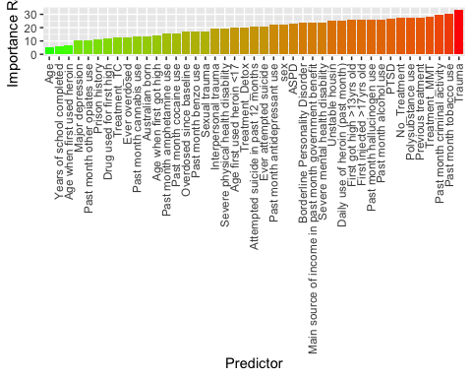

### HU_5YR

#### Performance

|  |  |  |
| --- | --- | --- |
| .metric | .estimator | .estimate |
| accuracy | binary | 0.8264463 |
| sens | binary | 0.8333333 |
| spec | binary | 0.8187135 |
| f_meas | binary | 0.8355091 |

#### Feature Importance

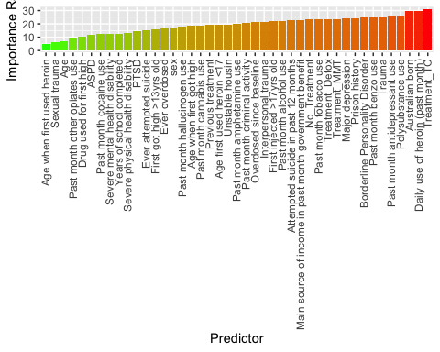

### HU_10YR

#### Performance

|  |  |  |
| --- | --- | --- |
| .metric | .estimator | .estimate |
| accuracy | binary | 0.8489583 |
| sens | binary | 0.9408602 |
| spec | binary | 0.7626263 |
| f_meas | binary | 0.8578431 |

#### Feature Importance

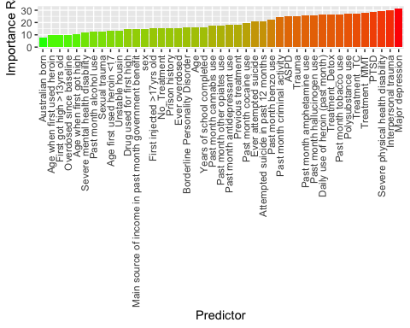

## Remission

### STA_1YR

#### Performance

|  |  |  |
| --- | --- | --- |
| .metric | .estimator | .estimate |
| accuracy | binary | 0.8695652 |
| sens | binary | 0.8952381 |
| spec | binary | 0.8431373 |
| f_meas | binary | 0.8744186 |

#### Feature Importance

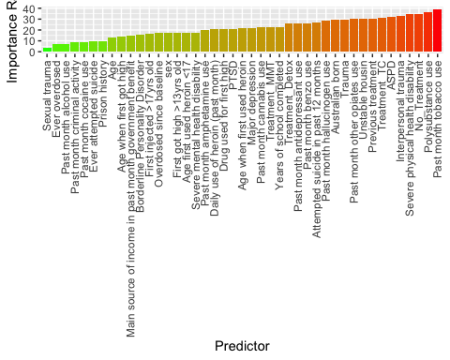

### STA_5YR

#### Performance

|  |  |  |
| --- | --- | --- |
| .metric | .estimator | .estimate |
| accuracy | binary | 0.9055556 |
| sens | binary | 0.9007092 |
| spec | binary | 0.9108527 |
| f_meas | binary | 0.9087657 |

#### Feature Importance

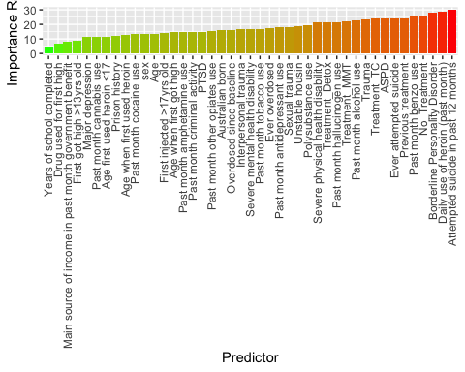

### MTA_5YR

#### Performance

|  |  |  |
| --- | --- | --- |
| .metric | .estimator | .estimate |
| accuracy | binary | 0.7530864 |
| sens | binary | 0.8275862 |
| spec | binary | 0.6666667 |
| f_meas | binary | 0.7826087 |

#### Feature Importance

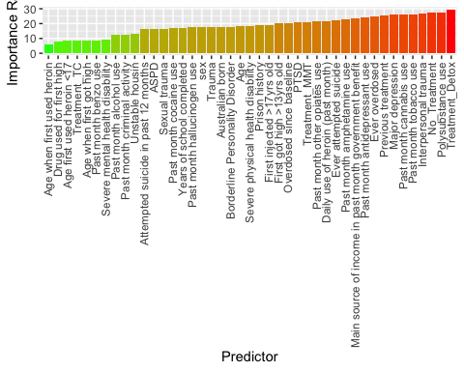

### STA_10YR

#### Performance

|  |  |  |
| --- | --- | --- |
| .metric | .estimator | .estimate |
| accuracy | binary | 0.8827839 |
| sens | binary | 0.9473684 |
| spec | binary | 0.8122605 |
| f_meas | binary | 0.8940397 |

#### Feature Importance

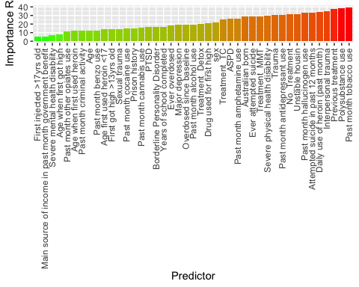

### MTA_10YR

#### Performance

|  |  |  |
| --- | --- | --- |
| .metric | .estimator | .estimate |
| accuracy | binary | 0.8209877 |
| sens | binary | 0.9806202 |
| spec | binary | 0.6403509 |
| f_meas | binary | 0.8532884 |

#### Feature Importance

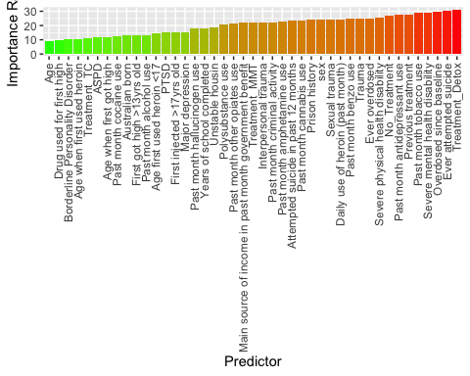

### LTA_10yr

#### Performance

|  |  |  |
| --- | --- | --- |
| .metric | .estimator | .estimate |
| accuracy | binary | 0.7493540 |
| sens | binary | 0.7795699 |
| spec | binary | 0.7213930 |
| f_meas | binary | 0.7493540 |

#### Feature Importance

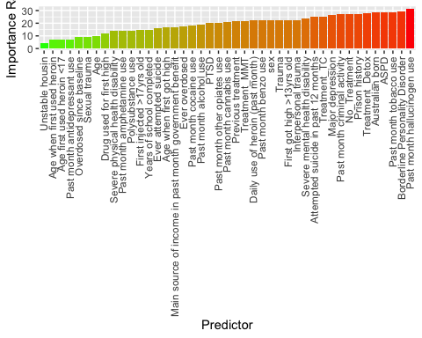

## OD

### OD_1YR

#### Performance

|  |  |  |
| --- | --- | --- |
| .metric | .estimator | .estimate |
| accuracy | binary | 0.9125683 |
| sens | binary | 0.8736842 |
| spec | binary | 0.9545455 |
| f_meas | binary | 0.9120879 |

#### Feature Importance

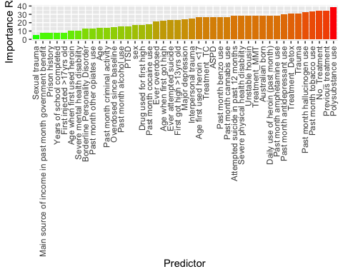

### OD_5YR

#### Performance

|  |  |  |
| --- | --- | --- |
| .metric | .estimator | .estimate |
| accuracy | binary | 0.8633094 |
| sens | binary | 0.8497653 |
| spec | binary | 0.8774510 |
| f_meas | binary | 0.8639618 |

#### Feature Importance

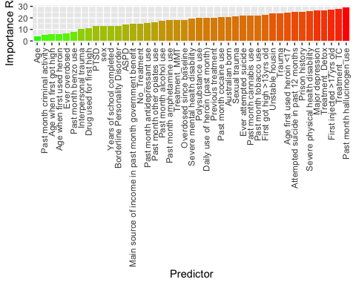

### OD_10YR

#### Performance

|  |  |  |
| --- | --- | --- |
| .metric | .estimator | .estimate |
| accuracy | binary | 0.7619048 |
| sens | binary | 0.7777778 |
| spec | binary | 0.7460317 |
| f_meas | binary | 0.7656250 |

#### Feature Importance

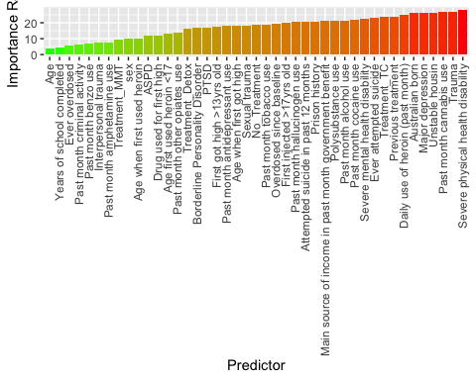

## Mortality

### DEATH_10YR

#### Performance

|  |  |  |
| --- | --- | --- |
| .metric | .estimator | .estimate |
| accuracy | binary | 0.8493827 |
| sens | binary | 0.8733850 |
| spec | binary | 0.8274232 |
| f_meas | binary | 0.8471178 |

#### Feature Importance

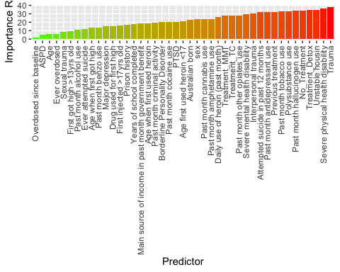

### DEATH_15YR

#### Performance

|  |  |  |
| --- | --- | --- |
| .metric | .estimator | .estimate |
| accuracy | binary | 0.8920765 |
| sens | binary | 0.8888889 |
| spec | binary | 0.8950131 |
| f_meas | binary | 0.8876245 |

#### Feature Importance

