**Foreeshop(App)**

**API’s Details**

**User Register API Detail :**

**URL :** https://demo.cogentecommerce.com/api/user_api.php?user=register

**Method :** POST

**Body/ from-data :** first_name, last_name, email, password, confirm_password, user_api_image, mobile_no, country, city, address

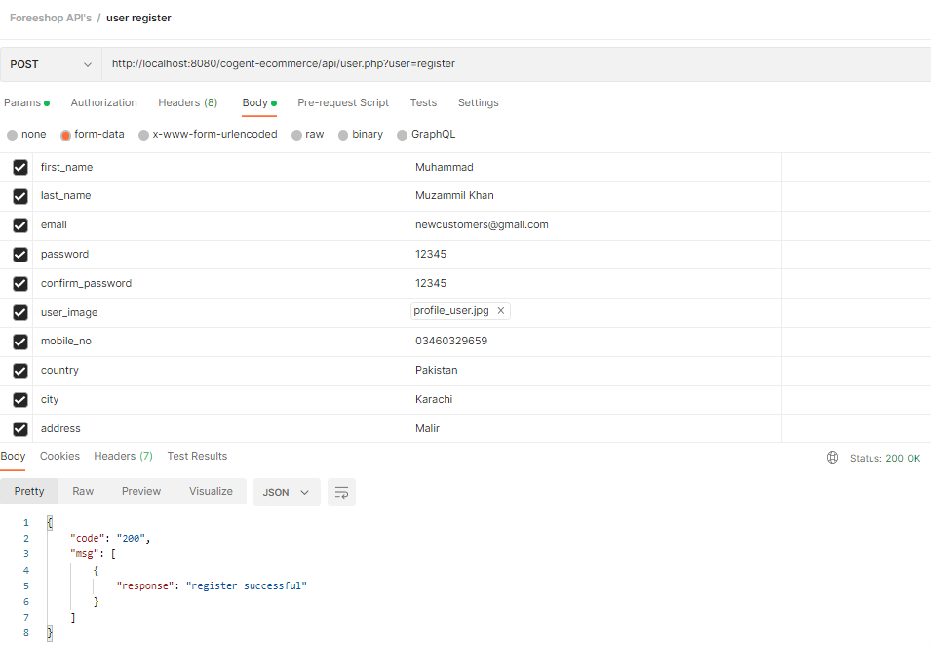

**User Login API Detail :**

**URL :** https://demo.cogentecommerce.com/api/user_api.php?user=login

**Method :** GET

**PARAMS :** email, password

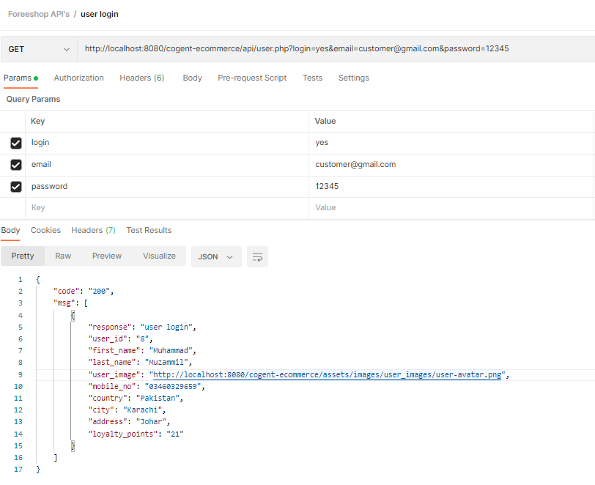

**User Change Password API Detail :**

**URL :** https://demo.cogentecommerce.com/api/user_api.php?user=change_password

**Method :**POST

**Body/ from-data :** user_api_id, current_password, new_password, confirm_password

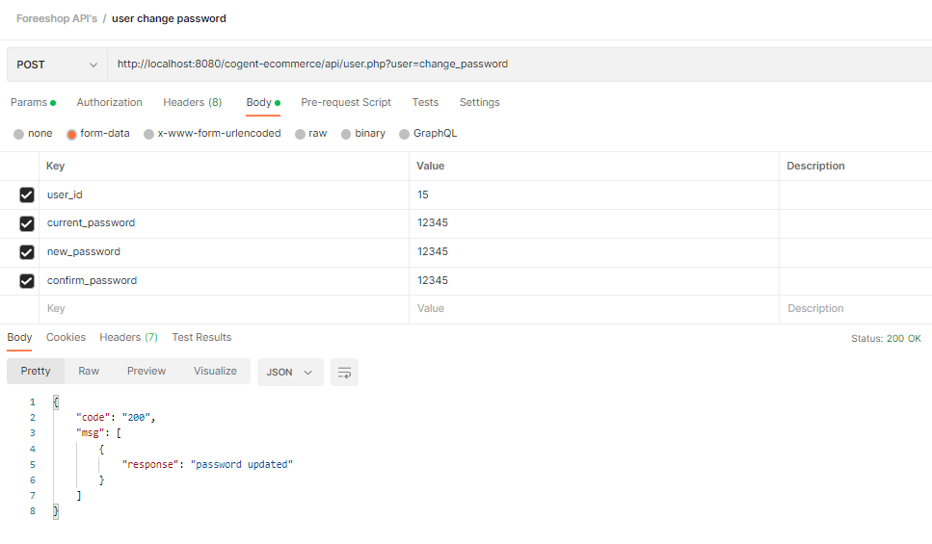

**User Forgot Password API Detail :**

**URL :** https://demo.cogentecommerce.com/api/user_api.php?user=forgot_password

**Method :**POST

**Body/ from-data :** email, new_password, confirm_password

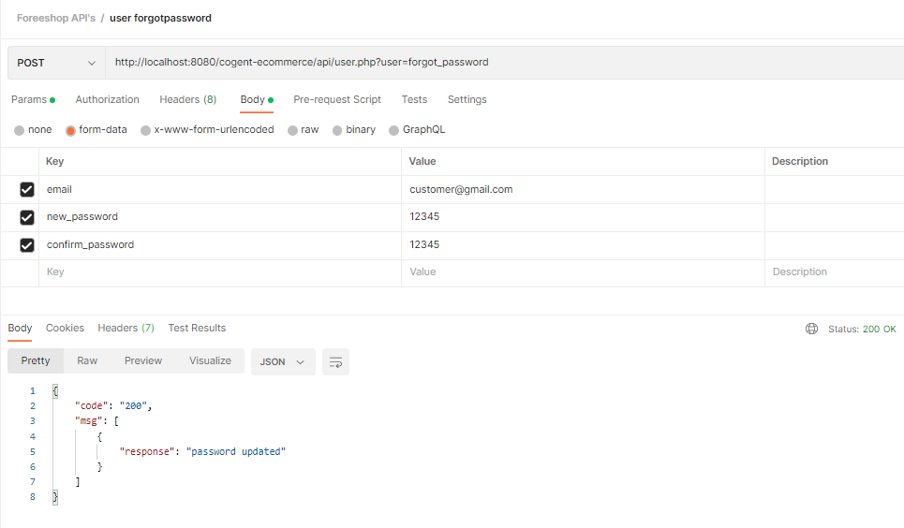

**User Update Profile API Detail :**

**URL :** https://demo.cogentecommerce.com/api/user_api.php?user=update-profile

**Method :** POST

**Body/ from-data :** user_id, first_name, last_name, email, user_image, mobile_no, country, city, address

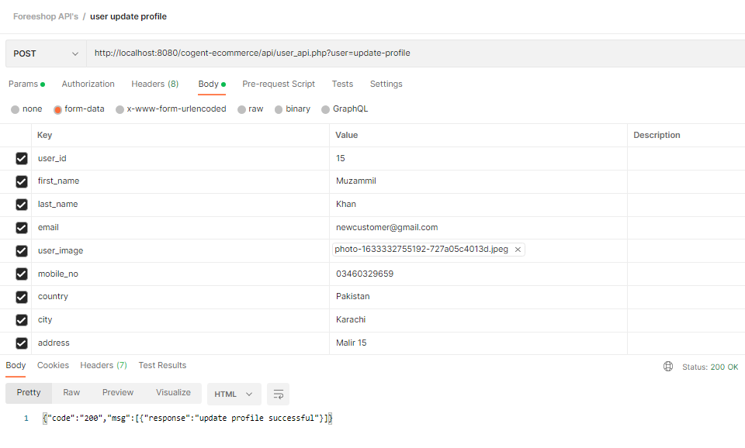

**View Country API Detail :**

**URL :** https://demo.cogentecommerce.com/api/view_data_api.php?view=country

**Method :** GET

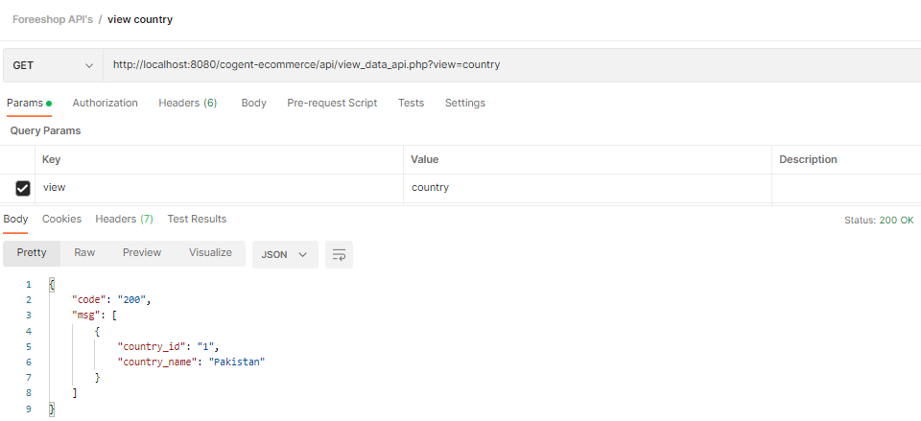

**View City API Detail :**

**URL :** https://demo.cogentecommerce.com/api/view_data_api.php?view=city

**Method :** GET

**PARAMS :** country_id

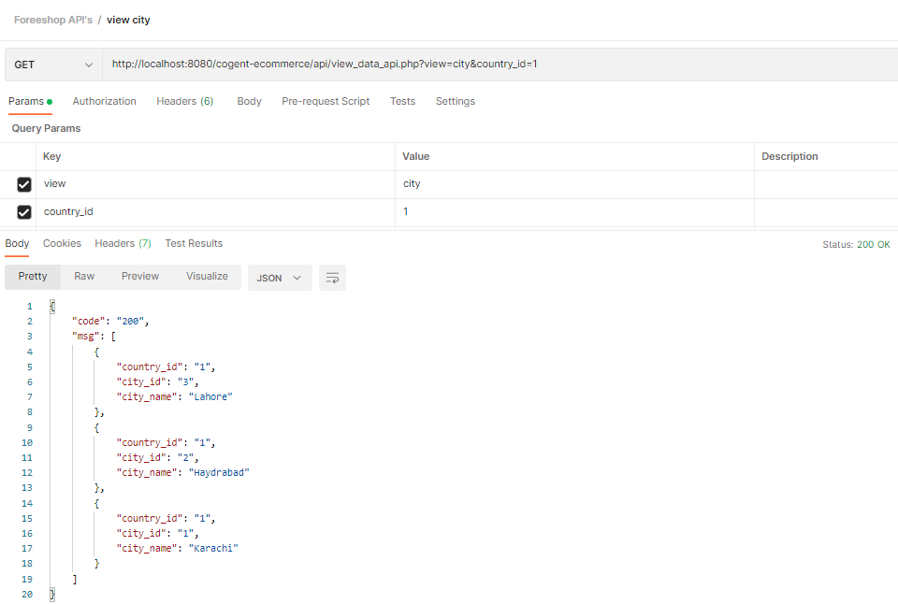

**View Category API Detail :**

**URL :** https://demo.cogentecommerce.com/api/view_data_api.php?view=catgeory

**Method :** GET

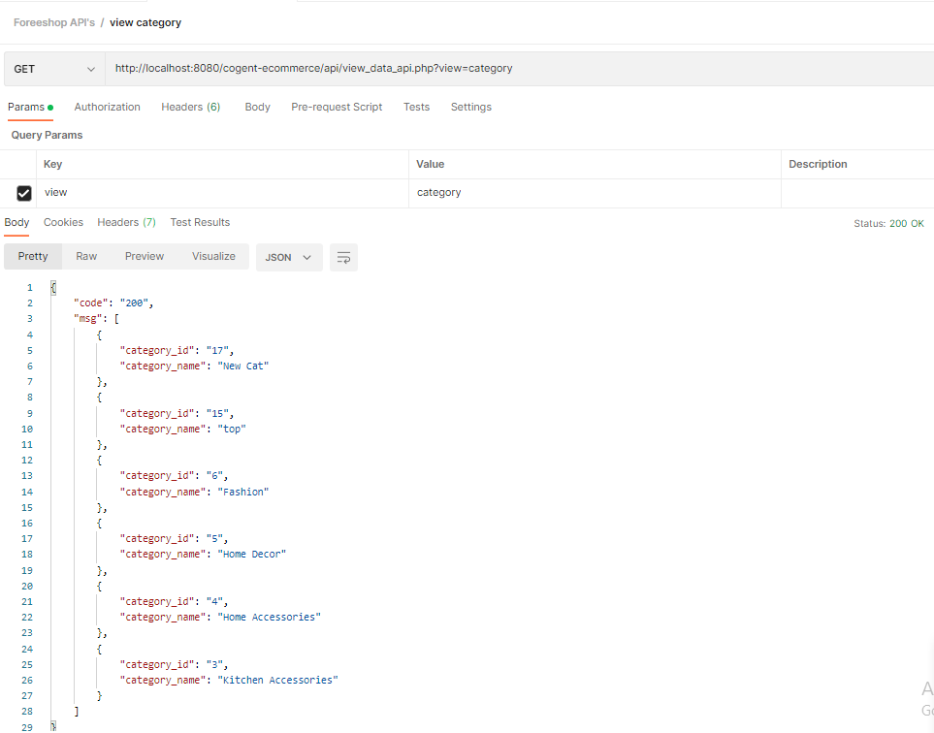

**View Sub-Category API Detail :**

**URL :** https://demo.cogentecommerce.com/api/view_data_api.php?view=sub-category

**Method :** GET

**PARAMS :** category_id

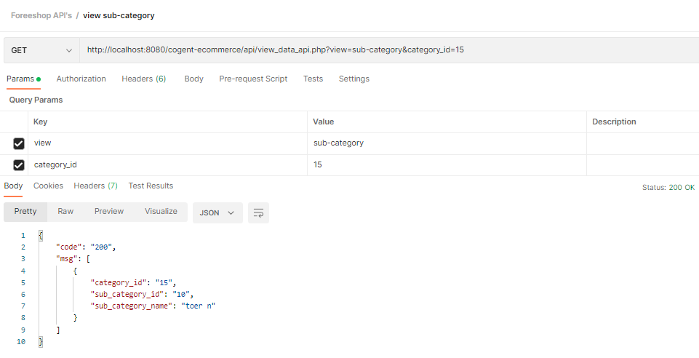

**View Sub-Sub-Category API Detail :**

**URL :** https://demo.cogentecommerce.com/api/view_data_api.php?view=sub-sub-category

**Method :** GET

**PARAMS :** category_id, sub_category_id

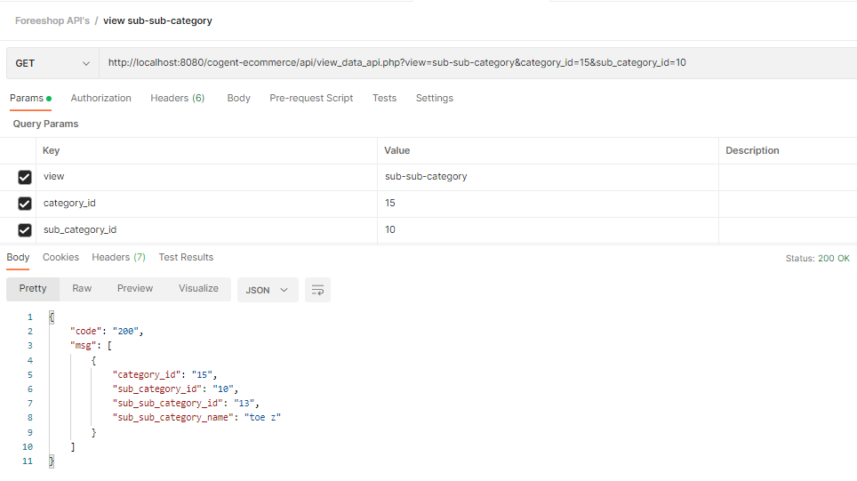

**View Brand API Detail :**

**URL :** https://demo.cogentecommerce.com/api/view_data_api.php?view=sub-sub-category

**Method :** GET

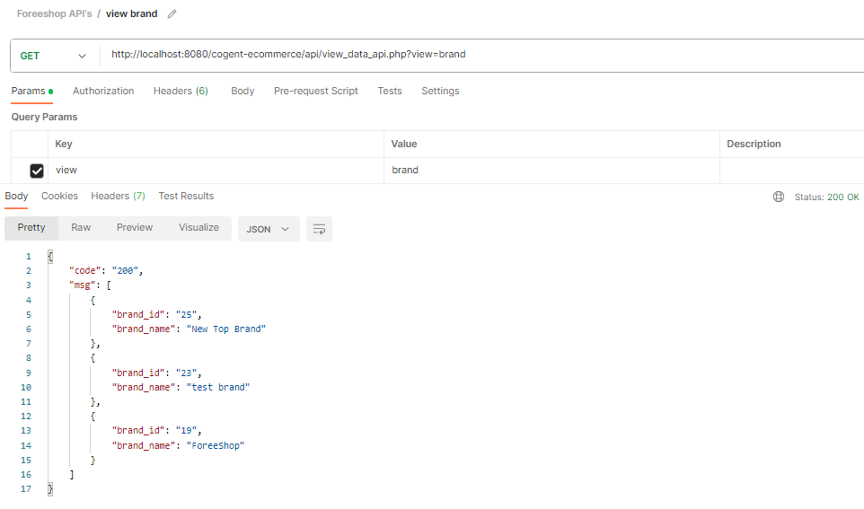

**View Products API Detail :**

**All Products URL :** https://demo.cogentecommerce.com/api/view_data_api.php?view=products&category_id=&sub_category_id=&sub_sub_category_id=&brand_id=

**With Category URL :** https://demo.cogentecommerce.com/api/view_data_api.php?view=products&category_id=**{category_id}**&sub_category_id=&sub_sub_category_id=&brand_id=

**With Category & Sub-Category URL :** https://demo.cogentecommerce.com/api/view_data_api.php?view=products&category_id=**{category_id}**&sub_category_id=**{sub_category_id}**&sub_sub_category_id=&brand_id=

**With Category & Sub-Category & Sub-Sub-Category URL :** https://demo.cogentecommerce.com/api/view_data_api.php?view=products&category_id=**{category_id}**&sub_category_id=**{sub_category_id}**&sub_sub_category_id=**{sub_sub_category_id}**&brand_id=

**With Category & Sub-Category & Sub-Sub-Category & Brand URL :** https://demo.cogentecommerce.com/api/view_data_api.php?view=products&category_id=**{category_id}**&sub_category_id=**{sub_category_id}**&sub_sub_category_id=**{sub_sub_category_id}**&brand_id=**{brand_id}**

**With Category & Sub-Category & Brand URL :** https://demo.cogentecommerce.com/api/view_data_api.php?view=products&category_id=**{category_id}**&sub_category_id=**{sub_category_id}**&sub_sub_category_id=&brand_id=**{brand_id}**

**With Category & Brand URL :** https://demo.cogentecommerce.com/api/view_data_api.php?view=products&category_id=**{category_id}**&sub_category_id=&sub_sub_category_id=&brand_id=**{brand_id}**

**With Brand URL :** https://demo.cogentecommerce.com/api/view_data_api.php?view=products&category_id=&sub_category_id=&sub_sub_category_id=&brand_id=**{brand_id}**

**Method :** GET

**PARAMS :** category_id, sub_category_id, sub_sub_category_id, brand_id

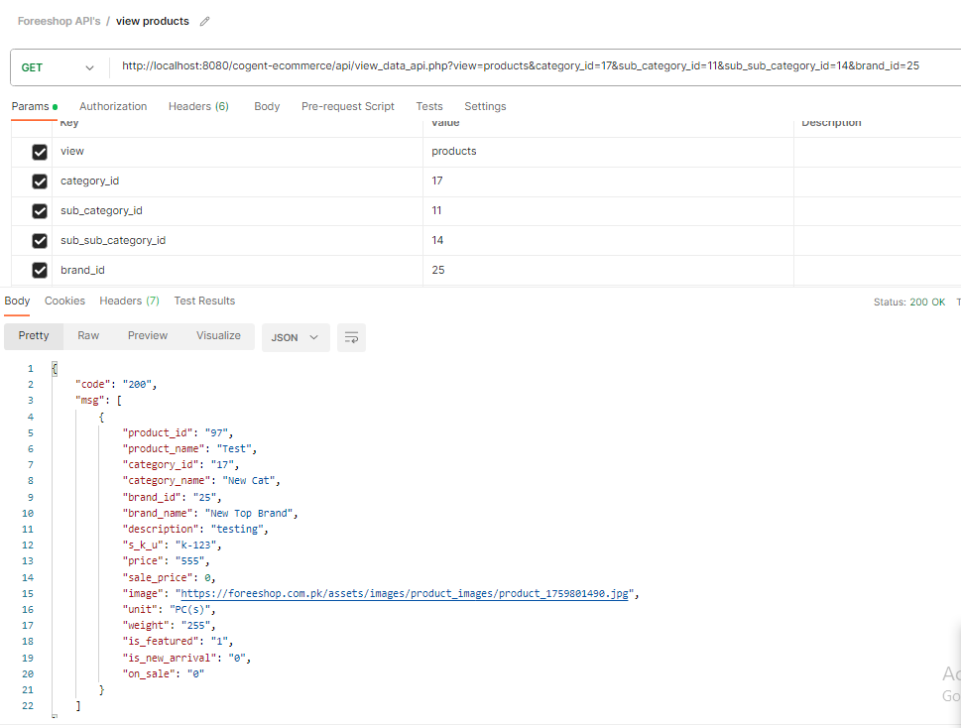

**View Single Product Detail API Detail :**

**URL :** https://demo.cogentecommerce.com/api/view_data_api.php?view=product-detail

**Method :** GET

**PARAMS :** product_id

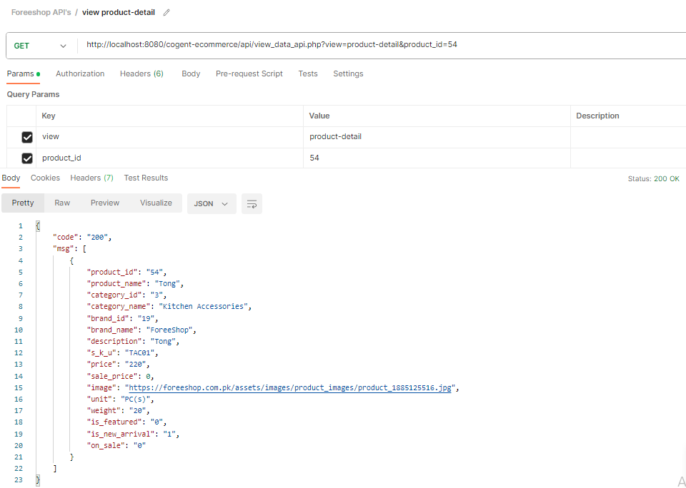

**View Search Products API Detail :**

**URL :** https://demo.cogentecommerce.com/api/view_data_api.php?view=product-search

**Method :** GET

**PARAMS :** key_word

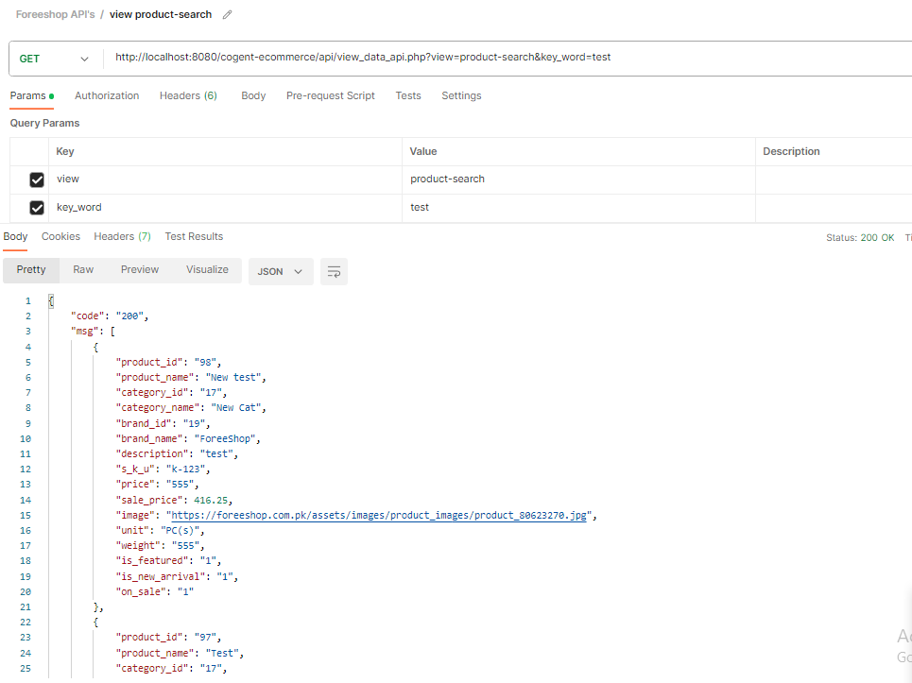

**Add To Cart API Detail :**

**URL :** https://demo.cogentecommerce.com/api/cart_api.php?cart=add-to-cart

**Method :** POST

**Body/ from-data :** user_id, product_id, size_id, color_id, product_image, product_name, quantity, price, weight

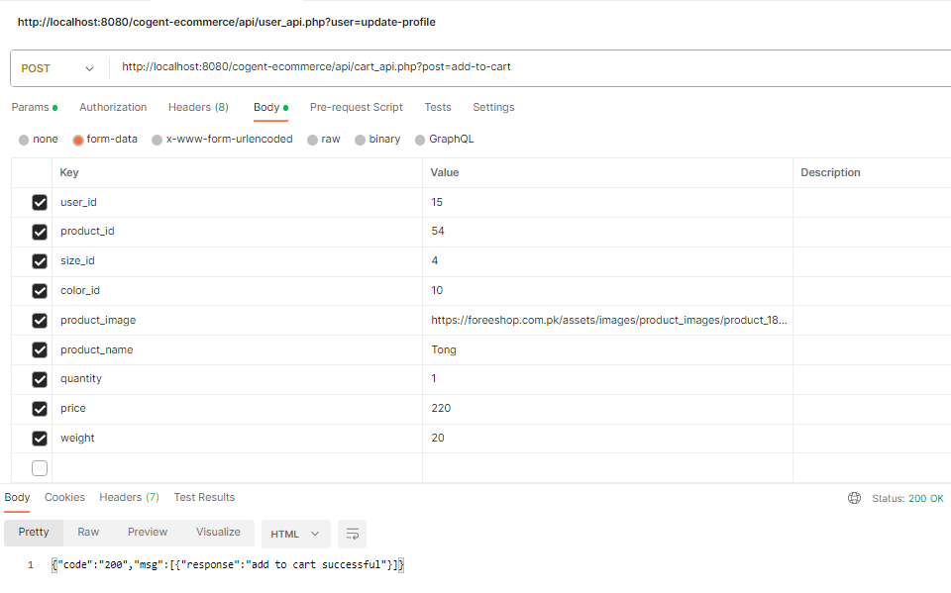

**View Cart Products API Detail :**

**URL :** https://demo.cogentecommerce.com/api/cart_api.php?cart=view-cart-products

**Method :** GET

**PARAMS :** user_id

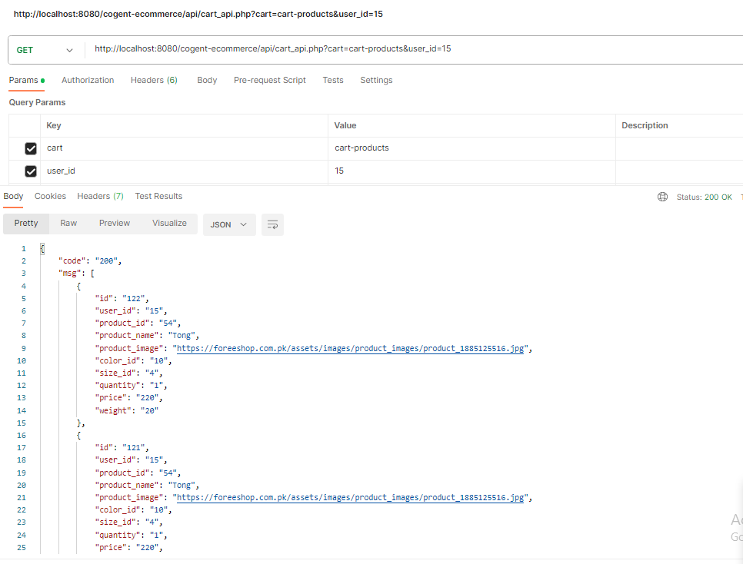

**Add Cart Product Quantity API Detail :**

**URL :** https://demo.cogentecommerce.com/api/cart_api.php?cart=add-quantity

**Method :** GET

**PARAMS :** id

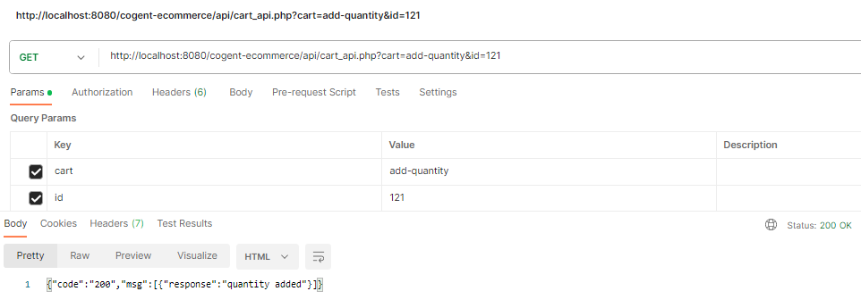

**Subtract Cart Product Quantity API Detail :**

**URL :** https://demo.cogentecommerce.com/api/cart_api.php?cart=sub-quantity

**Method :** GET

**PARAMS :** id

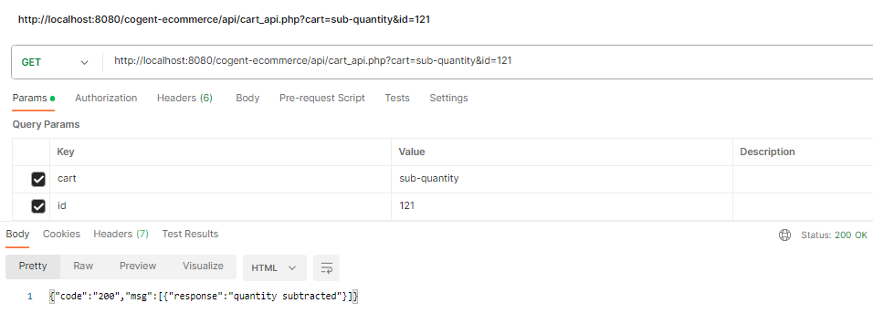

**Delete Cart Product API Detail :**

**URL :** https://demo.cogentecommerce.com/api/cart_api.php?cart=delete-cart-item

**Method :** GET

**PARAMS :** id

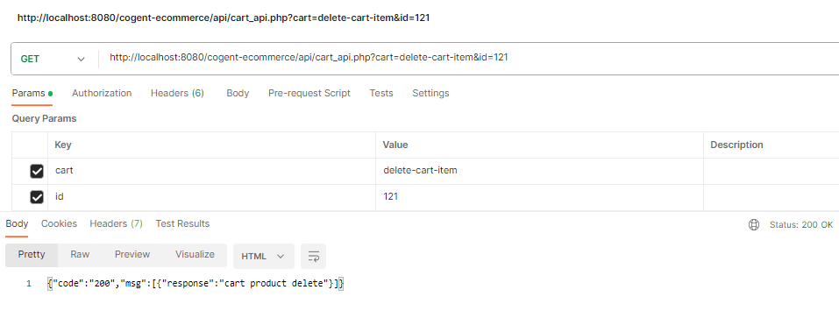

**Place Order API Detail :**

**URL :** https://demo.cogentecommerce.com/api/order_api.php?order=checkout

**Method :** POST

**Body/ from-data :** user_id, bfname, blname, bemail, bmobile, country_id, city_id, shipping_fee, baddress, u_ship_add, sfname, slname, semail, smobile, saddress, sdate, sub_total, GrandTotal, GrandWeight, ProductID[], SizeID[], ColorID[], Qyt[], SalePrice[], Total[], Weight[], TotalWeight[]

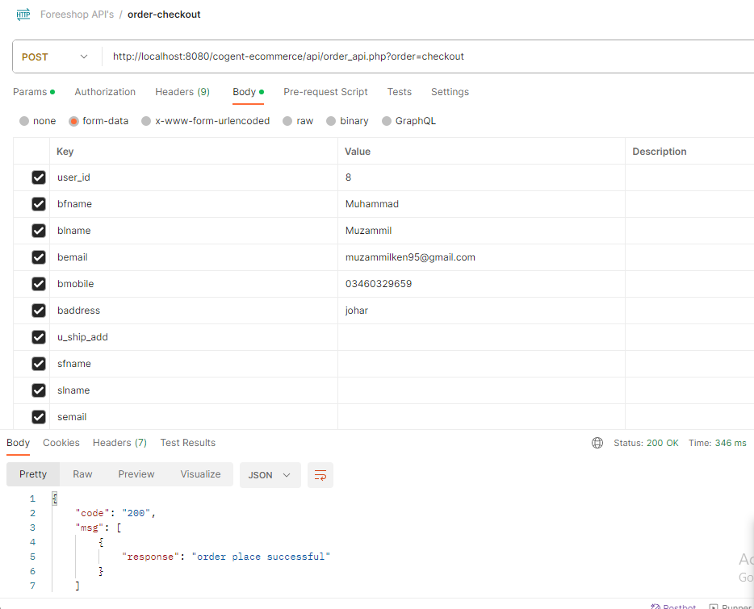

**View Orders API Detail :**

**URL :** https://demo.cogentecommerce.com/api/order_api.php?order=view-orders

**Method :** GET

**PARAMS :** user_id

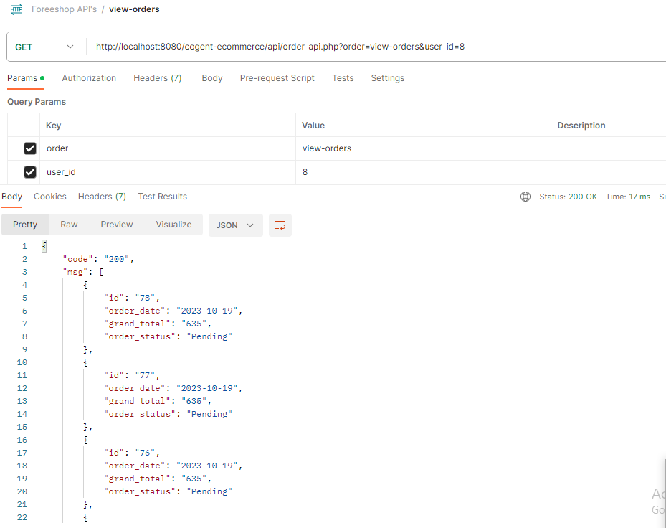

**View Order Details API Detail :**

**URL :** https://demo.cogentecommerce.com/api/order_api.php?order=view-order-detail

**Method :** GET

**PARAMS :** order_id

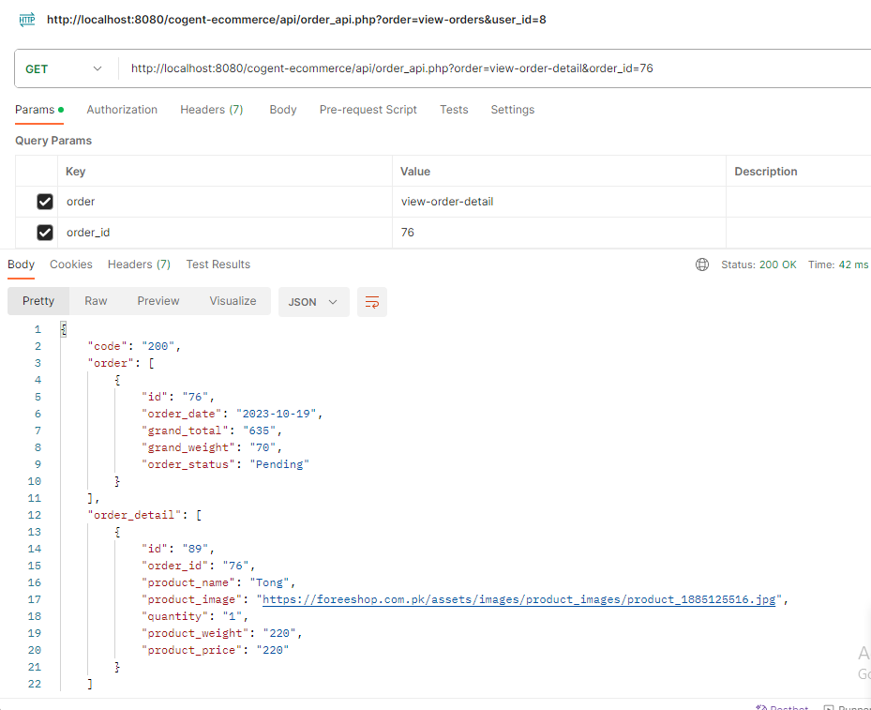

**View Product Color List API Detail :**

**URL :** https://demo.cogentecommerce.com/api/view_data_api.php?view=product-colors

**Method :** GET

**PARAMS :** product_id

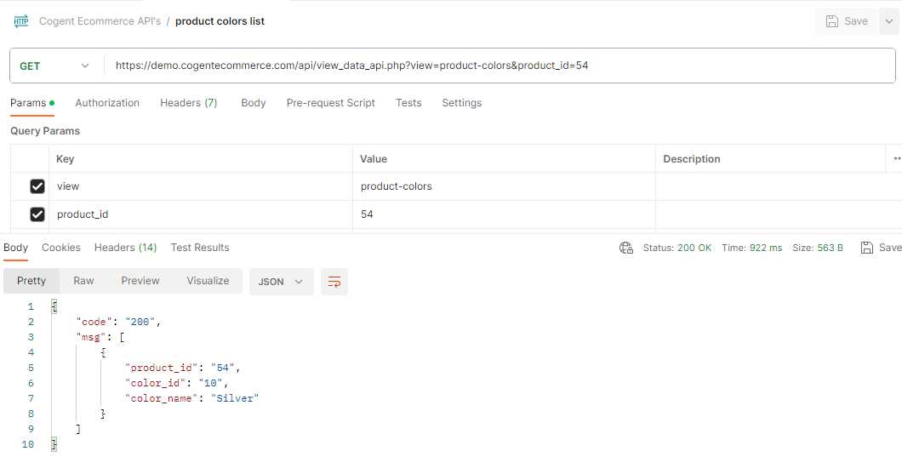

**View Product Size List API Detail :**

**URL :** https://demo.cogentecommerce.com/api/view_data_api.php?view=prodcut-sizes

**Method :** GET

**PARAMS :** product_id

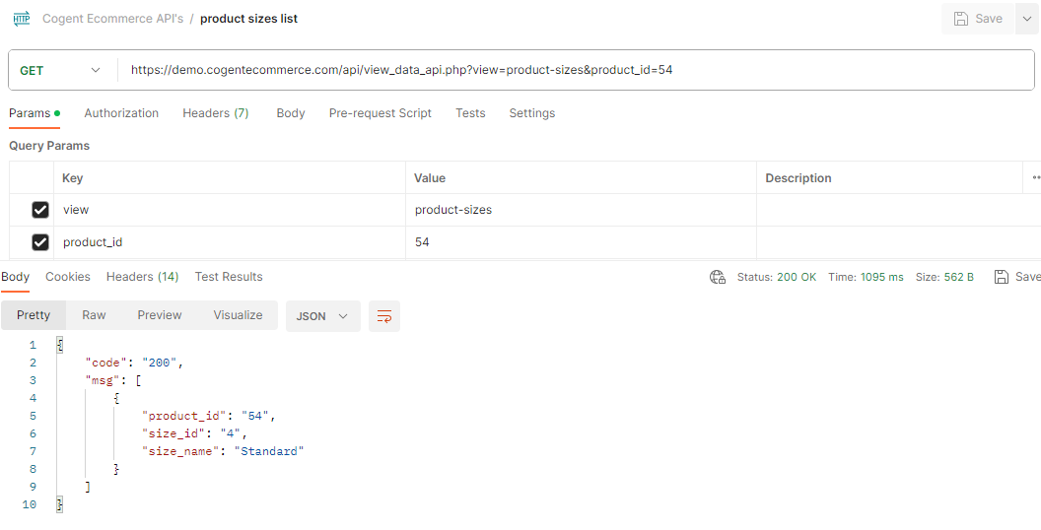

**View Product Stock and Price Detail :**

**URL :** https://demo.cogentecommerce.com/api/view_data_api.php?view=product-stock-price

**Method :** GET

**PARAMS :** product_id, color_id, size,id

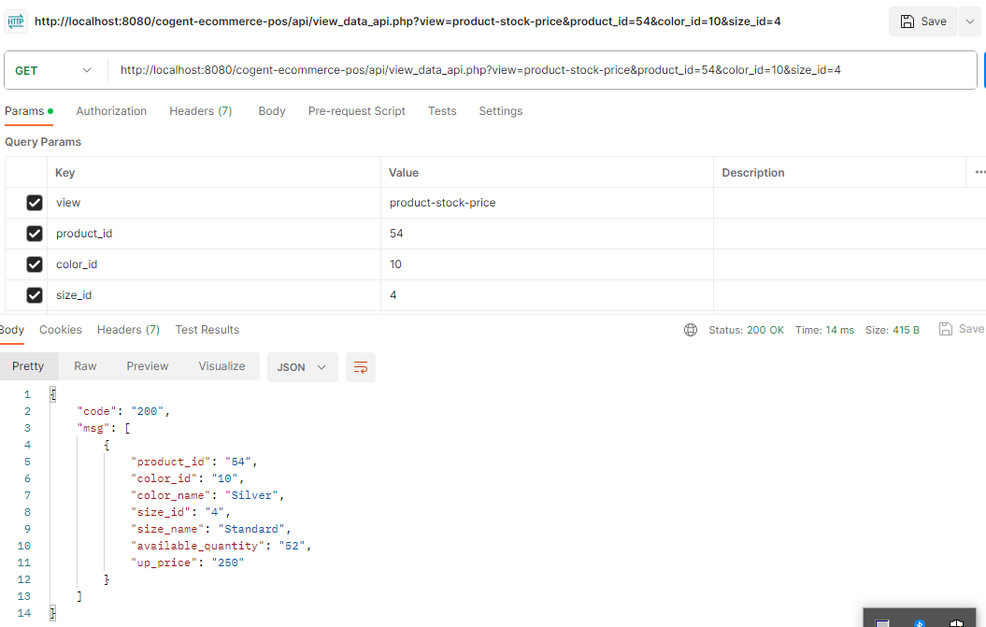

**Get Shipping Fee API Detail :**

**URL :** https://demo.cogentecommerce.com/api/view_data_api.php?view=get-shipping-fee

**Method :** GET

**PARAMS :** country_id, city_id, total_weight, sub_total_amount

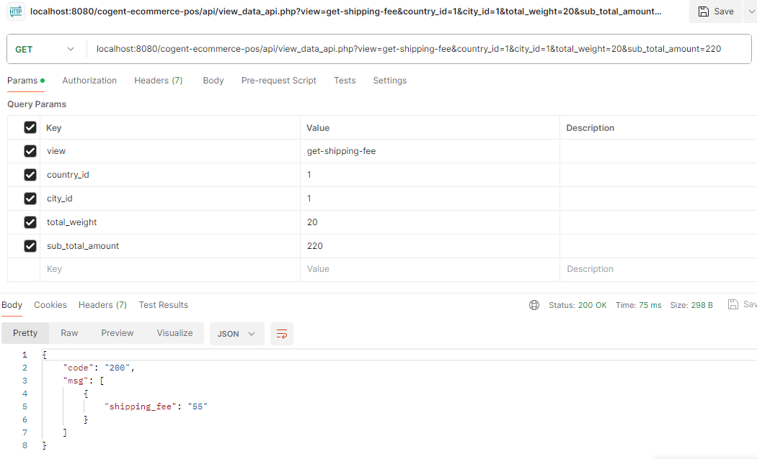

**About API Detail :**

**URL :** https://demo.cogentecommerce.com/api/view_data_api.php?view=about

**Method :** GET

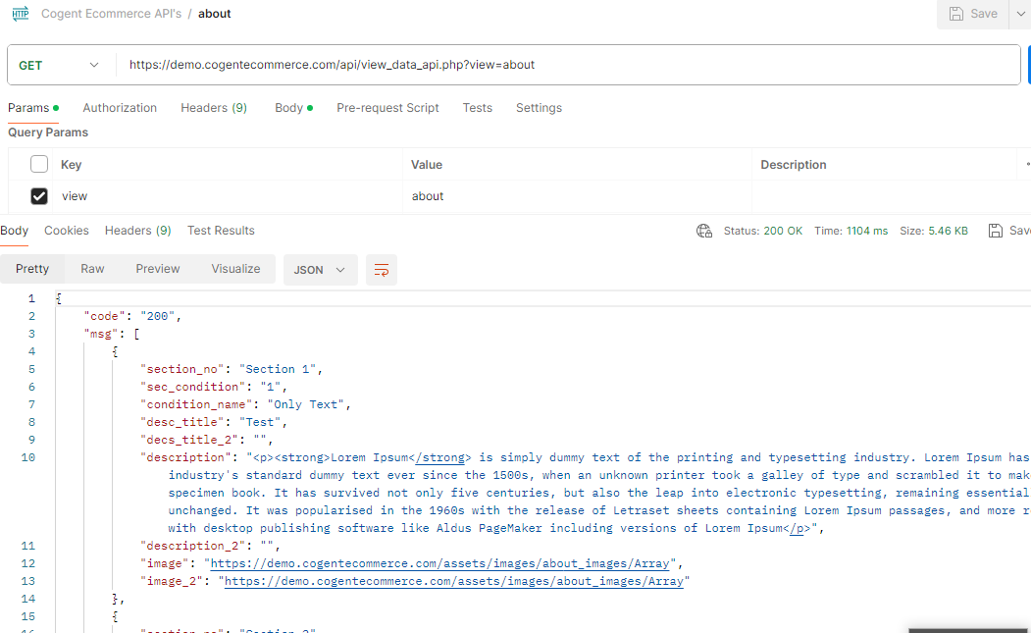

**Contact API Detail :**

**URL :** https://demo.cogentecommerce.com/api/contact_mail_api.php?contact=post

**Method :** POST

**Body/ from-data :** full_name, email, subject, message

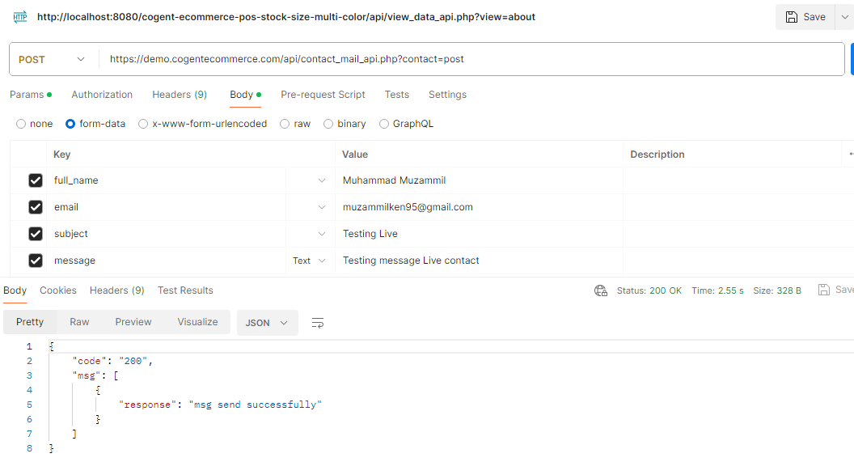

**View Deals API Detail :**

**URL :** https://demo.cogentecommerce.com/api/view_data_api.php?view=deals

**Method :** GET

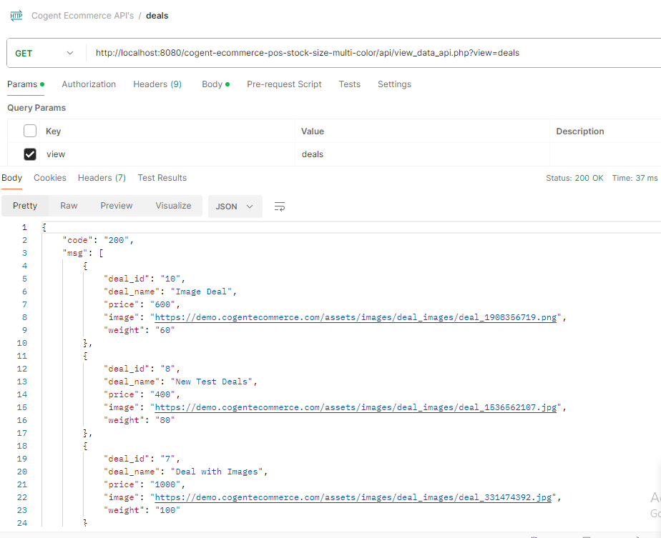

**View Single Deal Detail API Detail :**

**URL :** https://demo.cogentecommerce.com/api/view_data_api.php?view=deal-detail

**Method :** GET

**PARAMS :** deal_id

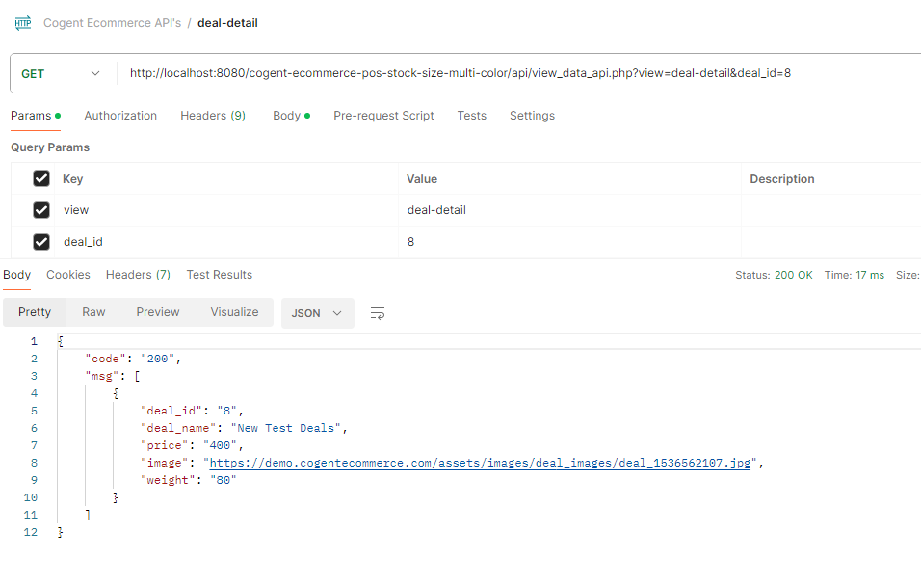

**Add To Cart Deal API Detail :**

**URL :** https://demo.cogentecommerce.com/api/cart_api.php?cart=add-to-cart-deal

**Method :** POST

**Body/ from-data :** user_id, deal_id, deal_image, deal_name, quantity, price, weight

