**DIGITAL SIGNAL PROCESSING LAB**

**(EL-302)**

**LABORATORY MANUAL**

**ENGR. Muhammad Ibrar Khan**

**QUICK REVIEW-SIGNAL & SYSTEMS(MATLAB)**

**(LAB # 01)**

Student Name: _____________Kamran_________________________________

Roll No: _____i140420___________ Section: __B__

Date performed: __21/1___________, 2019



____________________________________________________________________________________________________________________________________________________________

**NATIONAL UNIVERSITY OF COMPUTER AND EMERGING SCIENCES, ISLAMABAD**

Prepared by:

Last Edited by:

Verified by:

Engr. Muhammad Asim

Engr. Muhammad Asim, Jan 12, 2016

Dr. Shahzad Saleem

Updated: Spring 2016

|  |  |  |  |  |  |
| --- | --- | --- | --- | --- | --- |
| DSP - Lab | National University | Roll No: __________ | Lab# | **01** |  |
|  | of Computer and Emerging Sciences |  |  |
|  |  |  |  |  |
| (EL302) | Islamabad | Spring 2019 |  |  |  |

_____________________________________________________________________________________

**Lab # 01: QUICK REVIEW-SIGNAL & SYSTEMS(MATLAB)**

Digital signal processing is concerned with the digital representation of signals and use of digital processors to analyze, modify or extract information from signals. Most signals in nature are analog. Analog signals are varying with time, and represent the variations of physical quantities such as sound waves. The signals used in most popular forms of DSP are derived from analog signals which have been sampled at regular intervals and converted into digital form. The specific mean for processing a digital signal may be, for example, to remove interference of noise from the signal, to obtain the spectrum of the data or to transform the signal from the signal in to more suitable form. DSP is now used in many areas where analog methods were previously used and in entirely new applications which were difficult with analog methods. Basic building block of digital signal processing is shown in

**MATLAB Review:**

MATLAB is a powerful high-level programming language for scientific computations. It is very easy to learn and use in solving numerically complex engineering problems.

MATLAB consists of functions that are either built into the interpreter or available as M-files,

with each containing a sequence of program statements that execute a certain algorithm. A completely new algorithm can be written as a program containing only a few of these functions and can be saved as another M-file.

MATLAB works with three types of windows on your computer screen. These are the Command window, the Figure window and the Editor window. The Command window has the heading Command, the Figure window has the heading Figure No. 1, and the Editor window has the heading showing the name of an opened existing M-file or Untitled if it is a new M-file under construction. The Command window also shows the prompt >> indicating it is ready to execute MATLAB commands. Results of most printing commands are displayed in the Command window. This window can also be used to run small programs and saved M-files. All plots generated by the plotting commands appear in a Figure window.

Either new M-files or old M-files are run from the Command window. Existing M-files can also be run from the Command window by typing the name of the file. In addition to these windows there are also workspace and history windows. Workspace

**Basic Commands and Functions in Matlab:**

1. To add comment, use "%" symbol.
2. Help is provided by typing “help” or if you know the topic then “help function_name”.
3. If you don't know the exact name of the topic or command you are looking for, type "lookfor keyword" (e.g., "lookfor regression")
4. Three dots “...” are used to continue a statement to next line (row).
5. If after a statement “;” is entered then MATLAB will not display the result of the statement entered otherwise result would be displayed.
6. Use the up-arrow to recall commands without retyping them (and down arrow to

_____________________________________________________________________________________________

Page 3 of 12

|  |  |  |  |  |  |
| --- | --- | --- | --- | --- | --- |
| DSP - Lab | National University | Roll No: __________ | Lab# | **01** |  |
|  | of Computer and Emerging Sciences |  |  |
|  |  |  |  |  |
| (EL302) | Islamabad | Spring 2019 |  |  |  |

_____________________________________________________________________________________

|  |  |  |
| --- | --- | --- |
|  | go forward in commands). |  |
| vii. | MATLAB is case sensitive so “taxila” is not same as “TAXILA” | |
| viii. | Defining Column vector | v = [1;2;3] |
| ix. | Defining a row vector | w = [1 0 1] |
| x. | Transpose a vector | W = w‟ |
| xi. | Defining a range for a vector | X = 1:.5:5 |
| xii. | Empty vector | Y = [] |
| xiii. | Defining a matrix | M = [1 2 3; 3 2 1] |
| xiv. | Zero matrix M = zeros(2,3) % 1st parameter is row, 2nd parameter is col. | |
| xv. | Ones matrix | m = ones(2,3) |
| xvi. | The identity matrix | I = eye(3) |
| xvii. | Define a random matrix or vector | R = rand(1,3) |
| xviii. | Access a vector or matrix R(3) ans =0.6068 or R(1,2) ans =0.2311 | |

1. Access a row or column of matrix

I(2,:) %2nd row

I(:,2) %2nd col

I(1:2,1:2)

xx.

xxi.

Size and Length size(I) , length(I)

Already defined variable by a user who

1. MATLAB utilizes the following arithmetic operatops;
   * Addition

* Subtraction
* Multiplication
* Division

./ , .* Point by Point Mult. & Div.

* Power Operator
* Transpose

xxiii. To control the flow of commands, the makers of MATLAB supplied four devices a programmer can use while writing his/her computer code

_____________________________________________________________________________________________

Page 4 of 12

|  |  |  |  |  |  |
| --- | --- | --- | --- | --- | --- |
| DSP - Lab | National University | Roll No: __________ | Lab# | **01** |  |
|  | of Computer and Emerging Sciences |  |  |
|  |  |  |  |  |
| (EL302) | Islamabad | Spring 2019 |  |  |  |

_____________________________________________________________________________________

* the **while** loops
* the **for** loops
* the **if**-**else**-**end** constructions
* the **switch**-**case** constructions

**Syntax of the for loop is**

**for k = array**

**commands**

**end**

The commands between the **for** and **end** statements are executed for all values stored in

the **array.** The **for** loops can be nested

**Syntax of the while loop is**

**while expression statements**

**end**

This loop is used when the programmer does not know the number of repetitions a priori.

**Syntax of the construction is**

**if expression1**

**commands (evaluated if expression 1 is true)**

**elseif expression 2**

**commands (evaluated if expression 2 is true) elseif**

**…**

**...**

**else**

**commands (executed if all previous expressions evaluate to false)**

**end**

**Syntax of the switch-case construction is**

**switch expression (scalar or string)**

**case value1 (executes if expression evaluates to value1)**

**commands**

_____________________________________________________________________________________________

Page 5 of 12

|  |  |  |  |  |  |
| --- | --- | --- | --- | --- | --- |
| DSP - Lab | National University | Roll No: __________ | Lab# | **01** |  |
|  | of Computer and Emerging Sciences |  |  |
|  |  |  |  |  |
| (EL302) | Islamabad | Spring 2019 |  |  |  |

_____________________________________________________________________________________

**case value2 (executes if expression evaluates to value2)**

**commands**

**...**

**otherwise**

**statements**

**end**

**Note: use of the curly braces after the word case. This creates the so called *cell array* rather than the one-dimensional array, which requires use of the square brackets.**

xxiv. Some built in functions in MATLAB

abs magnitude of a number (absolute value for real

numbers)

angle angle of a complex number, in radians

b)

cos

sin

exp

log

round

sum

mean

std

max

min

cosine function, assumes argument is in radians

sine function, assumes argument is in radians

exponential function

logrithmic function, operates on each point of a column

round off the decimal numbers

calculates the sum of a vector

calculates mean of the vector

calculates standard deviation of the vector

finds the maximum value in a vector

finds the minimum value in a vector

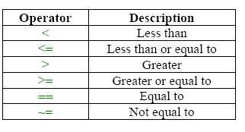

**Creating functions using m-files**

_____________________________________________________________________________________________

Page 6 of 12

|  |  |  |  |  |  |
| --- | --- | --- | --- | --- | --- |
| DSP - Lab | National University | Roll No: __________ | Lab# | **01** |  |
|  | of Computer and Emerging Sciences |  |  |
|  |  |  |  |  |
| (EL302) | Islamabad | Spring 2019 |  |  |  |

_____________________________________________________________________________________

There are two kinds of m-files: the *script files* and the *function files*. Script files do not take the input arguments or return the output arguments. The function files may take input arguments or return output arguments. To make the m-file click on File next select New and click on M-File from the pull-down menu. You will be presented with the MATLAB Editor/Debugger screen. Here you will type your code, can make changes, etc. Once you are done with typing, click on File, in the MATLAB Editor/Debugger screen and select Save As… . Chose a name for your file, e.g., firstgraph.m and click on Save. Make sure that your file is saved in the directory that is in MATLAB's search path. If you have at least two files with duplicated names, then the one that occurs first in MATLAB's search path will be executed.

To open the m-file from within the Command Window type edit filename and then press Enter or Return key.

Here is an example of a function file

function [b, j] = descsort(a)

This function call be called from command line as

descsort(X)

**Plots in Time and Frequency Domain**

* Type help to see the function of following commands

plot , stem , stair , xlabel , ylabel , title , axis , figure , subplot , legend

* Following are the commands for frequency domain poltting

freqz „finds the DTFT from the transfer function z-domain‟ pzmap „plots poles and zeros of transfer function on x and y axis‟

zpalne „plots poles and zeros of transfer function on zplane‟

**Basic Sequence Generation**

1. **Unit Sample Sequence**

The unit sample is defined by

function [x,n] = imseq(n0,n1,n2) n = [n1:n2]; x = [(n-n0) == 0];

1. **Unit Step Sequence**



The unit step, denoted by u(n), is defined by

_____________________________________________________________________________________________

Page 7 of 12

|  |  |  |  |  |  |
| --- | --- | --- | --- | --- | --- |
| DSP - Lab | National University | Roll No: __________ | Lab# | **01** |  |
|  | of Computer and Emerging Sciences |  |  |
|  |  |  |  |  |
| (EL302) | Islamabad | Spring 2019 |  |  |  |

_____________________________________________________________________________________



function [x,n] = stepseq(n0,n1,n2)

n = [n1: n2]; x = [(n-n0) >= 0];

1. **Exponential Sequence**

An *exponential* sequence is defined by

n = [0:10]; x = (0.9).^n

1. **Complex Exponential Sequence**

A complex *exponential* sequence is defined by

n = [0:10]; x = exp((2+3j)*n)

1. **Sinusoidal Sequence**

A sinusoid sequence is defined by



n = [0:10]; x = 3*cos(0.1*pi*n+pi/3) ;

**Basic Operations on Sequences**

1. **Signal addition**

It is implemented in MATLAB by the arithmetic operator “+”. However the lengths of x1(n) and x2(n) must be the same. We can use the following function for addition function [y,n] = sigadd(x1,n1,x2,n2)

_____________________________________________________________________________________________

Page 8 of 12

|  |  |  |  |  |  |
| --- | --- | --- | --- | --- | --- |
| DSP - Lab | National University | Roll No: __________ | Lab# | **01** |  |
|  | of Computer and Emerging Sciences |  |  |
|  |  |  |  |  |
| (EL302) | Islamabad | Spring 2019 |  |  |  |

_____________________________________________________________________________________

% y(n) = x1(n) + x2(n)

n = min(min(n1),min(n2)):max(max(n1),max(n2)); y1 = zeros(1,length(n)); y2 = y1; y1(find((n>=min(n1))&(n<=max(n1))==1))=x1; y2(find((n>=min(n2))&(n<=max(n2))==1))=x2; y = y1 + y2;

1. **Signal multiplication**

It is implemented in MATLAB by the array operator “.*”. To multiply sequences of different lengths we can use the following function

function [y,n] = sigmult(x1,n1,x2,n2) % y(n) = x1(n) * x2(n)

n = min(min(n1),min(n2)):max(max(n1),max(n2)); y1 = zeros(1,length(n)); y2 = y1; y1(find((n>=min(n1))&(n<=max(n1))==1))=x1; y2(find((n>=min(n2))&(n<=max(n2))==1))=x2; y = y1 .* y2;

1. **Shifting**

In this operation each sample of x(n) is shifted by an amount k to obtain a shifted sequence y(n)

Y(n) = {x(n-k)}

If we let m=n-k, then n=m+k and the above operation is given by Y(m+k) = {x(m)}

For this we can use the following function function [y,n] = sigshift(x,m,n0)

% y(n) = x(n-n0) n = m+n0; y = x;

1. **Folding**

_____________________________________________________________________________________________

Page 9 of 12

|  |  |  |  |  |  |
| --- | --- | --- | --- | --- | --- |
| DSP - Lab | National University | Roll No: __________ | Lab# | **01** |  |
|  | of Computer and Emerging Sciences |  |  |
|  |  |  |  |  |
| (EL302) | Islamabad | Spring 2019 |  |  |  |

_____________________________________________________________________________________

In this operation each sample of x(n) is fipped around n=0 to obtain a folded sequence y(n) Y(n) = {x(-n)}

For this the following function is shown function [y,n] = sigfold(x,n)

% y(n) = x(-n)

y = fliplr(x); n= -fliplr(n);

**Sequence Generation from Continuous Time Signals (Sampling)**

In [signal processing,](https://en.wikipedia.org/wiki/Signal_processing) sampling is the reduction of a [continuous signal](https://en.wikipedia.org/wiki/Continuous_signal) to a [discrete signal.](https://en.wikipedia.org/wiki/Discrete_signal) A common example is the conversion of a [sound wave](https://en.wikipedia.org/wiki/Sound_wave) (a continuous signal) to a sequence of samples (a discrete-time signal). A sample is a value or set of values at a point in time and/or space. A sampler is a subsystem or operation that extracts samples from a [continuous signal.](https://en.wikipedia.org/wiki/Continuous_signal)

clc, clear;

F=4000; Dt=0.01; f=1000/F; %Hz

t=0:Dt:12; % sec

y_t = sin(2*pi*f*t);

%% Oversampling

%y_n=y_t(1:1/((2*f/Fs)*Dt):end);

fs=4*f;Ts1=1/fs;

n1=t(1)/Ts1:1:t(end)/Ts1;

y_n1=sin(2*pi*f*n1*Ts1);

* Under sampling fs=1.5*f;Ts2=1/fs; n2=t(1)/Ts2:1:t(end)/Ts2; y_n2=sin(2*pi*f*n2*Ts2); %n=0:1/(2*f/Fs):12;
* plotting in time domain %%%%%%%%%%

subplot(2,3,1) plot (t,y_t)

title('CT Plot of Sinusoidal signal');

xlabel('Time t' );ylabel('CT Signal y(t)');grid on; subplot(2,3,2)

stem (n1*Ts1,y_n1); hold on plot (t,y_t,'g')

title('DT PlotT Oversampled');

xlabel('Time t' );ylabel('DT Signal');grid on; subplot(2,3,3)

stem (n2*Ts2,y_n2); hold on plot (t,y_t,'g')

title('DT PlotT Undersampled');

xlabel('Time t');ylabel('DT Signal');grid on;

* Computing frequency response of y_n and plotting %%%%%%%%%%

subplot(2,3,4)

_____________________________________________________________________________________________

Page 10 of 12

|  |  |  |  |  |  |
| --- | --- | --- | --- | --- | --- |
| DSP - Lab | National University | Roll No: __________ | Lab# | **01** |  |
|  | of Computer and Emerging Sciences |  |  |
|  |  |  |  |  |
| (EL302) | Islamabad | Spring 2019 |  |  |  |

_____________________________________________________________________________________ [Y_n,omega_n] = freqz(y_n1);

plot (omega_n*F/(2*pi),(abs(Y_n)))

title('Oversampling A sinusoidal signal in frequency domain');

xlabel('Frequency in Hz');ylabel('Magnitude response Y')

grid on;

subplot(2,3,5)

[Y_n,omega_n] = freqz(y_n2);

plot (omega_n*F/(2*pi),(abs(Y_n)))

title('Oversampling A sinusoidal signal in frequency domain'); xlabel('Frequency in Hz');ylabel('Magnitude response Y') grid on;

**Exercise:**

**Task#1** :Write a generic Matlab code that generates delayed (shifted) Unit Impulse function.

n=-50:50;

n0=1;

y=[n==n0]

stem(n,y)

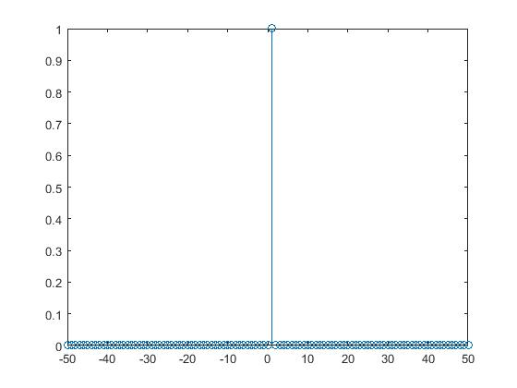

**Task#2:** Write a generic Matlab code that generates delayed (shifted) Unit step function.

n=-50:50;

n0=1;

y=[n>=n0]

stem(n,y)

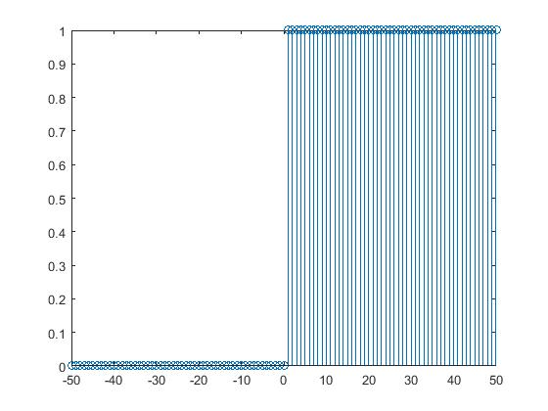

**Task#3:** Write a generic Matlab code that generate delayed (shifted) Unit ramp function.

n=-50:50;

n0=1;

y=[n>=n0]

K=n.*y

stem(n,K)

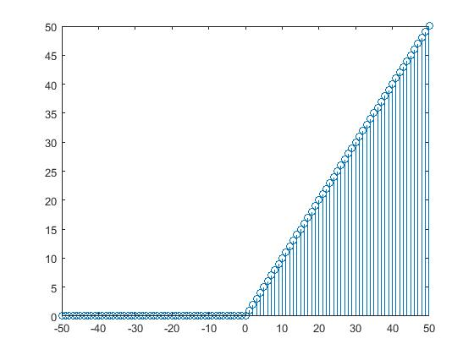

**Task#4:** Write a Matlab code that generate Exponential Function.

n=0:10;

z=exp(.5*n)

stem(z,n)

n=0:10;

z=exp(.5*n)

stem(z,n)

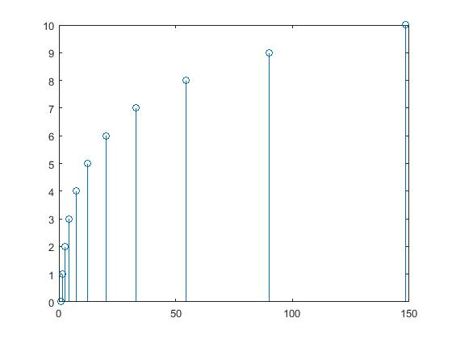

**Task#5:** Write a Matlab code that generate sinusoidal Function.

n1=0:10;

z=sin(2*pi*.5*n1)

stem(z,n1)

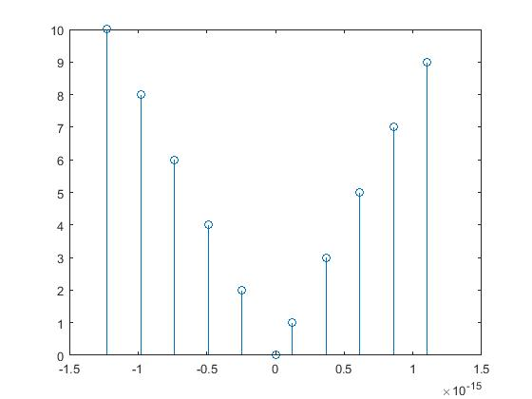**Task#6:** Write a Matlab code that generate Unit Ramp delay (shift) function

**Task#7:**

a. Z(n) = 2δ(n+2) – δ(n-4), -5 ≤ δ ≤ 5

1. X(n) = n[u(n)-u(n-10)] + 10 e-0.3(n-10)[u(n-10) – u(n-20)], 0 ≤ n ≤ 20

**Task#8:** Let x(n) = {1,2,***3***,4, 5, 6, 7, 6, 5, 4, 3, 2, 1}, Determine and plot the followingsequences.

1. x1(n) = 2x(n-5) – 3x(n+4)

x = [1 2 3 4 5 6 7 6 5 4 3 2 1] ;

n = -2:10;

n1 = n+5;

n2 = n-4;

[x1, n] = Ksig_thing(2.*x,n1, 3.*x, n2);

stem(n, x1)

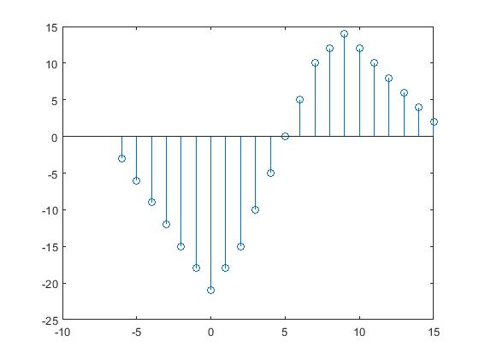

1. x2(n) = x(3-n) + x(n)x(n-2)

x = [1 2 3 4 5 6 7 6 5 4 3 2 1];

n = -2:12;

n1 = 3+(-1*n);

n2 = n+2;

[x3, n] = sigmulti(x, n, x, n2);

[x3, n] = sigmulti (x, n, x, n2);

[x2, n3] = sigadd(x3, n, x, n1);

stem(n3, x2)

**Task#9:** Generate a multi-tone sinusoidal signal with f1=2000Hz and f2=4000Hz, then bysampling generate the Oversampled and Undersampled version of it and display the frequency response also.

clc, clear;

Dt=0.01;

F=1000/(2000+4000);

t=0:Dt:12;

f1=sin(2*pi*2000*t);

f2=sin(2*4000*pi*t);

y_t = f1+f2;

% Oversampling

%y_n=y_t(1:1/((2*f/Fs)*Dt):end);

fs=4*F;

Ts1=1/fs;

n1=t(1)/Ts1:1:t(end)/Ts1;

y_n1=sin(2*pi*F*n1*Ts1);

%Under sampling

fs=1.5*F;Ts2=1/fs;

n2=t(1)/Ts2:1:t(end)/Ts2;

y_n2=sin(2*pi*F*n2*Ts2);

n=0:1/(2*F/fs):12;

% plotting in time domain %%%%%%%%%%

subplot(2,3,1)

plot (t,y_t)

title('CT Plot of Sinusoidal signal');

xlabel('Time t');

ylabel('CT Signal y(t)');

grid on;

subplot(2,3,2)

stem (n1*Ts1,y_n1);

hold on

plot (t,y_t,'g')

title('DT PlotT Oversampled');

xlabel('Time t');

ylabel('DT Signal');

grid on;

subplot(2,3,3)

stem (n2*Ts2,y_n2);

hold on

plot (t,y_t,'g')

title('DT PlotT Undersampled');

xlabel('Time t');

ylabel('DT Signal');

grid on;

% Computing frequency response of y_n and plotting %%%%%%%%%%

subplot(2,3,4)

[Y_n,omega_n] = freqz(y_n1);

plot (omega_n*F/(2*pi),(abs(Y_n)))

title('Oversampling A sinusoidal signal in frequency domain');

xlabel('Frequency in Hz');

ylabel('Magnitude response Y') ;

grid on;

subplot(2,3,5)

[Y_n,omega_n] = freqz(y_n2);

plot (omega_n*F/(2*pi),(abs(Y_n)))

title('Oversampling A sinusoidal signal in frequency domain');

xlabel('Frequency in Hz');

ylabel('Magnitude response Y')

grid on;

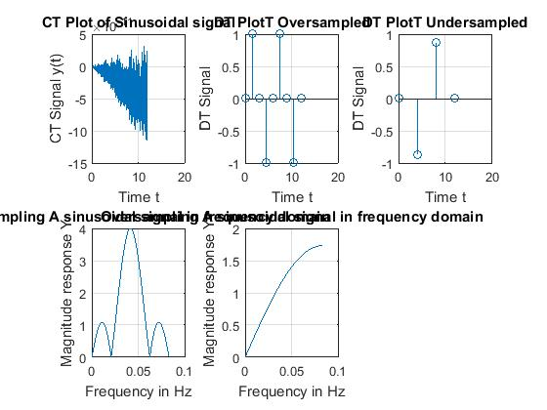

_____________________________________________________________________________________________

Page 11 of 12

|  |  |  |  |  |  |
| --- | --- | --- | --- | --- | --- |
| DSP - Lab | National University | Roll No: __________ | Lab# | **01** |  |
|  | of Computer and Emerging Sciences |  |  |
|  |  |  |  |  |
| (EL302) | Islamabad | Spring 2019 |  |  |  |

_____________________________________________________________________________________



**Student's feedback:** Purpose of feedback is to know the strengths and weaknesses of the systemfor future improvements. This feedback is for the 'current lab session'. Circle your choice:

[-3 = Extremely Poor, -2 = Very Poor, -1 = Poor, 0 = Average, 1 = Good, 2 = Very Good, 3 = Excellent]:

The following table should describe your experience with:



|  |  |  |  |  |  |  |  |  |  |  |
| --- | --- | --- | --- | --- | --- | --- | --- | --- | --- | --- |
| **S#** | **Field** | **Rating** | |  |  |  |  |  | **Describe in words if required** |  |
| 1 | Overall Session |  |  |  |  |  |  |  |  |  |
| -3 | -2 | -1 | 0 | 1 | 2 | 3 |  |  |
| 2 | Lab Instructor |  |  |  |  |  |  |  |  |  |
|  |  |  |  |  |  |  |  |  |
| -3 | -2 | -1 | 0 | 1 | 2 | 3 |  |  |
| 3 | Lab Staff |  |  |  |  |  |  |  |  |  |
|  |  |  |  |  |  |  |  |  |
| -3 | -2 | -1 | 0 | 1 | 2 | 3 |  |  |
| 4 | Equipment |  |  |  |  |  |  |  |  |  |
|  |  |  |  |  |  |  |  |  |
| -3 | -2 | -1 | 0 | 1 | 2 | 3 |  |  |
| 5 | Atmosphere |  |  |  |  |  |  |  |  |  |
|  |  |  |  |  |  |  |  |  |
| -3 | -2 | -1 | 0 | 1 | 2 | 3 |  |  |
|  |  |  |  |  |  |  |  |  |  |  |



Any other valuable feedback: ______________________________________________________

______________________________________________________________________________

______________________________________________________________________________

______________________________________________________________________________

Student's Signature: _________________________________

|  |  |  |  |  |  |  |  |
| --- | --- | --- | --- | --- | --- | --- | --- |
| **MARKSAWARDED** | **Attitude** | **Neatness** | **Correctnessofresults** | **Initiative** | **Originality** | **Conclusion** | **TOTAL** |
|  |  |  |  |  |  |  |  |
| TOTAL | **10** | **10** | **10** | **20** | **20** | **30** | **100** |
|  |  |  |  |  |  |  |  |
| EARNED |  |  |  |  |  |  |  |
|  |  |  |  |  |  |  |  |

Lab Instructor's Comments:________________________________________________________

______________________________________________________________________________

______________________________________________________________________________

______________________________________________________________________________

Lab Instructor's Signature: _________________________________

_____________________________________________________________________________________________

Page 12 of 12