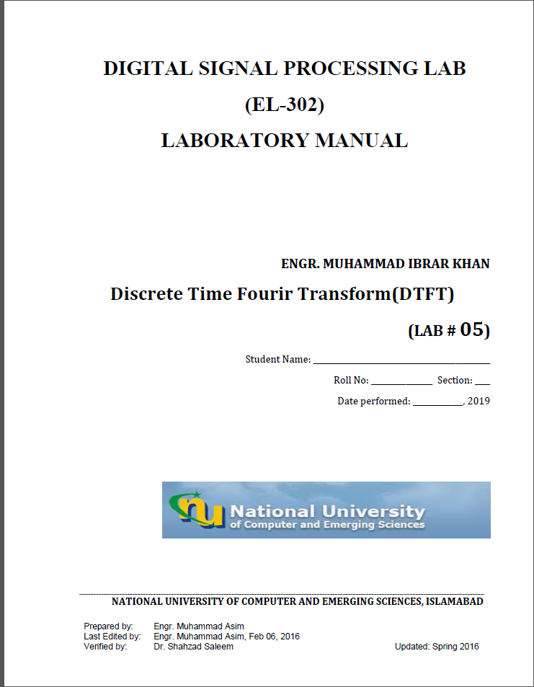

**Task1:**

w=[-4*pi:(8*pi/511):4*pi];

a=[0.7 -.5 .3 1];

b=[1 .3 -.5 .7];

h=freqz(a,b,w);

subplot(411)

plot((w/pi),abs(h))

title('mag')

xlabel('w/pi');

ylabel('magnitude');

subplot(412)

plot((w/pi),angle(h))

title('Phase')

xlabel('w/pi');

ylabel('phase');

subplot(413)

plot((w/pi),real(h))

title('real part')

xlabel('w/pi');

ylabel('magnitude');

subplot(414)

plot((w/pi),imag(h))

title('image')

xlabel('w/pi');

ylabel('magnitude');

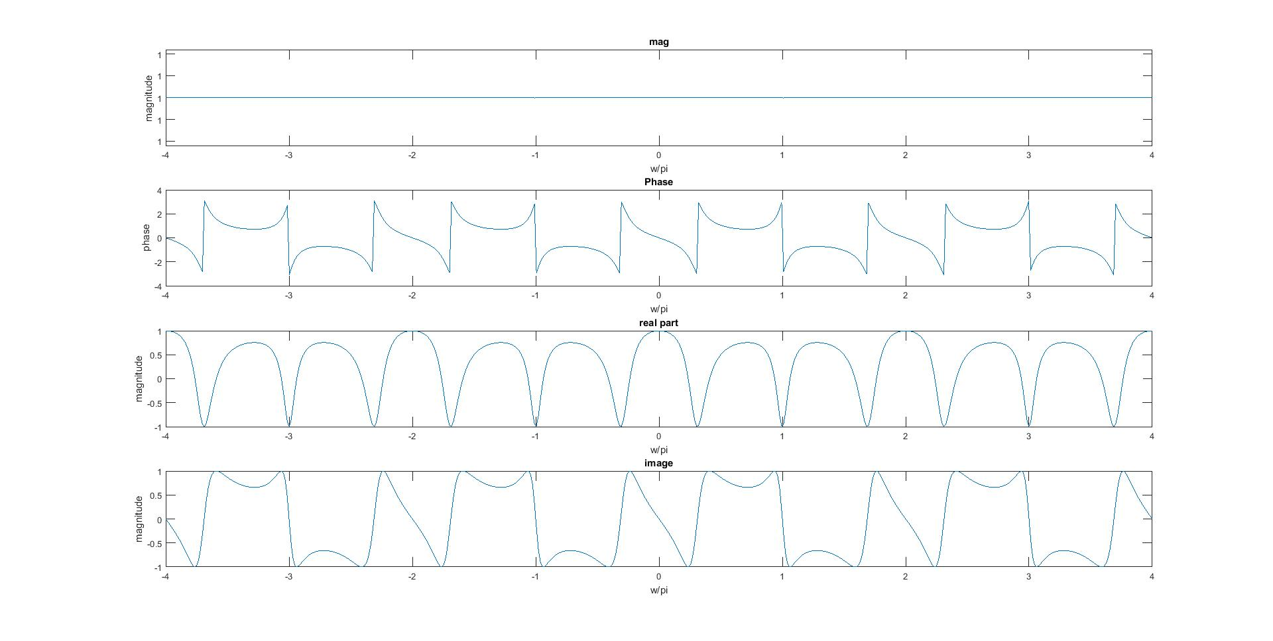

**Task2:**

% Compute the frequency samples of the DTFT

w = -4*pi:8*pi/511:4*pi;

num = [2 1];den = [1 -0.6];

h = freqz(num, den, w);

% Plot the DTFT

subplot(4,1,1)

plot(w/pi,real(h));grid

title('Real part of H(e^{j\omega})')

xlabel('\omega /\pi');

ylabel('Amplitude');

subplot(4,1,2)

plot(w/pi,imag(h));grid

title('Imaginary part of H(e^{j\omega})')

xlabel('\omega /\pi');

ylabel('Amplitude');

subplot(4,1,3)

plot(w/pi,abs(h));grid

title('Magnitude Spectrum |H(e^{j\omega})|')

xlabel('\omega /\pi');

ylabel('Amplitude');

subplot(4,1,4)

plot(w/pi,angle(h));grid

title('Phase Spectrum arg[H(e^{j\omega})]')

xlabel('\omega /\pi');

ylabel('Phase, radians')

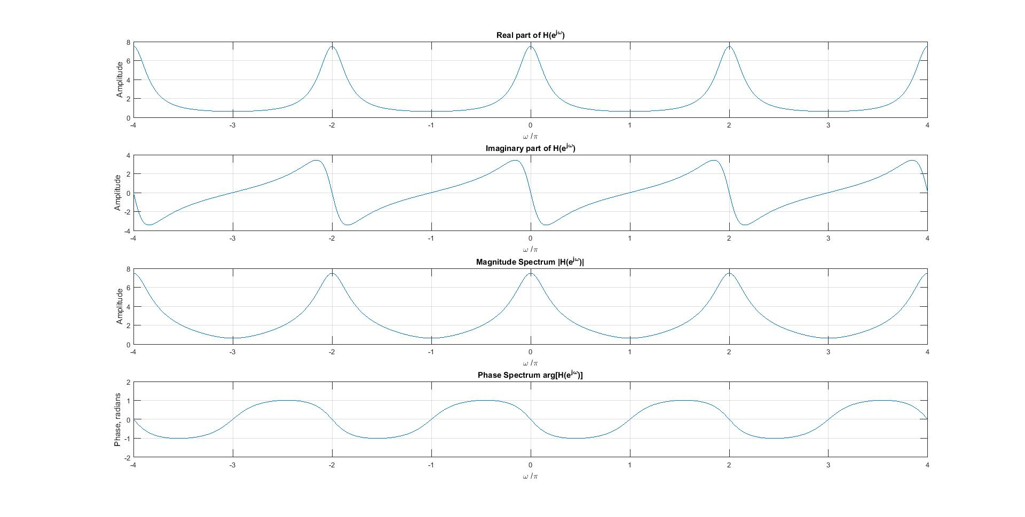

**Task3:**

w=[-4*pi:(8*pi/511):4*pi];

a=[0.7 -.5 .3 1];

b=[1 .3 -.5 .7];

h=freqz(a,b,w);

subplot(411)

plot((w/pi),abs(h))

title('mag')

xlabel('w/pi');

ylabel('magnitude');

subplot(412)

plot((w/pi),unwrap(angle(h)))

title('Phase')

xlabel('w/pi');

ylabel('phase');

subplot(413)

plot((w/pi),real(h))

title('real part')

xlabel('w/pi');

ylabel('magnitude');

subplot(414)

plot((w/pi),imag(h))

title('image')

xlabel('w/pi');

ylabel('magnitude');

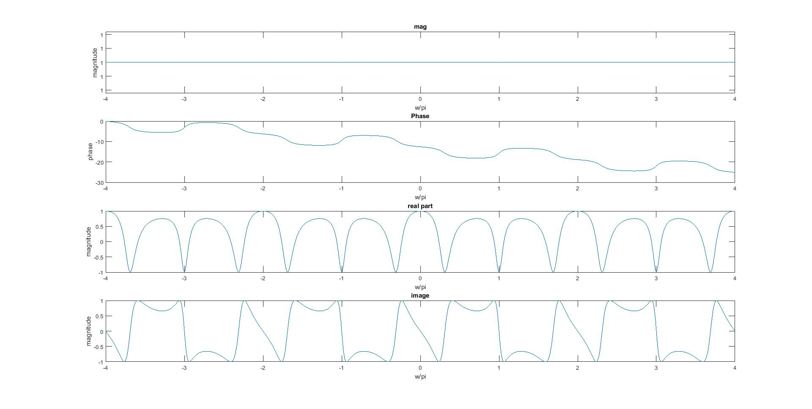

**Task4:**

n=0:25;

k=0:255;

w=k*(pi/255);

x1=randn(1,length(n));

x2=randn(1,length(n));

alpha=2;

beta=3;

x=(alpha.*x1)+(beta.*x2);

X=x*exp(-j*pi/255).^(n'*k);

X1=x1*exp(-j*pi/255).^(n'*k);

X2=x2*exp(-j*pi/255).^(n'*k);

TheX=X1+X2;

subplot(211)

plot((w/pi),abs(X))

title('Time dom added then fouriered ')

xlabel('w/pi');

ylabel('magnitude');

subplot(212)

plot((w/pi),abs(TheX))

title('Time dom fouriered then added ' )

xlabel('w/pi');

ylabel('magnitude');

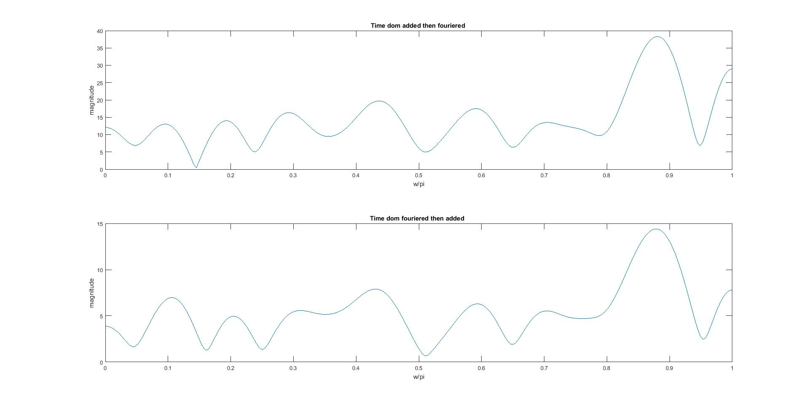

**Task5:**

n=0:50;

x1=sin(2*pi*0.5*n);

M=5;

b=(ones(1,M)*(1/M));

a=[1];

h=filter(b,a,x1)

[H,w]=freqz(h)

subplot(311)

stem(n,h)

subplot(312)

stem((w/pi),abs(H))

title('M=5 Amp')

xlabel('w/pi')

ylabel('Magnitude')

subplot(313)

stem((w/pi),angle(H))

title('M=5 Phase')

xlabel('w/pi')

ylabel('Magnitude')

