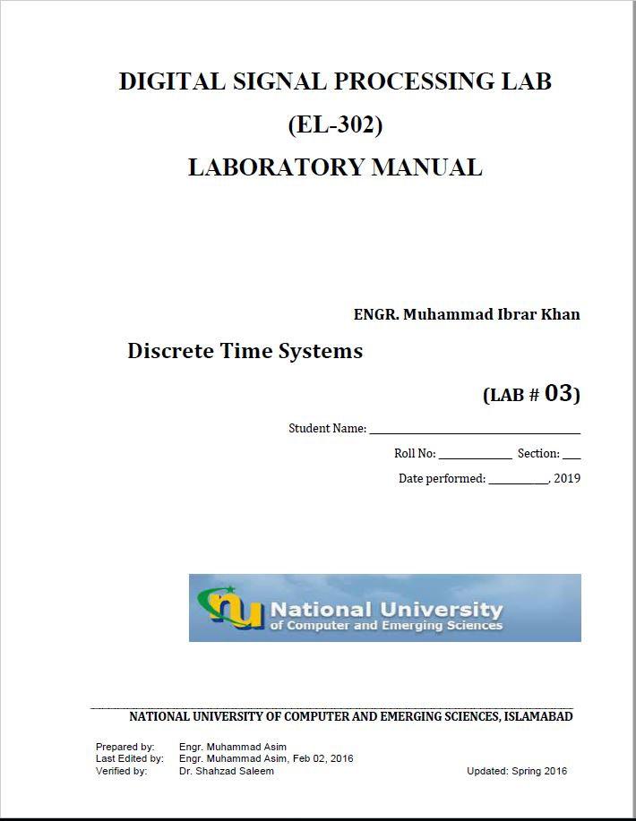

**Task1:**

close all

clc

clear all

n=0:7;

x=(n>0).*(n<5);

h=((0.5).*n).*((n>0).*(n<6));

y=conv(x,h)

subplot(311)

plot(n,x)

title('input')

xlabel('index')

ylabel('Amplitudes')

subplot(312)

plot(n,h)

title('system')

xlabel('index')

ylabel('Amplitudes')

subplot(313)

l=length(x)+(length(h)-1);

N=0:(l-1)

plot(N,y)

title('output')

xlabel('index')

ylabel('Amplitudes')

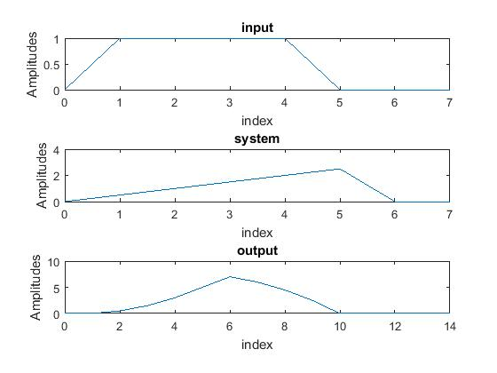

**Task4:**

close all

n=0:100;

fl=0.05;

fh=0.47;

x1=sin(2*pi*fl*n);

x2=sin(2*pi*fh*n);

x=x1+x2;

[m,w]=freqz(x)

subplot(411)

stem((w/pi),abs(m))

title('input sig')

xlabel('w/pi')

ylabel('Magnitude')

a=[1];

M=2;

b=(ones(1,M)*(1/M))

y=filter(b,a,x);

[k,w1]=freqz(y)

subplot(412)

stem((w1/pi),abs(k))

title('Mov avg fil 2')

xlabel('w/pi')

ylabel('Magnitude')

M=4;

b=(ones(1,M)*(1/M))

y1=filter(b,a,x);

[k1,w2]=freqz(y1)

subplot(413)

stem((w2/pi),abs(k1))

title('Mov avg fil 4')

xlabel('w/pi')

ylabel('Magnitude')

M=10;

b=(ones(1,M)*(1/M))

y2=filter(b,a,x);

[k3,w3]=freqz(y2)

subplot(414)

stem((w3/pi),abs(k3))

title('Mov avg fil 10')

xlabel('w/pi')

ylabel('Magnitude')

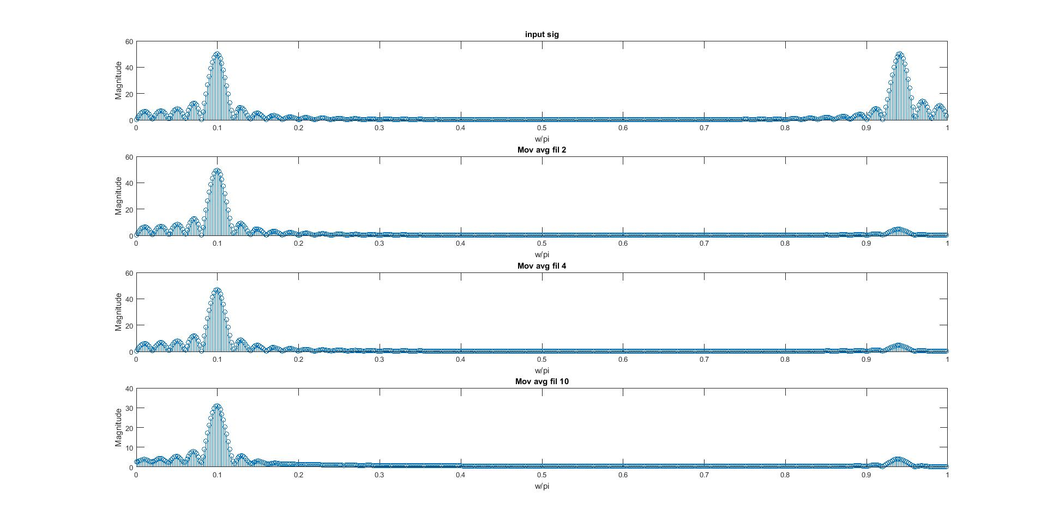

**M=10 provides better magnitude attenuation.**

**Task5:**

x=[2.2403 2.4908 2.2403];

y=[1 0.4 0.75];

s1=filter(b1,a1,x)

[k,w]=freqz(s1)

stem((w/pi),abs(k))

title('Filter & fft')

xlabel('w/pi')

ylabel('Magnitude')

figure

impz(x,y)

title('impz')

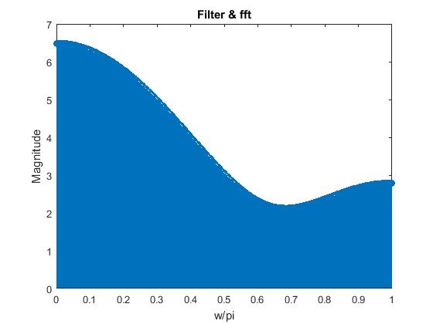

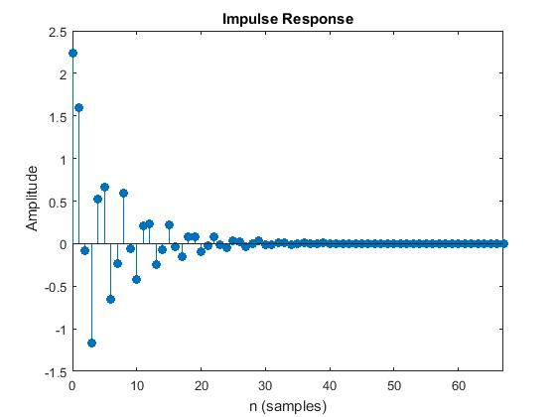

**Task6:**

n=0:299;

x=cos((20*pi*n)/250)+cos((200*pi*n)/250);

a1=[1];

b1=[0.5 0.27 0.77];

b2=[0.45 0.5 0.45];

a2=[1 -0.53 +0.46];

s1=filter(b1,a1,x)

[k,w]=freqz(s1)

subplot(211)

stem((w/pi),abs(k))

title('FIR System 1')

xlabel('w/pi')

ylabel('Magnitude')

s2=filter(b2,a2,x)

[K1,W1]=freqz(s2)

subplot(212)

stem((W1/pi),abs(K1))

title('IIR System 2')

xlabel('w/pi')

ylabel('Magnitude')

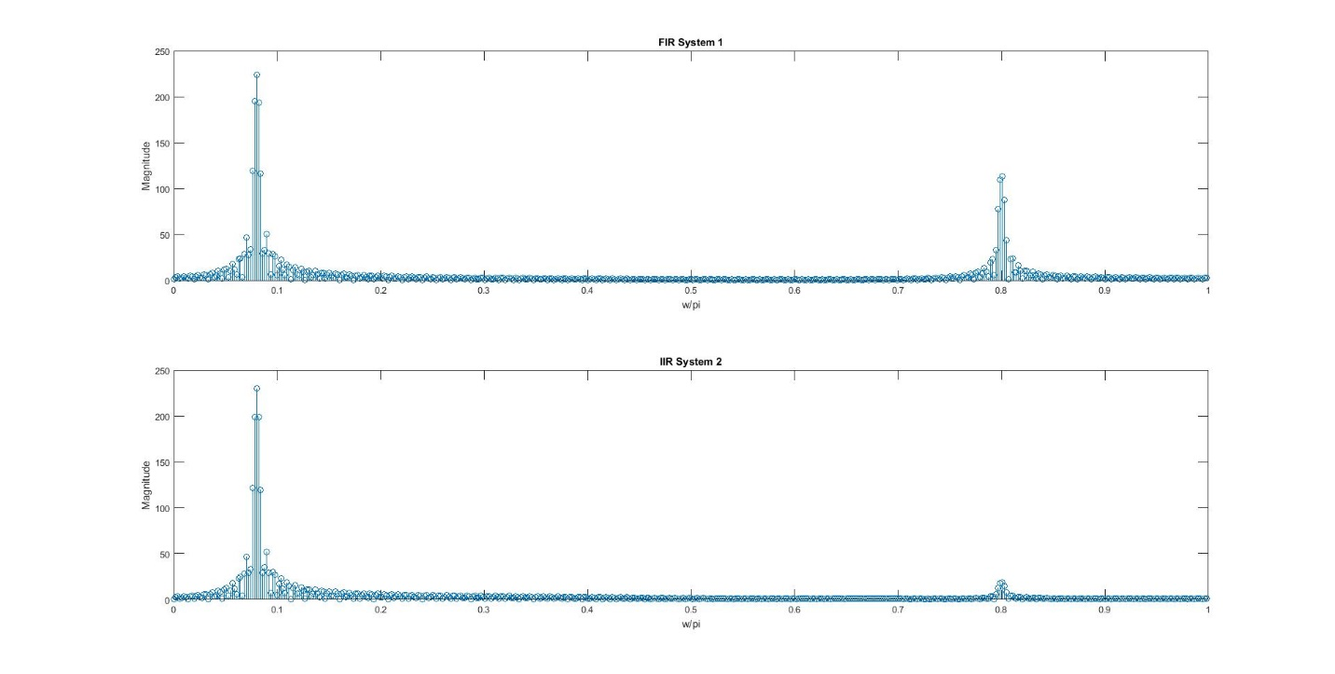

**IIR System provides better magnitude attenuation.**