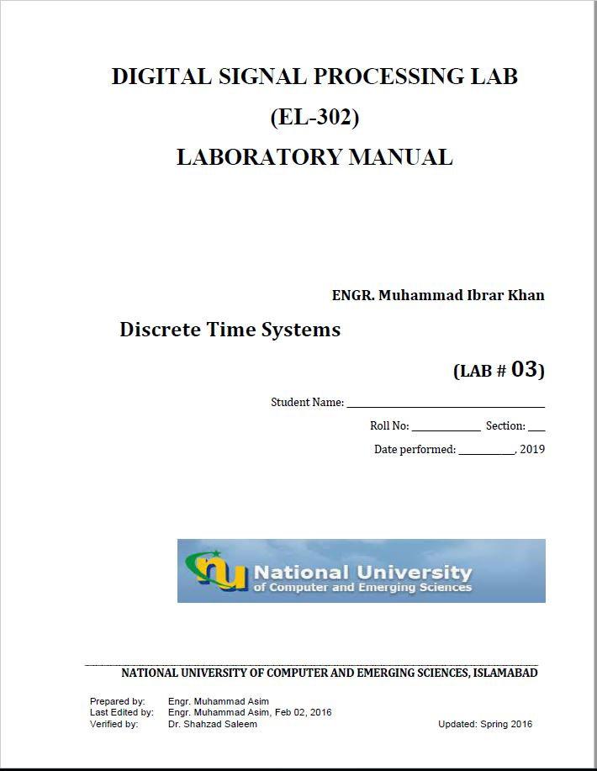

**Task1:**

n=-20:20;

x1=sin(2*pi*0.5*n);

k=randn(1,length(n));

x=x1+k;

M=3;

b=(ones(1,M)*(1/M));

a=[1];

y=filter(b,a,x);

[m,w]=freqz(y)

subplot(511)

stem((w/pi),abs(m))

title('M=3 Amp')

xlabel('w/pi')

ylabel('Magnitude')

M=7;

bs1=(ones(1,M)*(1/M));

y1=filter(bs1,a,x);

[m1,w1]=freqz(y1)

subplot(512)

stem((w1/pi),abs(m1))

title('M=7 Amp')

xlabel('w/pi')

ylabel('Magnitude')

M=11;

bs2=(ones(1,M)*(1/M));

y2=filter(bs2,a,x);

[m2,w2]=freqz(y2)

subplot(513)

stem((w2/pi),abs(m2))

title('M=11 Amp')

xlabel('w/pi')

ylabel('Magnitude')

myb1=[0.5 0.27 0.77];

myb2=[0.45 0.5 0.45];

mya=[1 -0.53 0.46];

s1=filter(myb1,a,x)

[k,wp]=freqz(s1)

subplot(514)

stem((wp/pi),abs(k))

title('FIR System 1')

xlabel('w/pi')

ylabel('Magnitude')

s2=filter(myb2,mya,x)

[K1,W1]=freqz(s2)

subplot(515)

stem((W1/pi),abs(K1))

title('IIR System 2')

xlabel('w/pi')

ylabel('Magnitude')

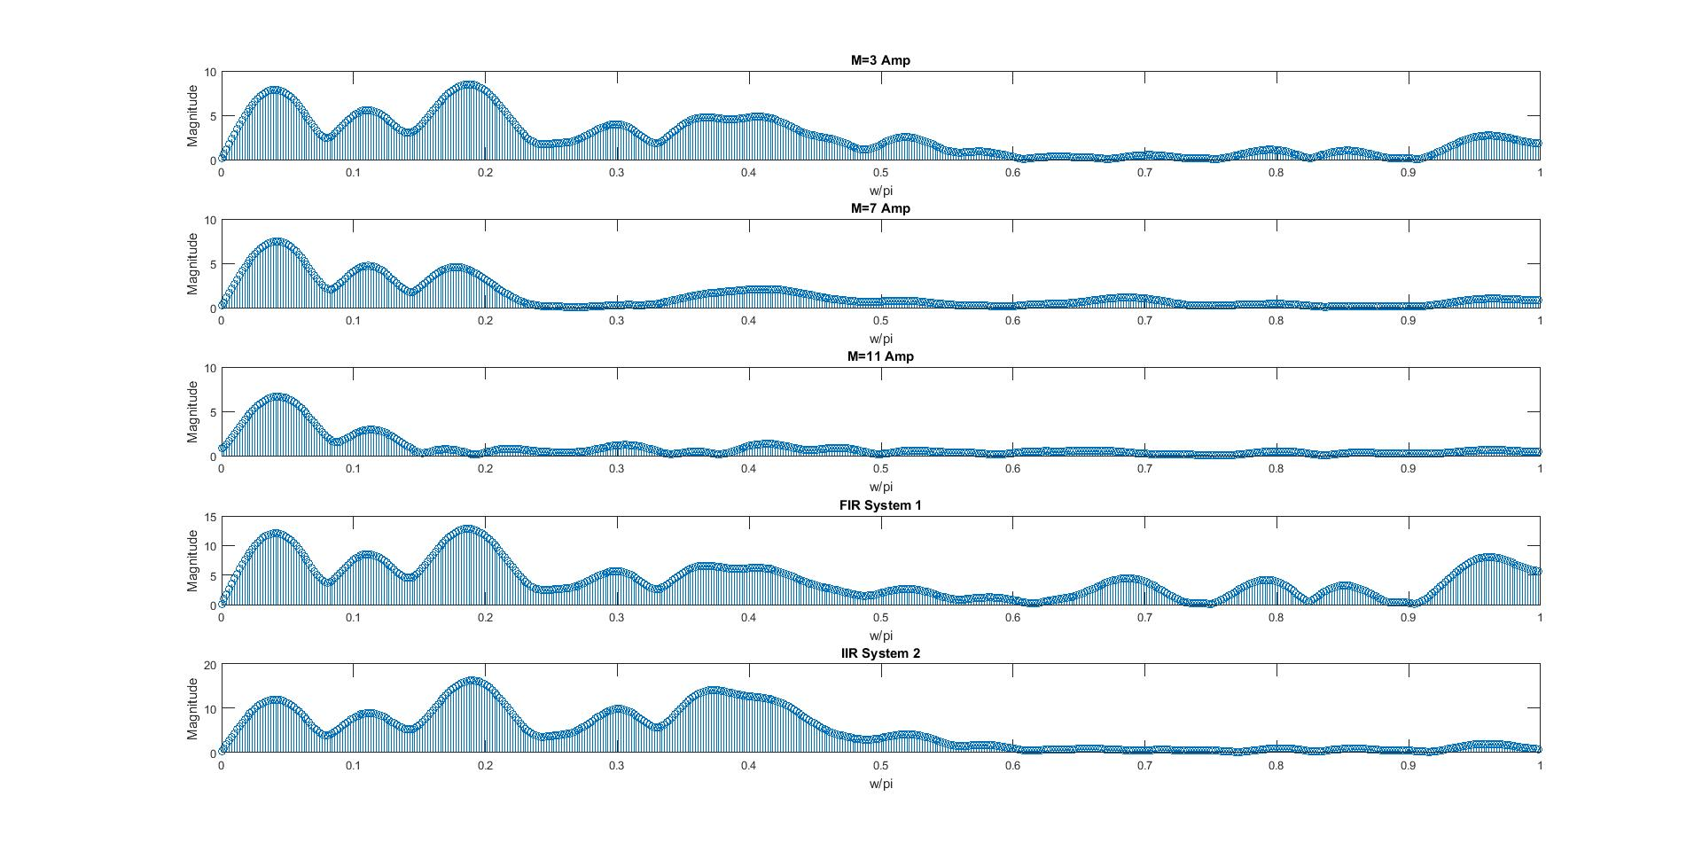

**M=11 among moving avg filters and IIR system among the systems provide best beyond stopband freq’s magnitude attenuation while M=11 moving avg filter provides best attenuation among M=11 and IIR.**

**Task2:**

close all

clc

clear all

n=-5:20;

x=(n>=0).*(n<10);

x1=(n==0);

subplot(411)

plot(n,x)

title('input')

xlabel('index')

ylabel('Amplitudes')

b=[1];

a=[1 -0.9];

h=filter(b,a,x1)

y=conv(x,h)

subplot(412)

plot(n,h)

title('system')

xlabel('index')

ylabel('Amplitudes')

subplot(413)

l=length(x)+(length(h)-1);

N=0:(l-1)

plot(N,y)

title('output using conv')

xlabel('index')

ylabel('Amplitudes')

subplot(414)

y1=filter(b,a,x)

plot(n,y1)

title('output using filter')

xlabel('index')

ylabel('Amplitudes')

