**DIGITAL SIGNAL PROCESSING LAB**

**(EL-302)**

**LABORATORY MANUAL**

**ENGR. MUHAMMAD IBRAR KHAN**

**Design of Simple FIR and IIR Filters**

**(LAB # 10)**

Student Name: ____Kamran________

Roll No: _____i140420___________ Section: __B__

Date performed: 20/4, 2019



____________________________________________________________________________________________________________________________________________________________

**NATIONAL UNIVERSITY OF COMPUTER AND EMERGING SCIENCES, ISLAMABAD**

Prepared by:

Last Edited by:

Verified by:

Engr. Muhammad Asim

Engr. Muhammad Asim, Mar 17, 2016

Dr. Shahzad Saleem

Updated: Spring 2016

|  |  |  |  |  |  |
| --- | --- | --- | --- | --- | --- |
| DSP - Lab | National University | Roll No: __________ | Lab# | **10** |  |
|  | of Computer and Emerging Sciences |  |  |
|  |  |  |  |  |
| (EL302) | Islamabad | Spring 2018 |  |  |  |

_____________________________________________________________________________________

**Lab # 10: Design of Simple FIR and IIR Filters**

**Task#01:**

1. Implement the above given transfer function $H_{0}\left(z\right)$ of FIR Lowpass filter using “tf” function in matlab.
2. Find poles and zeros of above computed transfer function and plot these using “zplane” command. Write down type of the filter.

**Lowpass filter**

1. Find frequency response using “freqz” function and plot its magnitude and phase response.
2. Observe the phase response whether it is linear or not?

**Linear**

1. Plot the gain function of filter and find its 3dB cutoff frequency. Compare it with mathematically computed $w_{c}$**.**

**Calculated=0.5, Observed=0.5**

z=tf('z')  
h=((1+z^(-1))/2);  
num=[1/2 1/2];  
den=[1];  
[z p k]=tf2zpk(num,den);  
zplane(z,p)  
title('PZ Map')  
figure  
freqz(num,den)  
[H,w]=freqz(num,den);  
title('freq resp')  
figure  
plot(w/pi,abs(H))  
title('Gain Factor')  
  
Cut_off_freq=180/2  
figure  
[Gd,w]=grpdelay(num,den);  
plot(w/pi,Gd)  
title('Group Delay')

z =  
   
 z  
   
Sample time: unspecified  
Discrete-time transfer function.  
  
  
Cut_off_freq =  
  
 90

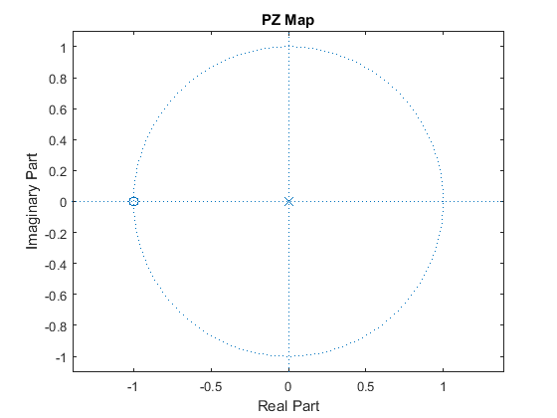

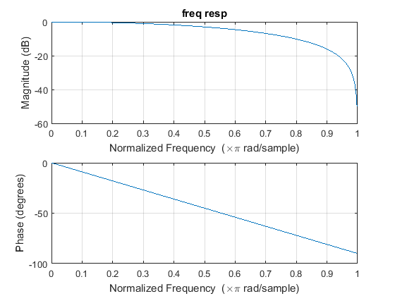

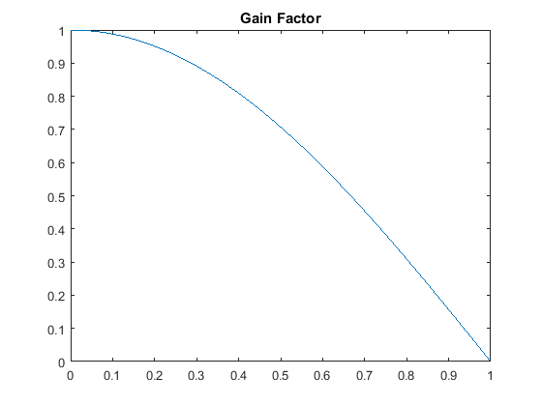

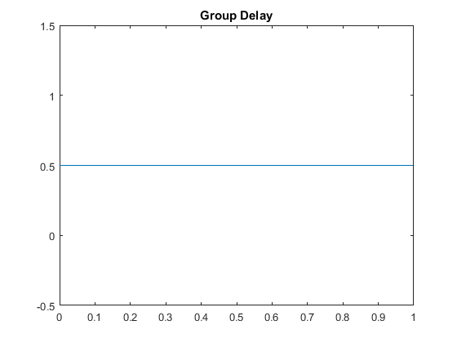

[*Published with MATLAB® R2015a*](http://www.mathworks.com/products/matlab)

**Task#02:**

1. Implement the above given transfer function $G_{0}\left(z\right)$ of cascaded FIR Lowpassfilter using “tf” function in matlab witk K=3.
2. Find poles and zeros of above computed transfer function and plot these using “zplane” command. Write down type of the filter.

**Cascaded Lowpass filter**

1. Find frequency response using “freqz” function and plot its magnitude and phase response.
2. Compare this frequency response with frequency response of a single low pass FIR filter.

**Cutoff sharpened due to cascading**

1. Observe the phase response whether it is linear or not?

**Linear**

1. Plot the gain function of filter and find its 3dB cutoff frequency. Compare it with mathematically computed $w_{c}$**.**

**Calculated=0.3, Observed=0.3**

close all; clear all  
z=tf('z')  
h=((1+z^(-1))/2);  
%k=0:511; w=k*pi/511; h=0.5*(1+exp(-j*w)).^M  
z=tf('z')  
K=3;  
G=((1+z^(-1))/2)^K  
num=[1 3 3 1];  
den=[1];  
[z p k]=tf2zpk(num,den);  
zplane(z,p)  
title('PZ Map')  
figure  
freqz(num,den)  
[H,w]=freqz(num,den);  
title('freq resp')  
figure  
plot(w/pi,abs(H))  
title('Gain Factor')  
Cut_off_freq=(2*acos(2^((-1)/(2*K))))/pi  
figure  
[Gd,w]=grpdelay(num,den);  
plot(w/pi,Gd)  
title('Group Delay')

z =  
   
 z  
   
Sample time: unspecified  
Discrete-time transfer function.  
  
  
z =  
   
 z  
   
Sample time: unspecified  
Discrete-time transfer function.  
  
  
G =  
   
 z^3 + 3 z^2 + 3 z + 1  
 ---------------------  
 8 z^3  
   
Sample time: unspecified  
Discrete-time transfer function.  
  
  
Cut_off_freq =  
  
 0.3002

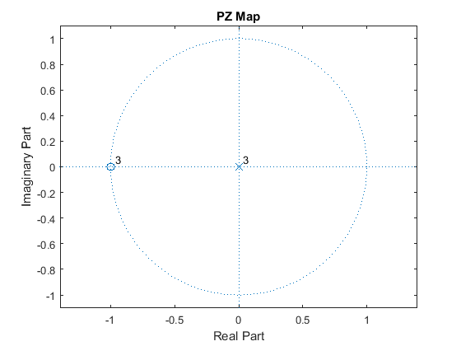

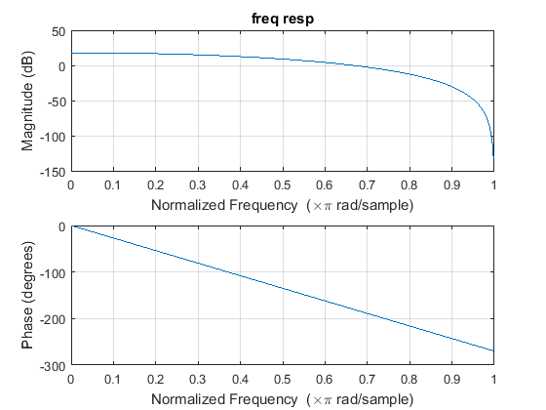

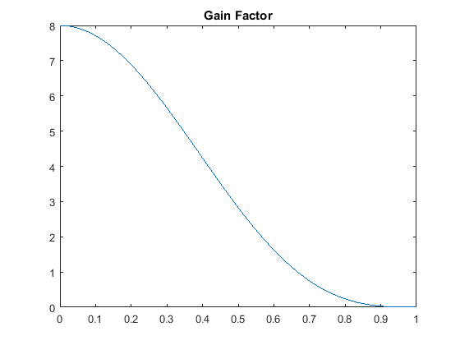

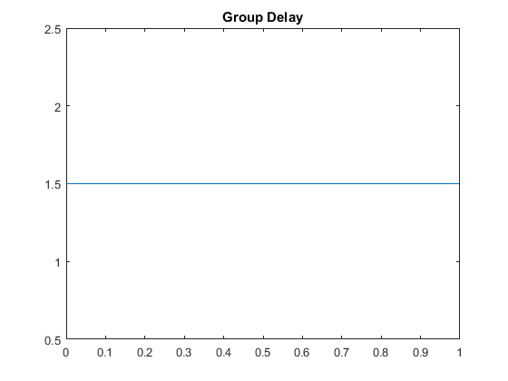

[*Published with MATLAB® R2015a*](http://www.mathworks.com/products/matlab)

**Task#03:**

1. Implement the above given transfer function $H_{1}\left(z\right)$ of FIR Highpass filter using “tf” function in matlab.
2. Find poles and zeros of above computed transfer function and plot these using “zplane” command. Write down type of the filter.

**Highpass filter**

1. Find frequency response using “freqz” function and plot its magnitude and phase response.
2. Observe the phase response whether it is linear or not?

**Linear**

1. Plot the gain function of filter and find its 3dB cutoff frequency. Compare it with mathematically computed $w_{c}$**.**

close all; clear all  
z=tf('z')  
h=((1-z^(-1))/2);  
num=[1/2 -1/2];  
den=[1];  
[z p k]=tf2zpk(num,den);  
zplane(z,p)  
title('PZ Map')  
figure  
freqz(num,den)  
[H,w]=freqz(num,den);  
title('freq resp')  
figure  
plot(w/pi,abs(H))  
title('Gain Factor')  
Cut_off_freq=180-(180/2)  
figure  
[Gd,w]=grpdelay(num,den);  
plot(w/pi,Gd)  
title('Group Delay')

z =  
   
 z  
   
Sample time: unspecified  
Discrete-time transfer function.  
  
  
Cut_off_freq =  
  
 90

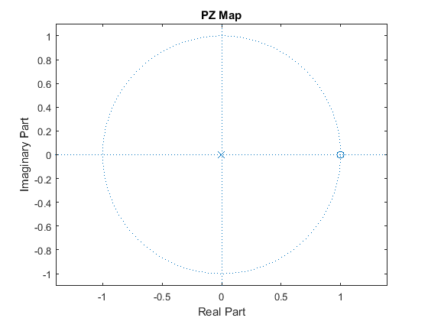

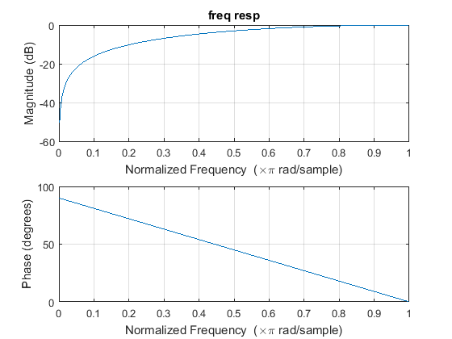

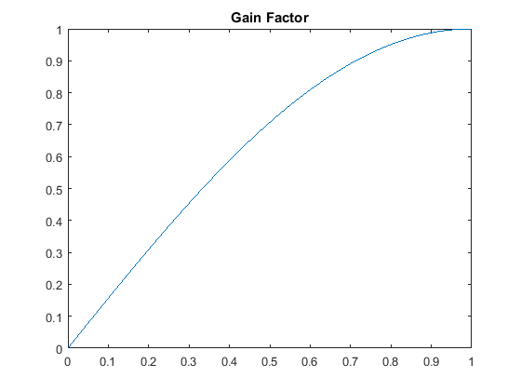

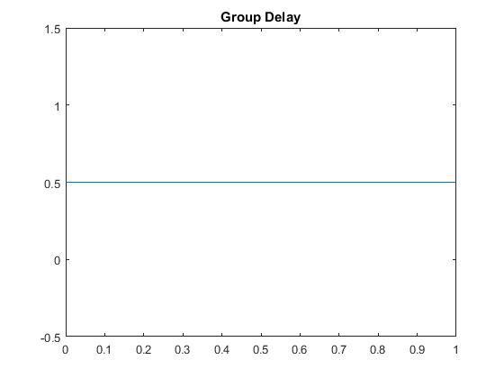

[*Published with MATLAB® R2015a*](http://www.mathworks.com/products/matlab)

**Task#04:**

1. Implement the transfer function $G_{1}\left(z\right)$ of cascaded FIR Highpassfilter using “tf” function in matlab witk K=3.
2. Find poles and zeros of above computed transfer function and plot these using “zplane” command. Write down type of the filter.

**Cascaded Highpass filter**

1. Find frequency response using “freqz” function and plot its magnitude and phase response.
2. Compare this frequency response with frequency response of a single high pass FIR filter.

**Cutoff sharpened due to cascading**

1. Observe the phase response whether it is linear or not?

**Linear**

1. Plot the gain function of filter and find its 3dB cutoff frequency. Compare it with mathematically computed $w_{c}$**.**

**Calculated=0.7, Observed=0.7**

close all; clear all  
z=tf('z')  
M=2;  
K=3  
H1=0;  
for n=0:(M-1)  
 H1=H1+((-1)^n)*(z^-n) ;  
end  
H1=((1/M)*H1)^K  
num=[0.125 -0.375 0.375 -0.125];  
  
den=[1];  
[z p k]=tf2zpk(num,den);  
zplane(z,p)  
title('PZ Map')  
figure  
freqz(num,den)  
[H,w]=freqz(num,den);  
title('freq resp')  
figure  
plot(w/pi,abs(H))  
title('Gain Factor')  
Cut_off_freq=1-(2*acos(2^((-1)/(2*K))))/pi  
figure  
[Gd,w]=grpdelay(num,den);  
plot(w/pi,Gd)  
title('Group Delay')

z =  
   
 z  
   
Sample time: unspecified  
Discrete-time transfer function.  
  
  
K =  
  
 3  
  
  
H1 =  
   
 0.125 z^3 - 0.375 z^2 + 0.375 z - 0.125  
 ---------------------------------------  
 z^3  
   
Sample time: unspecified  
Discrete-time transfer function.  
  
  
Cut_off_freq =  
  
 0.6998

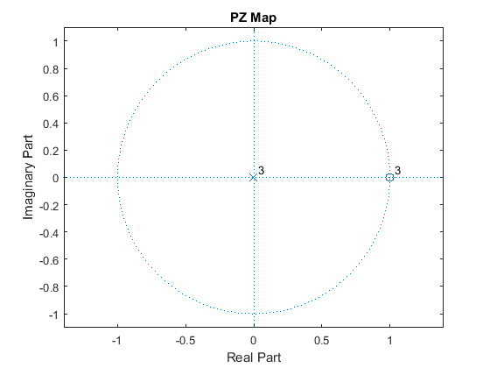

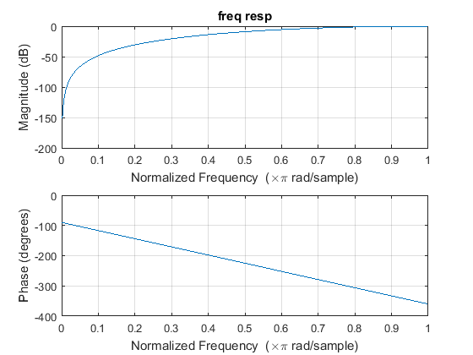

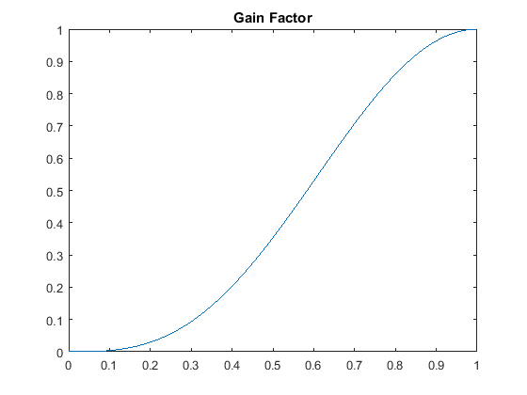

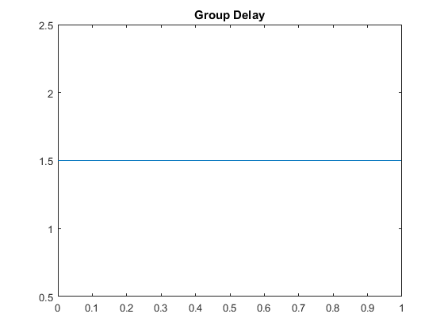

[*Published with MATLAB® R2015a*](http://www.mathworks.com/products/matlab)

**Task#05:**

1. Implement the above given transfer function $H_{LP}\left(z\right)$ of IIR Lowpassfilter using “tf” function in matlab.
2. Find poles and zeros of above computed transfer function and plot these using “zplane” command.
3. Find frequency response using “freqz” function and plot its magnitude and phase response.
4. Observe the phase response whether it is linear or not?

**Non Linear**

1. Plot the gain function of filter and find its 3dB cutoff frequency. Compare it with mathematically computed $w_{c}$**.**
2. Change the value of $α$ and observe how $w_{c}$ changes with $α$.

close all  
clear all  
z=tf('z')  
a=0.5;  
Hlp=((1-a)/2)*((1+z^(-1)))/(1-(a*(z)^(-1)))  
num=[0.25 0.25];  
den=[1 -0.5];  
[z p k]=tf2zpk(num,den);  
zplane(z,p)  
title('PZ Map')  
figure  
freqz(num,den)  
[Hlp,w]=freqz(num,den);  
title('freq resp')  
figure  
plot(w/pi,abs(Hlp))  
title('Gain Factor')  
figure  
[Gd,w1]=grpdelay(num,den);  
plot(w1/pi,Gd)  
title('Group Delay')  
  
wc=0.6443  
a=(1-sin(wc))/cos(wc)

z =  
   
 z  
   
Sample time: unspecified  
Discrete-time transfer function.  
  
  
Hlp =  
   
 0.25 z^2 + 0.25 z  
 -----------------  
 z^2 - 0.5 z  
   
Sample time: unspecified  
Discrete-time transfer function.  
  
  
wc =  
  
 0.6443  
  
  
a =  
  
 0.4995

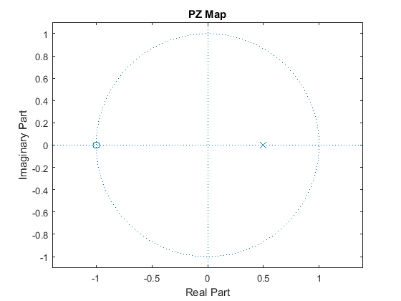

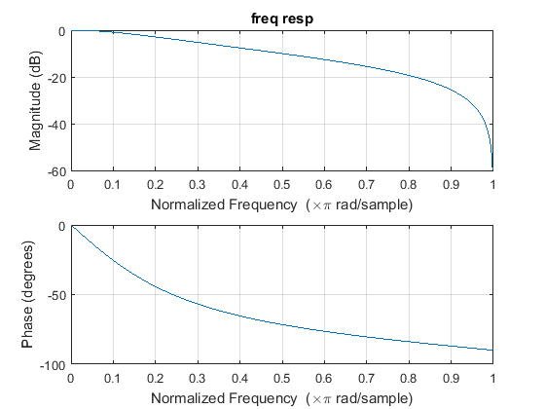

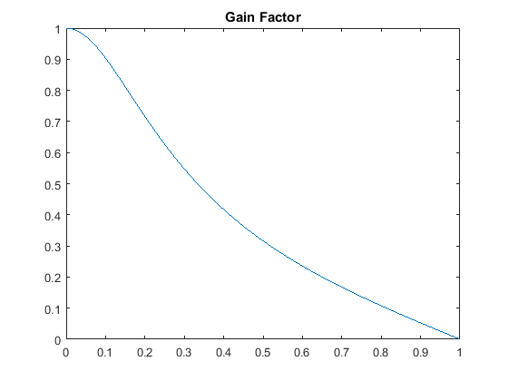

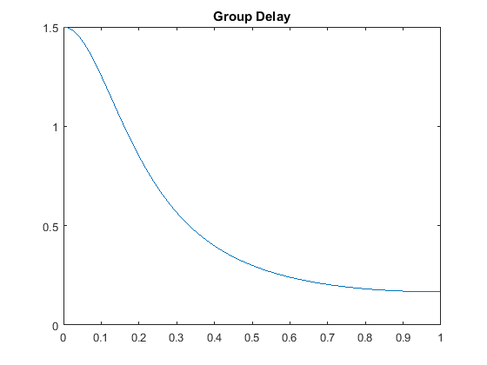

[*Published with MATLAB® R2015a*](http://www.mathworks.com/products/matlab)

**Task#06:**

1. Implement the above given transfer function $H_{HP}\left(z\right)$ of IIR Highpassfilter using “tf” function in matlab.
2. Find poles and zeros of above computed transfer function and plot these using “zplane” command.
3. Find frequency response using “freqz” function and plot its magnitude and phase response.
4. Observe the phase response whether it is linear or not?

**Non Linear**

1. Plot the gain function of filter and find its 3dB cutoff frequency. Compare it with mathematically computed $w_{c}$**.**
2. Change the value of $α$ and observe how $w_{c}$ changes with $α$.

close all  
clear all  
z=tf('z')  
a=0.5;  
Hhp=((1+a)/2)*((1-z^(-1)))/(1-(a*(z)^(-1)))  
num=[0.75 -0.75];  
den=[1 -0.5];  
[z p k]=tf2zpk(num,den);  
zplane(z,p)  
title('PZ Map')  
figure  
freqz(num,den)  
[Hhp,w]=freqz(num,den);  
title('freq resp')  
figure  
plot(w/pi,abs(Hhp))  
title('Gain Factor')  
figure  
[Gd,w1]=grpdelay(num,den);  
plot(w1/pi,Gd)  
title('Group Delay')  
  
wc=0.6443  
a=(1-sin(wc))/cos(wc)

z =  
   
 z  
   
Sample time: unspecified  
Discrete-time transfer function.  
  
  
Hhp =  
   
 0.75 z^2 - 0.75 z  
 -----------------  
 z^2 - 0.5 z  
   
Sample time: unspecified  
Discrete-time transfer function.  
  
  
wc =  
  
 0.6443  
  
  
a =  
  
 0.4995

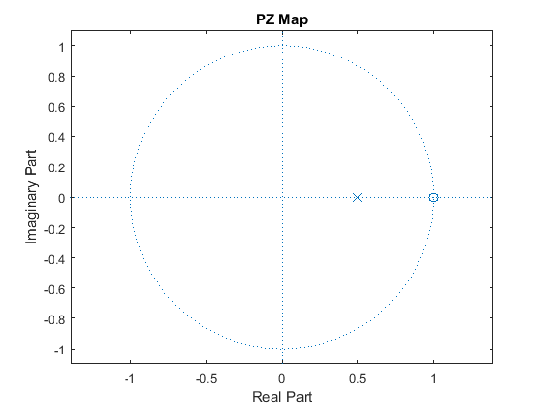

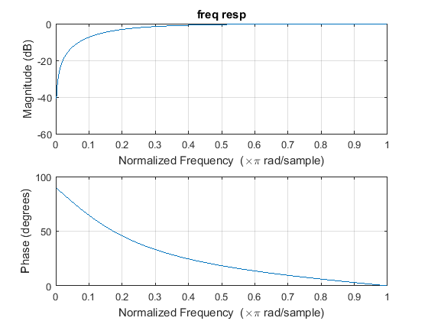

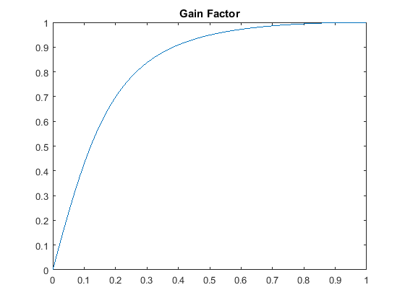

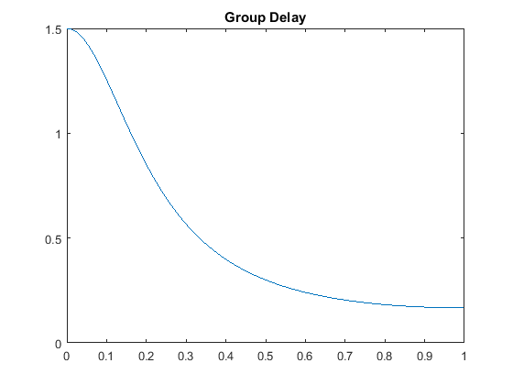

[*Published with MATLAB® R2015a*](http://www.mathworks.com/products/matlab)

**Task#07:**

1. Implement the above given transfer function $G_{LP}\left(z\right)$ of cascaded LowpassIIR filter system using “tf” function in matlab witk K=3.
2. Find poles and zeros of above computed transfer function and plot these using “zplane” command.
3. Find frequency response using “freqz” function and plot its magnitude and phase response.
4. Compare this frequency response with frequency response of a single low pass IIR filter.
5. Observe the phase response whether it is linear or not?

**Non Linear**

1. Plot the gain function of filter and find its 3dB cutoff frequency. Compare it with mathematically computed $w_{c}$**.**

close all  
clear all  
z=tf('z')  
a=0.5;  
K=3;  
Hlp=(((1-a)/2)*((1+z^(-1)))/(1-(a*(z)^(-1))))^K  
num=[0.01563 0.04688 0.04688 0.01563 0 0 0];  
den=[1 -1.5 0.75 -0.125 0 0 0];  
[z p k]=tf2zpk(num,den);  
zplane(z,p)  
title('PZ Map')  
figure  
freqz(num,den)  
[Hlp,w]=freqz(num,den);  
title('freq resp')  
figure  
plot(w/pi,abs(Hlp))  
title('Gain Factor')  
figure  
[Gd,w1]=grpdelay(num,den);  
plot(w1/pi,Gd)  
title('Group Delay')  
  
wc=0.6443  
a=(1-sin(wc))/cos(wc)

z =  
   
 z  
   
Sample time: unspecified  
Discrete-time transfer function.  
  
  
Hlp =  
   
 0.01563 z^6 + 0.04688 z^5 + 0.04688 z^4 + 0.01563 z^3  
 -----------------------------------------------------  
 z^6 - 1.5 z^5 + 0.75 z^4 - 0.125 z^3  
   
Sample time: unspecified  
Discrete-time transfer function.  
  
  
wc =  
  
 0.6443  
  
  
a =  
  
 0.4995

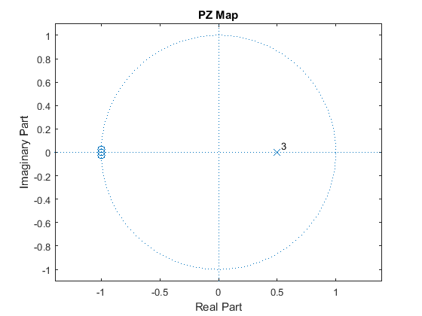

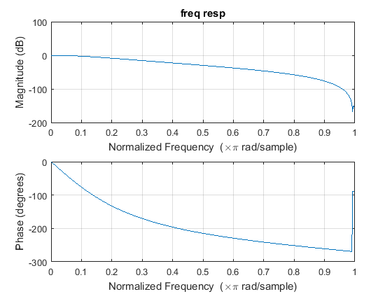

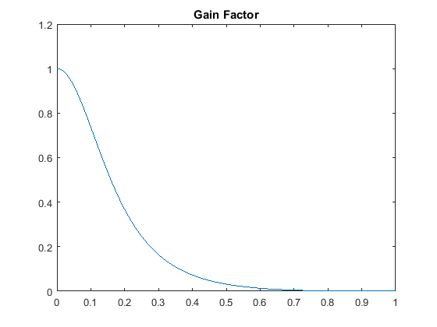

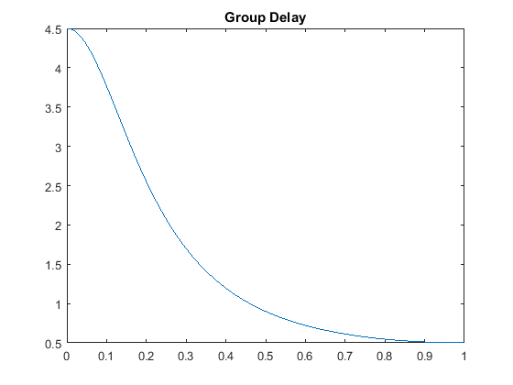

[*Published with MATLAB® R2015a*](http://www.mathworks.com/products/matlab)

**Task#08:**

1. Implement the above given transfer function $G_{HP}\left(z\right)$ of cascaded HighpassIIR filter system using “tf” function in matlab witk K=3.
2. Find poles and zeros of above computed transfer function and plot these using “zplane” command.
3. Find frequency response using “freqz” function and plot its magnitude and phase response.
4. Compare this frequency response with frequency response of a single high pass IIR filter.
5. Observe the phase response whether it is linear or not?

**Linear**

1. Plot the gain function of filter and find its 3dB cutoff frequency. Compare it with mathematically computed $w_{c}$

close all  
clear all  
z=tf('z')  
a=0.5;  
K=3;  
Hlp=(((1+a)/2)*((1-z^(-1)))/(1-(a*(z)^(-1))))^K  
num=[0.4219 -1.266 1.266 -0.4219 0 0 0];  
den=[1 -1.5 0.75 -0.125 0 0 0];  
[z p k]=tf2zpk(num,den);  
zplane(z,p)  
title('PZ Map')  
figure  
freqz(num,den)  
[Hhp,w]=freqz(num,den);  
title('freq resp')  
figure  
plot(w/pi,abs(Hhp))  
title('Gain Factor')  
figure  
[Gd,w1]=grpdelay(num,den);  
plot(w1/pi,Gd)  
title('Group Delay')  
  
wc=0.6443  
a=(1-sin(wc))/cos(wc)

z =  
   
 z  
   
Sample time: unspecified  
Discrete-time transfer function.  
  
  
Hlp =  
   
 0.4219 z^6 - 1.266 z^5 + 1.266 z^4 - 0.4219 z^3  
 -----------------------------------------------  
 z^6 - 1.5 z^5 + 0.75 z^4 - 0.125 z^3  
   
Sample time: unspecified  
Discrete-time transfer function.  
  
  
wc =  
  
 0.6443  
  
  
a =  
  
 0.4995

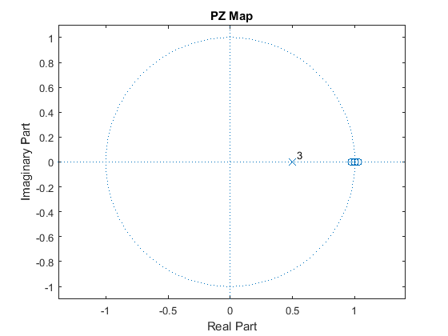

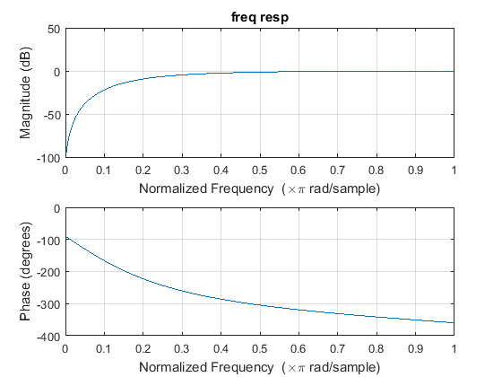

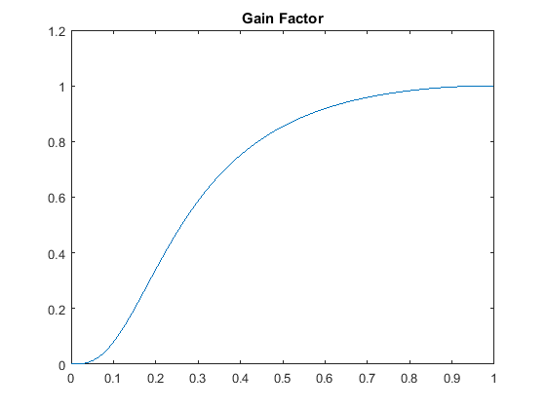

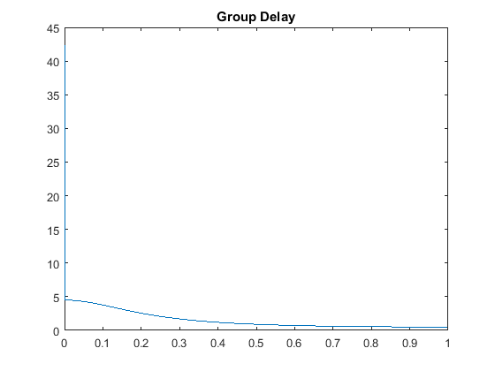

[*Published with MATLAB® R2015a*](http://www.mathworks.com/products/matlab)

**Student's feedback:**Purpose of feedback is to know the strengths and weaknesses of the systemfor future improvements. This feedback is for the 'current lab session'. Circle your choice:

[-3 = Extremely Poor, -2 = Very Poor, -1 = Poor, 0 = Average, 1 = Good, 2 = Very Good, 3 = Excellent]:

The following table should describe your experience with:

|  |  |  |  |
| --- | --- | --- | --- |
| **S#** | **Field** | **Rating** | **Describe in words if required** |
| 1 | Overall Session | |  |  |  |  |  |  |  | | --- | --- | --- | --- | --- | --- | --- | | -3 | -2 | -1 | 0 | 1 | 2 | 3 | |  |
| 2 | Lab Instructor | |  |  |  |  |  |  |  | | --- | --- | --- | --- | --- | --- | --- | | -3 | -2 | -1 | 0 | 1 | 2 | 3 | |  |
| 3 | Lab Staff | |  |  |  |  |  |  |  | | --- | --- | --- | --- | --- | --- | --- | | -3 | -2 | -1 | 0 | 1 | 2 | 3 | |  |
| 4 | Equipment | |  |  |  |  |  |  |  | | --- | --- | --- | --- | --- | --- | --- | | -3 | -2 | -1 | 0 | 1 | 2 | 3 | |  |
| 5 | Atmosphere | |  |  |  |  |  |  |  | | --- | --- | --- | --- | --- | --- | --- | | -3 | -2 | -1 | 0 | 1 | 2 | 3 | |  |

Any other valuable feedback: ______________________________________________________

______________________________________________________________________________

______________________________________________________________________________

______________________________________________________________________________

Student'sSignature: _________________________________

|  |  |  |  |  |  |  |  |
| --- | --- | --- | --- | --- | --- | --- | --- |
| **MARKS AWARDED** | **Attitude** | **Neatness** | **Correctness of results** | **Initiative** | **Originality** | **Conclusion** | **TOTAL** |
| TOTAL | **10** | **10** | **10** | **20** | **20** | **30** | **100** |
| EARNED |  |  |  |  |  |  |  |

Lab Instructor's Comments:________________________________________________________

______________________________________________________________________________

______________________________________________________________________________

______________________________________________________________________________

Lab Instructor's Signature: _________________________________