**DIGITAL SIGNAL PROCESSING LAB**

**(EL-302)**

**LABORATORY MANUAL**

**ENGR. MUHAMMAD IBRAR KHAN**

**IIR Filter Design**

**(LAB # 11)**

Student Name: _______________Kamran_______________________________

Roll No: ____i140420_________ Section: __B_

Date performed: ______25/4____, 2019



____________________________________________________________________________________________________________________________________________________________

**NATIONAL UNIVERSITY OF COMPUTER AND EMERGING SCIENCES, ISLAMABAD**

Prepared by:

Last Edited by:

Verified by:

Engr. Muhammad Asim

Engr. Muhammad Asim, Mar 29, 2016

Dr. Shahzad Saleem

Updated: Spring 2016

|  |  |  |  |  |  |
| --- | --- | --- | --- | --- | --- |
| DSP - Lab | National University | Roll No: __________ | Lab# | **12** |  |
|  | of Computer and Emerging Sciences |  |  |
|  |  |  |  |  |
| (EL302) | Islamabad | Spring 2018 |  |  |  |

_____________________________________________________________________________________

**LPF:**

**Butter:**

clc;

clear all;

close all;

disp('IIR filter design using Butterworth Approximation');

%wp=input('Enter pass band frequency wp ');

%ws=input('Enter stop band frequency ws ');

wp=0.4

ws=0.6

%Error message

if (wp<=0)

error('Pass band edge must be larger than 0');

end

if (wp>=ws)

error('Stop band edge must be smaller than pass band edge');

end

Fs=1;%Fs=input('Enter sampling frequency F in samples/sec ');

%a1=input('Enter pass band ripple in dB ');

%a2=input('Enter stop band ripple in dB ');

ap=-40;as=-60

%conversion of frequency for transformation

Wp=tan(wp*(pi/2))

Ws=tan(ws*(pi/2))

[N,Wc]=buttord(Wp,Ws,ap,as,'s')

[b,a]=butter(N,Wc,'s')

[bz,az]=bilinear(b,a,Fs)

[H,w]=freqz(bz,az,512);

disp('Order of the filter is:');

disp(N);

disp('Filter coefficients are:');

disp('a');

disp(az);

disp('b');

disp(bz);

%Plotting responses

subplot(2,1,1);

plot(w/pi,abs(H));

xlabel('w/pi');

ylabel('|H(w)|');

title('Magnitude response of IIR filter with Butterworth approximation using Bilinear ');

grid on;

subplot(2,1,2);

plot(w/pi,(angle(H)));

xlabel('w/pi');

ylabel('Phase of H(w)');

title('Phase response of IIR filter with Butterworth approximation using Bilinear');

grid on;

**Butter_BPF:**

clc;

clear all;

close all;

disp('IIR filter design using Butterworth Approximation');

ws=[0.2 .8];

wp=[0.5 0.7];

if ((wp(1) || wp(2))<=0)

error('Pass band edge must be larger than 0');

%Error message

end

if (ws<=0)

error('Pass band edge must be larger than 0');

end

if (ws>=wp)

error('Stop band edge must be smaller than pass band edge');

end

Fs=1

a1=-50;

a2=-80;

%conversion and normalization of frequencies

%pi radians/second

%conversion of frequency for transformation

Wp=2*Fs*tan(wp*pi/2);

Ws=2*Fs*tan(ws*pi/2);

[N,Wc]=buttord(Wp,Ws,a1,a2,'s');

[b,a]=butter(N,Wc,'bandpass','s');

[bz,az]=bilinear(b,a,Fs);

[H,w]=freqz(bz,az,512,Fs);

disp('Order of the filter is:');

disp(N);

disp('Filter coefficients are:');

disp('a');

disp(az);

disp('b');

disp(bz);

%Plotting responses

subplot(2,1,1);

plot(w/pi,abs(H));

xlabel('f in Hz');

ylabel('|H(w)|');

title(['Magnitude response of IIR filter with Butterworth approximation using ']);

grid on;

subplot(2,1,2);

plot(w/pi,angle(H));

xlabel('f in Hz');

ylabel('Phase of H(w)');

title(['Phase response of IIR filter with Butterworth approximation using ']); grid on;

**Cheby1_LPF:**

clc;

clear all;

close all;

disp('IIR filter design using Butterworth Approximation');

fp=input('Enter pass band frequency fp in Hz ');

fs=input('Enter stop band frequency fs in Hz ');

%Error message

if fs<=0

error('Pass band edge must be larger than 0');

end

if fs>=fp

error('Stop band edge must be smaller than pass band edge');

end

Fs=input('Enter sampling frequency F in samples/sec ');

a1=input('Enter pass band ripple in dB ');

a2=input('Enter stop band ripple in dB ');

%conversion and normalization of frequencies

%pi radians/second

wp=2*fp/Fs;

ws=2*fs/Fs;

%conversion of frequency for transformation

Wp=2*Fs*tan(wp*pi/2);

Ws=2*Fs*tan(ws*pi/2);

[N,Wc]=cheb1ord(Wp,Ws,a1,a2,'s');

[b,a]=cheby1(N,abs(a1),Wc,'s');

[bz,az]=bilinear(b,a,Fs);

[H,f]=freqz(bz,az,512,Fs);

disp('Order of the filter is:');

disp(N);

disp('Filter coefficients are:');

disp('a');

disp(az);

disp('b');

disp(bz);

%Plotting responses

subplot(2,1,1);

plot(f,abs(H));

xlabel('f in Hz');

ylabel('|H(w)|');

title(['Magnitude response of IIR filter with Butterworth approximation using ']);

grid on;

subplot(2,1,2);

plot(f,angle(H));

xlabel('f in Hz');

ylabel('Phase of H(w)');

title(['Phase response of IIR filter with Butterworth approximation using ']); grid on;

**Cheby1_BPF:**

clc;

clear all;

close all;

disp('IIR filter design using Butterworth Approximation');

fs=input('Enter stop band frequencies fs1 and fs2 (fs2 >fs1) in Hz ');

fp=input('Enter pass band frequencies fp1 and fs2 (fp1 >fs1 and fp2<fp2) in Hz '); if (fp(1) || fp(2))<=0

error('Pass band edge must be larger than 0');

%Error message

end

if fs<=0

error('Pass band edge must be larger than 0');

end

if fs>=fp

error('Stop band edge must be smaller than pass band edge');

end

Fs=input('Enter sampling frequency F in samples/sec ');

a1=input('Enter pass band ripple in dB ');

a2=input('Enter stop band ripple in dB ');

%conversion and normalization of frequencies

%pi radians/second

wp=2*fp/Fs;

ws=2*fs/Fs;

%conversion of frequency for transformation

Wp=2*Fs*tan(wp*pi/2);

Ws=2*Fs*tan(ws*pi/2);

[N,Wc]=cheb1ord(Wp,Ws,a1,a2,'s');

[b,a]=cheby1(N,abs(a1),Wc,'s');

[bz,az]=bilinear(b,a,Fs);

[H,f]=freqz(bz,az,512,Fs);

disp('Order of the filter is:');

disp(N);

disp('Filter coefficients are:');

disp('a');

disp(az);

disp('b');

disp(bz);

%Plotting responses

subplot(2,1,1);

plot(f,abs(H));

xlabel('f in Hz');

ylabel('|H(w)|');

title(['Magnitude response of IIR ',ftype,' filter with Butterworth approximation using ',trans]);

grid on;

subplot(2,1,2);

plot(f,angle(H));

xlabel('f in Hz');

ylabel('Phase of H(w)');

title(['Phase response of IIR ',ftype,' filter with Butterworth approximation using ',trans]); grid on;

**Cheby2_LPF:**

clc;

clear all;

close all;

disp('IIR filter design using Butterworth Approximation');

fp=input('Enter pass band frequency fp in Hz ');

fs=input('Enter stop band frequency fs in Hz ');

%Error message

if fs<=0

error('Pass band edge must be larger than 0');

end

if fs>=fp

error('Stop band edge must be smaller than pass band edge');

end

Fs=input('Enter sampling frequency F in samples/sec ');

a1=input('Enter pass band ripple in dB ');

a2=input('Enter stop band ripple in dB ');

%conversion and normalization of frequencies

%pi radians/second

wp=2*fp/Fs;

ws=2*fs/Fs;

%conversion of frequency for transformation

Wp=2*Fs*tan(wp*pi/2);

Ws=2*Fs*tan(ws*pi/2);

[N,Wc]=cheb2ord(Wp,Ws,a1,a2,'s');

[b,a]=cheby2(N,abs(a1),Wc,'s');

[bz,az]=bilinear(b,a,Fs);

[H,f]=freqz(bz,az,512,Fs);

disp('Order of the filter is:');

disp(N);

disp('Filter coefficients are:');

disp('a');

disp(az);

disp('b');

disp(bz);

%Plotting responses

subplot(2,1,1);

plot(f,abs(H));

xlabel('f in Hz');

ylabel('|H(w)|');

title(['Magnitude response of IIR filter with Butterworth approximation using ']);

grid on;

subplot(2,1,2);

plot(f,angle(H));

xlabel('f in Hz');

ylabel('Phase of H(w)');

title(['Phase response of IIR filter with Butterworth approximation using ']); grid on;

**Cheby2_BPF:**

clc;

clear all;

close all;

disp('IIR filter design using Butterworth Approximation');

fs=input('Enter stop band frequencies fs1 and fs2 (fs2 >fs1) in Hz ');

fp=input('Enter pass band frequencies fp1 and fs2 (fp1 >fs1 and fp2<fp2) in Hz '); if (fp(1) || fp(2))<=0

error('Pass band edge must be larger than 0');

%Error message

end

if fs<=0

error('Pass band edge must be larger than 0');

end

if fs>=fp

error('Stop band edge must be smaller than pass band edge');

end

Fs=input('Enter sampling frequency F in samples/sec ');

a1=input('Enter pass band ripple in dB ');

a2=input('Enter stop band ripple in dB ');

%conversion and normalization of frequencies

%pi radians/second

wp=2*fp/Fs;

ws=2*fs/Fs;

%conversion of frequency for transformation

Wp=2*Fs*tan(wp*pi/2);

Ws=2*Fs*tan(ws*pi/2);

[N,Wc]=cheb2ord(Wp,Ws,a1,a2,'s');

[b,a]=cheby2(N,abs(a1),Wc,'s');

[bz,az]=bilinear(b,a,Fs);

[H,f]=freqz(bz,az,512,Fs);

disp('Order of the filter is:');

disp(N);

disp('Filter coefficients are:');

disp('a');

disp(az);

disp('b');

disp(bz);

%Plotting responses

subplot(2,1,1);

plot(f,abs(H));

xlabel('f in Hz');

ylabel('|H(w)|');

title(['Magnitude response of IIR ',ftype,' filter with Butterworth approximation using ',trans]);

grid on;

subplot(2,1,2);

plot(f,angle(H));

xlabel('f in Hz');

ylabel('Phase of H(w)');

title(['Phase response of IIR ',ftype,' filter with Butterworth approximation using ',trans]); grid on;

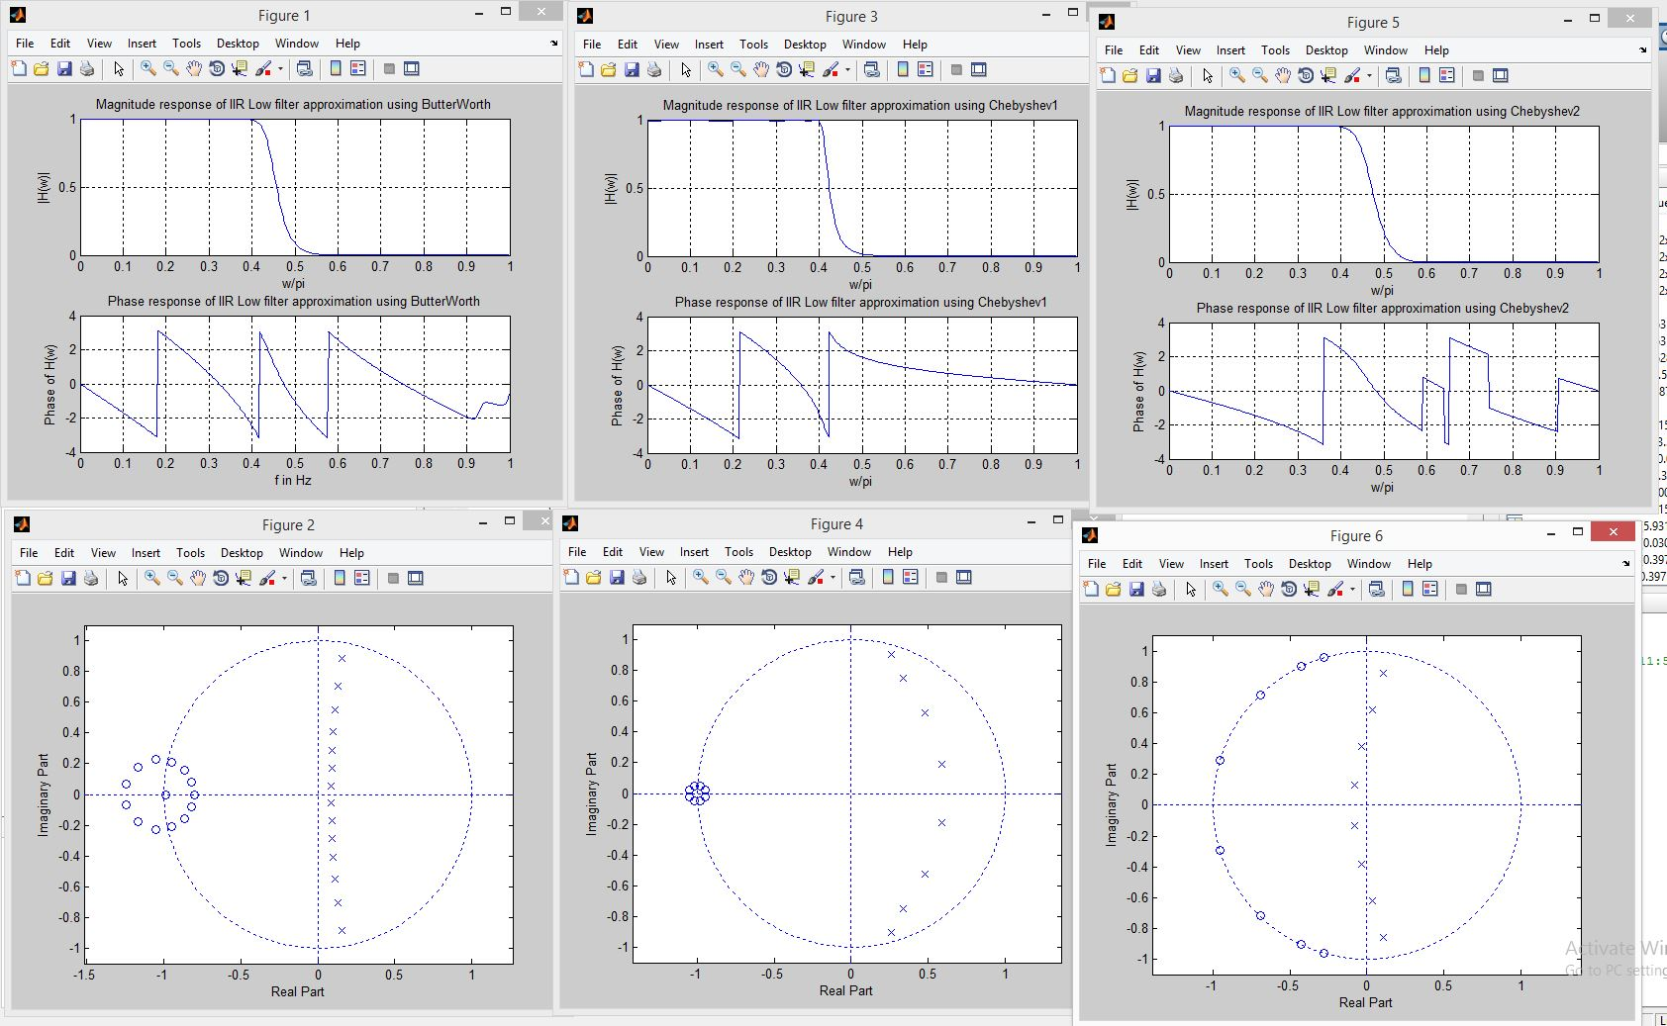

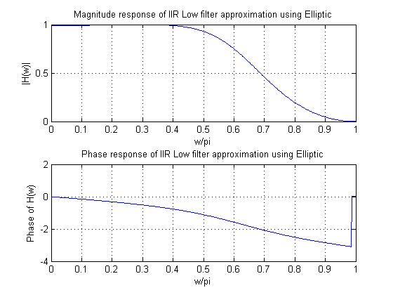

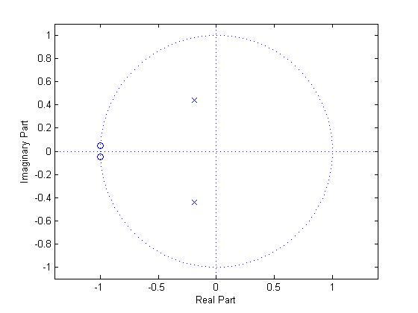

**Task#2IIR bandpass Filter Design:**

Consider the band-pass discrete time filter specification,

*0.99≤|H(ejw)| ≤1.01 , 0.45 π≤|w|≤0.6π,*

*|H(ejw)| ≤0.001 , 0.75π ≤|w|≤ π, 0 ≤|w|≤0.3 π*

Design using MATLAB this band-pass filter by butterworth, Chebyshev( I and II), elliptic approximation. Plot the gain response, detailted plot of magnitude in pass-band and pole-zero plot for each approximation

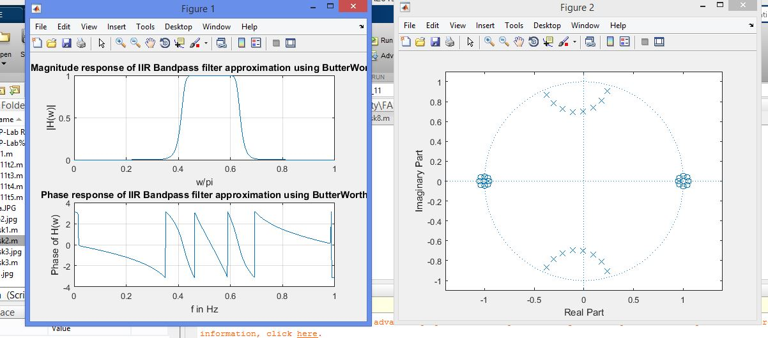

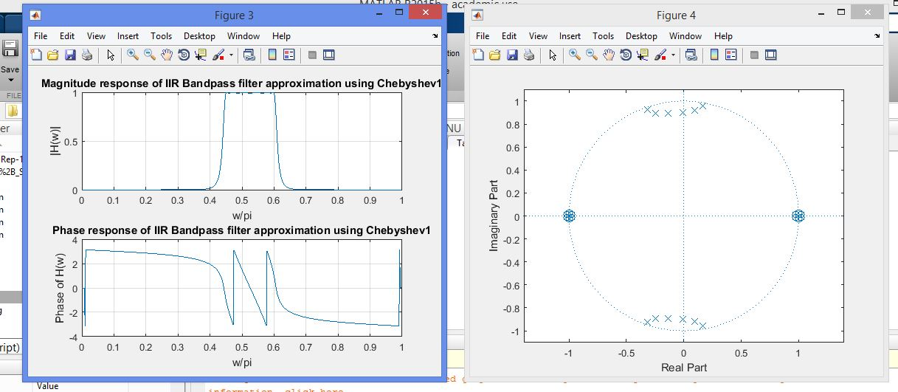

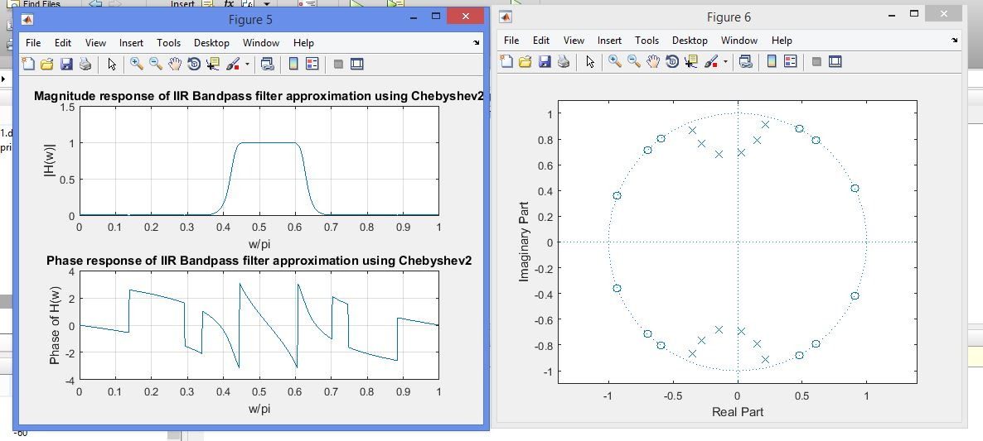

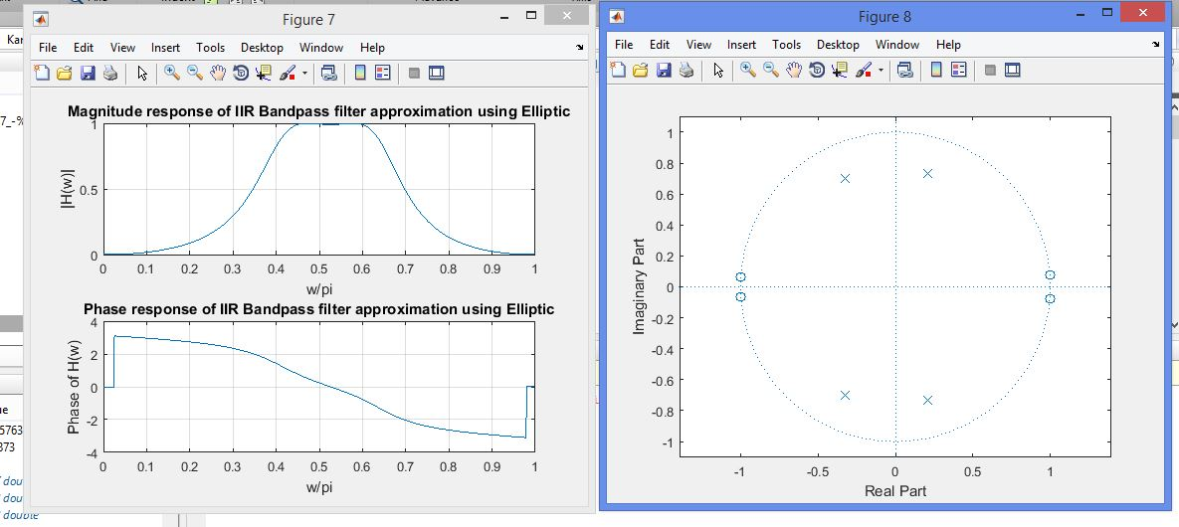

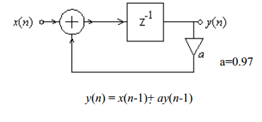

**Task#3:** Generate the code for the given IIR filter, having the coefficient b0=0, b1= 1 and a0=1, a1=0.97.Taking impulse signal as x(n) having 80 samples.

a0=1;

a1=0.97;

b0=0;

b1=1;

a=[a0 a1]

b=[b0 b1]

impz(b,a,80);

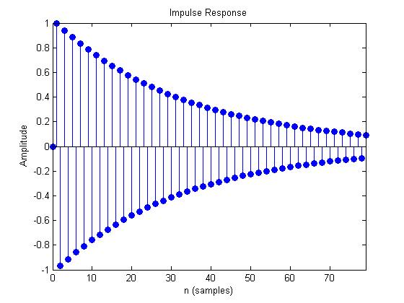

**Student's feedback:**Purpose of feedback is to know the strengths and weaknesses of the systemfor future improvements. This feedback is for the 'current lab session'. Circle your choice:

[-3 = Extremely Poor, -2 = Very Poor, -1 = Poor, 0 = Average, 1 = Good, 2 = Very Good, 3 = Excellent]:

The following table should describe your experience with:

|  |  |  |  |
| --- | --- | --- | --- |
| **S#** | **Field** | **Rating** | **Describe in words if required** |
| 1 | Overall Session | |  |  |  |  |  |  |  | | --- | --- | --- | --- | --- | --- | --- | | -3 | -2 | -1 | 0 | 1 | 2 | 3 | |  |
| 2 | Lab Instructor | |  |  |  |  |  |  |  | | --- | --- | --- | --- | --- | --- | --- | | -3 | -2 | -1 | 0 | 1 | 2 | 3 | |  |
| 3 | Lab Staff | |  |  |  |  |  |  |  | | --- | --- | --- | --- | --- | --- | --- | | -3 | -2 | -1 | 0 | 1 | 2 | 3 | |  |
| 4 | Equipment | |  |  |  |  |  |  |  | | --- | --- | --- | --- | --- | --- | --- | | -3 | -2 | -1 | 0 | 1 | 2 | 3 | |  |
| 5 | Atmosphere | |  |  |  |  |  |  |  | | --- | --- | --- | --- | --- | --- | --- | | -3 | -2 | -1 | 0 | 1 | 2 | 3 | |  |

Any other valuable feedback: ______________________________________________________

______________________________________________________________________________

______________________________________________________________________________

______________________________________________________________________________

Student'sSignature: _________________________________

|  |  |  |  |  |  |  |  |
| --- | --- | --- | --- | --- | --- | --- | --- |
| **MARKS AWARDED** | **Attitude** | **Neatness** | **Correctness of results** | **Initiative** | **Originality** | **Conclusion** | **TOTAL** |
| TOTAL | **10** | **10** | **10** | **20** | **20** | **30** | **100** |
| EARNED |  |  |  |  |  |  |  |

Lab Instructor's Comments:________________________________________________________

______________________________________________________________________________

______________________________________________________________________________

______________________________________________________________________________

Lab Instructor's Signature: _________________________________