**DIGITAL SIGNAL PROCESSING LAB**

**(EL-302)**

**LABORATORY MANUAL**

**ENGR. MUHAMMAD IBRAR KHAN**

**FIR Filter Design**

**(LAB # 13)**

Student Name: _______________Kamran_______________________________

Roll No: _______i140420_________ Section: __B__

Date performed: ______9/5_______, 2019



____________________________________________________________________________________________________________________________________________________________

**NATIONAL UNIVERSITY OF COMPUTER AND EMERGING SCIENCES, ISLAMABAD**

Prepared by:

Last Edited by:

Verified by:

Engr. Muhammad Asim

Engr. Muhammad Asim, Apr 10, 2016

Dr. Shahzad Saleem

Updated: Spring 2016

|  |  |  |  |  |  |
| --- | --- | --- | --- | --- | --- |
| DSP - Lab | National University | Roll No: __________ | Lab# | **13** |  |
|  | of Computer and Emerging Sciences |  |  |
|  |  |  |  |  |
| (EL302) | Islamabad | Spring 2019 |  |  |  |

_____________________________________________________________________________________

**Task1:**

**Type1:**

close all  
clear all  
w=0:4;  
b=[2 3 0 3 2] ;  
a=[1];  
zplane(b,a);  
l=length(b);  
x=ones(1,l);  
[h]=filter(b,a,x);  
figure  
subplot 311  
plot(w,abs(h))  
xlabel('w')  
ylabel('Magnitude')  
title('Frequency Response')  
subplot 312  
plot(w,angle(h))  
xlabel('w')  
ylabel('Phase')  
title('Phase Response')  
subplot 313  
grpdelay(b,a)

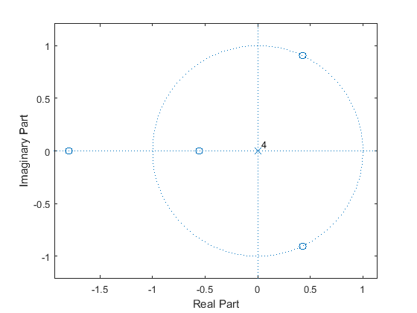

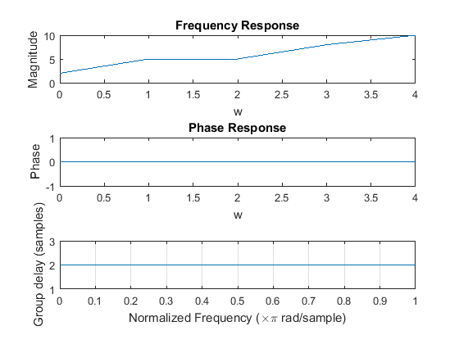

[*Published with MATLAB® R2015a*](http://www.mathworks.com/products/matlab)

**Type2:**

close all  
clear all  
w=0:3;  
b=[2 3 3 2] ;  
a=[1];  
zplane(b,a)  
l=length(b)  
x=ones(1,l)  
[h]=filter(b,a,x)  
figure  
subplot 311  
plot(w,abs(h))  
xlabel('w')  
ylabel('Magnitude')  
title('Frequency Response')  
subplot 312  
plot(w,angle(h))  
xlabel('w')  
ylabel('Phase')  
title('Phase Response')  
subplot 313  
grpdelay(b,a)

l =  
  
 4  
  
  
x =  
  
 1 1 1 1  
  
  
h =  
  
 2 5 8 10

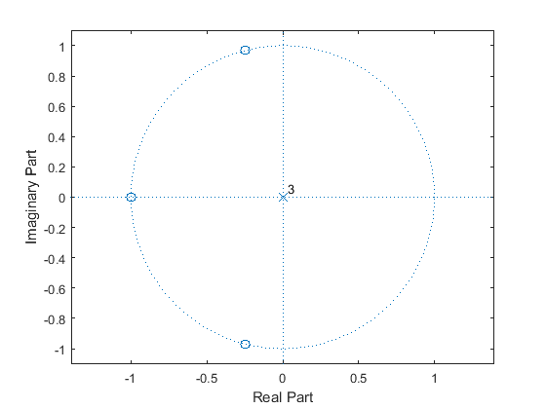

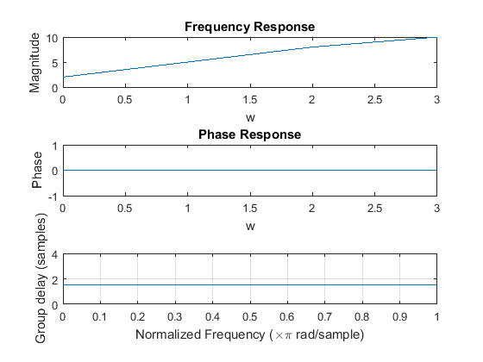

[*Published with MATLAB® R2015a*](http://www.mathworks.com/products/matlab)

**Type3:**

close all  
clear all  
w=0:4;  
b=[1 2 0 -2 -1] ;  
a=[1];  
zplane(b,a);  
l=length(b);  
x=ones(1,l);  
[h]=filter(b,a,x);  
figure  
subplot 311  
plot(w,abs(h))  
xlabel('w')  
ylabel('Magnitude')  
title('Frequency Response')  
subplot 312  
plot(w,angle(h))  
xlabel('w')  
ylabel('Phase')  
title('Phase Response')  
subplot 313  
grpdelay(b,a)

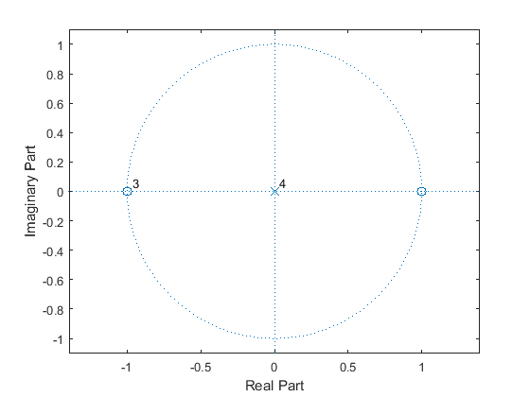

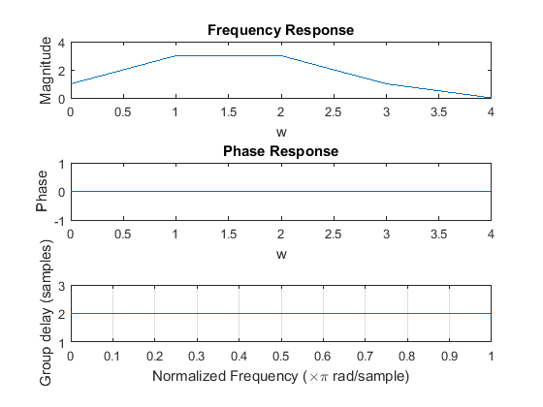

[*Published with MATLAB® R2015a*](http://www.mathworks.com/products/matlab)

**Type4:**

close all  
clear all  
w=0:3;  
b=[1 2 -2 -1] ;  
a=[1];  
zplane(b,a);  
l=length(b);  
x=ones(1,l);  
[h]=filter(b,a,x);  
figure  
subplot 311  
plot(w,abs(h))  
xlabel('w')  
ylabel('Magnitude')  
title('Frequency Response')  
subplot 312  
plot(w,angle(h))  
xlabel('w')  
ylabel('Phase')  
title('Phase Response')  
subplot 313  
grpdelay(b,a)

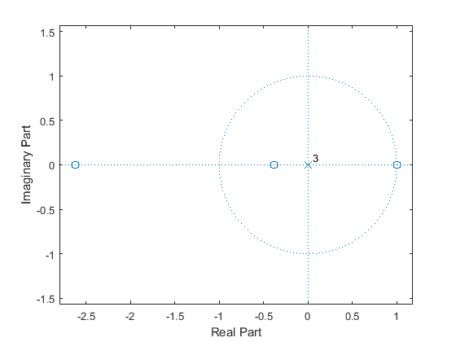

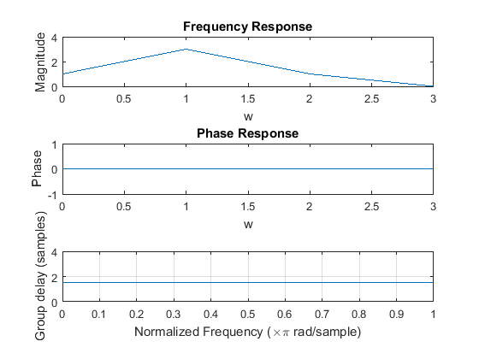

[*Published with MATLAB® R2015a*](http://www.mathworks.com/products/matlab)

**5) Exercise:**

**Task#1: Window-Based FIR filter design:**

Consider the low-pass specification for the design of Kaiser window

*1-δs≤|H(ejw)| ≤1+ δs* *,* *|w|≤0.3 π,*

*|H(ejw)| ≤ δs* *,* *0.4 π ≤|w|≤ π*

Where *δs* =0.003162. Plot using MATLAB the gain response of kasier window.

**LPF:**

fc=input('Enter cut-off frequency fc in Hz ');

if fc<=0

error('Cut-off frequency must be larger than zero');

end

Fs=input('Enter sampling frequency F in samples/sec ');

N=input('Enter the order of the filter ');

%length of filter

M=N+1;

%conversion and normalization of frequencies

%pi radians/second

wc=2*fc/Fs;

%input to window type

wintype=input('Enter the window (Rectangular,Bartlett,Hann,Hamming,Blackman, Kaiser): ');

switch wintype

case 'Rectangular'

%Rectangular window

w=rectwin(M);

case 'Bartlett'

%Bartlett window

w=bartlett(M);

case 'Hann'

%Hanning window

w=hann(M);

case 'Hamming'

%Hamming window

w=hamming(M);

case 'Blackman'

%Blackmann window

w=blackman(M);

case 'Kaiser'

%Kaiser window

beta=input('Enter shape parameter beta');

w=kaiser(M,beta);

end

%Digital filter response

bz=fir1(N,wc,w);

%Frequency response

[H,f]=freqz(bz,1,512,Fs);

%display H(z)

disp('Filter coefficients are:');

disp('b');

disp(bz);

%Plotting windows and responses

n=0:1:M-1;

subplot(3,1,1);

plot (n,w)

xlabel('n');

ylabel('w(n)');

title([wintype,' window for FIR ',ftype]);

subplot(3,1,2);

plot(f,20*log10(abs(H)));

xlabel('f in Hz');

ylabel('H(w)in dB');

title(['Magnitude response of FIR ',ftype,' filter with ',wintype,' window']);

grid on;

subplot(3,1,3);

plot(f,angle(H));

xlabel('f in Hz');

ylabel('Phase of H(w)');

title(['Phase response of FIR ',ftype,' filter with ',wintype,' window']);

grid on;

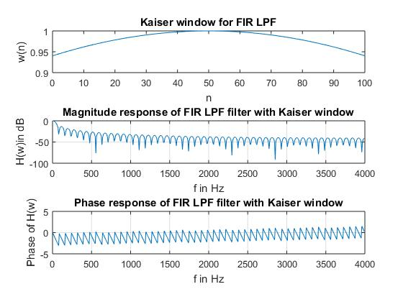



**Task#2:** Generate the code for the given FIR filter, having the coefficient b0=1, b1= -1and b2=1. Taking sinusoid as x(n) having 80 samples, frequency =1/8 and phase= pi/6.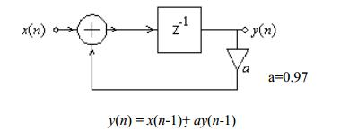

close all  
clear all  
b=[1 -1 1]  
a=[1];  
n=1:80;  
x=sin(2*pi*1/8*n+(pi/6));  
y=filter(b,a,x);  
plot(n,abs(y))  
xlabel('w/pi')  
ylabel('Magnitude')  
figure  
freqz(b,a)

b =  
  
 1 -1 1

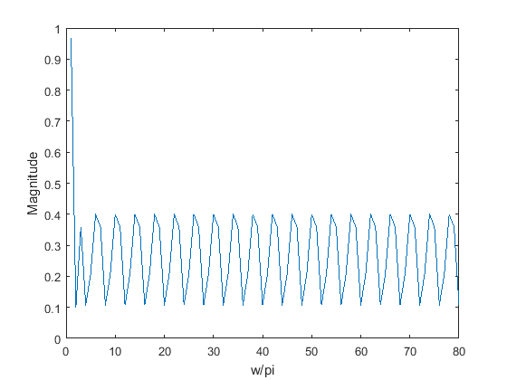

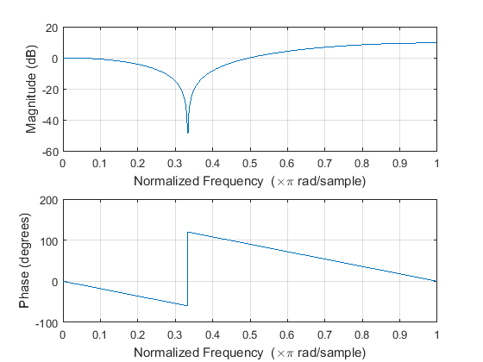

[*Published with MATLAB® R2015a*](http://www.mathworks.com/products/matlab)