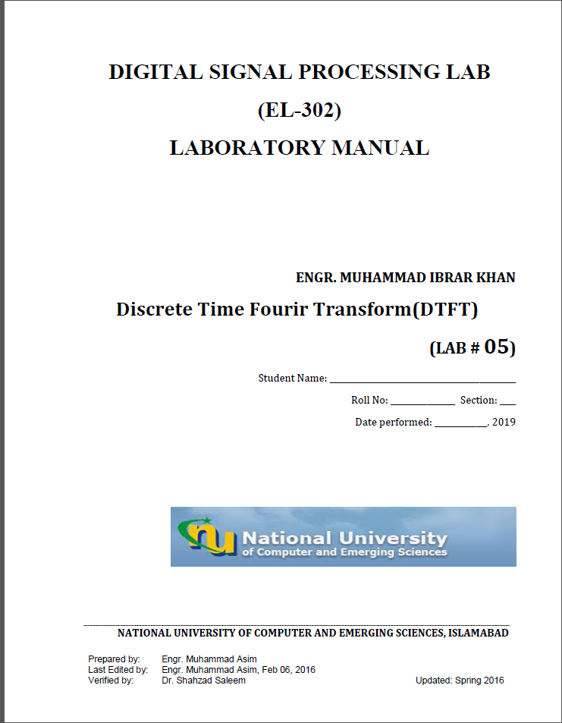

**Task-4:**

k=0:511;

w=k*(pi/511);

n=0:8;

g=[1 3 5 7 9 11 13 15 17];

G=g*exp(-j*pi/511).^(n'*k);

subplot(211)

plot((w/pi),abs(G))

title('mag')

xlabel('w/pi');

ylabel('magnitude');

subplot(212)

plot((w/pi),angle(G))

title('Phase')

xlabel('w/pi');

ylabel('phase');

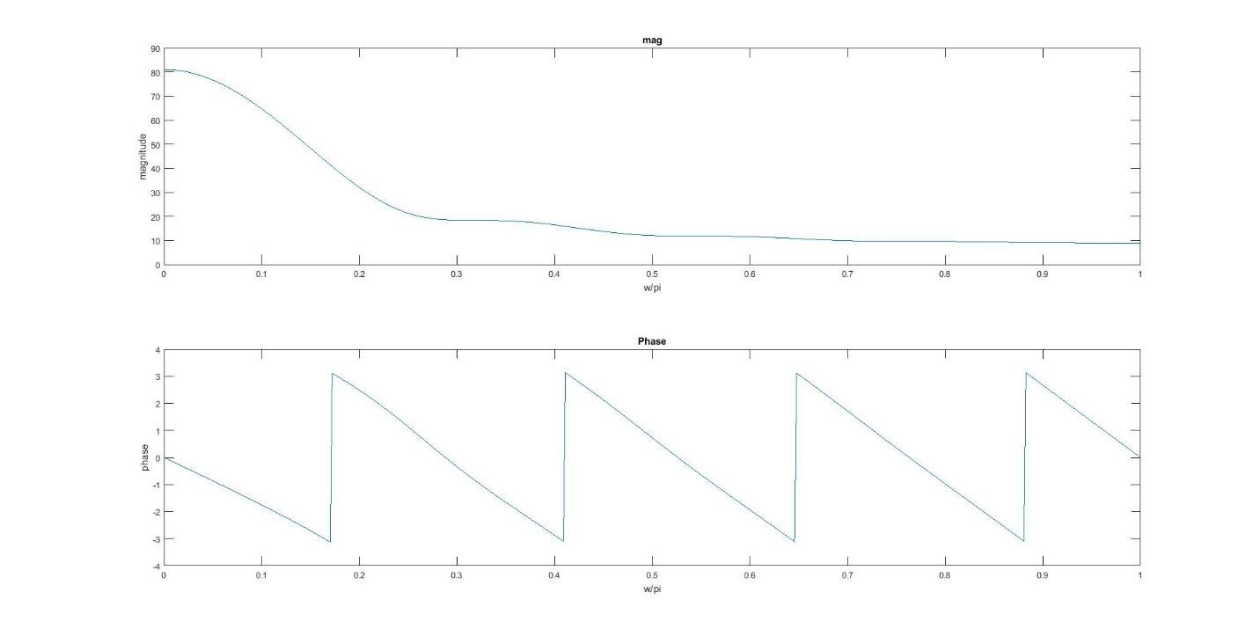

**Task-4b:**

k=0:511;

w=k*(pi/511);

n=0:8;

g=[1 3 5 7 9 11 13 15 17];

G=g*exp(-j*pi/511).^(n'*k);

subplot(211)

plot((w/pi),abs(G))

title('mag')

xlabel('w/pi');

ylabel('magnitude');

subplot(212)

plot((w/pi),(angle(G)*57.3))

title('Phase')

xlabel('w/pi');

ylabel('phase');

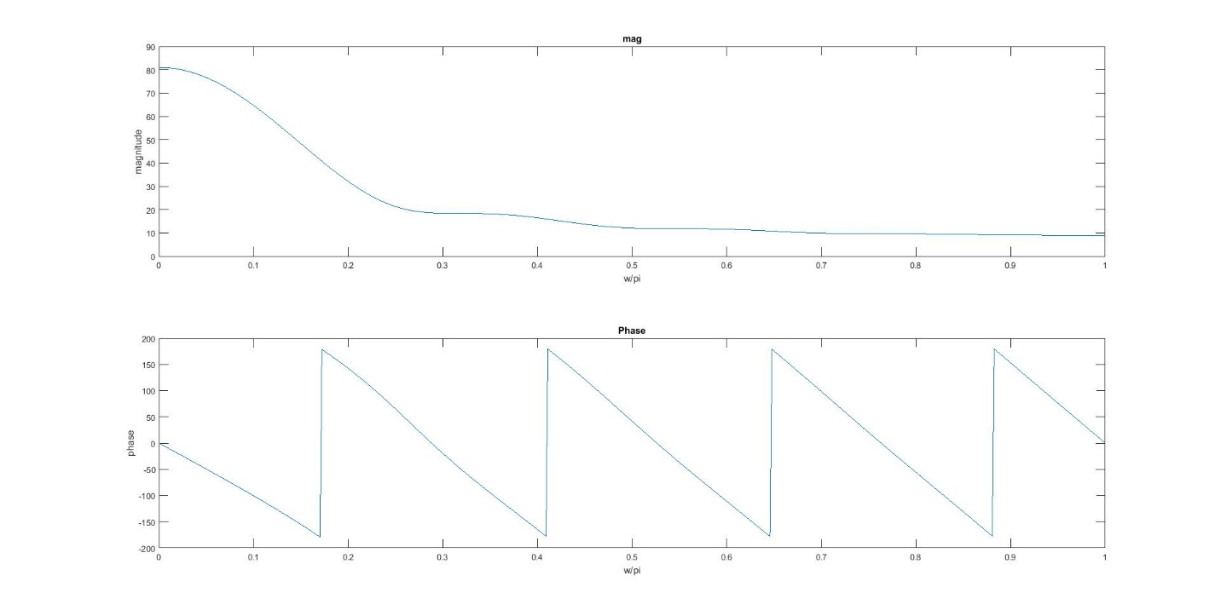

**Task-5_1:**

k=-256:256;

w=k*(pi/256);

n=0:8;

g=[1 2 3 4 5 6 7 8 9];

G=g*exp(-j*pi/511).^(n'*k);

subplot(211)

plot((w/pi),abs(G))

title('mag')

xlabel('w/pi');

ylabel('magnitude');

subplot(212)

plot((w/pi),(angle(G)))

title('Phase')

xlabel('w/pi');

ylabel('phase');

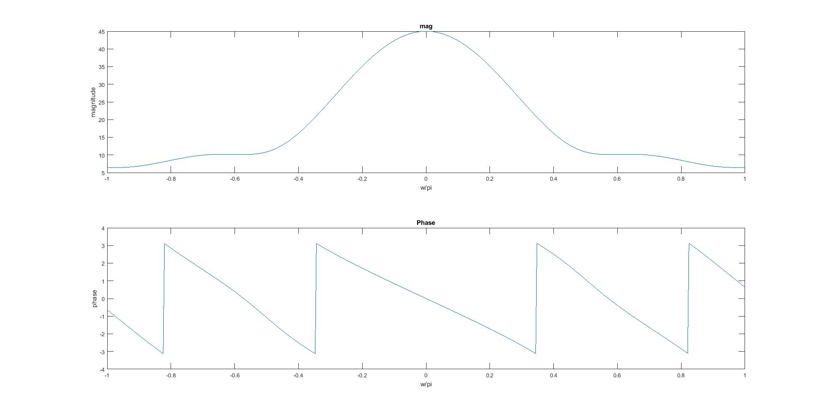

**Task-5_2:**

clear all

close all

w=[-pi:(pi/512):pi];

n0=10;

g=[1 2 3 4 5 6 7 8 9];

b=[1];

G=freqz(g,b,w);

G1=G.*exp(-j*w*n0);

g2=[zeros(1,10) g];

G2=freqz(g2,b,w);

subplot(411)

plot((w/pi),abs(G1))

title('Freq dom shifted ')

xlabel('w/pi');

ylabel('magnitude');

subplot(412)

plot((w/pi),phase(G1))

title('Freq dom shifted ')

xlabel('w/pi');

ylabel('phase');

subplot(413)

plot((w/pi),abs(G2))

title('Time dom shifted ')

xlabel('w/pi');

ylabel('magnitude');

subplot(414)

plot((w/pi),phase(G2))

title('Time dom shifted ')

xlabel('w/pi');

ylabel('phase');

max(abs(G1-G2))

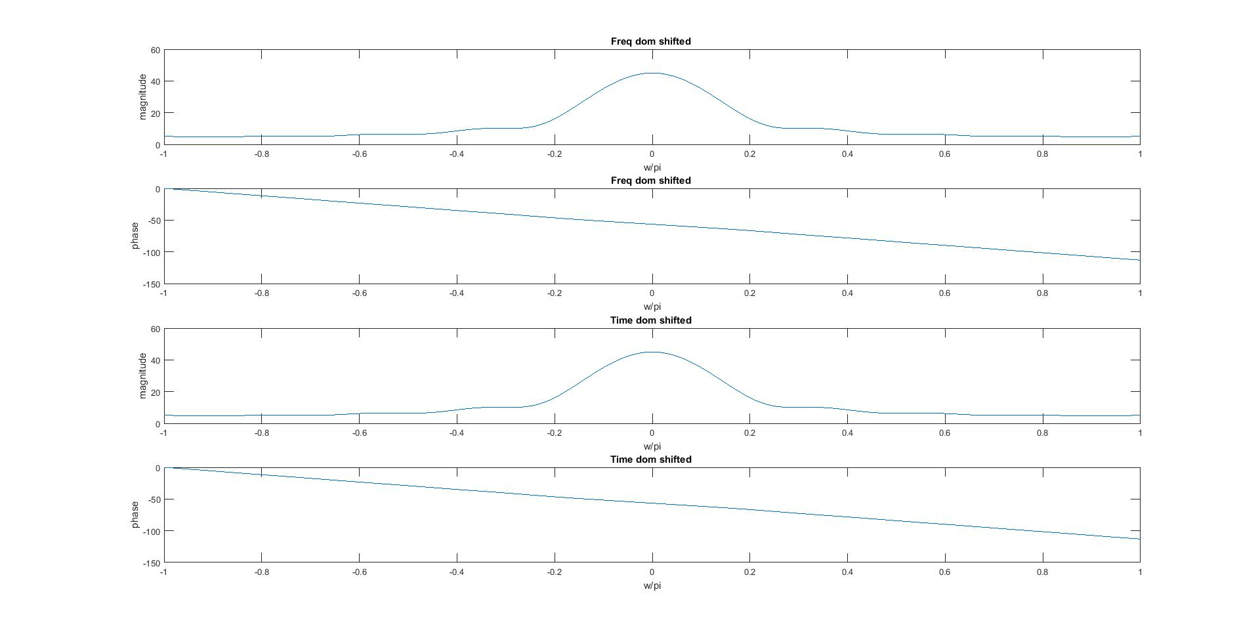

**error =2.4161e-14**

**Task5_3:**

clear all

close all

w=[-pi:(pi/511):pi];

w0=0.5*pi;

g=[1 2 3 4 5 6 7 8 9];

n=length(g);

b=[1];

G=g.*exp(j*w0*n);

G1=freqz(g,b,w);

G2=freqz(G,b,w);

subplot(411)

plot((w/pi),abs(G1))

title('Freq dom shifted ')

xlabel('Time');

ylabel('magnitude');

subplot(412)

plot((w/pi),phase(G1))

title('Freq dom shifted ')

xlabel('Time');

ylabel('phase');

subplot(413)

plot((w/pi),abs(G2))

title('Time dom shifted ')

xlabel('Time');

ylabel('magnitude');

subplot(414)

plot((w/pi),phase(G2))

title('Time dom shifted ')

xlabel('Time');

ylabel('phase');

max(abs(G1-G2))

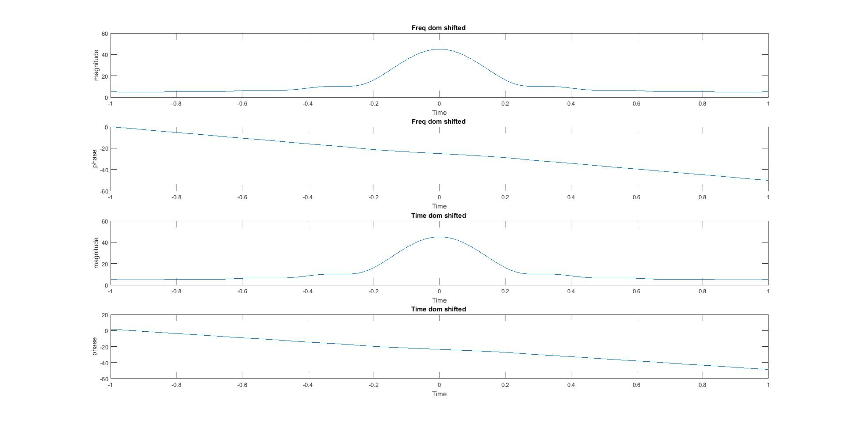

**error=**

**63.6396**

**Task-6:**

clear all

close all

w=[-pi:(pi/256):pi];

b=[1];

g=[1 2 3 4 5 6 7 8 9];

n=length(g);

h=[1 -2 3 -2 1];

newcon=conv(g,h);

G=freqz(newcon,b,w);

G1=freqz(g,b,w);

G2=freqz(h,b,w);

freqcon=G1.*G2;

subplot(411)

plot((w/pi),abs(G))

title('Time dom shifted ')

xlabel('w/pi');

ylabel('magnitude');

subplot(412)

plot((w/pi),57.3*angle(G))

title('Time dom shifted ')

xlabel('w/pi');

ylabel('phase');

subplot(413)

plot((w/pi),abs(freqcon))

title('Freq dom shifted ')

xlabel('w/pi');

ylabel('magnitude');

subplot(414)

plot((w/pi),57.3*angle(freqcon))

title('Freq dom shifted ')

xlabel('w/pi');

ylabel('phase');

error=max(abs(G-freqcon))

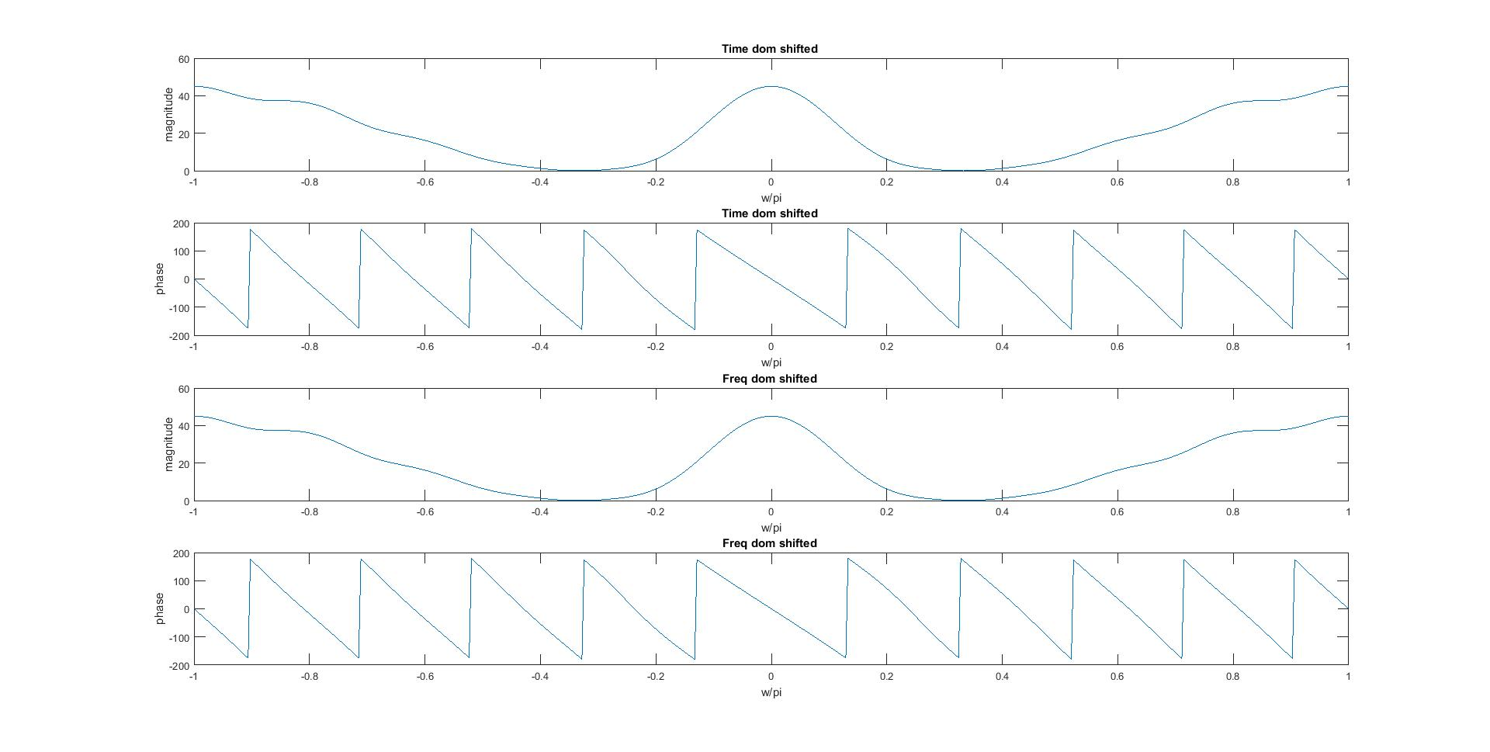

**error =**

**1.5897e-13**