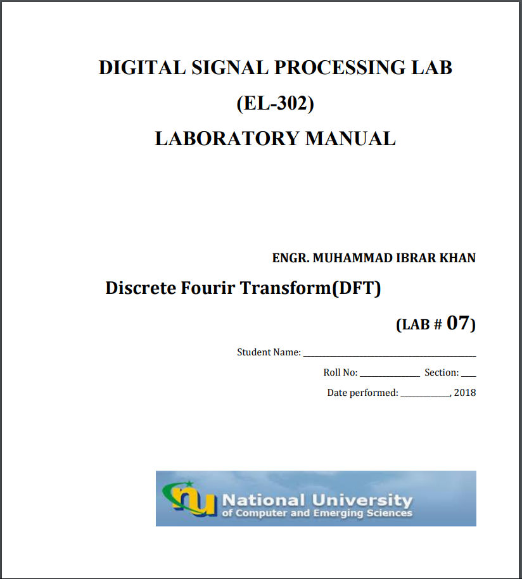

**Task-1:**

close all; clear all

n=0:1:31;

k=0:31;

N=length(n);

w=k*(pi/N);

f1=200;

f2=600;

f3=1300;

Fs=3000;

x=sin((2*pi*f1*n)/Fs)+sin((2*pi*f2*n)/Fs)+sin((2*pi*f3*n)/Fs);

subplot(411)

stem(n,x);

title('Original')

xlabel('\omega/\pi')

ylabel('Amplitude')

D=exp(-j*2*pi/N).^(n'*k);

X=x*D;

k=0:1:N-1;

[Xdtft,w]=freqz(x);

subplot(412)

title('Magnitude')

xlabel('\omega/\pi')

ylabel('Amplitude')

stem(k,abs(X))

hold on

line(w,abs(Xdtft))

subplot(413)

title('Phase')

xlabel('\omega/\pi')

ylabel('Rads')

stem(k,angle(X))

hold on

line(w,angle(Xdtft))

C=conj(D);

xidft=(1/N)*X*C;

subplot(414)

stem(n,xidft)

title('xidft')

xlabel('\omega/\pi')

ylabel('Amplitude')

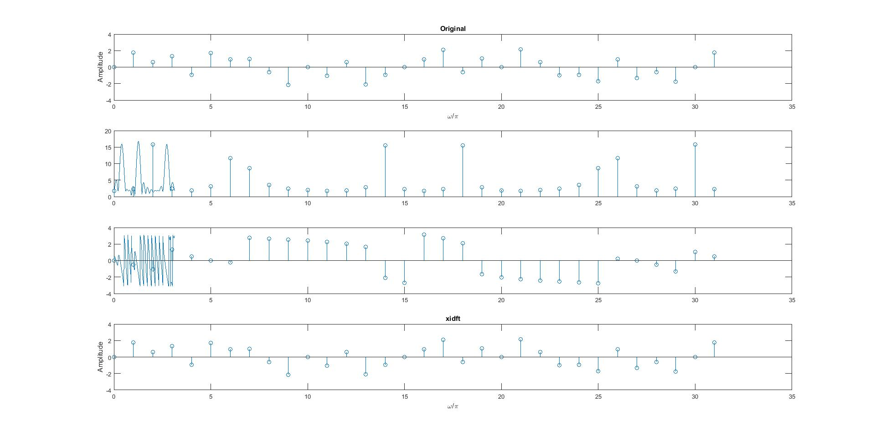

**Task-2:**

**a)**

function [X] =dft(n,x,N);

k=n;

D=exp(-j*2*pi/N).^(n'*k);

X=x*D;

close all

clear all

n=0:1:31;

k=0:31;

N=length(n);

w=k*(pi/N);

f1=200;

f2=600;

f3=1300;

Fs1=3000;

Fs2=3200;

x1=sin((2*pi*f1*n)/Fs1)+sin((2*pi*f2*n)/Fs1)+sin((2*pi*f3*n)/Fs1);

X1=dft(n,x1,N);

subplot(211)

stem((w/pi),abs(X1))

x2=sin((2*pi*f1*n)/Fs2)+sin((2*pi*f2*n)/Fs2)+sin((2*pi*f3*n)/Fs2);

X2=x2*exp(-j*2*pi/N).^(n'*k);

subplot(212)

stem(w/pi,abs(X2))

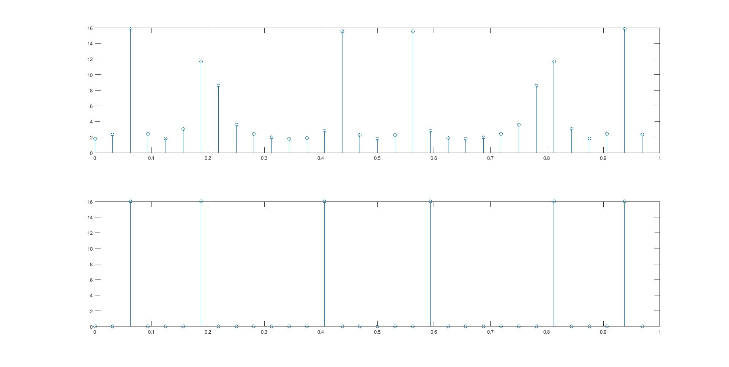

**b)**

function [idx] =idft(n,X,N);

k=n;

D=exp(-j*2*pi/N).^(n'*k);

X=x*D;

C=conj(D);

idx=(1/N)*X*C;

**Task-3:**

n=[0:1:200];

N=length(n);

f1=900;

Fs=2000;

x=sin((2*pi*f1*n)/Fs);

y=fft(x,N);

subplot(211)

stem(n,abs(y))

title('Magnitude')

xlabel('t')

ylabel('Amplitude')

subplot(212)

stem(n,angle(y))

title('Phase')

xlabel('t')

ylabel('Rads')

k1=(f1*N)/Fs

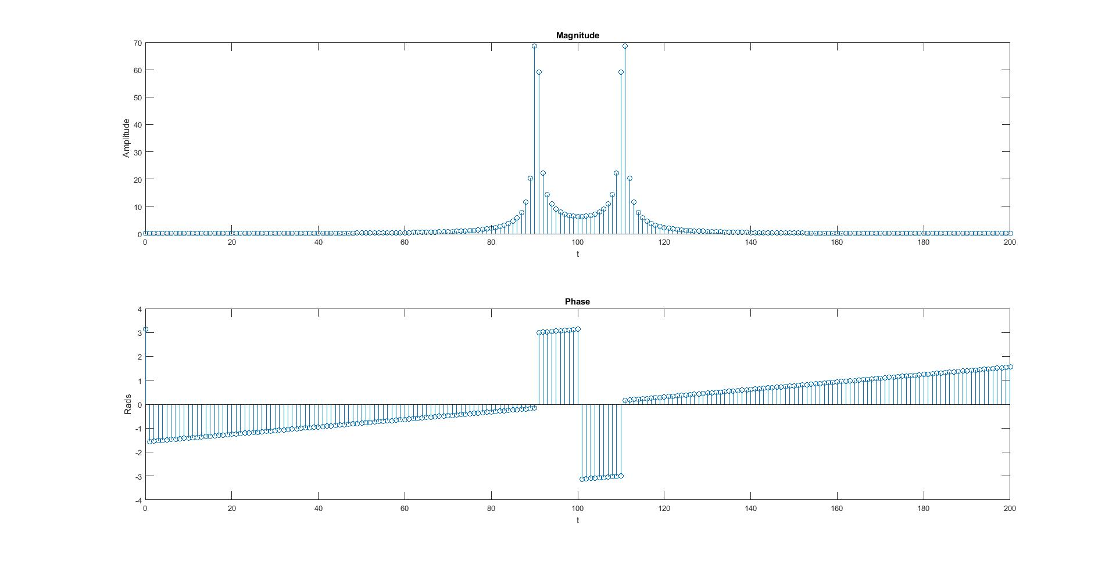

**K=90.45**