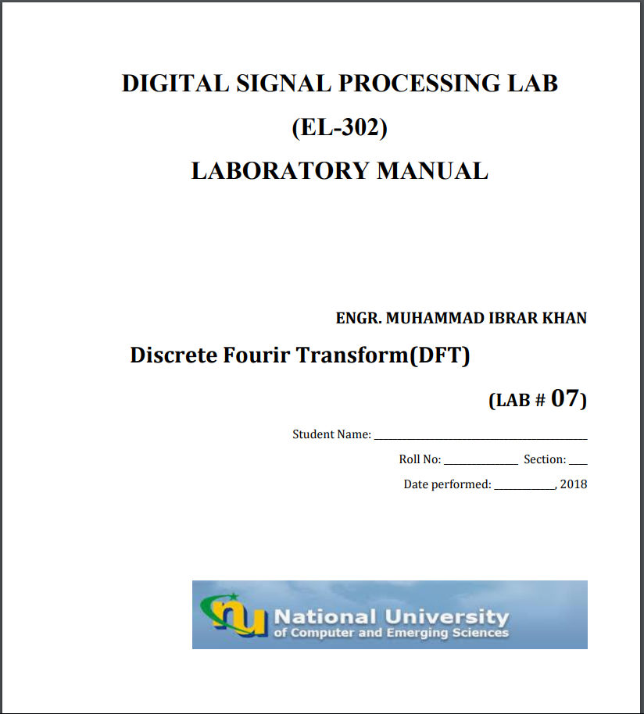

**Task1(4) b:**

close all  
clear all  
n0=5;  
n=0:7;  
k=0:7;  
N=length(n);  
D=exp(-j*2*pi*n0/N).^(k);  
g=sin(2*pi*0.5*n);  
subplot(311)  
stem(g)  
title('Sinusoidal Signal')  
xlabel('t')  
ylabel('Amplitude')  
[newsig,newn]=Kcircshifty(g,n,n0);  
stem(newsig)  
G=fft(newsig);  
  
newG=fft(g);  
subplot (312)  
stem(newn,abs(G))  
title('time dom Circ-shifted')  
xlabel('w/pi')  
ylabel('Amplitude')  
subplot (313)  
stem(n,abs(newG))  
title('Original time dom')  
xlabel('w/pi')  
ylabel('Amplitude')  
max(abs(newG-G))

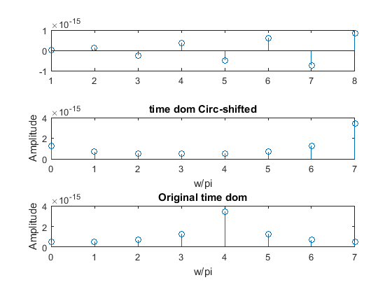

[*Published with MATLAB® R2015a*](http://www.mathworks.com/products/matlab)

**Task1(4) c:**

close all  
clear all  
n0=5;  
n=0:7;  
k=n;  
N=length(n)  
g=sin(2*pi*0.5*n);  
D=exp(j*2*pi*n/N).^(5);  
subplot(311)  
stem(g)  
title('Sinusoidal Signal')  
xlabel('t')  
ylabel('Amplitude')  
expomultd=g.*D;  
G=fft(expomultd);  
  
newG=fft(g);  
subplot (312)  
stem(((2*pi*n)/8),abs(G))  
title('time dom Exponential Multiplied')  
xlabel('w/pi')  
ylabel('Amplitude')  
subplot (313)  
stem(((2*pi*n)/8),abs(newG))  
title('original time dom')  
xlabel('w/pi')  
ylabel('Amplitude')  
max(abs(G-newG))

ans =  
  
 3.9241e-15

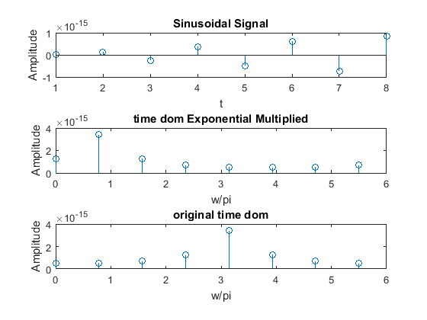

[*Published with MATLAB® R2015a*](http://www.mathworks.com/products/matlab)

**Task2(5) :**

n1=0:6;  
n2=0:6;  
N=length(n1)  
g=sin(2*pi*0.5*n1)  
h=sin(2*pi*0.3*n2)  
y1=cconv(g,h,N)  
Y1=fft(y1)  
  
  
G=fft(g)  
H=fft(h)  
Y2=G.*H  
  
subplot 211  
stem(((2*pi*n1)/6),abs(Y1))  
title('Circ-convolvedd in t dom')  
xlabel('w/pi')  
ylabel('Amplitude')  
  
subplot 212  
stem(((2*pi*n2)/6),abs(Y2))  
title('Freq dom multiplied')  
xlabel('w/pi')  
ylabel('Amplitude')  
max(abs(Y2-Y1))

ans =  
  
 1.7256e-31  
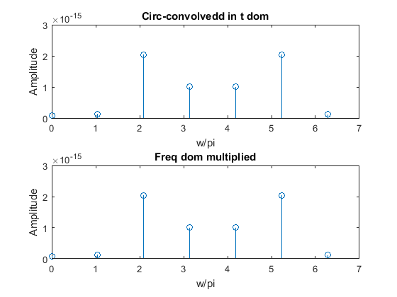

[*Published with MATLAB® R2015a*](http://www.mathworks.com/products/matlab)

**Task3(6) :**

function [y,newn]=Kcircshifty(x,n,n0)  
N=length(n);  
y=x;  
for i=1:N  
newn(i)=mod((n(i)-n0),N)  
end  
end

[*Published with MATLAB® R2015a*](http://www.mathworks.com/products/matlab)

close all  
clear all  
n=0:6;  
m=0:9;  
N=length(n)  
M=length(m)  
g=sin(2*pi*0.5*n)  
h=sin(2*pi*0.3*m)  
y=conv(g,h);  
newg=[g zeros(1,(M-1))];  
newh=[h zeros(1,(N-1))];  
G=fft(newg);  
H=fft(newh);  
newY=G.*H;  
y1=ifft(newY)  
max(abs(y1-y))  
newn=0:15;  
NewN=length(newn)  
subplot(211)  
  
stem(((2*pi*newn)/NewN),y)  
title('linear conv')  
xlabel('t')  
ylabel('Amplitude')  
subplot(212)  
stem(((2*pi*newn)/NewN),y1)  
title('circ conv')  
xlabel('t')  
ylabel('Amplitude')

ans =  
  
 1.9722e-31

