DIGITAL SIGNAL PROCESSING LAB

(EL-302)

LABORATORY MANUAL

ENGR. MUHAMMAD IBRAR KHAN

BASIC CONCEPTS OF DIGITAL SIGNAL PROCESSING (LAB # 02)

Student Name: ______________________Kamran________________________

Roll No: ______i140420__________ Section: ___B_

Date performed: __________7/2___, 2019


____________________________________________________________________________________________________________________________________________________________

NATIONAL UNIVERSITY OF COMPUTER AND EMERGING SCIENCES, ISLAMABAD

Prepared by:

Last Edited by:

Verified by:

Engr. Muhammad Asim

Engr. Muhammad Asim, Jan 20, 2016

Dr. Shahzad Saleem

Updated: Spring 2016

DSP - Lab | National University | Roll No: __________ | Lab# | 02
 | of Computer and Emerging Sciences |  | Lab# | 02
(EL302) | Islamabad | Spring 2019
_________________________________________________________________________________

Lab # 02: BASIC CONCEPTS OF DIGITAL SIGNAL PROCESSING
Task#05:
Generate a multi-tone sinusoidal signal with f₁=2000Hz and f₂=4000Hz, then by sampling generate the Oversampled and Undersampled version of it and display the frequency response also.

clc, clear;
Dt=0.01;
F=1000/(2000+4000);
t=0:Dt:12;
f1=sin(2*pi*2000*t);
f2=sin(2*4000*pi*t);
y_t = f1+f2;
% Oversampling
%y_n=y_t(1:1/((2*f/Fs)*Dt):end);
fs=4*F;
Ts1=1/fs;
n1=t(1)/Ts1:1:t(end)/Ts1;
y_n1=sin(2*pi*F*n1*Ts1);
%Under sampling
fs=1.5*F;Ts2=1/fs;
n2=t(1)/Ts2:1:t(end)/Ts2;
y_n2=sin(2*pi*F*n2*Ts2);
n=0:1/(2*F/fs):12;
% plotting in time domain %%%%%%%%%%
subplot(2,3,1)
plot (t,y_t)
title('CT Plot of Sinusoidal signal');
xlabel('Time t');
ylabel('CT Signal y(t)');
grid on;
subplot(2,3,2)
stem (n1*Ts1,y_n1);
hold on
plot (t,y_t,'g')
title('DT PlotT Oversampled');
xlabel('Time t');
ylabel('DT Signal');
grid on;
subplot(2,3,3)
stem (n2*Ts2,y_n2);
hold on
plot (t,y_t,'g')
title('DT PlotT Undersampled');
xlabel('Time t');
ylabel('DT Signal');
grid on;
% Computing frequency response of y_n and plotting %%%%%%%%%%
subplot(2,3,4)
[Y_n,omega_n] = freqz(y_n1);
plot (omega_n*F/(2*pi),(abs(Y_n)))
title('Oversampling A sinusoidal signal in frequency domain');
xlabel('Frequency in Hz');
ylabel('Magnitude response Y') ;
grid on;
subplot(2,3,5)
[Y_n,omega_n] = freqz(y_n2);
plot (omega_n*F/(2*pi),(abs(Y_n)))
title('Oversampling A sinusoidal signal in frequency domain');
xlabel('Frequency in Hz');
ylabel('Magnitude response Y')
grid on;
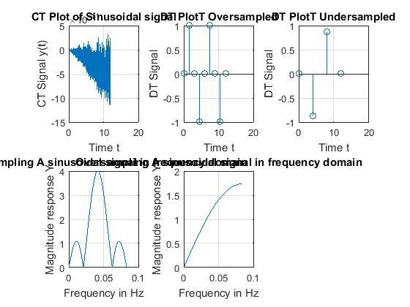

Task 06:
1. | Generate and plot the follwing sinusoidal sequence
2. | Generate and plot | by upsampling the above sequence | by 3.
3. | Generate and plot | by downsampling the above sequence | by 3.
- Help: Use „upsample‟ and „downsample ‟commands

5. | Now, generate and plot | by upsampling | by 3.
6. | Now, generate and plot | by downsampling | by 3.

Question

Does and are similar? If Yes/No then Why?

Question

Does and are similar? If Yes/No the Why?
n=-15:20;
x=sin(2*pi*0.25*n);
subplot(511)
stem(x);
title('Original Signal')
x1=upsample(x,3);
subplot(512)
stem(x1);
title('Upsampled Signal')
x2=downsample(x,3);
subplot(513)
stem(x2);
title('Downsampled Signal')
x3=upsample(x2,3);
subplot(514)
stem(x3);
title('Down then upsampled Signal')
x4=downsample(x1,3);
subplot(515)
stem(x4);
title('Up then Downsampled Signal')
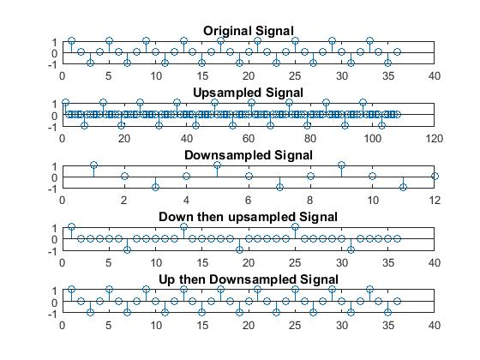
New Task3:
a)y1[n]=x[n]+y1[n-1]
n=-10:10;
x=[n>=0];
b0=[1];
a0=[1 1];
y0=filter(b0,a0,x);
subplot(211)
stem(n,y0)
b1=[1];
a1=[1 -1];
y1=filter(b1,a1,x);
subplot(212)
stem(n,y1)

ans: both are unstable
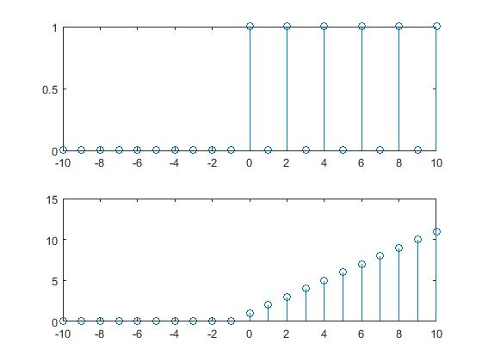

b)y2[n]=x[n]+0.7y2[n-1]
n=-10:10;
x=[n>=0];
b0=[1];
a0=[1 0.7];
y0=filter(b0,a0,x);
subplot(211)
stem(n,y0)
b1=[1];
a1=[1 -0.7];
y1=filter(b1,a1,x);
subplot(212)
stem(n,y1)
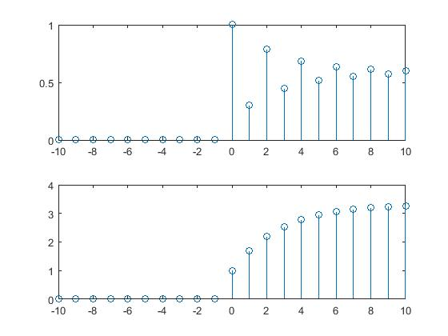
Ans: first is stable while second unstable
c)y3[n]=x[n]+1.2y3[n-1]
n=-10:10;
x=[n>=0];
b0=[1];
a0=[1 1.2];
y0=filter(b0,a0,x);
subplot(211)
stem(n,y0)
b1=[1];
a1=[1 -1.2];
y1=filter(b1,a1,x);
subplot(212)
stem(n,y1)

ans: both are unstable
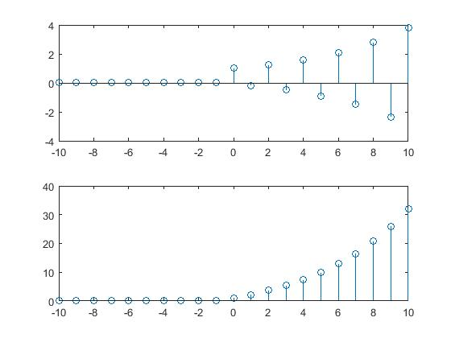
Task4:Moving Avg filter:
M=5:
n=-10:10;
x=[n==0];
M=5;
b=(ones(1,M)*(1/M));
a=[1];
y=filter(b,a,x);
stem(n,y)
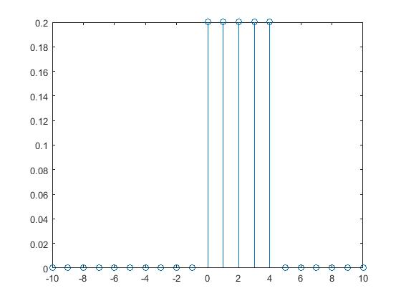
M=7:
n=-10:10;
x=[n==0];
M=7;
b=(ones(1,M)*(1/M));
a=[1];
y=filter(b,a,x);
stem(n,y)
