close all
clear all
w=0:3;
b=[2 3 3 2] ;
a=[1];
zplane(b,a)
l=length(b)
x=ones(1,l)
[h]=filter(b,a,x)
figure
subplot 311
plot(w,abs(h))
xlabel('w')
ylabel('Magnitude')
title('Frequency Response')
subplot 312
plot(w,angle(h))
xlabel('w')
ylabel('Phase')
title('Phase Response')
subplot 313
grpdelay(b,a)
l =
4
x =
1 1 1 1
h =
2 5 8 10
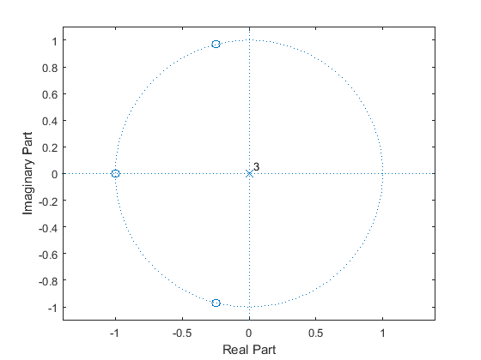
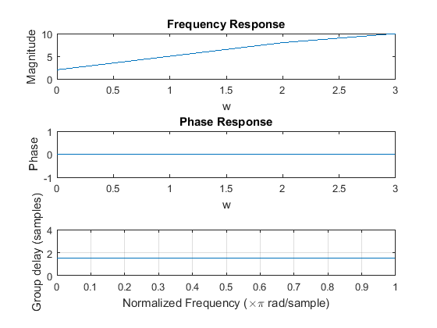
Published with MATLAB® R2015a

