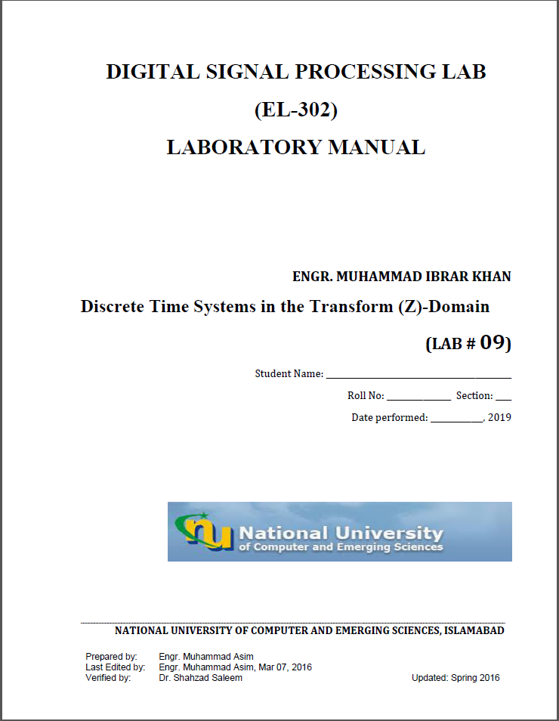

T1:
num=[2 16 44 56 32];
den=[3 3 -15 18 -12];
subplot 211
[z p k]=tf2zpk(num,den)
zplane(z,p)
subplot 212
impz(num,den)
z =
-4.0000 + 0.0000i
-2.0000 + 0.0000i
-1.0000 + 1.0000i
-1.0000 - 1.0000i
p =
-3.2361 + 0.0000i
1.2361 + 0.0000i
0.5000 + 0.8660i
0.5000 - 0.8660i
k =
0.6667
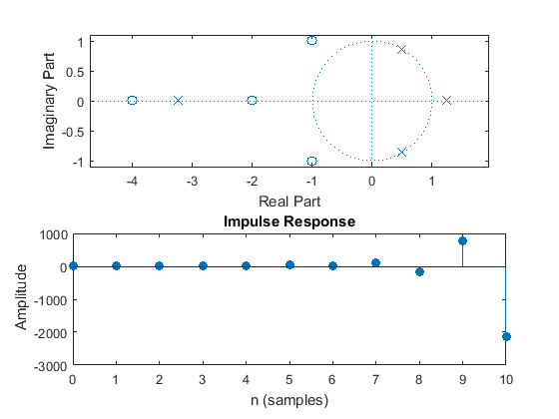
T2:
z=[0.21; 3.14;-0.3+j*0.5;-0.3-j*0.5];
p=[-0.45; 0.67; 0.81+j*0.72; 0.81-j*0.72] ;
k=2.2;
[num,den]=zp2tf(z,p,k);
pzmap(num,den)
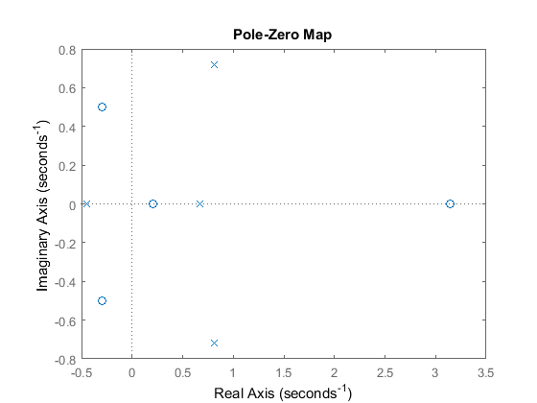
Published with MATLAB® R2015a

T3:
num=[18 0 0 0];
den=[18 3 -4 -1];
[r,p,k]=residuez(num,den)
a='(0.36/1-0.5z^-1) + (0.24/1+0.3333z^-1)+(0.4/1+0.3333z^-1)'
r =
0.3600
0.2400
0.4000
p =
0.5000
-0.3333
-0.3333
k =
0
a =
(0.36/1-0.5z^-1) + (0.24/1+0.3333z^-1)+(0.4/1+0.3333z^-1)
Published with MATLAB® R2015a

T4:
syms z
a1=(0.36/1-(0.5)*z^-1);
a2=(0.24/1+(0.3333)*z^-1);
a3=(0.4/1+(0.3333)*z^-1);
a=[a1;a2;a3]
iztrans(a)
a =
9/25 - 1/(2*z)
3333/(10000*z) + 6/25
3333/(10000*z) + 2/5
ans =
(9*kroneckerDelta(n, 0))/25 - kroneckerDelta(n - 1, 0)/2
(3333*kroneckerDelta(n - 1, 0))/10000 + (6*kroneckerDelta(n, 0))/25
(3333*kroneckerDelta(n - 1, 0))/10000 + (2*kroneckerDelta(n, 0))/5
Published with MATLAB® R2015a

T5:
num=[0.15 0 -.15];
den=[1 -0.5 0.7];
mytf=tf(num,den)
[z p k]=tf2zpk(num,den);
zplane(z,p)
figure
freqz(num,den)
mytf =
0.15 s^2 - 0.15
-----------------
s^2 - 0.5 s + 0.7
Continuous-time transfer function.
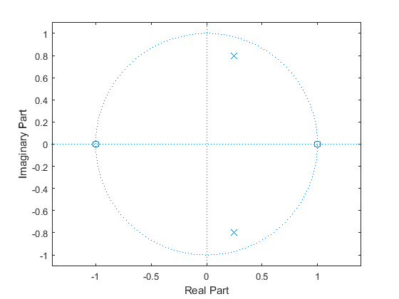
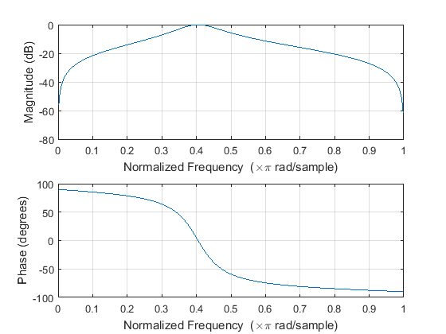
Published with MATLAB® R2015a

T6:
close all
clear all
num=[-1 0 0.15];
den=[0.7 0 -3 1];
mytff=tf(num,den)
subplot 211
zplane(num,den)
subplot 212
impz(num,den)
figure
freqz(num,den)
mytff =
-s^2 + 0.15
-----------------
0.7 s^3 - 3 s + 1
Continuous-time transfer function.
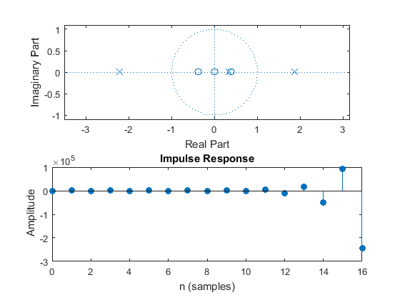
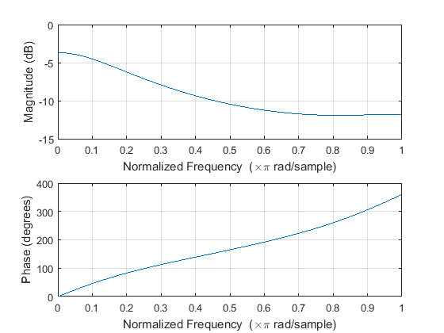
Published with MATLAB® R2015a

T7:
close all
clear all
num=[3 0 0 0.15 0 -1];
den=[-3 1 0 0 .7];
mrtf=tf(num,den)
subplot 211
zplane(num,den)
subplot 212
impz(num,den)
figure
freqz(num,den)
mrtf =
-3 s^5 - 0.15 s^2 + 1
---------------------
3 s^4 - s^3 - 0.7
Continuous-time transfer function.
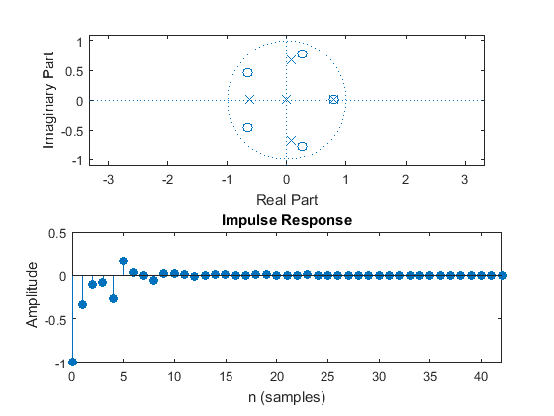
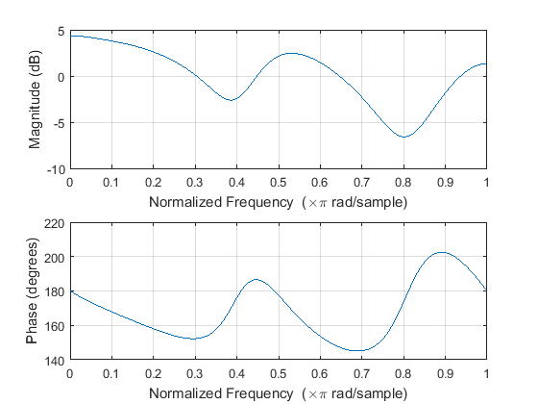
Published with MATLAB® R2015a

T8:
close all
clear all
num=[1 2];
den=[1 0.4 -0.12];
impz(num,den,11)
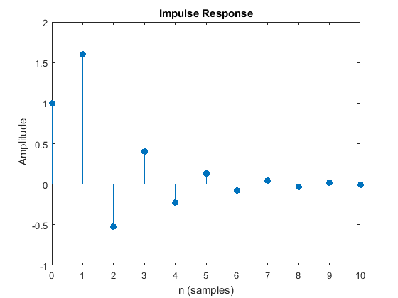
Published with MATLAB® R2015a

T9:
close all
clear all
num=[1 -1.2 1];
den=[1 -1.3 1.04 -0.22];
[gd,w]=grpdelay(num,den);
plot(w/pi,gd)
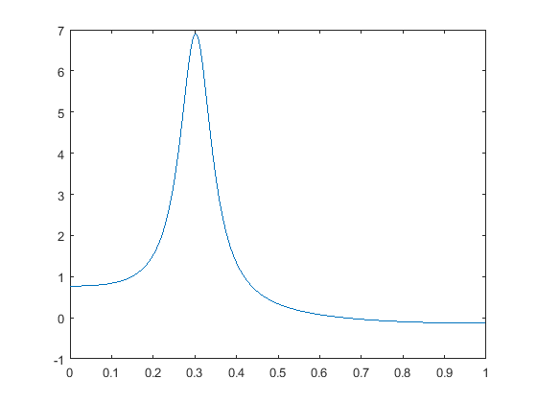
Published with MATLAB® R2015a

