num=[2 16 44 56 32];
den=[3 3 -15 18 -12];
subplot 211
[z p k]=tf2zpk(num,den)
zplane(z,p)
subplot 212
impz(num,den)
z =
-4.0000 + 0.0000i
-2.0000 + 0.0000i
-1.0000 + 1.0000i
-1.0000 - 1.0000i
p =
-3.2361 + 0.0000i
1.2361 + 0.0000i
0.5000 + 0.8660i
0.5000 - 0.8660i
k =
0.6667
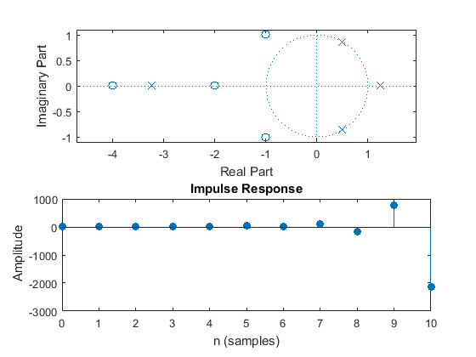
Published with MATLAB® R2015a

