z=[0.21; 3.14;-0.3+j*0.5;-0.3-j*0.5];
p=[-0.45; 0.67; 0.81+j*0.72; 0.81-j*0.72] ;
k=2.2;
[num,den]=zp2tf(z,p,k);
pzmap(num,den)
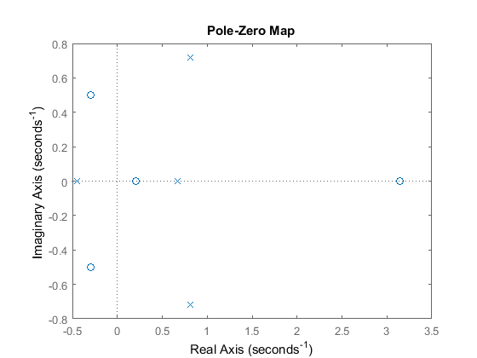
Published with MATLAB® R2015a

