num=[0.15 0 -.15];
den=[1 -0.5 0.7];
mytf=tf(num,den)
[z p k]=tf2zpk(num,den);
zplane(z,p)
figure
freqz(num,den)
mytf =
0.15 s^2 - 0.15
-----------------
s^2 - 0.5 s + 0.7
Continuous-time transfer function.
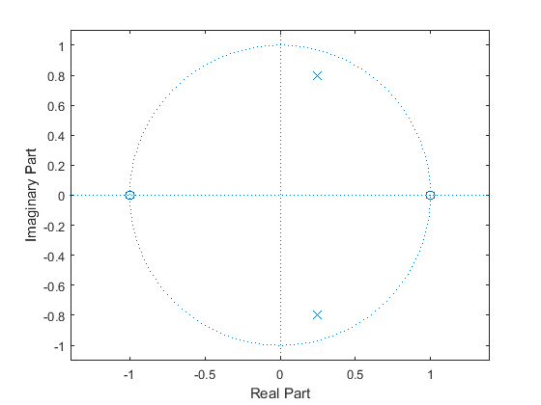
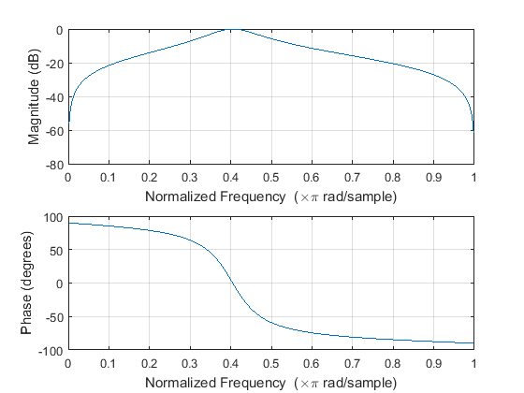
Published with MATLAB® R2015a

