close all
clear all
num=[-1 0 0.15];
den=[0.7 0 -3 1];
mytff=tf(num,den)
subplot 211
zplane(num,den)
subplot 212
impz(num,den)
figure
freqz(num,den)
mytff =
-s^2 + 0.15
-----------------
0.7 s^3 - 3 s + 1
Continuous-time transfer function.
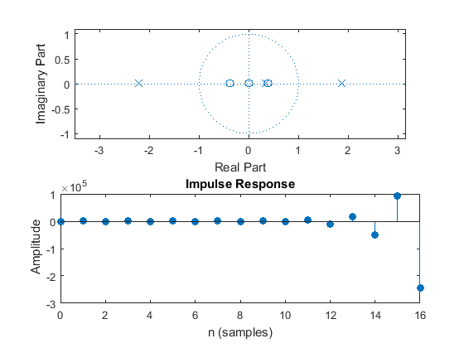
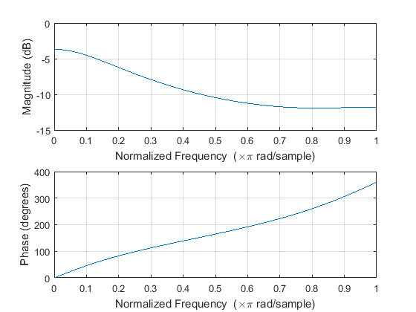
Published with MATLAB® R2015a

