close all
clear all
num=[3 0 0 0.15 0 -1];
den=[-3 1 0 0 .7];
mrtf=tf(num,den)
subplot 211
zplane(num,den)
subplot 212
impz(num,den)
figure
freqz(num,den)
mrtf =
-3 s^5 - 0.15 s^2 + 1
---------------------
3 s^4 - s^3 - 0.7
Continuous-time transfer function.
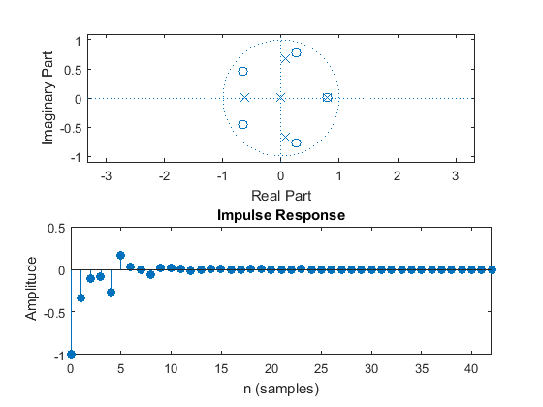
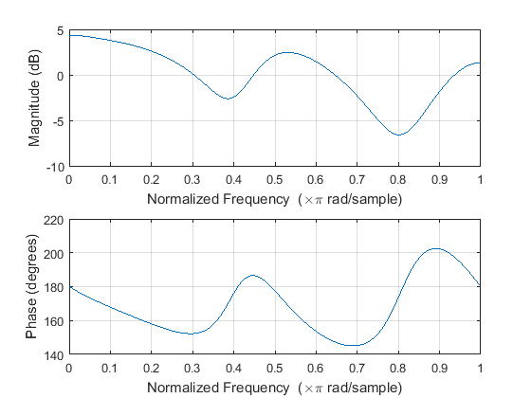
Published with MATLAB® R2015a

