close all
clear all
num=[1 2];
den=[1 0.4 -0.12];
impz(num,den,11)
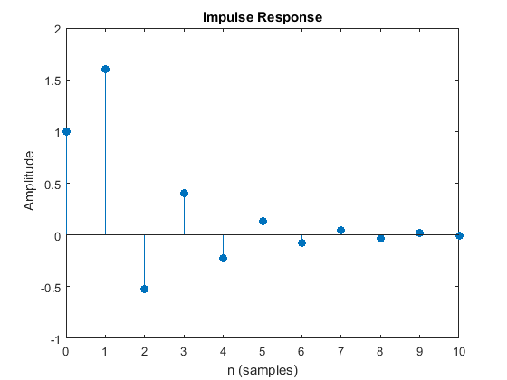
Published with MATLAB® R2015a

