**EMBEDDED SYSTEMS**

**(EL-419)**

# LABORATORY MANUAL



**Engr. Aneela Sabir**

**Getting started with Raspberry Pi 3B+**

**(LAB # 10)**

Student Name: ___Kamran,Moiz,Aqib,Yasir_________________________________

Roll No: _i140420,i15-402,443,i12-525_______________ Section: ___A_

Date performed: ________10/4_____, 2019

**MARKS AWARDED: ________ / 10**

____________________________________________________________________________________________________________________________________________________________ **NATIONAL UNIVERSITY OF COMPUTER AND EMERGING SCIENCES, ISLAMABAD**

|  |  |  |  |
| --- | --- | --- | --- |
|  |  |  |  |
| Prepared by: | Engr. Aneela Sabir |  | Version: 1.0.0 |
|  |  |  |  |
| Verified by: | Dr. Adnan |  | Updated: Spring 2019 |

**Lab # 10: Getting started with Raspberry Pi 3B+**

**Introduction to Raspberry Pi 3B+**

* Raspberry Pi 3 B+ was introduced by Raspberry Pi foundation on 14th March 2018. It is an advanced version of Raspberry Pi 3 B model that was introduced in 2016.
* It is a tiny computer board that comes with CPU, GPU, USB ports, I/O pins, WiFi, Bluetooth, USB and network boot and is capable of doing some functions like a regular computer. Features of the B+ version are almost same as B model; however, USB and Network Boot and Power over Ethernet facility only come with B+ model. Also, two extra USB ports are added to this device.
* The SoC (system on chip) combines both CPU and GPU on a single package and turns out to be faster than Pi 2 and Pi 3 models.

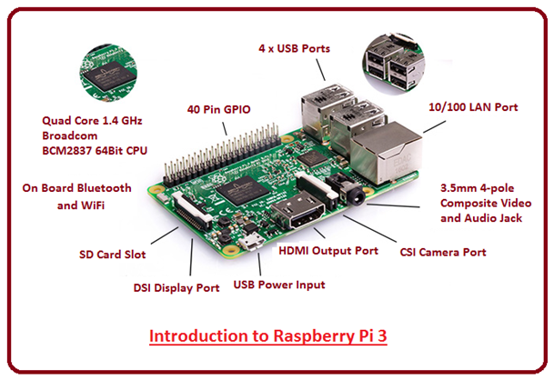

**RPi 3B+ Pinout Configuration:**

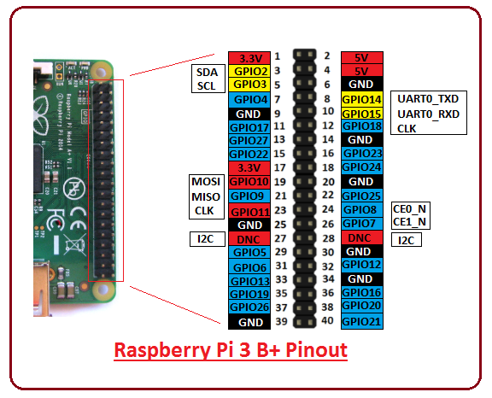

40 Pin header is used to develop an external connection with the electronic device.

* Out of 40 pins, 26 are used as a digital I/O pins and 9 of the remaining 14 pins are termed as dedicated I/O pins which indicate they don’t come with alternative function.
* Pin 3 and 5 comes with an onboard pull up resistor which 1.8 kΩ and Pin 27 and 28 are dedicated to ID EEPROM. In B+ model the GPIO header is slightly repositioned to allow more space for the additional mounting hole.

**Hardware Specifications:**

**CPU**: The CPU is a brain of this tiny computer that helps in carrying out a number of instruction based on the mathematical and logical formulas. It comes with a capacity of 64 bit.

**Clock Speed and RAM:** It comes with a clock speed of 1.4 GHz Broadcom BCM2837B0 that contains quad-core ARM Cortex-A53 and RAM memory is around 1GB (identical to the previous version)

**GPU**: It stands for graphics processing unit, used for carrying out image calculation. Broadcom video core cable is added in the device that is mainly used for playing video games.

**USB Ports:**Two more USB ports are introduced in this new version, setting you free from the hassle of using an external USB hub when you aim to join a number of peripherals with the device.

**MicroUSB Power Source Connector:** This connector is used for providing 5V power to the board. It draws 170 to 200mA more power than B model.

**HDMI and Composite Connection:**Both audio output socket and video composite now reside in a single 4-pole 3.5mm socket which resides near HDMI. And the power connector is also repositioned in new B+ model and lives next to HDMI socket. All the power and audio video composite socket are now placed on the one side of the PCB, giving it a clean and precise look.

**USB Hard Drive:** The USB hard drive is available on the board that is used to boot the device. It is identical to the hard drive of regular computer where windows is used to boot the hard drive of the computer.

**PoE:**B+ model comes with a facility of Power over Ethernet (PoE); a new feature added in this device which allows the necessary electrical current using data cables

.

**Other Changes:** The B+ version comes with little improvement in the features and poses slightly different layout in terms of location of the components. The SD memory slot is replaced by a micro SD memory card slot (works similar to the previous version). The status LEDs now only contain red and green color and relocated to the opposite end of the PCB.

**RPi 3b+ Technical Specifications:**

* CPU is 64 bit with 1GB RAM (random access memory)
* Contains Broadcom BCM2837B0 chipset
* Comes with 1.4GHz Quad-Core ARM Cortex-A53, 4 cores
* Consists of 40 pin header (26 GPIOs)
* Stereo audio and composite video is supported by 3.5mm jack connector
* 4 USB 2.0 ports
* Gigabit Ethernet
* PoE (power over Ethernet) is a major feature incorporated in this device that lacks in B model
* 2-pin reset header
* Micro SD socket, used to enhance the memory capacity of the board
* MicroUSB power connector, used for transferring power to the device
* HDMI
* CSI camera interface
* Comes with WiFi and Bluetooth facility that were not present in previous Raspberry Pi 1 and 2 versions
* DSI connector for official screen

**Applications:**

Raspberry Pi comes with a wide range of applications and works as a regular computer in some cases.

* Tablet Computer
* Home Automation
* Controlling Robots
* Coffee Projects
* Arcade Machine
* Media Streamer
* Internet Radio
* Cosmic Computer

**Operating System in RPi:**

Raspbian is the recommended operating system for normal use on a Raspberry Pi. Raspbian is a free operating system based on Debian, optimized for the Raspberry Pi hardware. Raspbian comes with over 35,000 packages: precompiled software bundled in a nice format for easy installation on your Raspberry Pi.

For details, please check: <https://www.raspberrypi.org/documentation/raspbian/>

**Download and install Raspbian:**

* 1. To download OS for RPi, please click on the link given below:

<https://www.raspberrypi.org/downloads/raspbian/> and download “Raspbian Stretch with desktop and recommended software”.

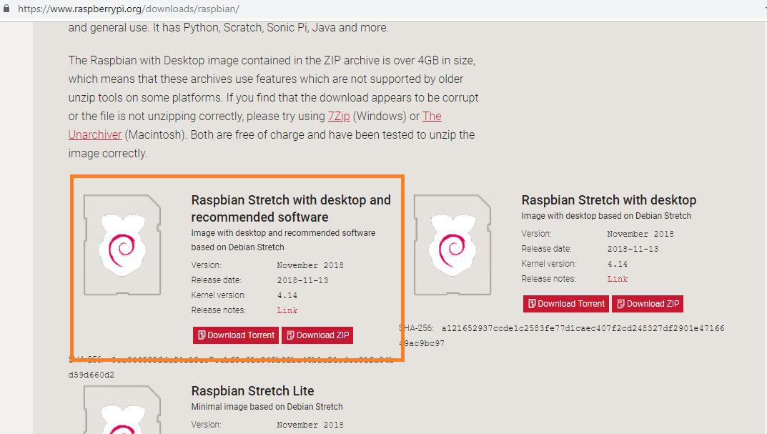

* 1. After downloading the setup, you need to extract the file. You will get “2018-11-13-raspbian-stretch-full.img” file.
  2. Then you need to write “2018-11-13-raspbian-stretch-full.img” file into memory card. For this purpose, you can download “win32 disk manager” from the link: <https://win32-disk-imager.en.uptodown.com/windows>

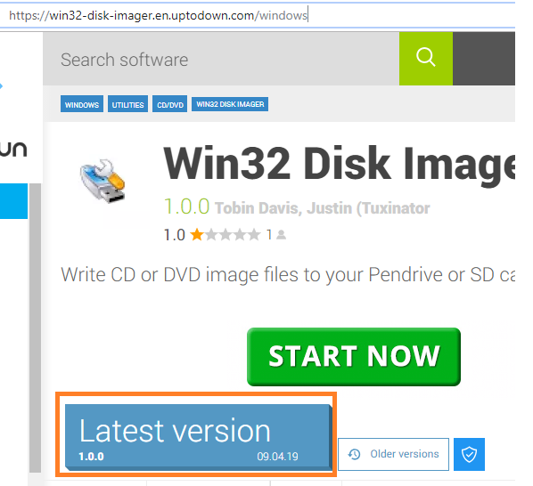

* 1. Run “Win32DiskImager.exe” and select file that you want to write in memory card.

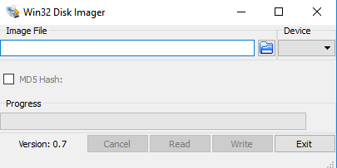

* 1. Once the writing is done, you need to close Win32 Disk Imager. And insert memory card in Raspberry Pi 3B+.

You can also follow the installation steps given the below link:

<https://www.raspberrypi.org/documentation/installation/installing-images/README.md>

**Lan Tasks:**

You need to solve three tasks from the link given below:

<https://rpi.science.uoit.ca/>

1. Running basic codes on RPi 3b+

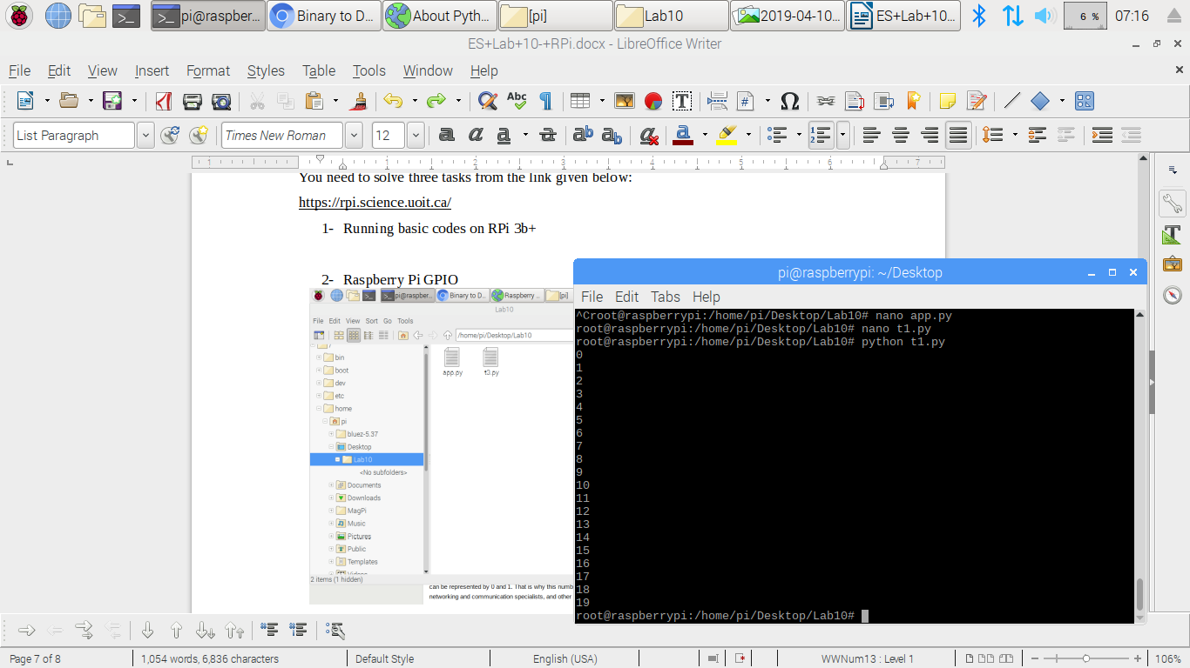

1. Raspberry Pi GPIO

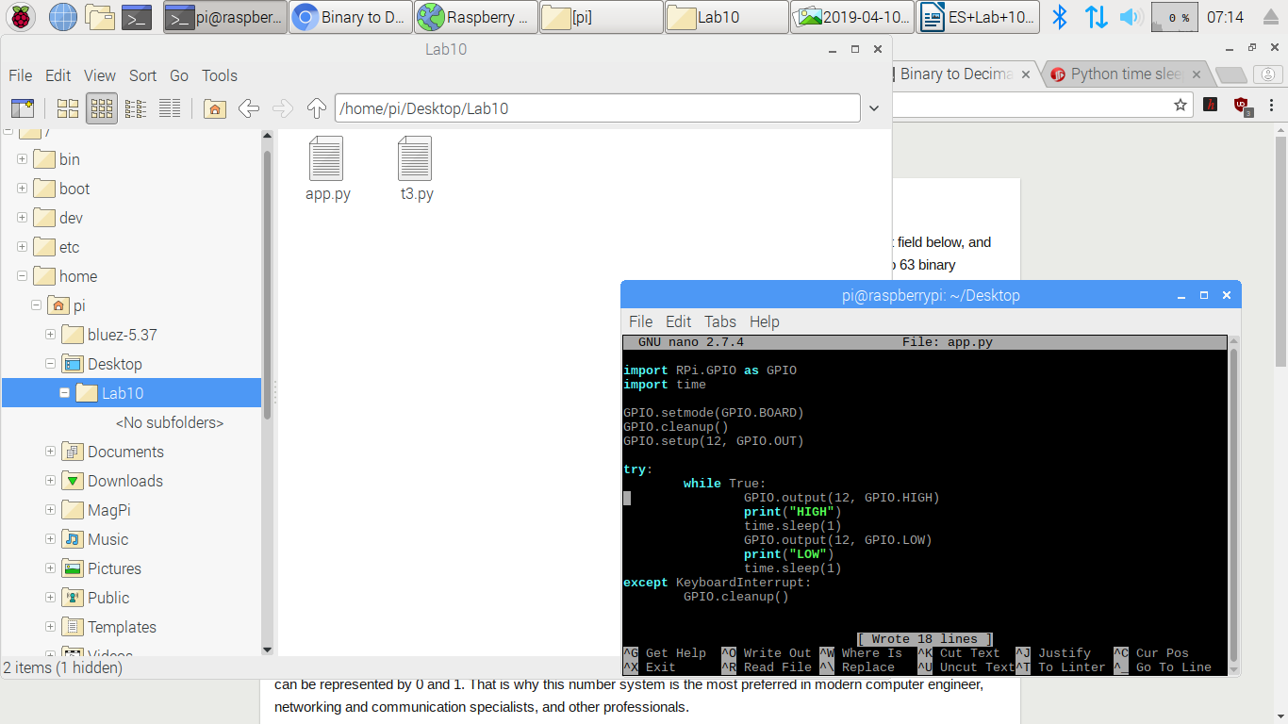

1. Binary Number Representation

