|  |
| --- |
| **VLSI Lab** |
|  |
| **LABORATORY MANUAL** |
| **Spring 2019** |



|  |  |  |  |  |
| --- | --- | --- | --- | --- |
| **LAB 01** | | | | |
| **Title of Lab Experiment : Verification of Boolean algebra laws(Expression to Gate level implementation)** | | | | |
| **Engr. Rashid Karim** | | | | |
|  | |  | |  |
| ________________________________________ | | __________ | | ___ |
| STUDENT NAME | | ROLL NO | | SEC |
|  | | | | |
| ______________________________________ | | | | |
| LAB ENGINEER SIGNATURE & DATE | | | | |
| **MARKS AWARDED:**  /**10** | | | | |
| ________________________________________________________________ | | | | |
| **NATIONAL UNIVERSITY OF COMPUTER AND EMERGING SCIENCES (NUCES), ISLAMABAD** | | | | |
|  | | | | |
| Prepared by: | Engr. Furqan Mehmood | Version: | 2.1 | |
| Last Edited by: | Engr. Aneela Sabir | Date: | 31 Aug,2019 | |
| Verified by: | Engr. Rashid Karim. |  |  | |
|  |  |  |  | |

|  |  |  |
| --- | --- | --- |
| **LAB:** | **01** | **Verification of Boolean algebra laws(Expression to Gate level implementation)** |

#### **Learning Objectives:**

1. Gate level implimentation of Boolean expressions.
2. Verification of Boolean algebra laws.

#### **Equipment Required:**

Software : Dsch v2

1. Introduction:
2. Boolean Expressions

A **Boolean expression** is an expression that results in a Boolean value, that is, in a value of either **true** or **false**

Examples :

Z = Output A,B = Inputs

Z = A + B OR

Z = A . B AND

Z = ~ A NOT

1. **Gate Level Implimentation :**

**2-input AND Gate**

For a 2-input AND gate, the output Q is true if BOTH input A “AND” input B are both true, giving the Boolean Expression of: (Q = A and B ).

|  |  |  |  |
| --- | --- | --- | --- |
| **Symbol** | **Truth Table** | | |
| boolean algebra AND gate truth table | A | B | Q |
| 0 | 0 | 0 |
| 0 | 1 | 0 |
| 1 | 0 | 0 |
| 1 | 1 | 1 |
| **Boolean Expression Q = A.B** | **Read as A AND B gives Q** | | |

Note that the Boolean Expression for a two input AND gate can be written as: A.B

## 2-input OR (Inclusive OR) Gate

For a 2-input OR gate, the output Q is true if EITHER input A “OR” input B is true, giving the Boolean Expression of: (Q = A or B ).

|  |  |  |  |
| --- | --- | --- | --- |
| **Symbol** | **Truth Table** | | |
| boolean algebra OR gate truth table | A | B | Q |
| 0 | 0 | 0 |
| 0 | 1 | 1 |
| 1 | 0 | 1 |
| 1 | 1 | 1 |
| **Boolean Expression Q = A+B** | **Read as A OR B gives Q** | | |

## NOT Gate

For a single input NOT gate, the output Q is ONLY true when the input is “NOT” true, the output is the inverse or complement of the input giving the Boolean Expression of: ( Q = NOT A ).

|  |  |  |
| --- | --- | --- |
| **Symbol** | **Truth Table** | |
| boolean algebra NOT gate truth table | A | Q |
| 0 | 1 |
| 1 | 0 |
| **Boolean Expression Q = NOT A or A** | **Read as inversion of A gives Q** | |

The NAND and the NOR Gates are a combination of the AND and OR Gates with that of a NOT Gate or inverter.

## 2-input NAND (Not AND) Gate

For a 2-input NAND gate, the output Q is true if BOTH input A and input B are NOT true, giving the Boolean Expression of: ( Q = not(A and B) ).

|  |  |  |  |
| --- | --- | --- | --- |
| **Symbol** | **Truth Table** | | |
| NAND gate truth table | A | B | Q |
| 0 | 0 | 1 |
| 0 | 1 | 1 |
| 1 | 0 | 1 |
| 1 | 1 | 0 |
| **Boolean Expression Q = A .B** | **Read as A AND B gives NOT-Q** | | |

1. **Procedure:**

Verification of law of common identities. A. (A’+B) = A.B

Steps:

1. Run Dsch software
2. Select Foundry
3. Implement A. (A’ + B)

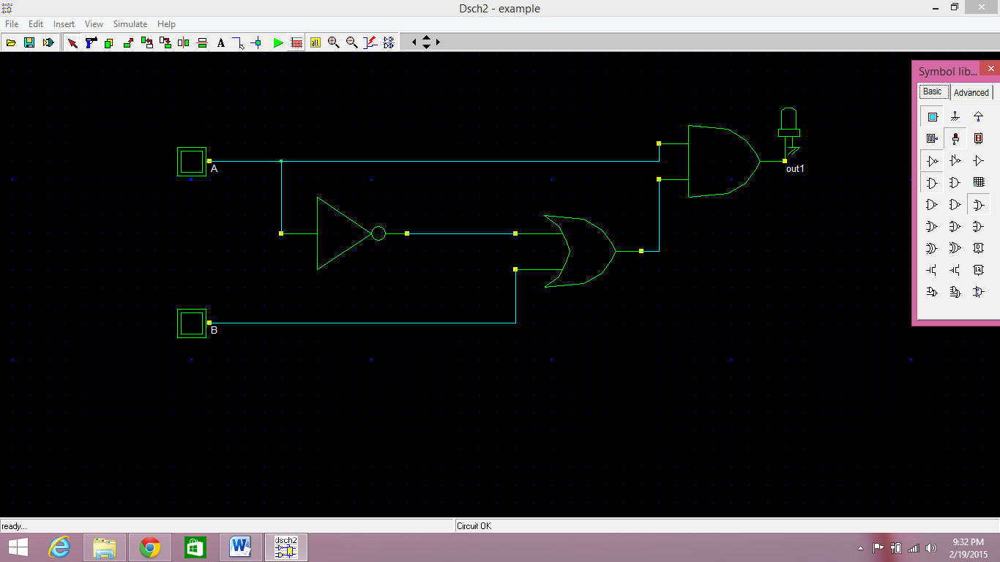

1. Implement A.B

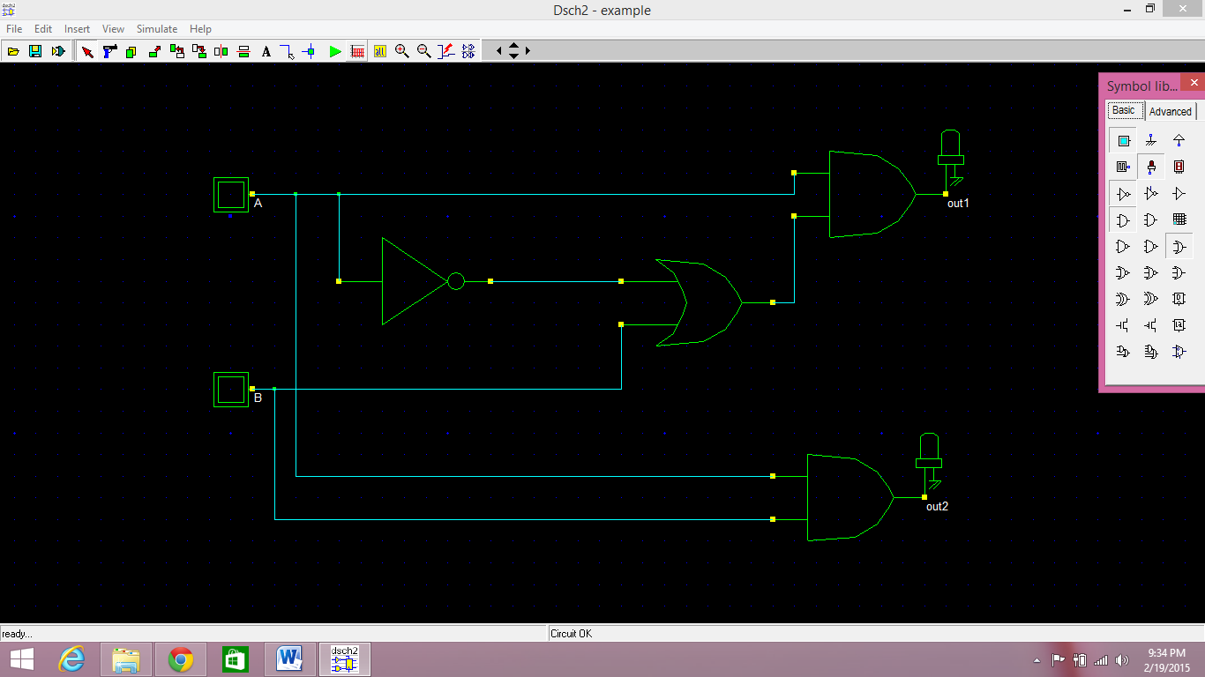

1. Output of both circuits should be same.

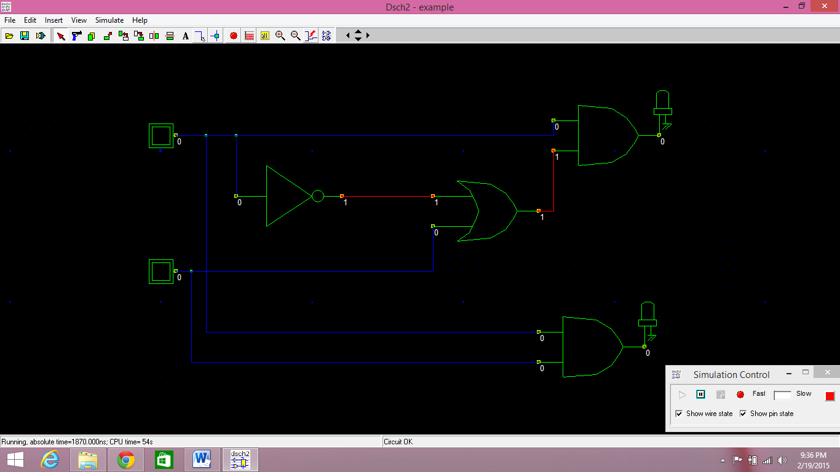

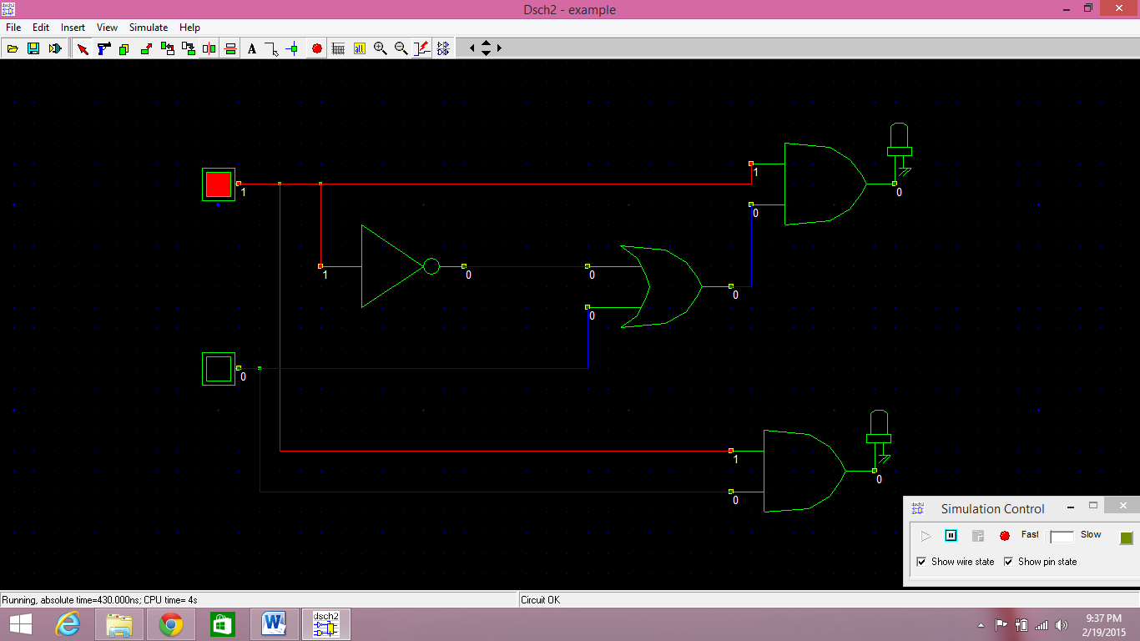

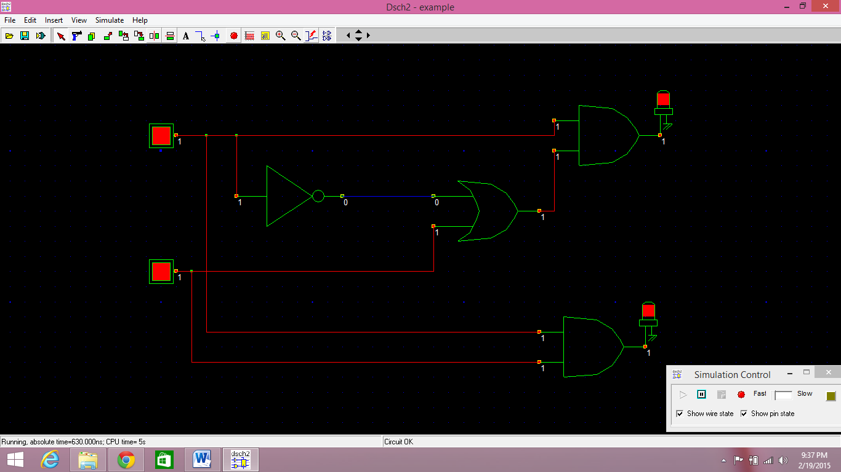

1. **Tasks:**

Impliment and verify following laws by gate level implimentation of following boolean expressions. Fill the truth table for each input combination.

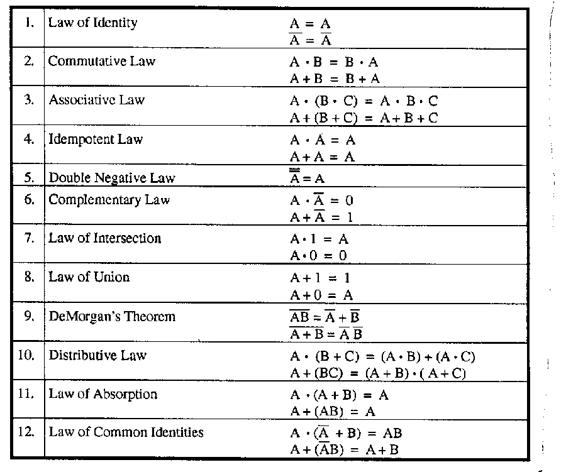









**Truth Table:**

|  |  |  |  |  |  |  |  |  |  |  |  |  |
| --- | --- | --- | --- | --- | --- | --- | --- | --- | --- | --- | --- | --- |
| **Inputs** | | | **Outputs** | | | | | | | | | |
| **A** | **B** | **C** | **Associative Law** | | **DeMorgan’s Theorem** | | **Distribution Law** | | **Law of Absorption** | | **Law of Common Identities** | |
| **A.(B.C)**  **=A.B.C** | **A+(B+C)**  **=A+B+C** | $$\overline{AB}= \overline{A}+ \overline{B}$$ | $$\overline{A+B}= \overline{A} \overline{B}$$ | **A.(B+C)**  **= (A.B + (A.C)** | **A+(BC) = (A+B). (A+C** | **A.(A+B)=A** | **A+(AB)=A** | **A. $( \overline{A}$ + B) = AB** | **A + ( $\overline{A} B)$ = A+B** |
| 0 | 0 | 0 |  |  |  |  |  |  |  |  |  |  |
| 0 | 0 | 1 |  |  |  |  |  |  |  |  |  |  |
| 0 | 1 | 0 |  |  |  |  |  |  |  |  |  |  |
| 0 | 1 | 1 |  |  |  |  |  |  |  |  |  |  |
| 1 | 0 | 0 |  |  |  |  |  |  |  |  |  |  |
| 1 | 0 | 1 |  |  |  |  |  |  |  |  |  |  |
| 1 | 1 | 0 |  |  |  |  |  |  |  |  |  |  |
| 1 | 1 | 1 |  |  |  |  |  |  |  |  |  |  |

**Submission Declaration by the Student:**

In submitting this lab write-up to the Lab Engineer/Instructor, I hereby declare that:

* I have performed all the practical work myself
* I have noted down actual measurements in this writeup from my own working
* I have written un-plagarised answers to various questions
* I have/have not obtained the desired objectives of the lab.

Reasons of not obtaining objectoves (if applicable):

___________________________________________________________________

___________________________________________________________________

___________________________________________________________________

___________________________

Student’s signature and Date

**Student Evaluation by the Lab Engineer:**

The Lab Engineer can separate this page from the writeup and keep it for his/her own record. It must be signed by the student with date on it.

* **Lab Work:** objectives achieved (correctness of measurements, calculations, answers to questions posed, conclusion) ________/30
* **Lab Writeup:** Neatness, appropriateness, intime submission ________/10
* **Troubleshooting:** Were the student able to troubleshoot his/her work when it was purposedly changed? ________/10
* **TOTAL:** ________/50

**Feedback on student behaviour:**

***Encircle*** your choice. -2 means poorest/worst/extremely inadequate/irrevlevant, 0 gives an average score, and +2 means best/most relevant/most adequate.

* Did the student join the lab at the start/remained in lab? -2 -1 0 1 2
* Did the student remain focused on his/her work during lab? -2 -1 0 1 2
* Rate student's behaviour with fellows/staff/Lab Engineer? -2 -1 0 1 2
* Did the student cause any distraction during the Lab? -2 -1 0 1 2
* Was the student found in any sort of plagiarism? -2 -1 0 1 2

Additional comments (if any) by the Lab Engineer:

__________________________________________________________________

___________________________________________________________________

___________________________________________________________________

___________________________________________________________________

___________________________

Lab Engineer’s signature and Date

**Student's feedback: [Separate this page; fill it; drop in the Drop Box.]**

* Providing feedback for every lab session is optional. No feedback means you are satisified
* The Lab Committee will consider only duly filled forms submitted within one week after the lab
* This feedabck is for LAB session: LAB Number: _____, Date: _____________________
* General (to provide feedback on a persistent practice/ocurrence in LABs).
* Your current CGPA is in the range 4.00 to 3.00/2.99 to 2.00/1.99 to 1.00/0.99 to 0.00

**This feedback is:**

* For a Particular
* Who conducted the LAB? __________________________________________________
* Actual Start time: _______________ Total Duration of Lab: _______________________
* Instruction Duration: _________________ Practical Duration: _____________________
* LAB writeup available before LAB? Yes/No with the Photocopier/in LAB/in SLATE
* Had the theory related to lab been covered in theory class? Yes/No

***Encircle*** your choice. -2 means poorest/worst/extremely inadequate/irrevlevant, 0 gives an average score, and +2 means best/most relevant/most adequate.

|  |  |  |  |  |  |  |  |
| --- | --- | --- | --- | --- | --- | --- | --- |
| **Instruction Session** | Was duration of instruction session adequate? | |  |  |  |  |  | | --- | --- | --- | --- | --- | | **-2** | **-1** | **0** | **+1** | **+2** | |
| How much did you understand about the practical? | |  |  |  |  |  | | --- | --- | --- | --- | --- | | **-2** | **-1** | **0** | **+1** | **+2** | |
| How much content was irrelevant to the practical? | |  |  |  |  |  | | --- | --- | --- | --- | --- | | **-2** | **-1** | **0** | **+1** | **+2** | |
| Did the instructor allowed Q/A and discussion? | |  |  |  |  |  | | --- | --- | --- | --- | --- | | **-2** | **-1** | **0** | **+1** | **+2** | |
| **Practical** | Did you get sufficient time for practical? | |  |  |  |  |  | | --- | --- | --- | --- | --- | | **-2** | **-1** | **0** | **+1** | **+2** | |
| **Lab**  **Engineer** | Presence in lab at all time? | |  |  |  |  |  | | --- | --- | --- | --- | --- | | **-2** | **-1** | **0** | **+1** | **+2** | |
| Ability to convey? | |  |  |  |  |  | | --- | --- | --- | --- | --- | | **-2** | **-1** | **0** | **+1** | **+2** | |
| Readiness to help during practical? | |  |  |  |  |  | | --- | --- | --- | --- | --- | | **-2** | **-1** | **0** | **+1** | **+2** | |
| Readiness to discuss theoretical aspects? | |  |  |  |  |  | | --- | --- | --- | --- | --- | | **-2** | **-1** | **0** | **+1** | **+2** | |
| Helps in troubleshooting? | |  |  |  |  |  | | --- | --- | --- | --- | --- | | **-2** | **-1** | **0** | **+1** | **+2** | |
| Guides hows & whys of troubleshooting? | |  |  |  |  |  | | --- | --- | --- | --- | --- | | **-2** | **-1** | **0** | **+1** | **+2** | |
| **Staff** | How friendly was the lab staff? | |  |  |  |  |  | | --- | --- | --- | --- | --- | | **-2** | **-1** | **0** | **+1** | **+2** | |
| Presence of staff throughout the lab session? | |  |  |  |  |  | | --- | --- | --- | --- | --- | | **-2** | **-1** | **0** | **+1** | **+2** | |
| Impact of availability of staff on your practical? | |  |  |  |  |  | | --- | --- | --- | --- | --- | | **-2** | **-1** | **0** | **+1** | **+2** | |
| **Equipment** | Performance of Electronic Instruments? | |  |  |  |  |  | | --- | --- | --- | --- | --- | | **-2** | **-1** | **0** | **+1** | **+2** | |
| Performance of Breadboard/experiment kit? | |  |  |  |  |  | | --- | --- | --- | --- | --- | | **-2** | **-1** | **0** | **+1** | **+2** | |
| Performance of circuit components esp. ICs? | |  |  |  |  |  | | --- | --- | --- | --- | --- | | **-2** | **-1** | **0** | **+1** | **+2** | |
| **Overall** | Your overall rating for the whole lab session? | |  |  |  |  |  | | --- | --- | --- | --- | --- | | **-2** | **-1** | **0** | **+1** | **+2** | |

Other comments: _________________________________________________________________

_________________________________________________________________

_________________________________________________________________