|  |
| --- |
| **VLSI Lab** |
|  |
| **LABORATORY REPORT** |
| **Spring 2019** |



|  |  |  |  |  |
| --- | --- | --- | --- | --- |
| **LAB 12** | | | | |
| **Title of Lab Experiment: Symbol generation of basic digital designs using Pseudo NMOS Technology on S-Edit** | | | | |
| **Engr. Rashid Karim** | | | | |
|  | | |  |  |
| ___________Kamran_______________ | | | __i140420___ | _A_ |
| STUDENT NAME | | | ROLL NO | SEC |
| Student’s signature and Submission Date: ___________19/4/19__________ | | | | |
| ______________________________________ | | | | |
| LAB ENGINEER’S SIGNATURE & DATE | | | | |
|  | | | | |
| **MARKS AWARDED:**  /**10** | | | | |
| ________________________________________________________________ | | | | |
| **NATIONAL UNIVERSITY OF COMPUTER AND EMERGING SCIENCES (NUCES), ISLAMABAD** | | | | |
|  | | | | |
| **LAB:** | **12** | **Symbol generation of basic digital designs using Pseudo NMOS Technology on S-Edit** | | | |

#### **Learning Objectives:**

Symbol generation in S-Edit of Pseudo NMOS.

#### **Equipment Required:**

Software : S-Edit

1. Lab Summary:

In this lab,we implemented Pseudo Nmos schematic and simulated in T_Spice.

1. Task:

4-in-NAND

Schematic Screenshot

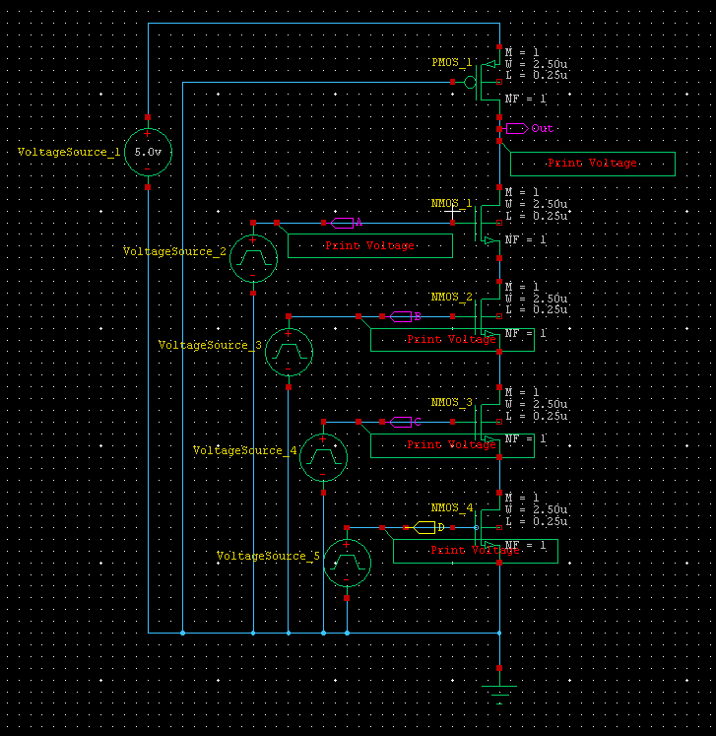

Waveform/Results



Symbol

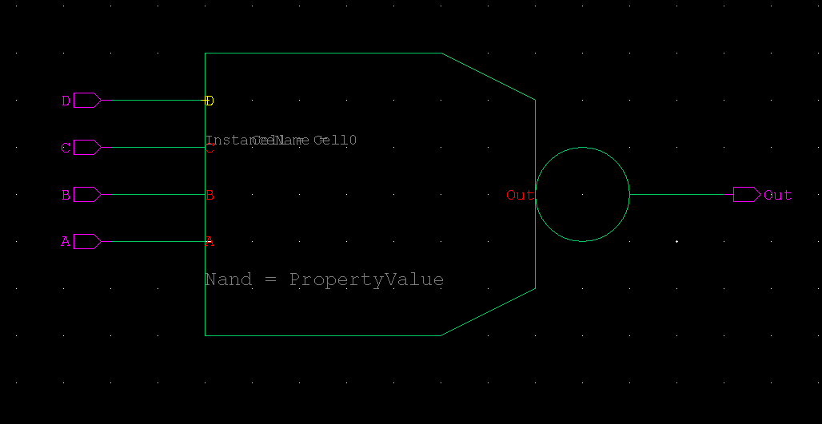

6-in-NOR

Schematic Screenshot

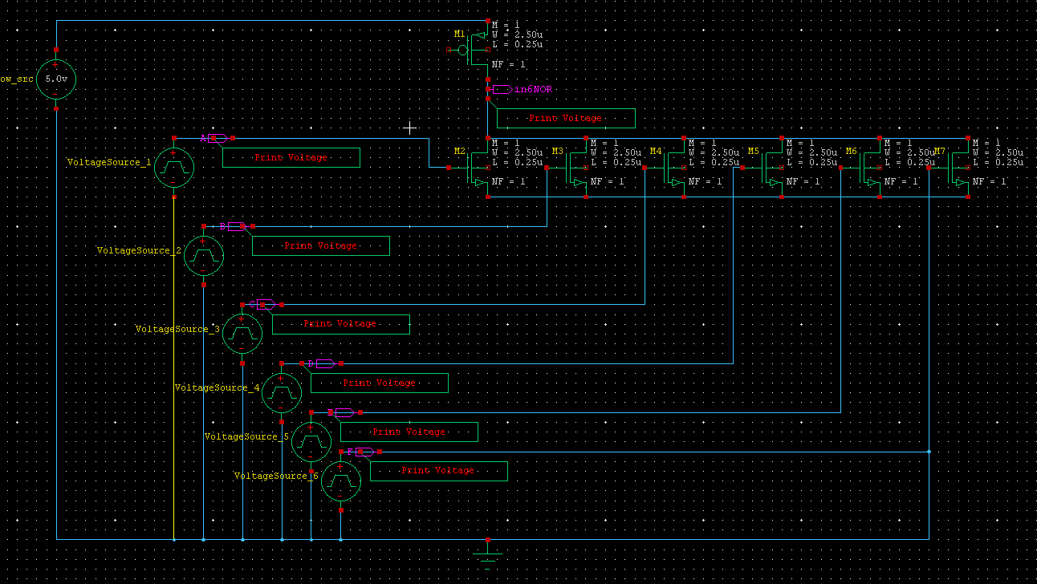

Waveform/Results



Symbol

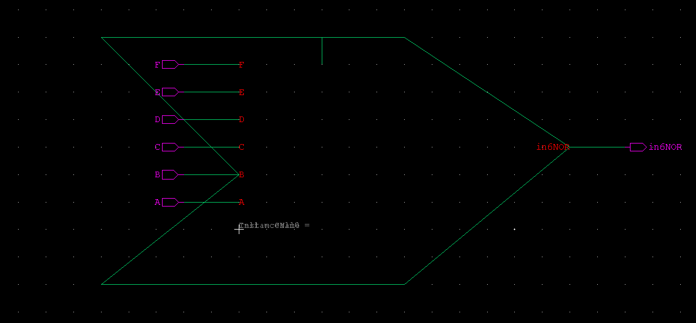

2-in-XOR

Schematic Screenshot

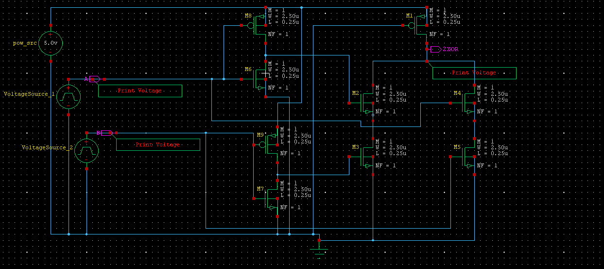

Waveform/Results



Symbol

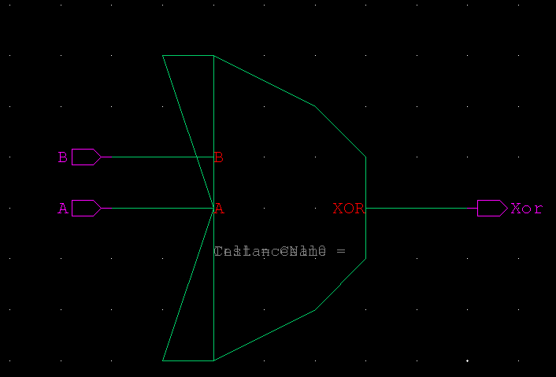

2-in-XNOR

Schematic Screenshot

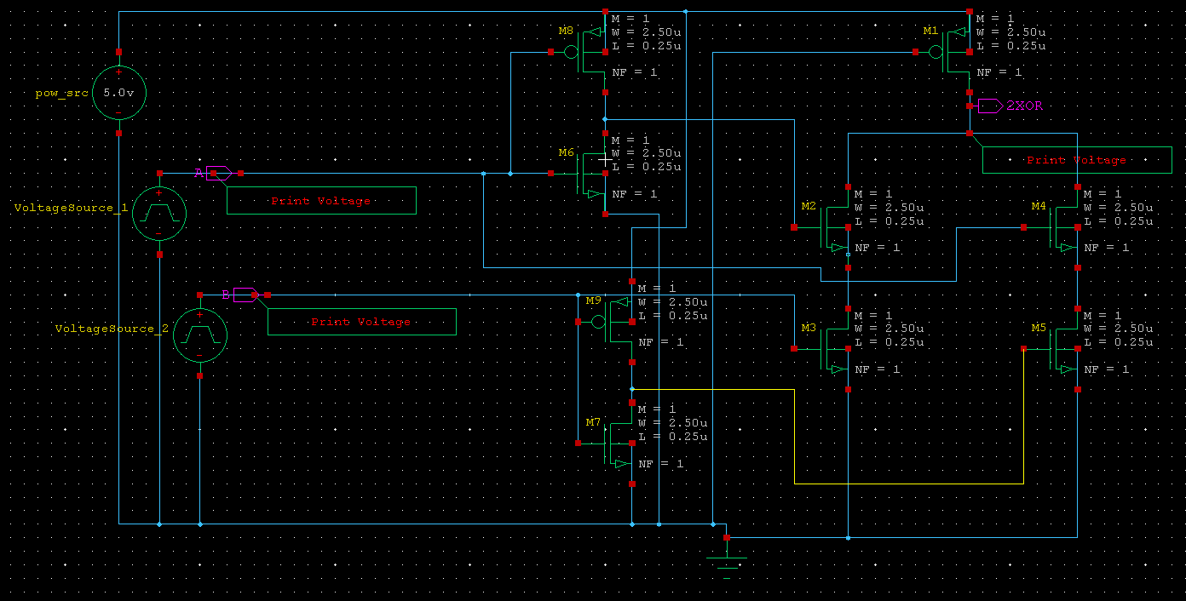

Waveform/Results



Symbol

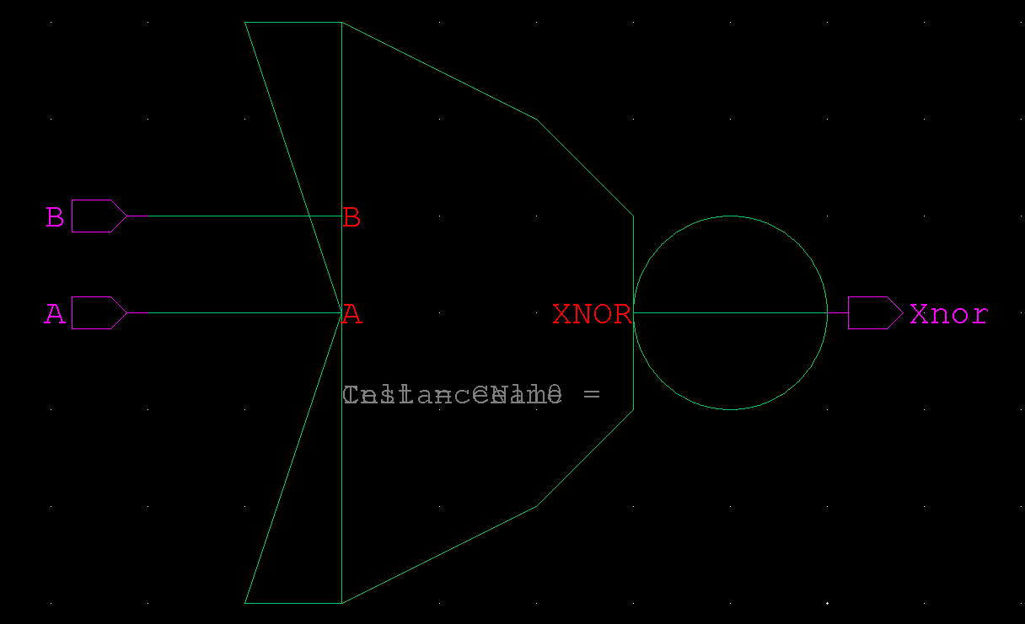

FA

Schematic Screenshot

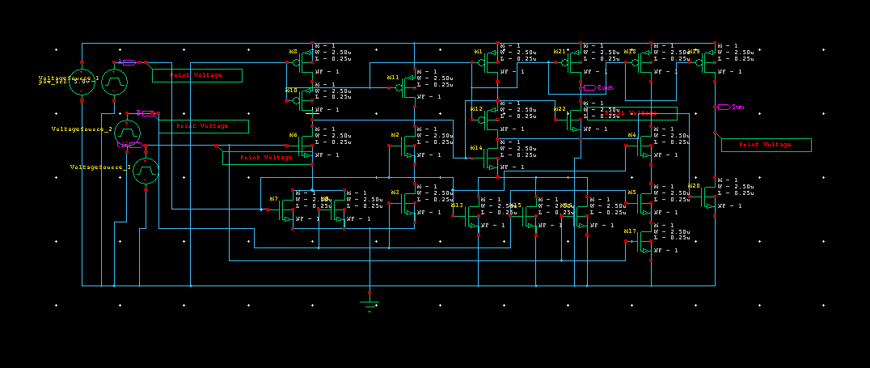

Waveform/Results



Symbol

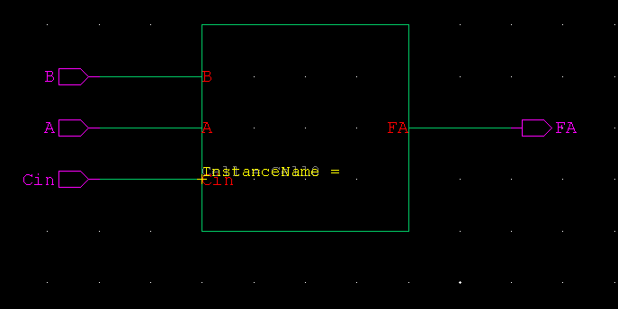

**Submission Declaration by the Student:**

In submitting this lab write-up to the Lab Engineer/Instructor, I hereby declare that:

I have performed all the practical work myself

* I have noted down actual measurements in this writeup from my own working
* I have written un-plagarised answers to various questions
* I have/have not obtained the desired objectives of the lab.

Reasons of not obtaining objectoves (if applicable):

___________________________________________________________________

___________________________________________________________________

___________________________________________________________________

___________________________

Student’s signature and Date

**Student Evaluation by the Lab Engineer:**

The Lab Engineer can separate this page from the writeup and keep it for his/her own record. It must be signed by the student with date on it.

* **Lab Work:** objectives achieved (correctness of measurements, calculations, answers to questions posed, conclusion) ________/30
* **Lab Writeup:** Neatness, appropriateness, intime submission ________/10
* **Troubleshooting:** Were the student able to troubleshoot his/her work when it was purposedly changed? ________/10
* **TOTAL:** ________/50

**Feedback on student behaviour:**

***Encircle*** your choice. -2 means poorest/worst/extremely inadequate/irrevlevant, 0 gives an average score, and +2 means best/most relevant/most adequate.

* Did the student join the lab at the start/remained in lab? -2 -1 0 1 2
* Did the student remain focused on his/her work during lab? -2 -1 0 1 2
* Rate student's behaviour with fellows/staff/Lab Engineer? -2 -1 0 1 2
* Did the student cause any distraction during the Lab? -2 -1 0 1 2
* Was the student found in any sort of plagiarism? -2 -1 0 1 2

Additional comments (if any) by the Lab Engineer:

__________________________________________________________________

___________________________________________________________________

___________________________________________________________________

___________________________________________________________________

___________________________

Lab Engineer’s signature and Date

**Student's feedback: [Separate this page; fill it; drop in the Drop Box.]**

* Providing feedback for every lab session is optional. No feedback means you are satisified
* The Lab Committee will consider only duly filled forms submitted within one week after the lab
* This feedabck is for LAB session: LAB Number: _____, Date: _____________________
* General (to provide feedback on a persistent practice/ocurrence in LABs).
* Your current CGPA is in the range 4.00 to 3.00/2.99 to 2.00/1.99 to 1.00/0.99 to 0.00

**This feedback is:**

* For a Particular
* Who conducted the LAB? __________________________________________________
* Actual Start time: _______________ Total Duration of Lab: _______________________
* Instruction Duration: _________________ Practical Duration: _____________________
* LAB writeup available before LAB? Yes/No with the Photocopier/in LAB/in SLATE
* Had the theory related to lab been covered in theory class? Yes/No

***Encircle*** your choice. -2 means poorest/worst/extremely inadequate/irrevlevant, 0 gives an average score, and +2 means best/most relevant/most adequate.

|  |  |  |  |  |  |  |  |
| --- | --- | --- | --- | --- | --- | --- | --- |
| **Instruction Session** | Was duration of instruction session adequate? | |  |  |  |  |  | | --- | --- | --- | --- | --- | | **-2** | **-1** | **0** | **+1** | **+2** | |
| How much did you understand about the practical? | |  |  |  |  |  | | --- | --- | --- | --- | --- | | **-2** | **-1** | **0** | **+1** | **+2** | |
| How much content was irrelevant to the practical? | |  |  |  |  |  | | --- | --- | --- | --- | --- | | **-2** | **-1** | **0** | **+1** | **+2** | |
| Did the instructor allowed Q/A and discussion? | |  |  |  |  |  | | --- | --- | --- | --- | --- | | **-2** | **-1** | **0** | **+1** | **+2** | |
| **Practical** | Did you get sufficient time for practical? | |  |  |  |  |  | | --- | --- | --- | --- | --- | | **-2** | **-1** | **0** | **+1** | **+2** | |
| **Lab**  **Engineer** | Presence in lab at all time? | |  |  |  |  |  | | --- | --- | --- | --- | --- | | **-2** | **-1** | **0** | **+1** | **+2** | |
| Ability to convey? | |  |  |  |  |  | | --- | --- | --- | --- | --- | | **-2** | **-1** | **0** | **+1** | **+2** | |
| Readiness to help during practical? | |  |  |  |  |  | | --- | --- | --- | --- | --- | | **-2** | **-1** | **0** | **+1** | **+2** | |
| Readiness to discuss theoretical aspects? | |  |  |  |  |  | | --- | --- | --- | --- | --- | | **-2** | **-1** | **0** | **+1** | **+2** | |
| Helps in troubleshooting? | |  |  |  |  |  | | --- | --- | --- | --- | --- | | **-2** | **-1** | **0** | **+1** | **+2** | |
| Guides hows & whys of troubleshooting? | |  |  |  |  |  | | --- | --- | --- | --- | --- | | **-2** | **-1** | **0** | **+1** | **+2** | |
| **Staff** | How friendly was the lab staff? | |  |  |  |  |  | | --- | --- | --- | --- | --- | | **-2** | **-1** | **0** | **+1** | **+2** | |
| Presence of staff throughout the lab session? | |  |  |  |  |  | | --- | --- | --- | --- | --- | | **-2** | **-1** | **0** | **+1** | **+2** | |
| Impact of availability of staff on your practical? | |  |  |  |  |  | | --- | --- | --- | --- | --- | | **-2** | **-1** | **0** | **+1** | **+2** | |
| **Equipment** | Performance of Electronic Instruments? | |  |  |  |  |  | | --- | --- | --- | --- | --- | | **-2** | **-1** | **0** | **+1** | **+2** | |
| Performance of Breadboard/experiment kit? | |  |  |  |  |  | | --- | --- | --- | --- | --- | | **-2** | **-1** | **0** | **+1** | **+2** | |
| Performance of circuit components esp. ICs? | |  |  |  |  |  | | --- | --- | --- | --- | --- | | **-2** | **-1** | **0** | **+1** | **+2** | |
| **Overall** | Your overall rating for the whole lab session? | |  |  |  |  |  | | --- | --- | --- | --- | --- | | **-2** | **-1** | **0** | **+1** | **+2** | |

Other comments: _________________________________________________________________

________________________________________________________________