|  |
| --- |
| **VLSI Lab** |
|  |
| **LABORATORY REPORT** |
| **Spring 2019** |



|  |  |  |  |  |
| --- | --- | --- | --- | --- |
| **LAB 04** | | | | |
| **Title of Lab Experiment : Layout design of inverter using L-Edit** | | | | |
| **Engr. Rashid Karim** | | | | |
|  | | |  |  |
| _______________Kamran_____________________ | | | __i140420__ | _A |
| STUDENT NAME | | | ROLL NO | SEC |
| Submission Date: _______20/2______________ | | | | |
| ______________________________________ | | | | |
| LAB ENGINEER SIGNATURE & DATE | | | | |
|  | | | | |
| **MARKS AWARDED:**  /**10** | | | | |
| ________________________________________________________________ | | | | |
| **NATIONAL UNIVERSITY OF COMPUTER AND EMERGING SCIENCES (NUCES), ISLAMABAD** | | | | |
|  | | | | |
| **LAB:** | **04** | **Layout design of inverter using L-Edit** | | | |

#### **Learning Objectives:**

a. Software learning L-Edit.

b. Implementing Layout of CMOS Inverter.

c. Extracting Spice file from the Layout.

d. Testing Inverter using Spice File

#### **Equipment Required:**

Software : L-Edit , T-Spice, W-Edit

1. Lab Summary:
2. Task

**Layout:**

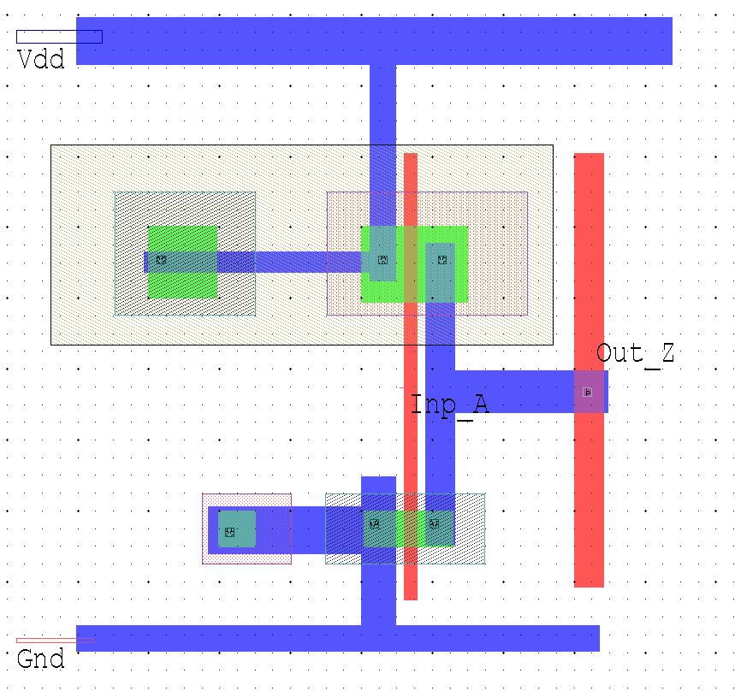

**Spice File Code**

* Circuit Extracted by Tanner Research's L-Edit Version 13.00 / Extract Version 13.00 ;

* TDB File: C:\Users\i140420\Desktop\Kamran_VLSI_4\L4_K_420.tdb

* Cell: Cell0 Version 1.13

* Extract Definition File: Generic_025.ext.txt

* Extract Date and Time: 02/22/2019 - 13:28

.INCLUDE SpecialDevices.md

* NODE NAME ALIASES

* 1 = Out_Z (387.3 , 14.46)

* 3 = Vdd (379.14 , 18.6)

* 4 = Inp_A (384.66 , 13.68)

M1 Out_Z Inp_A 2 2 NMOS L=180n W=510n AD=260.1f PD=2.04u AS=290.7f PS=2.16u $ (384.6 11.49 384.78 12)

M2 Out_Z Inp_A Vdd Vdd PMOS L=180n W=1.08u AD=777.6f PD=3.6u AS=648f PS=3.36u $ (384.6 14.94 384.78 16.02)

* Total Nodes: 2

* Total Elements: 2

* Total Number of Shorted Elements not written to the SPICE file: 0

* Total Number Elements with Missing Pins: 1

* Output Generation Elapsed Time: 0.000 sec

* Total Extract Elapsed Time: 0.765 sec

.tran 10n 100n

.lib "C:\Users\i140420\Desktop\Kamran_VLSI_4\Generic_025.lib" TT

v1 Inp_A Gnd PULSE (0 5 0 1n 1n 10n 20n)

v3 Vdd Gnd 5

.print tran v(Inp_A,Gnd) v(Out_Z,Gnd)

.END

.op

.END

**Simulation Results**

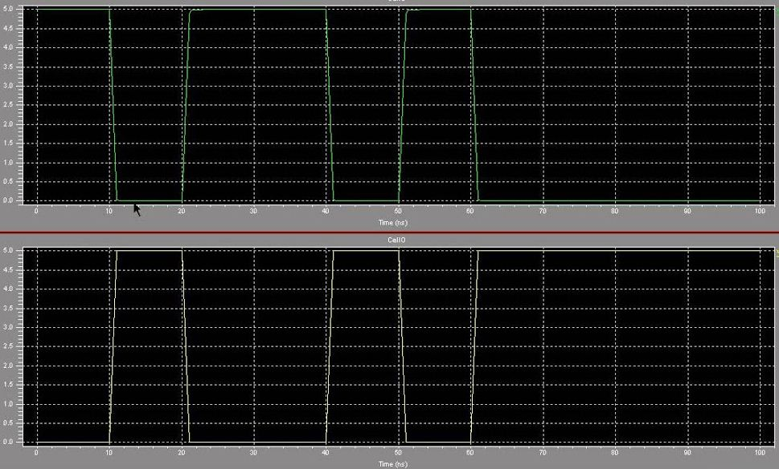

**Submission Declaration by the Student:**

In submitting this lab write-up to the Lab Engineer/Instructor, I hereby declare that:

* I have performed all the practical work myself
* I have noted down actual measurements in this writeup from my own working
* I have written un-plagarised answers to various questions
* I have/have not obtained the desired objectives of the lab.

Reasons of not obtaining objectoves (if applicable):

___________________________________________________________________

___________________________________________________________________

___________________________________________________________________

___________________________

Student’s signature and Date

**Student Evaluation by the Lab Engineer:**

The Lab Engineer can separate this page from the writeup and keep it for his/her own record. It must be signed by the student with date on it.

* **Lab Work:** objectives achieved (correctness of measurements, calculations, answers to questions posed, conclusion) ________/30
* **Lab Writeup:** Neatness, appropriateness, intime submission ________/10
* **Troubleshooting:** Were the student able to troubleshoot his/her work when it was purposedly changed? ________/10
* **TOTAL:** ________/50

**Feedback on student behaviour:**

***Encircle*** your choice. -2 means poorest/worst/extremely inadequate/irrevlevant, 0 gives an average score, and +2 means best/most relevant/most adequate.

* Did the student join the lab at the start/remained in lab? -2 -1 0 1 2
* Did the student remain focused on his/her work during lab? -2 -1 0 1 2
* Rate student's behaviour with fellows/staff/Lab Engineer? -2 -1 0 1 2
* Did the student cause any distraction during the Lab? -2 -1 0 1 2
* Was the student found in any sort of plagiarism? -2 -1 0 1 2

Additional comments (if any) by the Lab Engineer:

__________________________________________________________________

___________________________________________________________________

___________________________________________________________________

___________________________________________________________________

___________________________

Lab Engineer’s signature and Date

**Student's feedback: [Separate this page; fill it; drop in the Drop Box.]**

* Providing feedback for every lab session is optional. No feedback means you are satisified
* The Lab Committee will consider only duly filled forms submitted within one week after the lab
* This feedabck is for LAB session: LAB Number: _____, Date: _____________________
* General (to provide feedback on a persistent practice/ocurrence in LABs).
* Your current CGPA is in the range 4.00 to 3.00/2.99 to 2.00/1.99 to 1.00/0.99 to 0.00

**This feedback is:**

* For a Particular
* Who conducted the LAB? __________________________________________________
* Actual Start time: _______________ Total Duration of Lab: _______________________
* Instruction Duration: _________________ Practical Duration: _____________________
* LAB writeup available before LAB? Yes/No with the Photocopier/in LAB/in SLATE
* Had the theory related to lab been covered in theory class? Yes/No

***Encircle*** your choice. -2 means poorest/worst/extremely inadequate/irrevlevant, 0 gives an average score, and +2 means best/most relevant/most adequate.

|  |  |  |  |  |  |  |  |
| --- | --- | --- | --- | --- | --- | --- | --- |
| **Instruction Session** | Was duration of instruction session adequate? | |  |  |  |  |  | | --- | --- | --- | --- | --- | | **-2** | **-1** | **0** | **+1** | **+2** | |
| How much did you understand about the practical? | |  |  |  |  |  | | --- | --- | --- | --- | --- | | **-2** | **-1** | **0** | **+1** | **+2** | |
| How much content was irrelevant to the practical? | |  |  |  |  |  | | --- | --- | --- | --- | --- | | **-2** | **-1** | **0** | **+1** | **+2** | |
| Did the instructor allowed Q/A and discussion? | |  |  |  |  |  | | --- | --- | --- | --- | --- | | **-2** | **-1** | **0** | **+1** | **+2** | |
| **Practical** | Did you get sufficient time for practical? | |  |  |  |  |  | | --- | --- | --- | --- | --- | | **-2** | **-1** | **0** | **+1** | **+2** | |
| **Lab**  **Engineer** | Presence in lab at all time? | |  |  |  |  |  | | --- | --- | --- | --- | --- | | **-2** | **-1** | **0** | **+1** | **+2** | |
| Ability to convey? | |  |  |  |  |  | | --- | --- | --- | --- | --- | | **-2** | **-1** | **0** | **+1** | **+2** | |
| Readiness to help during practical? | |  |  |  |  |  | | --- | --- | --- | --- | --- | | **-2** | **-1** | **0** | **+1** | **+2** | |
| Readiness to discuss theoretical aspects? | |  |  |  |  |  | | --- | --- | --- | --- | --- | | **-2** | **-1** | **0** | **+1** | **+2** | |
| Helps in troubleshooting? | |  |  |  |  |  | | --- | --- | --- | --- | --- | | **-2** | **-1** | **0** | **+1** | **+2** | |
| Guides hows & whys of troubleshooting? | |  |  |  |  |  | | --- | --- | --- | --- | --- | | **-2** | **-1** | **0** | **+1** | **+2** | |
| **Staff** | How friendly was the lab staff? | |  |  |  |  |  | | --- | --- | --- | --- | --- | | **-2** | **-1** | **0** | **+1** | **+2** | |
| Presence of staff throughout the lab session? | |  |  |  |  |  | | --- | --- | --- | --- | --- | | **-2** | **-1** | **0** | **+1** | **+2** | |
| Impact of availability of staff on your practical? | |  |  |  |  |  | | --- | --- | --- | --- | --- | | **-2** | **-1** | **0** | **+1** | **+2** | |
| **Equipment** | Performance of Electronic Instruments? | |  |  |  |  |  | | --- | --- | --- | --- | --- | | **-2** | **-1** | **0** | **+1** | **+2** | |
| Performance of Breadboard/experiment kit? | |  |  |  |  |  | | --- | --- | --- | --- | --- | | **-2** | **-1** | **0** | **+1** | **+2** | |
| Performance of circuit components esp. ICs? | |  |  |  |  |  | | --- | --- | --- | --- | --- | | **-2** | **-1** | **0** | **+1** | **+2** | |
| **Overall** | Your overall rating for the whole lab session? | |  |  |  |  |  | | --- | --- | --- | --- | --- | | **-2** | **-1** | **0** | **+1** | **+2** | |

Other comments: _________________________________________________________________

_________________________________________________________________

_________________________________________________________________