|  |
| --- |
| **VLSI Lab** |
|  |
| **LABORATORY REPORT** |
| **Spring 2019** |



|  |  |  |  |  |
| --- | --- | --- | --- | --- |
| **LAB 06** | | | | |
| **Title of Lab Experiment: Decoder Layout Design and Simulation using available CAD Tools** | | | | |
| **Engr. Rashid Karim** | | | | |
|  | | |  |  |
| _____________Kamran____________ | | | ___i140420_____ | _A_ |
| STUDENT NAME | | | ROLL NO | SEC |
| Submission Date: ___________6/3/19__________ | | | | |
| ______________________________________ | | | | |
| LAB ENGINEER SIGNATURE & DATE | | | | |
|  | | | | |
| **MARKS AWARDED:**  /**10** | | | | |
| ________________________________________________________________ | | | | |
| **NATIONAL UNIVERSITY OF COMPUTER AND EMERGING SCIENCES (NUCES), ISLAMABAD** | | | | |
|  | | | | |
| **LAB:** | **06** | **Decoder Layout Design and Simulation using available CAD Tools** | | | |

#### **Learning Objectives:**

* Mask level implementation of all basic cells
* Functional verification through output/input waveforms

#### **Equipment Required:**

L-Edit, S-Edit, W-Edit

1. Lab Summary:

In this lab, we made transistor level,stick and abstract diagrams for a decoder.

We then implemented the stick diagram as a layout in L-Edit,extracted the layout into a T-Spice Fortran Code,added necessary commands and simulated it and viewed it’s Waveform on W-Edit.

1. Task

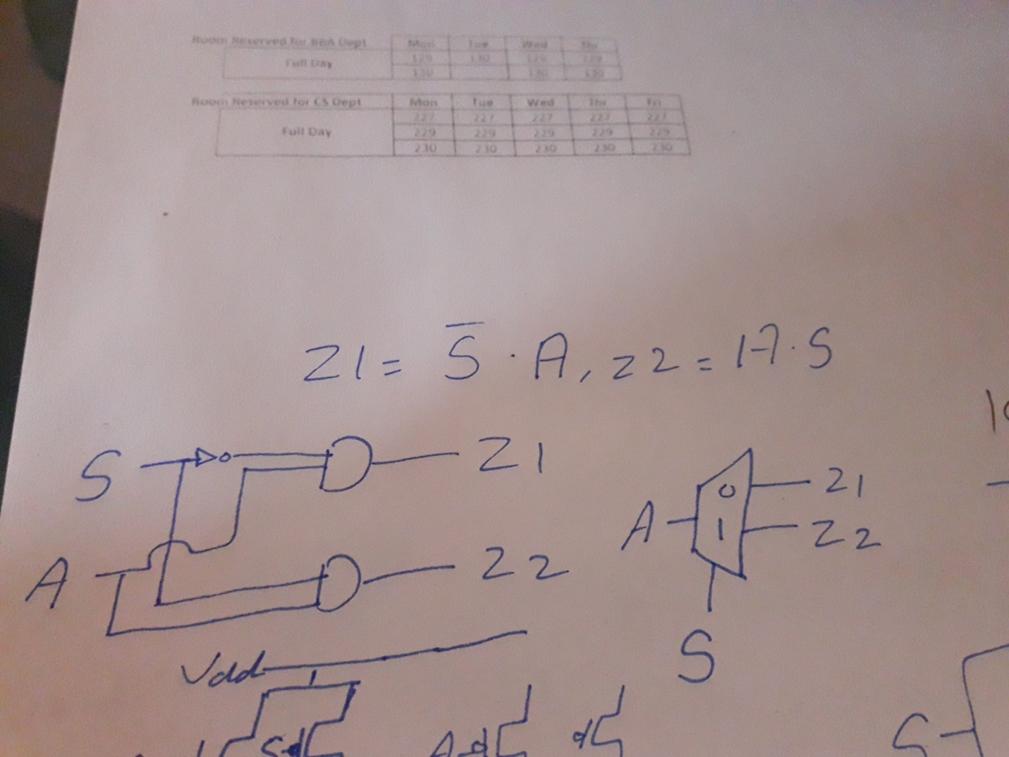

Transistor Level Diagram

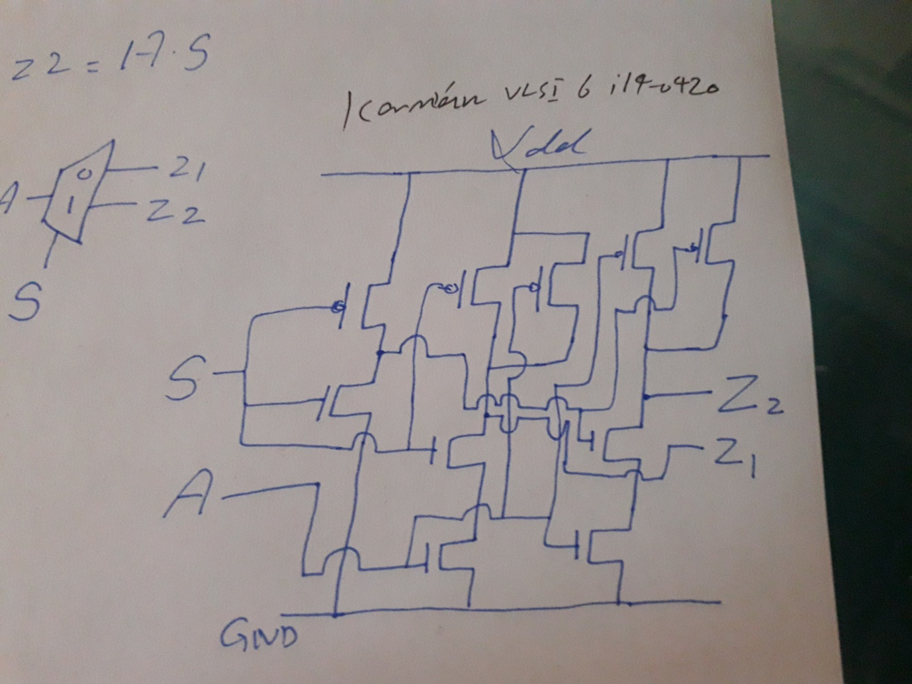

Stick Digram

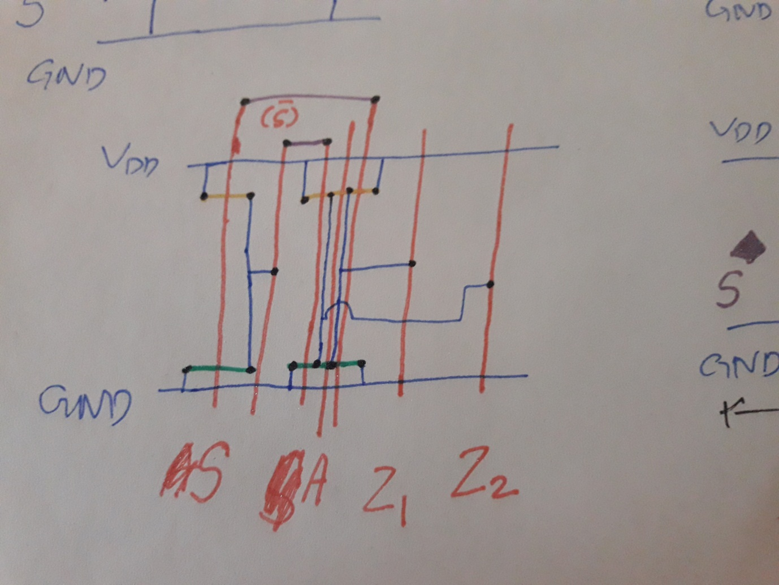

**Abstract:**

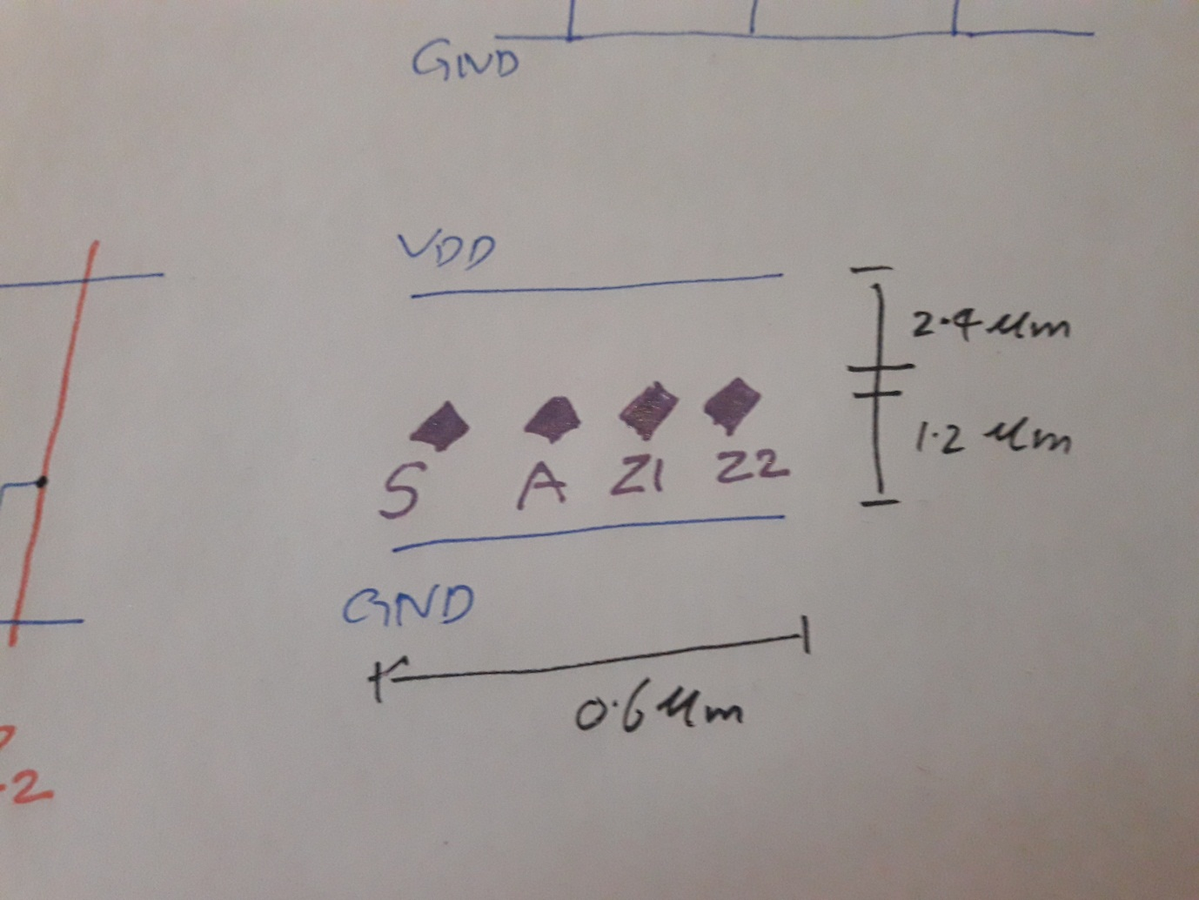

**Layout:**

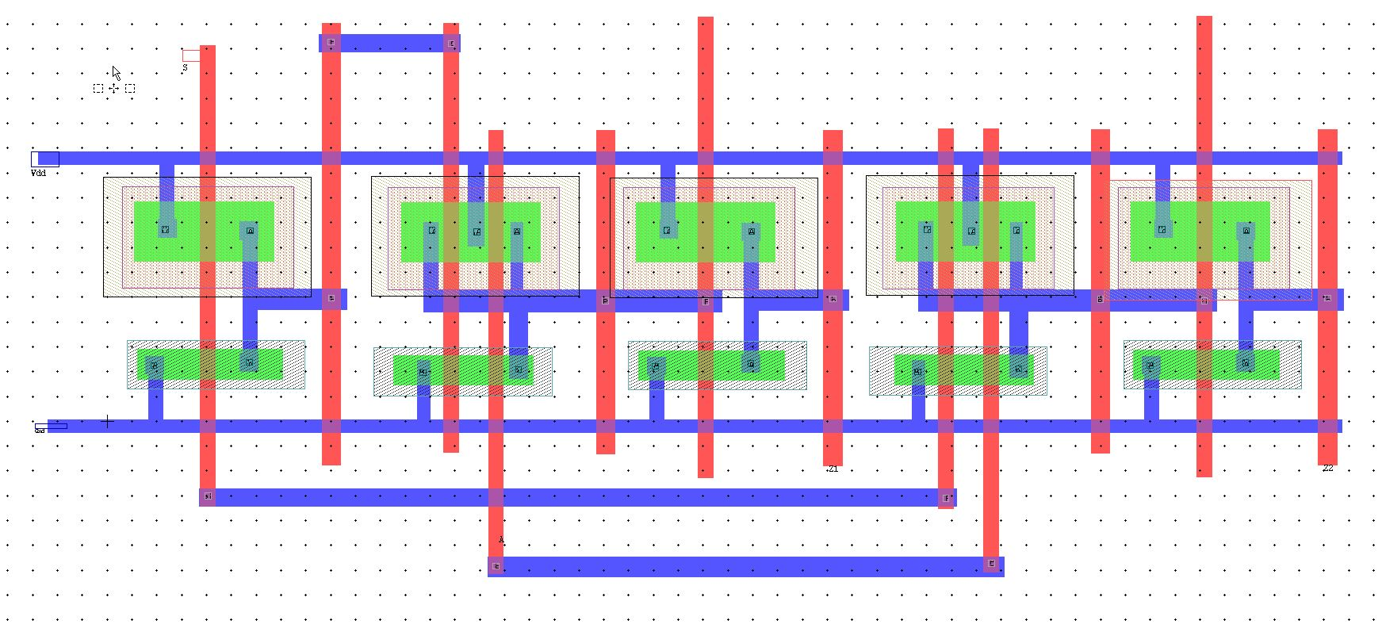

**Spice File Code**

* Circuit Extracted by Tanner Research's L-Edit Version 13.00 / Extract Version 13.00 ;

* TDB File: C:\Users\i140420\Desktop\Kamran_VLSI_6_6-3\L6_NAND.tdb

* Cell: Cell0_1 Version 1.26

* Extract Definition File: Generic_025.ext

* Extract Date and Time: 03/06/2019 - 11:26

.INCLUDE SpecialDevices.md

.lib "C:\Users\i140420\Desktop\Kamran_VLSI_6_6-3\Generic_025.lib" TT

.tran 10n 100n

v1 A Gnd PULSE (0 5 0 1n 1n 10n 20n)

v3 S Gnd PULSE (0 5 5n 1n 1n 10n 20n)

v4 Vdd Gnd 5

.print tran v(A,Gnd) v(S,Gnd) v(Z1,Gnd) v(Z2,Gnd)

* NODE NAME ALIASES

* 7 = S (3.034 , 14.505)

* 9 = Gnd (-2.907 , -0.293)

* 10 = Vdd (-3.044 , 10.23)

* 11 = A (15.777 , -4.498)

* 12 = Z2 (48.976 , -1.621)

* 14 = Z1 (29.05 , -1.65)

M1 Z2 13 Vdd 1 PMOS L=600n W=2.4u AD=5.64p PD=9.5u AS=6.36p PS=10.1u $ (43.876 6.429 44.476 8.829)

M2 Z1 6 Vdd 2 PMOS L=600n W=2.4u AD=5.9952p PD=9.796u AS=6.0048p PS=9.804u $ (23.802 6.4 24.402 8.8)

M3 8 S Vdd 3 PMOS L=600n W=2.4u AD=5.6352p PD=9.496u AS=6.3648p PS=10.104u $ (3.758 6.437 4.358 8.837)

M4 Vdd S 13 4 PMOS L=600n W=2.4u AD=1.4736p PD=3.628u AS=4.08p PS=8.2u $ (33.476 6.429 34.076 8.829)

M5 13 A Vdd 4 PMOS L=600n W=2.4u AD=3.5328p PD=7.744u AS=1.4736p PS=3.628u $ (35.304 6.429 35.904 8.829)

M6 Vdd 8 6 5 PMOS L=600n W=2.4u AD=1.4436p PD=3.603u AS=4.08p PS=8.2u $ (13.55 6.4 14.15 8.8)

M7 6 A Vdd 5 PMOS L=600n W=2.4u AD=3.5928p PD=7.794u AS=1.4436p PS=3.603u $ (15.353 6.4 15.953 8.8)

M8 Z2 13 Gnd 15 NMOS L=600n W=1.2u AD=3.252p PD=7.82u AS=3.06p PS=7.5u $ (43.876 1.679 44.476 2.879)

M9 Z1 6 Gnd 15 NMOS L=600n W=1.2u AD=3.4296p PD=8.116u AS=2.8824p PS=7.204u $ (23.802 1.65 24.402 2.85)

M10 8 S Gnd 15 NMOS L=600n W=1.2u AD=3.2496p PD=7.816u AS=3.0624p PS=7.504u $ (3.758 1.687 4.358 2.887)

M11 17 S Gnd 15 NMOS L=600n W=1.2u AD=736.8f PD=2.428u AS=2.1252p PS=5.942u $ (33.476 1.464 34.076 2.664)

M12 13 A 17 15 NMOS L=600n W=1.2u AD=1.6932p PD=5.222u AS=736.8f PS=2.428u $ (35.304 1.464 35.904 2.664)

M13 16 8 Gnd 15 NMOS L=600n W=1.2u AD=721.8f PD=2.403u AS=2.4p PS=6.4u $ (13.55 1.45 14.15 2.65)

M14 6 A 16 15 NMOS L=600n W=1.2u AD=1.4484p PD=4.814u AS=721.8f PS=2.403u $ (15.353 1.45 15.953 2.65)

* Total Nodes: 17

* Total Elements: 14

* Total Number of Shorted Elements not written to the SPICE file: 0

* Output Generation Elapsed Time: 0.001 sec

* Total Extract Elapsed Time: 1.374 sec

.op

.END

**Simulation Results/Waveforms**

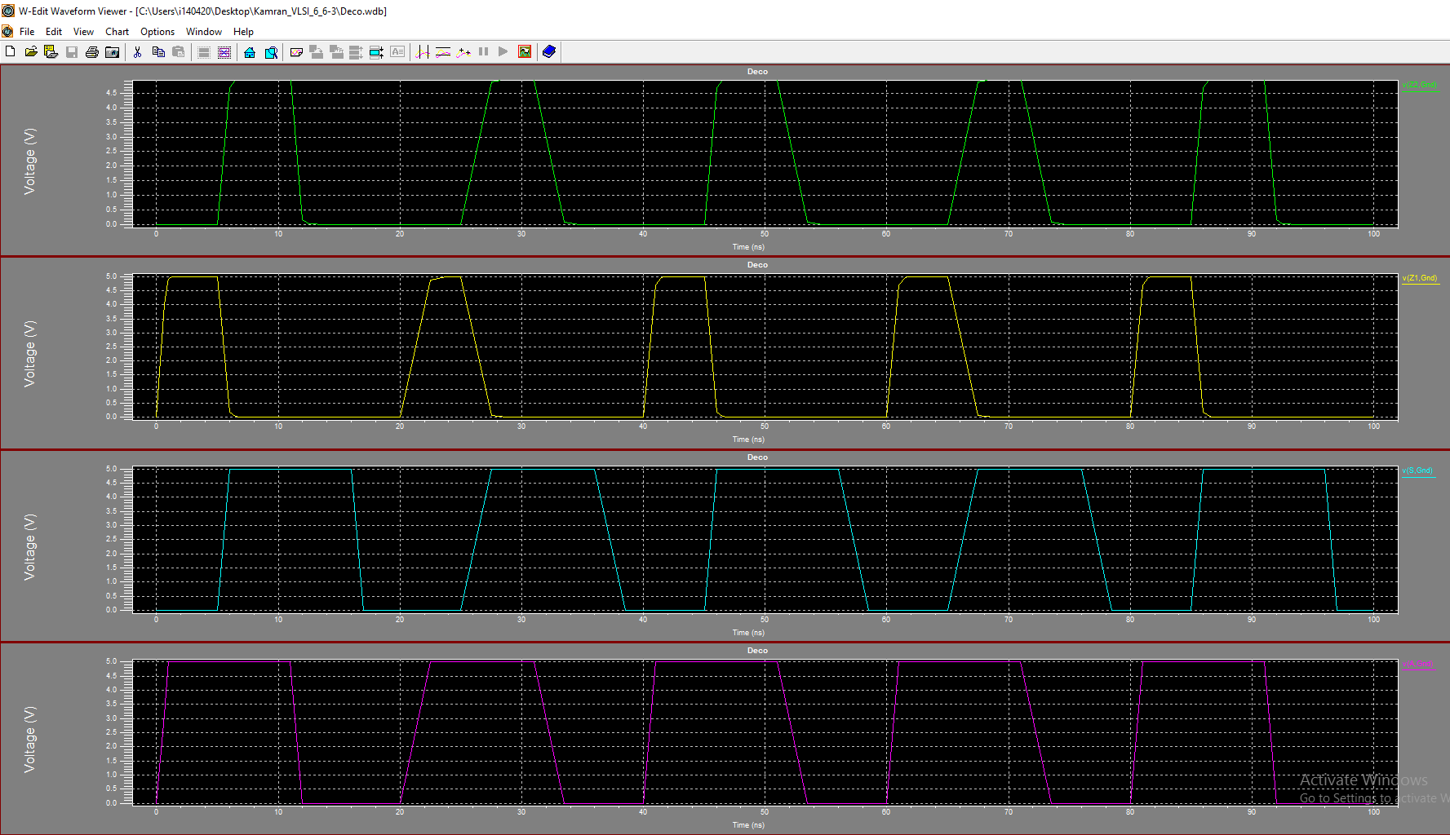

**Submission Declaration by the Student:**

In submitting this lab write-up to the Lab Engineer/Instructor, I hereby declare that:

* I have performed all the practical work myself
* I have noted down actual measurements in this writeup from my own working
* I have written un-plagarised answers to various questions
* I have/have not obtained the desired objectives of the lab.

Reasons of not obtaining objectoves (if applicable):

___________________________________________________________________

___________________________________________________________________

___________________________________________________________________

___________________________

Student’s signature and Date

**Student Evaluation by the Lab Engineer:**

The Lab Engineer can separate this page from the writeup and keep it for his/her own record. It must be signed by the student with date on it.

* **Lab Work:** objectives achieved (correctness of measurements, calculations, answers to questions posed, conclusion) ________/30
* **Lab Writeup:** Neatness, appropriateness, intime submission ________/10
* **Troubleshooting:** Were the student able to troubleshoot his/her work when it was purposedly changed? ________/10
* **TOTAL:** ________/50

**Feedback on student behaviour:**

***Encircle*** your choice. -2 means poorest/worst/extremely inadequate/irrevlevant, 0 gives an average score, and +2 means best/most relevant/most adequate.

* Did the student join the lab at the start/remained in lab? -2 -1 0 1 2
* Did the student remain focused on his/her work during lab? -2 -1 0 1 2
* Rate student's behaviour with fellows/staff/Lab Engineer? -2 -1 0 1 2
* Did the student cause any distraction during the Lab? -2 -1 0 1 2
* Was the student found in any sort of plagiarism? -2 -1 0 1 2

Additional comments (if any) by the Lab Engineer:

__________________________________________________________________

___________________________________________________________________

___________________________________________________________________

___________________________________________________________________

___________________________

Lab Engineer’s signature and Date

**Student's feedback: [Separate this page; fill it; drop in the Drop Box.]**

* Providing feedback for every lab session is optional. No feedback means you are satisified
* The Lab Committee will consider only duly filled forms submitted within one week after the lab
* This feedabck is for LAB session: LAB Number: _____, Date: _____________________
* General (to provide feedback on a persistent practice/ocurrence in LABs).
* Your current CGPA is in the range 4.00 to 3.00/2.99 to 2.00/1.99 to 1.00/0.99 to 0.00

**This feedback is:**

* For a Particular
* Who conducted the LAB? __________________________________________________
* Actual Start time: _______________ Total Duration of Lab: _______________________
* Instruction Duration: _________________ Practical Duration: _____________________
* LAB writeup available before LAB? Yes/No with the Photocopier/in LAB/in SLATE
* Had the theory related to lab been covered in theory class? Yes/No

***Encircle*** your choice. -2 means poorest/worst/extremely inadequate/irrevlevant, 0 gives an average score, and +2 means best/most relevant/most adequate.

|  |  |  |  |  |  |  |  |
| --- | --- | --- | --- | --- | --- | --- | --- |
| **Instruction Session** | Was duration of instruction session adequate? | |  |  |  |  |  | | --- | --- | --- | --- | --- | | **-2** | **-1** | **0** | **+1** | **+2** | |
| How much did you understand about the practical? | |  |  |  |  |  | | --- | --- | --- | --- | --- | | **-2** | **-1** | **0** | **+1** | **+2** | |
| How much content was irrelevant to the practical? | |  |  |  |  |  | | --- | --- | --- | --- | --- | | **-2** | **-1** | **0** | **+1** | **+2** | |
| Did the instructor allowed Q/A and discussion? | |  |  |  |  |  | | --- | --- | --- | --- | --- | | **-2** | **-1** | **0** | **+1** | **+2** | |
| **Practical** | Did you get sufficient time for practical? | |  |  |  |  |  | | --- | --- | --- | --- | --- | | **-2** | **-1** | **0** | **+1** | **+2** | |
| **Lab**  **Engineer** | Presence in lab at all time? | |  |  |  |  |  | | --- | --- | --- | --- | --- | | **-2** | **-1** | **0** | **+1** | **+2** | |
| Ability to convey? | |  |  |  |  |  | | --- | --- | --- | --- | --- | | **-2** | **-1** | **0** | **+1** | **+2** | |
| Readiness to help during practical? | |  |  |  |  |  | | --- | --- | --- | --- | --- | | **-2** | **-1** | **0** | **+1** | **+2** | |
| Readiness to discuss theoretical aspects? | |  |  |  |  |  | | --- | --- | --- | --- | --- | | **-2** | **-1** | **0** | **+1** | **+2** | |
| Helps in troubleshooting? | |  |  |  |  |  | | --- | --- | --- | --- | --- | | **-2** | **-1** | **0** | **+1** | **+2** | |
| Guides hows & whys of troubleshooting? | |  |  |  |  |  | | --- | --- | --- | --- | --- | | **-2** | **-1** | **0** | **+1** | **+2** | |
| **Staff** | How friendly was the lab staff? | |  |  |  |  |  | | --- | --- | --- | --- | --- | | **-2** | **-1** | **0** | **+1** | **+2** | |
| Presence of staff throughout the lab session? | |  |  |  |  |  | | --- | --- | --- | --- | --- | | **-2** | **-1** | **0** | **+1** | **+2** | |
| Impact of availability of staff on your practical? | |  |  |  |  |  | | --- | --- | --- | --- | --- | | **-2** | **-1** | **0** | **+1** | **+2** | |
| **Equipment** | Performance of Electronic Instruments? | |  |  |  |  |  | | --- | --- | --- | --- | --- | | **-2** | **-1** | **0** | **+1** | **+2** | |
| Performance of Breadboard/experiment kit? | |  |  |  |  |  | | --- | --- | --- | --- | --- | | **-2** | **-1** | **0** | **+1** | **+2** | |
| Performance of circuit components esp. ICs? | |  |  |  |  |  | | --- | --- | --- | --- | --- | | **-2** | **-1** | **0** | **+1** | **+2** | |
| **Overall** | Your overall rating for the whole lab session? | |  |  |  |  |  | | --- | --- | --- | --- | --- | | **-2** | **-1** | **0** | **+1** | **+2** | |

Other comments: _________________________________________________________________

_________________________________________________________________

_________________________________________________________________