|  |
| --- |
| **VLSI Lab** |
|  |
| **LABORATORY REPORT** |
| **Spring 2019** |



|  |  |  |  |  |
| --- | --- | --- | --- | --- |
| **LAB 07** | | | | |
| **Title of Lab Experiment: Implementation of Transmission Gate Circuits Layout using available CAD Tools** | | | | |
| **Engr. Rashid Karim** | | | | |
|  | | |  |  |
| ______Kamran__________________ | | | ___i140420___ | _A_ |
| STUDENT NAME | | | ROLL NO | SEC |
| Submission Date: ________13/3/19________ | | | | |
| ______________________________________ | | | | |
| LAB ENGINEER SIGNATURE & DATE | | | | |
|  | | | | |
| **MARKS AWARDED:**  /**10** | | | | |
| ________________________________________________________________ | | | | |
| **NATIONAL UNIVERSITY OF COMPUTER AND EMERGING SCIENCES (NUCES), ISLAMABAD** | | | | |
|  | | | | |
| **LAB:** | **07** | **Implementation of Transmission Gate Circuits Layout using available CAD Tools** | | | |

#### **Learning Objectives:**

a. Transmission Gate circuits

b. Layout design using Transmission Gate.

#### **Equipment Required:**

Software : L-Edit

1. Lab Summary:

In this lab,we made gate level, transistor level and stick diagrams of XOR gate using Transmission gates.We then implemented it’s layout on L-Edit,extracted into T-Spice file code and simulated and verified using W-Edit tools.

1. Task

Transistor Level Diagram

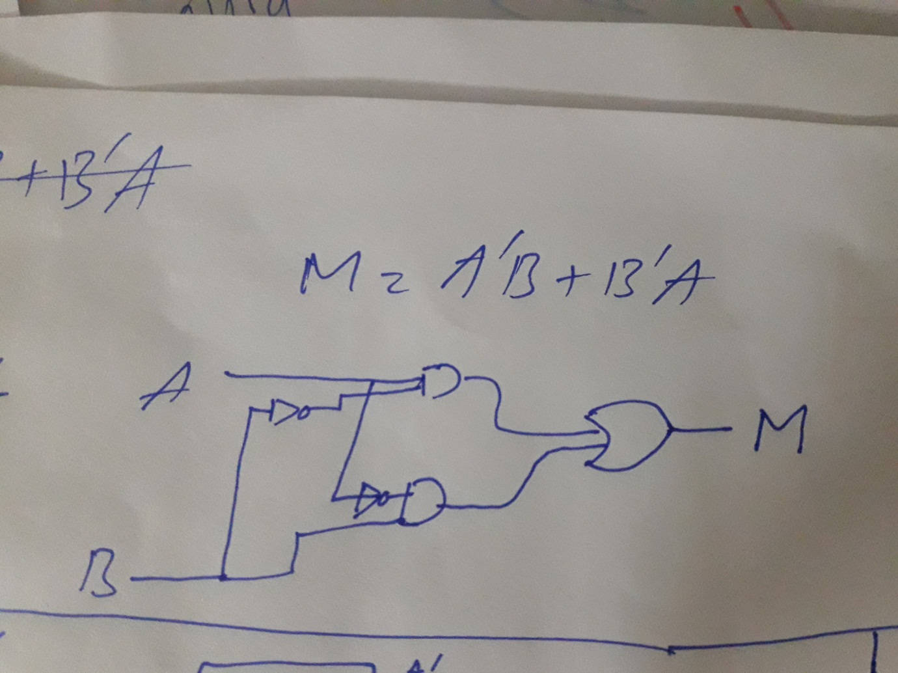

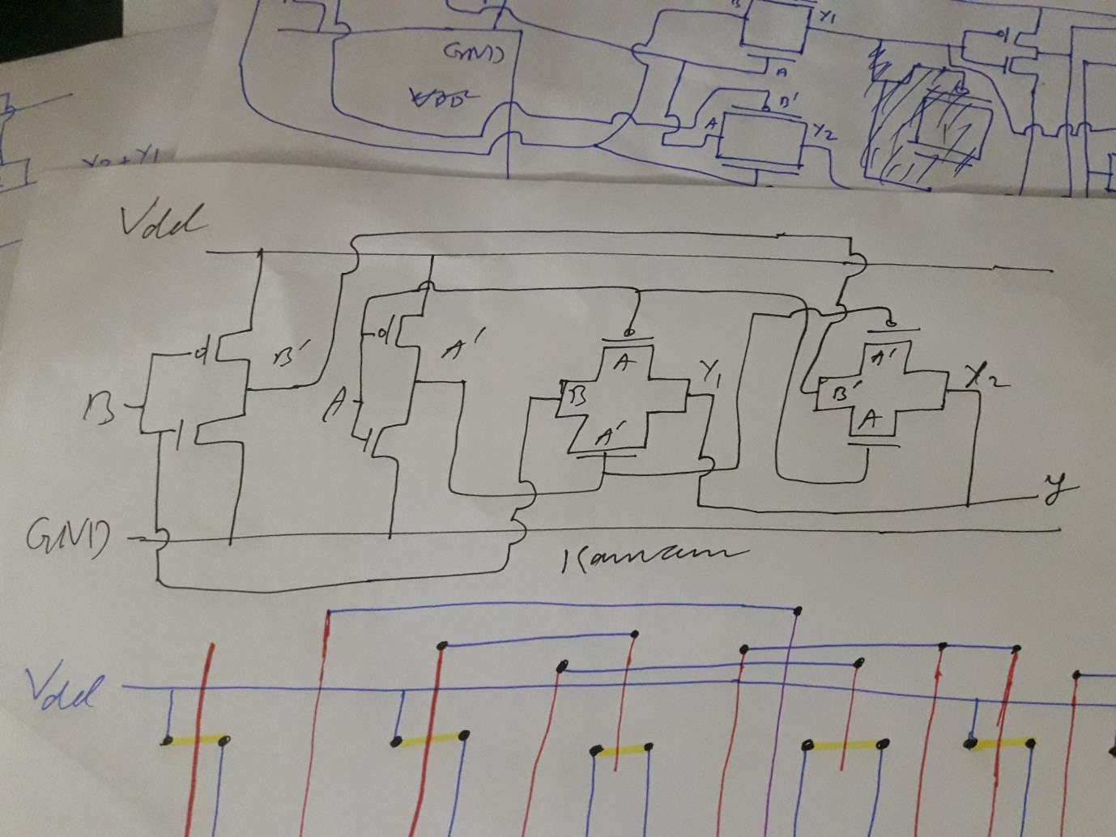

Stick Diagram

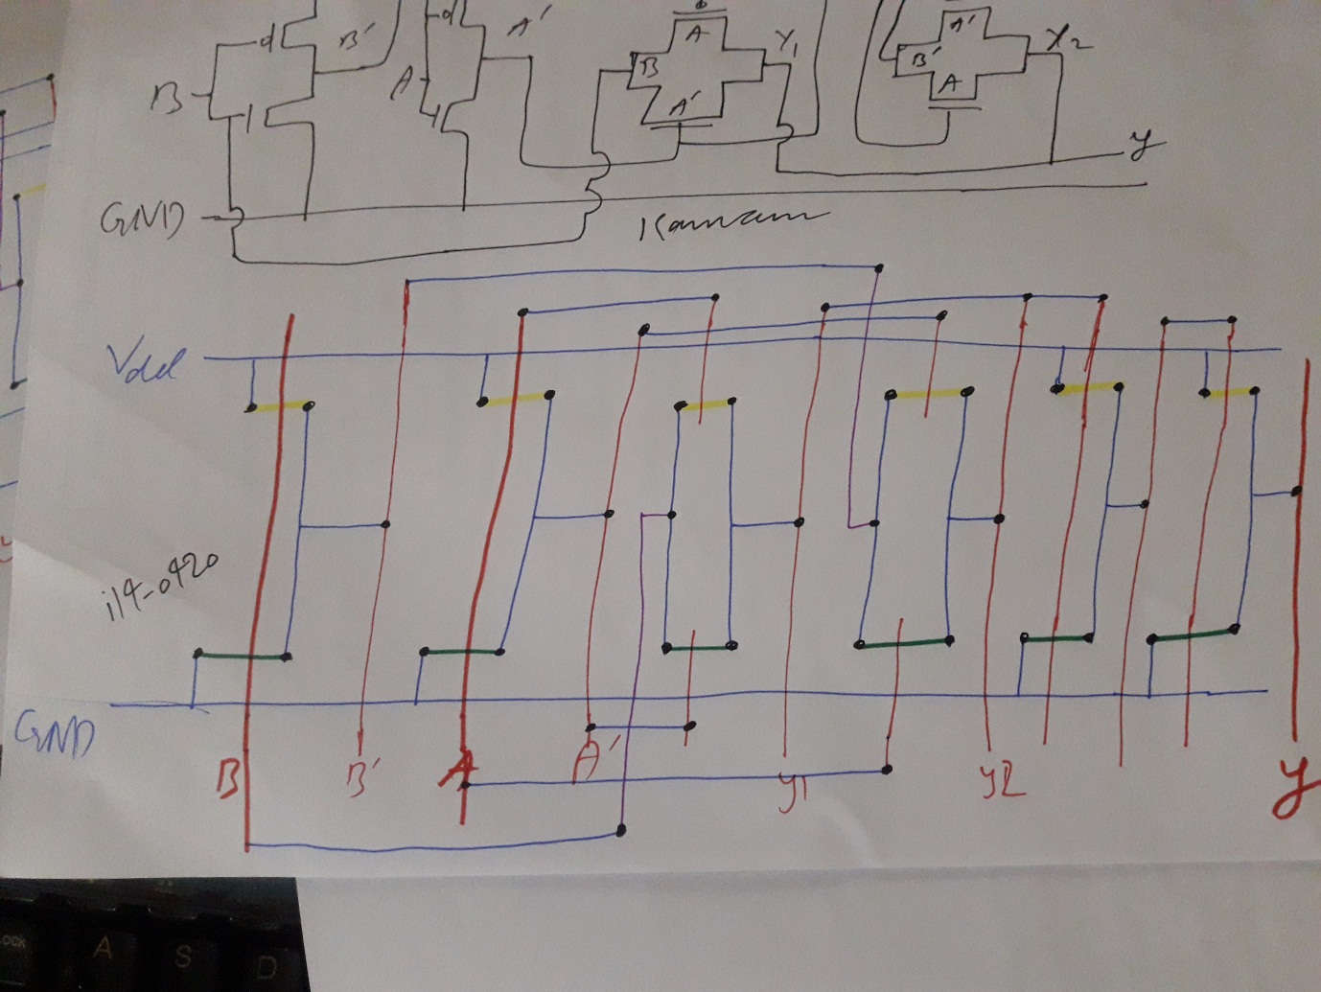

Abstract

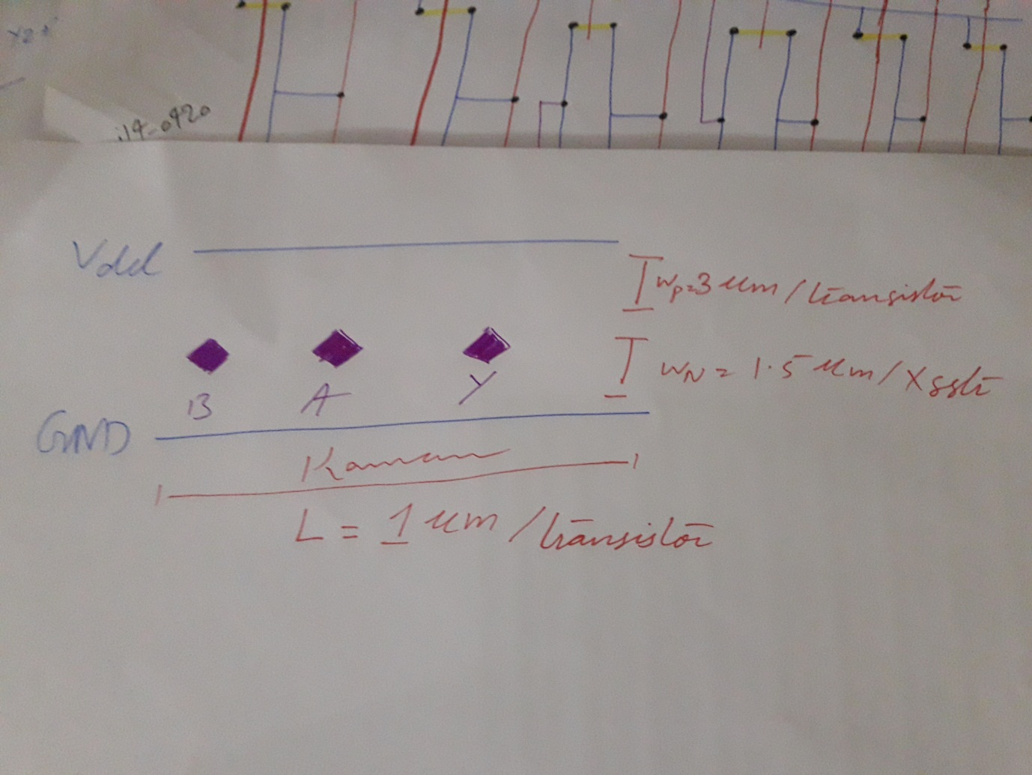

**Layout:**

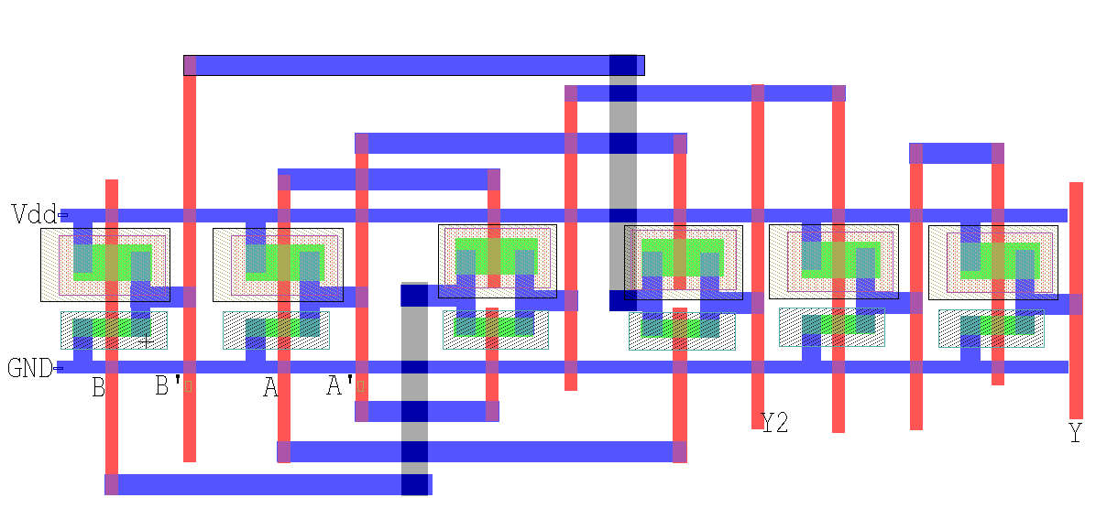

**Spice File Code**

* Circuit Extracted by Tanner Research's L-Edit Version 13.00 / Extract Version 13.00 ;

* TDB File: D:\Kamran\Study\FAST NUCES\Mad Max 19\VLSI Lab\Kamran_VLSI_7_13-3\New Xmsn XOR.tdb

* Cell: Cell0 Version 1.26

* Extract Definition File: Generic_025.ext

* Extract Date and Time: 03/14/2019 - 23:08

.INCLUDE SpecialDevices.md

.lib "D:\Kamran\Study\FAST NUCES\Mad Max 19\VLSI Lab\Kamran_VLSI_7_13-3\Generic_025.lib" TT

.tran 10n 100n

v1 A GND PULSE (0 5 0 1n 1n 10n 20n)

v3 B GND PULSE (0 5 5n 1n 1n 10n 20n)

v4 Vdd GND 5

.print tran v(A,GND) v(B,GND) v(Y,GND)

* NODE NAME ALIASES

* 3 = Y (77.26 , -6.19)

* 4 = GND (-7.7 , -2.35)

* 5 = Vdd (-7.3 , 10.4)

* 6 = Y2 (50.68 , -6.95)

* 8 = A (11.12 , -4.28)

* 17 = B (-3.24 , -4.28)

M1 Y 2 Vdd 9 PMOS L=1u W=3u AD=8.91p PD=11.94u AS=7.59p PS=11.06u $ (70.42 5.23 71.42 8.23)

M2 2 Y2 Vdd 10 PMOS L=1u W=3u AD=8.91p PD=11.94u AS=7.59p PS=11.06u $ (57.17 5.33 58.17 8.33)

M3 Y2 1 16 11 PMOS L=1.02u W=3u AD=9.3p PD=12.2u AS=7.98p PS=11.32u $ (43.98 5.49 45 8.49)

M4 7 A Vdd 12 PMOS L=1u W=3u AD=8.55p PD=11.7u AS=7.95p PS=11.3u $ (11.01 5.05 12.01 8.05)

M5 Y2 A B 13 PMOS L=1.02u W=3u AD=9.3p PD=12.2u AS=7.98p PS=11.32u $ (28.46 5.61 29.48 8.61)

M6 16 B Vdd 14 PMOS L=1u W=3u AD=8.55p PD=11.7u AS=7.95p PS=11.3u $ (-3.35 5.05 -2.35 8.05)

M7 Y 2 GND 15 NMOS L=1u W=1.5u AD=3.825p PD=8.1u AS=3.795p PS=8.06u $ (70.42 0.58 71.42 2.08)

M8 2 Y2 GND 15 NMOS L=1u W=1.5u AD=3.825p PD=8.1u AS=3.795p PS=8.06u $ (57.17 0.68 58.17 2.18)

M9 Y2 A 16 15 NMOS L=1.1u W=1.5u AD=4.065p PD=8.42u AS=4.035p PS=8.38u $ (43.91 0.32 45.01 1.82)

M10 7 A GND 15 NMOS L=1u W=1.5u AD=3.645p PD=7.86u AS=3.975p PS=8.3u $ (11.01 0.4 12.01 1.9)

M11 Y2 7 B 15 NMOS L=1u W=1.5u AD=4.29p PD=8.72u AS=3.96p PS=8.28u $ (28.34 0.44 29.34 1.94)

M12 16 B GND 15 NMOS L=1u W=1.5u AD=4.125p PD=8.5u AS=4.125p PS=8.5u $ (-3.35 0.4 -2.35 1.9)

* Total Nodes: 17

* Total Elements: 12

* Total Number of Shorted Elements not written to the SPICE file: 0

* Output Generation Elapsed Time: 0.000 sec

* Total Extract Elapsed Time: 0.705 sec

.op

.END

**Simulation Results/Waveforms**

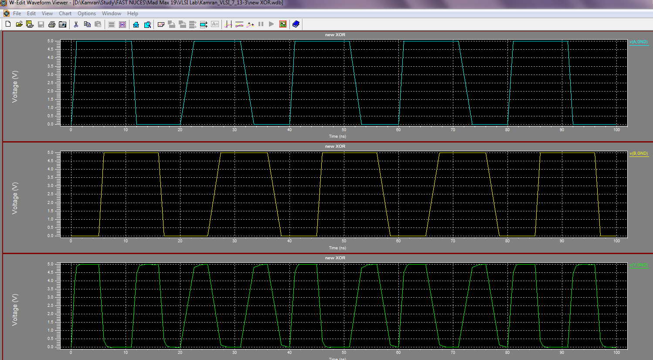

**Submission Declaration by the Student:**

In submitting this lab write-up to the Lab Engineer/Instructor, I hereby declare that:

* I have performed all the practical work myself
* I have noted down actual measurements in this writeup from my own working
* I have written un-plagarised answers to various questions
* I have/have not obtained the desired objectives of the lab.

Reasons of not obtaining objectoves (if applicable):

___________________________________________________________________

___________________________________________________________________

___________________________________________________________________

___________________________

Student’s signature and Date

**Student Evaluation by the Lab Engineer:**

The Lab Engineer can separate this page from the writeup and keep it for his/her own record. It must be signed by the student with date on it.

* **Lab Work:** objectives achieved (correctness of measurements, calculations, answers to questions posed, conclusion) ________/30
* **Lab Writeup:** Neatness, appropriateness, intime submission ________/10
* **Troubleshooting:** Were the student able to troubleshoot his/her work when it was purposedly changed? ________/10
* **TOTAL:** ________/50

**Feedback on student behaviour:**

***Encircle*** your choice. -2 means poorest/worst/extremely inadequate/irrevlevant, 0 gives an average score, and +2 means best/most relevant/most adequate.

* Did the student join the lab at the start/remained in lab? -2 -1 0 1 2
* Did the student remain focused on his/her work during lab? -2 -1 0 1 2
* Rate student's behaviour with fellows/staff/Lab Engineer? -2 -1 0 1 2
* Did the student cause any distraction during the Lab? -2 -1 0 1 2
* Was the student found in any sort of plagiarism? -2 -1 0 1 2

Additional comments (if any) by the Lab Engineer:

__________________________________________________________________

___________________________________________________________________

___________________________________________________________________

___________________________________________________________________

___________________________

Lab Engineer’s signature and Date

**Student's feedback: [Separate this page; fill it; drop in the Drop Box.]**

* Providing feedback for every lab session is optional. No feedback means you are satisified
* The Lab Committee will consider only duly filled forms submitted within one week after the lab
* This feedabck is for LAB session: LAB Number: _____, Date: _____________________
* General (to provide feedback on a persistent practice/ocurrence in LABs).
* Your current CGPA is in the range 4.00 to 3.00/2.99 to 2.00/1.99 to 1.00/0.99 to 0.00

**This feedback is:**

* For a Particular
* Who conducted the LAB? __________________________________________________
* Actual Start time: _______________ Total Duration of Lab: _______________________
* Instruction Duration: _________________ Practical Duration: _____________________
* LAB writeup available before LAB? Yes/No with the Photocopier/in LAB/in SLATE
* Had the theory related to lab been covered in theory class? Yes/No

***Encircle*** your choice. -2 means poorest/worst/extremely inadequate/irrevlevant, 0 gives an average score, and +2 means best/most relevant/most adequate.

|  |  |  |  |  |  |  |  |
| --- | --- | --- | --- | --- | --- | --- | --- |
| **Instruction Session** | Was duration of instruction session adequate? | |  |  |  |  |  | | --- | --- | --- | --- | --- | | **-2** | **-1** | **0** | **+1** | **+2** | |
| How much did you understand about the practical? | |  |  |  |  |  | | --- | --- | --- | --- | --- | | **-2** | **-1** | **0** | **+1** | **+2** | |
| How much content was irrelevant to the practical? | |  |  |  |  |  | | --- | --- | --- | --- | --- | | **-2** | **-1** | **0** | **+1** | **+2** | |
| Did the instructor allowed Q/A and discussion? | |  |  |  |  |  | | --- | --- | --- | --- | --- | | **-2** | **-1** | **0** | **+1** | **+2** | |
| **Practical** | Did you get sufficient time for practical? | |  |  |  |  |  | | --- | --- | --- | --- | --- | | **-2** | **-1** | **0** | **+1** | **+2** | |
| **Lab**  **Engineer** | Presence in lab at all time? | |  |  |  |  |  | | --- | --- | --- | --- | --- | | **-2** | **-1** | **0** | **+1** | **+2** | |
| Ability to convey? | |  |  |  |  |  | | --- | --- | --- | --- | --- | | **-2** | **-1** | **0** | **+1** | **+2** | |
| Readiness to help during practical? | |  |  |  |  |  | | --- | --- | --- | --- | --- | | **-2** | **-1** | **0** | **+1** | **+2** | |
| Readiness to discuss theoretical aspects? | |  |  |  |  |  | | --- | --- | --- | --- | --- | | **-2** | **-1** | **0** | **+1** | **+2** | |
| Helps in troubleshooting? | |  |  |  |  |  | | --- | --- | --- | --- | --- | | **-2** | **-1** | **0** | **+1** | **+2** | |
| Guides hows & whys of troubleshooting? | |  |  |  |  |  | | --- | --- | --- | --- | --- | | **-2** | **-1** | **0** | **+1** | **+2** | |
| **Staff** | How friendly was the lab staff? | |  |  |  |  |  | | --- | --- | --- | --- | --- | | **-2** | **-1** | **0** | **+1** | **+2** | |
| Presence of staff throughout the lab session? | |  |  |  |  |  | | --- | --- | --- | --- | --- | | **-2** | **-1** | **0** | **+1** | **+2** | |
| Impact of availability of staff on your practical? | |  |  |  |  |  | | --- | --- | --- | --- | --- | | **-2** | **-1** | **0** | **+1** | **+2** | |
| **Equipment** | Performance of Electronic Instruments? | |  |  |  |  |  | | --- | --- | --- | --- | --- | | **-2** | **-1** | **0** | **+1** | **+2** | |
| Performance of Breadboard/experiment kit? | |  |  |  |  |  | | --- | --- | --- | --- | --- | | **-2** | **-1** | **0** | **+1** | **+2** | |
| Performance of circuit components esp. ICs? | |  |  |  |  |  | | --- | --- | --- | --- | --- | | **-2** | **-1** | **0** | **+1** | **+2** | |
| **Overall** | Your overall rating for the whole lab session? | |  |  |  |  |  | | --- | --- | --- | --- | --- | | **-2** | **-1** | **0** | **+1** | **+2** | |

Other comments: _________________________________________________________________

_________________________________________________________________

_________________________________________________________________