|  |
| --- |
| **VLSI Lab** |
|  |
| **LABORATORY REPORT** |
| **Spring 2019** |



|  |  |  |  |  |
| --- | --- | --- | --- | --- |
| **LAB 08** | | | | |
| **Title of Lab Experiment: Layout design of sequential circuits using available CAD tools using Gate Matrix mehtod** | | | | |
| **Engr. Rashid Karim** | | | | |
|  | | |  |  |
| _____Kamran_________________ | | | ____i140420____ | _A_ |
| STUDENT NAME | | | ROLL NO | SEC |
| Submission Date: ______29/3/19__________________ | | | | |
| ______________________________________ | | | | |
| LAB ENGINEER SIGNATURE & DATE | | | | |
|  | | | | |
| **MARKS AWARDED:**  /**10** | | | | |
| ________________________________________________________________ | | | | |
| **NATIONAL UNIVERSITY OF COMPUTER AND EMERGING SCIENCES (NUCES), ISLAMABAD** | | | | |
|  | | | | |
| **LAB:** | **08** | **Layout design of sequential circuits using available CAD tools using Gate Matrix mehtod** | | | |

#### **Learning Objectives:**

a. Sequential digital circuits

b. Layout design using Gate matrix method

#### **Equipment Required:**

Software : L-Edit,S-Edit,W-Edit

1. Lab Summary:

In this lab,we implemented multi-layer gates using Gate matrix style and simulated the layout design.

1. Task

Gate Level Diagram

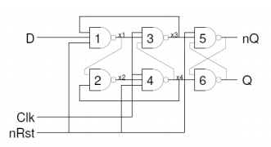

Stick Digram

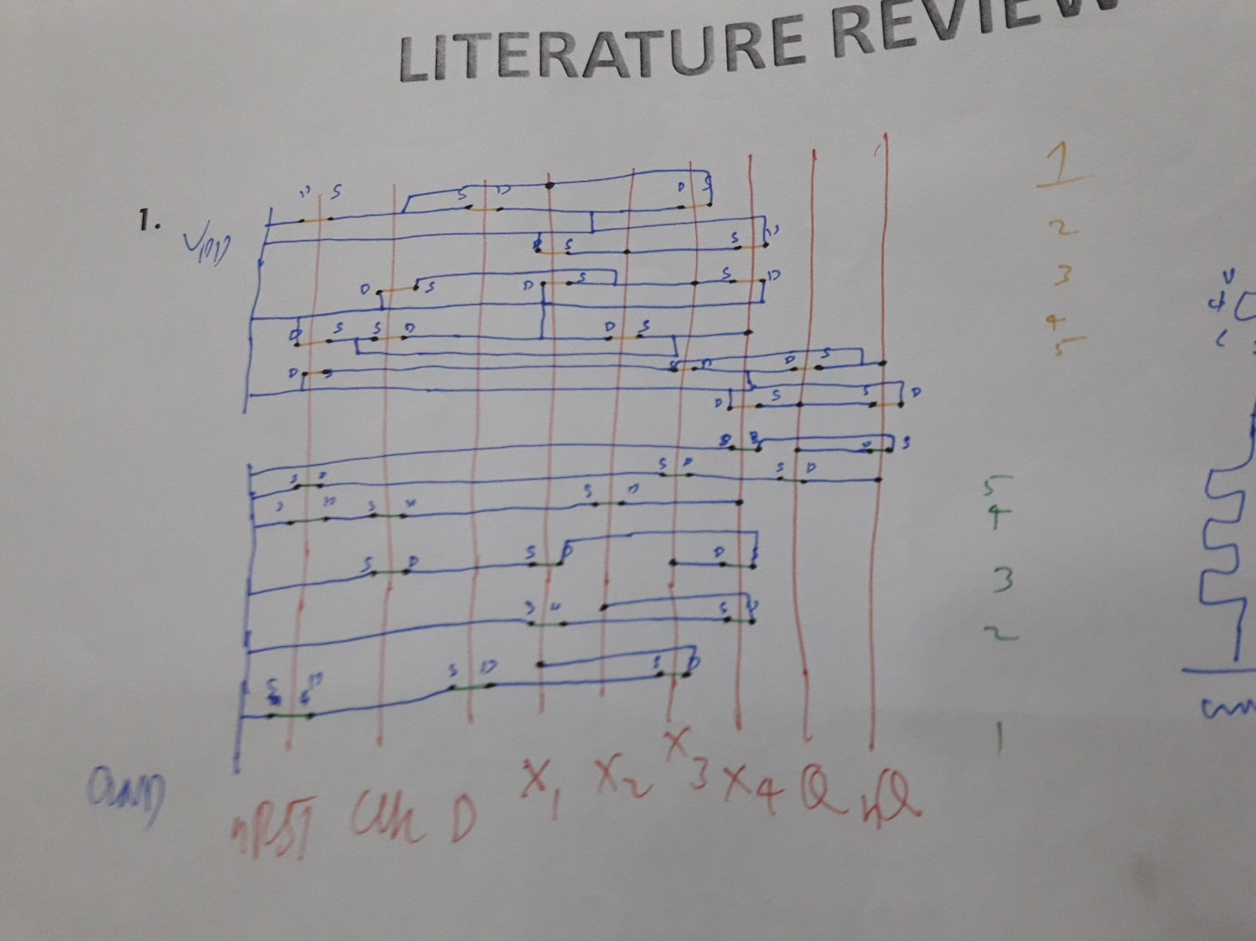

**Layout:**

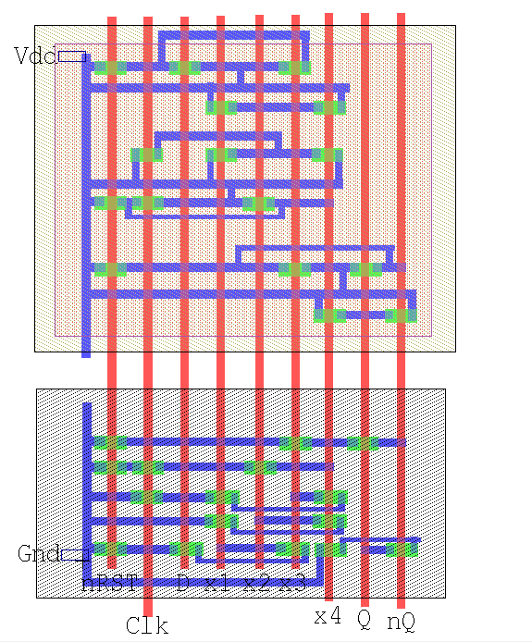

**Spice File Code**

* Circuit Extracted by Tanner Research's L-Edit Version 13.00 / Extract Version 13.00 ;

* TDB File: C:\Users\ACG\Desktop\Kamran_VLSI_8_27-3\Kamran_VLSI_8_27-3.tdb

* Cell: Cell0 Version 1.12

* Extract Definition File: Generic_025.ext

* Extract Date and Time: 03/29/2019 - 22:01

.INCLUDE SpecialDevices.md

*.lib "C:\Users\i140420\Desktop\Kamran_VLSI_8_27-3\Generic_025.lib" TT

.lib "C:\Users\ACG\Desktop\Kamran_VLSI_8_27-3\Generic_025.lib" TT

.tran 10n 100n

v1 nRST Gnd PULSE (0 5 0 1n 1n 50n 100n)

v2 Clk Gnd PULSE (0 5 0 1n 1n 10n 20n)

v3 D Gnd PULSE (0 5 5n 1n 1n 10n 20n)

v11 Vdd Gnd 5

.print tran v(nRST,Gnd) v(Clk,Gnd) v(D,Gnd) v(Q,Gnd) v(nQ,Gnd)

* NODE NAME ALIASES

* 1 = Gnd (-2.1 , 0.1)

* 2 = Vdd (-2.4 , 48.3)

* 3 = Q (27.25 , -4.15)

* 4 = nQ (30.8 , -4.35)

* 5 = x4 (23.8 , -3.85)

* 6 = x3 (20.4 , -0.75)

* 7 = x2 (16.9 , -0.75)

* 8 = x1 (13.15 , -0.75)

* 21 = nRST (2.65 , -0.75)

* 22 = Clk (6.15 , -0.75)

* 23 = D (9.65 , -0.75)

M1 Q x4 Vdd 19 PMOS L=750n W=1.25u AD=1.5p PD=4.9u AS=1.3125p PS=4.6u $ (23.4 23.1 24.15 24.35)

M2 Vdd x4 x3 19 PMOS L=750n W=1.25u AD=1.25p PD=4.5u AS=1.5625p PS=5u $ (23.4 38.7 24.15 39.95)

M3 Vdd x4 x2 19 PMOS L=750n W=1.25u AD=1.5p PD=4.9u AS=1.3125p PS=4.6u $ (23.4 43.2 24.15 44.45)

M4 x3 x1 Vdd 19 PMOS L=750n W=1.25u AD=1.5p PD=4.9u AS=1.3125p PS=4.6u $ (12.9 38.7 13.65 39.95)

M5 x2 x1 Vdd 19 PMOS L=750n W=1.25u AD=1.5p PD=4.9u AS=1.3125p PS=4.6u $ (12.9 43.2 13.65 44.45)

M6 Vdd x3 nQ 19 PMOS L=750n W=1.25u AD=1.3125p PD=4.6u AS=1.5p PS=4.9u $ (20.15 27.6 20.9 28.85)

M7 x1 x3 Vdd 19 PMOS L=750n W=1.25u AD=1.3125p PD=4.6u AS=1.5p PS=4.9u $ (20.15 47.1 20.9 48.35)

M8 nQ Q Vdd 19 PMOS L=750n W=1.25u AD=1.5p PD=4.9u AS=1.3125p PS=4.6u $ (26.9 27.6 27.65 28.85)

M9 Vdd nQ Q 19 PMOS L=750n W=1.25u AD=1.375p PD=4.7u AS=1.4375p PS=4.8u $ (30.4 23.1 31.15 24.35)

M10 x4 x2 Vdd 19 PMOS L=750n W=1.25u AD=1.3125p PD=4.6u AS=1.5p PS=4.9u $ (16.65 33.9 17.4 35.15)

M11 Vdd D x1 19 PMOS L=750n W=1.25u AD=1.5p PD=4.9u AS=1.3125p PS=4.6u $ (9.4 47.1 10.15 48.35)

M12 Vdd Clk x4 19 PMOS L=750n W=1.25u AD=1.375p PD=4.7u AS=1.4375p PS=4.8u $ (5.9 34 6.65 35.25)

M13 x3 Clk Vdd 19 PMOS L=750n W=1.25u AD=1.25p PD=4.5u AS=1.5625p PS=5u $ (5.9 38.7 6.65 39.95)

M14 nQ nRST Vdd 19 PMOS L=750n W=1.25u AD=1.25p PD=4.5u AS=1.5625p PS=5u $ (2.4 27.6 3.15 28.85)

M15 x4 nRST Vdd 19 PMOS L=750n W=1.25u AD=1.25p PD=4.5u AS=1.5625p PS=5u $ (2.4 34 3.15 35.25)

M16 x1 nRST Vdd 19 PMOS L=750n W=1.25u AD=1.25p PD=4.5u AS=1.5625p PS=5u $ (2.4 47.1 3.15 48.35)

M17 9 x4 Gnd 20 NMOS L=750n W=1.25u AD=1.625p PD=5.1u AS=1.1875p PS=4.4u $ (23.4 0.4 24.15 1.65)

M18 15 x4 x3 20 NMOS L=750n W=1.25u AD=1.75p PD=5.3u AS=1.3125p PS=4.6u $ (23.4 5.5 24.15 6.75)

M19 16 x4 x2 20 NMOS L=750n W=1.25u AD=1.625p PD=5.1u AS=1.4375p PS=4.8u $ (23.4 3.2 24.15 4.45)

M20 15 x1 14 20 NMOS L=750n W=1.25u AD=1.75p PD=5.3u AS=1.3125p PS=4.6u $ (12.9 5.5 13.65 6.75)

M21 16 x1 Gnd 20 NMOS L=750n W=1.25u AD=1.625p PD=5.1u AS=1.4375p PS=4.8u $ (12.9 3.2 13.65 4.45)

M22 10 x3 11 20 NMOS L=750n W=1.25u AD=1.4375p PD=4.8u AS=1.375p PS=4.7u $ (20.15 10.7 20.9 11.95)

M23 17 x3 x1 20 NMOS L=750n W=1.25u AD=1.1875p PD=4.4u AS=1.875p PS=5.5u $ (20.15 0.5 20.9 1.75)

M24 nQ Q 10 20 NMOS L=750n W=1.25u AD=1.125p PD=4.3u AS=1.6875p PS=5.2u $ (26.9 10.7 27.65 11.95)

M25 9 nQ Q 20 NMOS L=750n W=1.25u AD=1.5p PD=4.9u AS=1.3125p PS=4.6u $ (30.4 0.4 31.15 1.65)

M26 x4 x2 12 20 NMOS L=750n W=1.25u AD=1.5625p PD=5u AS=1.25p PS=4.5u $ (16.65 8.4 17.4 9.65)

M27 17 D 18 20 NMOS L=750n W=1.25u AD=1.75p PD=5.3u AS=1.3125p PS=4.6u $ (9.4 0.5 10.15 1.75)

M28 12 Clk 13 20 NMOS L=750n W=1.25u AD=1.375p PD=4.7u AS=1.4375p PS=4.8u $ (5.9 8.4 6.65 9.65)

M29 14 Clk Gnd 20 NMOS L=750n W=1.25u AD=1.25p PD=4.5u AS=1.5625p PS=5u $ (5.9 5.5 6.65 6.75)

M30 11 nRST Gnd 20 NMOS L=750n W=1.25u AD=1.25p PD=4.5u AS=1.5625p PS=5u $ (2.4 10.8 3.15 12.05)

M31 13 nRST Gnd 20 NMOS L=750n W=1.25u AD=1.25p PD=4.5u AS=1.5625p PS=5u $ (2.4 8.4 3.15 9.65)

M32 18 nRST Gnd 20 NMOS L=750n W=1.25u AD=1.25p PD=4.5u AS=1.5625p PS=5u $ (2.4 0.5 3.15 1.75)

* Total Nodes: 23

* Total Elements: 32

* Total Number of Shorted Elements not written to the SPICE file: 0

* Output Generation Elapsed Time: 0.004 sec

* Total Extract Elapsed Time: 1.672 sec

.op

.END

**Simulation Results/Waveforms**



**Submission Declaration by the Student:**

In submitting this lab write-up to the Lab Engineer/Instructor, I hereby declare that:

* I have performed all the practical work myself
* I have noted down actual measurements in this writeup from my own working
* I have written un-plagarised answers to various questions
* I have/have not obtained the desired objectives of the lab.

Reasons of not obtaining objectoves (if applicable):

___________________________________________________________________

___________________________________________________________________

___________________________________________________________________

___________________________

Student’s signature and Date

**Student Evaluation by the Lab Engineer:**

The Lab Engineer can separate this page from the writeup and keep it for his/her own record. It must be signed by the student with date on it.

* **Lab Work:** objectives achieved (correctness of measurements, calculations, answers to questions posed, conclusion) ________/30
* **Lab Writeup:** Neatness, appropriateness, intime submission ________/10
* **Troubleshooting:** Were the student able to troubleshoot his/her work when it was purposedly changed? ________/10
* **TOTAL:** ________/50

**Feedback on student behaviour:**

***Encircle*** your choice. -2 means poorest/worst/extremely inadequate/irrevlevant, 0 gives an average score, and +2 means best/most relevant/most adequate.

* Did the student join the lab at the start/remained in lab? -2 -1 0 1 2
* Did the student remain focused on his/her work during lab? -2 -1 0 1 2
* Rate student's behaviour with fellows/staff/Lab Engineer? -2 -1 0 1 2
* Did the student cause any distraction during the Lab? -2 -1 0 1 2
* Was the student found in any sort of plagiarism? -2 -1 0 1 2

Additional comments (if any) by the Lab Engineer:

__________________________________________________________________

___________________________________________________________________

___________________________________________________________________

___________________________________________________________________

___________________________

Lab Engineer’s signature and Date

**Student's feedback: [Separate this page; fill it; drop in the Drop Box.]**

* Providing feedback for every lab session is optional. No feedback means you are satisified
* The Lab Committee will consider only duly filled forms submitted within one week after the lab
* This feedabck is for LAB session: LAB Number: _____, Date: _____________________
* General (to provide feedback on a persistent practice/ocurrence in LABs).
* Your current CGPA is in the range 4.00 to 3.00/2.99 to 2.00/1.99 to 1.00/0.99 to 0.00

**This feedback is:**

* For a Particular
* Who conducted the LAB? __________________________________________________
* Actual Start time: _______________ Total Duration of Lab: _______________________
* Instruction Duration: _________________ Practical Duration: _____________________
* LAB writeup available before LAB? Yes/No with the Photocopier/in LAB/in SLATE
* Had the theory related to lab been covered in theory class? Yes/No

***Encircle*** your choice. -2 means poorest/worst/extremely inadequate/irrevlevant, 0 gives an average score, and +2 means best/most relevant/most adequate.

|  |  |  |  |  |  |  |  |
| --- | --- | --- | --- | --- | --- | --- | --- |
| **Instruction Session** | Was duration of instruction session adequate? | |  |  |  |  |  | | --- | --- | --- | --- | --- | | **-2** | **-1** | **0** | **+1** | **+2** | |
| How much did you understand about the practical? | |  |  |  |  |  | | --- | --- | --- | --- | --- | | **-2** | **-1** | **0** | **+1** | **+2** | |
| How much content was irrelevant to the practical? | |  |  |  |  |  | | --- | --- | --- | --- | --- | | **-2** | **-1** | **0** | **+1** | **+2** | |
| Did the instructor allowed Q/A and discussion? | |  |  |  |  |  | | --- | --- | --- | --- | --- | | **-2** | **-1** | **0** | **+1** | **+2** | |
| **Practical** | Did you get sufficient time for practical? | |  |  |  |  |  | | --- | --- | --- | --- | --- | | **-2** | **-1** | **0** | **+1** | **+2** | |
| **Lab**  **Engineer** | Presence in lab at all time? | |  |  |  |  |  | | --- | --- | --- | --- | --- | | **-2** | **-1** | **0** | **+1** | **+2** | |
| Ability to convey? | |  |  |  |  |  | | --- | --- | --- | --- | --- | | **-2** | **-1** | **0** | **+1** | **+2** | |
| Readiness to help during practical? | |  |  |  |  |  | | --- | --- | --- | --- | --- | | **-2** | **-1** | **0** | **+1** | **+2** | |
| Readiness to discuss theoretical aspects? | |  |  |  |  |  | | --- | --- | --- | --- | --- | | **-2** | **-1** | **0** | **+1** | **+2** | |
| Helps in troubleshooting? | |  |  |  |  |  | | --- | --- | --- | --- | --- | | **-2** | **-1** | **0** | **+1** | **+2** | |
| Guides hows & whys of troubleshooting? | |  |  |  |  |  | | --- | --- | --- | --- | --- | | **-2** | **-1** | **0** | **+1** | **+2** | |
| **Staff** | How friendly was the lab staff? | |  |  |  |  |  | | --- | --- | --- | --- | --- | | **-2** | **-1** | **0** | **+1** | **+2** | |
| Presence of staff throughout the lab session? | |  |  |  |  |  | | --- | --- | --- | --- | --- | | **-2** | **-1** | **0** | **+1** | **+2** | |
| Impact of availability of staff on your practical? | |  |  |  |  |  | | --- | --- | --- | --- | --- | | **-2** | **-1** | **0** | **+1** | **+2** | |
| **Equipment** | Performance of Electronic Instruments? | |  |  |  |  |  | | --- | --- | --- | --- | --- | | **-2** | **-1** | **0** | **+1** | **+2** | |
| Performance of Breadboard/experiment kit? | |  |  |  |  |  | | --- | --- | --- | --- | --- | | **-2** | **-1** | **0** | **+1** | **+2** | |
| Performance of circuit components esp. ICs? | |  |  |  |  |  | | --- | --- | --- | --- | --- | | **-2** | **-1** | **0** | **+1** | **+2** | |
| **Overall** | Your overall rating for the whole lab session? | |  |  |  |  |  | | --- | --- | --- | --- | --- | | **-2** | **-1** | **0** | **+1** | **+2** | |

Other comments: _________________________________________________________________

_________________________________________________________________

_________________________________________________________________