|  |
| --- |
| **VLSI Lab** |
|  |
| **LABORATORY REPORT** |
| **Spring 2019** |



|  |  |  |  |  |
| --- | --- | --- | --- | --- |
| **LAB 09** | | | | |
| **Title of Lab Experiment: Implementation of Layout of Multi-bit ALU using L-Edit** | | | | |
| **Engr. Rashid Karim** | | | | |
|  | | |  |  |
| _____________Kamran_________________ | | | ____i140420__ | _A_ |
| STUDENT NAME | | | ROLL NO | SEC |
| Submission Date: _______3-4_________________ | | | | |
| ______________________________________ | | | | |
| LAB ENGINEER SIGNATURE & DATE | | | | |
|  | | | | |
| **MARKS AWARDED:**  /**10** | | | | |
| ________________________________________________________________ | | | | |
| **NATIONAL UNIVERSITY OF COMPUTER AND EMERGING SCIENCES (NUCES), ISLAMABAD** | | | | |
|  | | | | |
| **LAB:** | **09** | **Implementation of Layout of Multi-bit ALU using L-Edit** | | | |

#### **Learning Objectives:**

Data path designing(Multi bit)

#### **Equipment Required:**

L-Edit,W-Edit,S-Edit

1. Lab Summary:

In this lab,we implemented datapath and simulated it using L-Edit,W-Edit and S-Edit.

1. Task

Gate Level Diagram

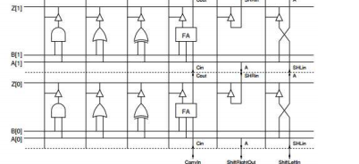

Stick Digram

**Layout:**

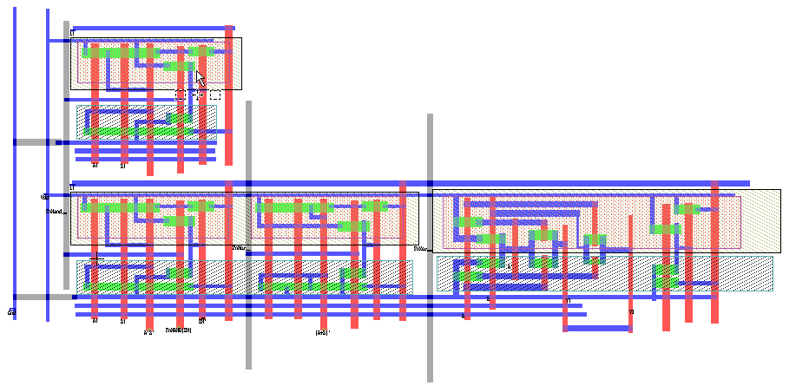

**Spice File Code**

* Circuit Extracted by Tanner Research's L-Edit Version 13.00 / Extract Version 13.00 ;

* TDB File: C:\Users\i140420\Desktop\Kamran_VLSI_9_3-4\v0.5 Kamran_VLSI_lab9.tdb

* Cell: Cell0 Version 1.09

* Extract Definition File: Generic_025.ext

* Extract Date and Time: 04/03/2019 - 11:31

.INCLUDE SpecialDevices.md

.lib "C:\Users\i140420\Desktop\Kamran_VLSI_9_3-4\Generic_025.lib" TT

.tran 10n 100n

v1 A0 Gnd PULSE (0 5 1n 1n 1n 30n 60n)

v2 B0 Gnd PULSE (0 5 3n 1n 1n 40n 70n)

v3 FnNor Gnd PULSE (0 5 1n 1n 1n 90n 100n)

v5 FnNand Gnd PULSE (0 0 1n 1n 1n 90n 100n)

v4 Vdd Gnd 5

.print tran v(A0,Gnd) v(B0,Gnd) v(FnNor,Gnd) v(Z0,Gnd)

* NODE NAME ALIASES

* 3 = Vdd (-15.98 , 19.22)

* 7 = Z1 (-7.88 , 68.9)

* 10 = A1 (-0.68 , 28.9)

* 11 = B1 (7.72 , 28.8)

* 15 = A0 (-0.8 , -17.9)

* 16 = B0 (7.6 , -18)

* 17 = Z0 (-8 , 22.1)

* 20 = FnNor (45.06 , 2.44)

* 21 = Gnd (-26.04 , -15.32)

* 22 = FnNand (-10.5 , 13.6)

M1 Z0 1 5 19 PMOS L=2u W=2.7u AD=6.48p PD=10.2u AS=8.91p PS=12u $ (83.46 14.4 85.46 17.1)

M2 1 FnNor Vdd 19 PMOS L=2u W=2.7u AD=9.18p PD=12.2u AS=10.8p PS=13.4u $ (76.76 8.44 78.76 11.14)

M3 1 FnNor Gnd 2 NMOS L=2u W=2.7u AD=6.75p PD=10.4u AS=8.91p PS=12u $ (76.76 -5.7 78.76 -3)

M4 Z0 FnNor 27 2 NMOS L=2u W=2.2u AD=6.16p PD=10u AS=7.92p PS=9.4u $ (76.76 -9.5 78.76 -7.3)

M5 28 A0 Vdd 19 PMOS L=2u W=2.7u AD=9.315p PD=9.6u AS=8.1p PS=11.4u $ (50.96 14 52.96 16.7)

M6 4 B0 28 19 PMOS L=2u W=2.7u AD=7.695p PD=8.4u AS=9.315p PS=9.6u $ (59.86 14 61.86 16.7)

M7 5 4 4 19 PMOS L=2u W=2.7u AD=5.13p PD=9.2u AS=7.695p PS=8.4u $ (67.56 14 69.56 16.7)

M8 Z1 6 8 18 PMOS L=2u W=2.7u AD=6.48p PD=10.2u AS=8.91p PS=12u $ (31.02 61.2 33.02 63.9)

M9 6 FnNand Vdd 18 PMOS L=2u W=2.7u AD=9.18p PD=12.2u AS=10.8p PS=13.4u $ (24.32 56.8 26.32 59.5)

M10 8 9 Vdd 18 PMOS L=2u W=2.7u AD=5.13p PD=9.2u AS=7.695p PS=8.4u $ (15.12 60.8 17.12 63.5)

M11 Vdd B1 9 18 PMOS L=2u W=2.7u AD=7.695p PD=8.4u AS=9.315p PS=9.6u $ (7.42 60.8 9.42 63.5)

M12 9 A1 Vdd 18 PMOS L=2u W=2.7u AD=9.315p PD=9.6u AS=8.1p PS=11.4u $ (-1.48 60.8 0.52 63.5)

M13 Z0 12 13 19 PMOS L=2u W=2.7u AD=6.48p PD=10.2u AS=8.91p PS=12u $ (30.9 14.4 32.9 17.1)

M14 12 FnNand Vdd 19 PMOS L=2u W=2.7u AD=9.18p PD=12.2u AS=10.8p PS=13.4u $ (24.2 10 26.2 12.7)

M15 13 14 Vdd 19 PMOS L=2u W=2.7u AD=5.13p PD=9.2u AS=7.695p PS=8.4u $ (15 14 17 16.7)

M16 Vdd B0 14 19 PMOS L=2u W=2.7u AD=7.695p PD=8.4u AS=9.315p PS=9.6u $ (7.3 14 9.3 16.7)

M17 14 A0 Vdd 19 PMOS L=2u W=2.7u AD=9.315p PD=9.6u AS=8.1p PS=11.4u $ (-1.6 14 0.4 16.7)

M18 Gnd A0 4 2 NMOS L=2u W=2.2u AD=7.59p PD=9.1u AS=5.06p PS=9u $ (50.96 -9.5 52.96 -7.3)

M19 4 B0 Gnd 2 NMOS L=2u W=2.2u AD=6.27p PD=7.9u AS=7.59p PS=9.1u $ (59.86 -9.5 61.86 -7.3)

M20 27 4 4 2 NMOS L=2u W=2.2u AD=7.92p PD=9.4u AS=6.27p PS=7.9u $ (67.56 -9.5 69.56 -7.3)

M21 6 FnNand Gnd 2 NMOS L=2u W=2.7u AD=6.75p PD=10.4u AS=8.91p PS=12u $ (24.32 41.1 26.32 43.8)

M22 Z1 FnNand 26 2 NMOS L=2u W=2.2u AD=6.16p PD=10u AS=7.92p PS=9.4u $ (24.32 37.3 26.32 39.5)

M23 26 9 Gnd 2 NMOS L=2u W=2.2u AD=7.92p PD=9.4u AS=6.27p PS=7.9u $ (15.12 37.3 17.12 39.5)

M24 Gnd B1 25 2 NMOS L=2u W=2.2u AD=6.27p PD=7.9u AS=7.59p PS=9.1u $ (7.42 37.3 9.42 39.5)

M25 25 A1 9 2 NMOS L=2u W=2.2u AD=7.59p PD=9.1u AS=5.06p PS=9u $ (-1.48 37.3 0.52 39.5)

M26 12 FnNand Gnd 2 NMOS L=2u W=2.7u AD=6.75p PD=10.4u AS=8.91p PS=12u $ (24.2 -5.7 26.2 -3)

M27 Z0 FnNand 24 2 NMOS L=2u W=2.2u AD=6.16p PD=10u AS=7.92p PS=9.4u $ (24.2 -9.5 26.2 -7.3)

M28 24 14 Gnd 2 NMOS L=2u W=2.2u AD=7.92p PD=9.4u AS=6.27p PS=7.9u $ (15 -9.5 17 -7.3)

M29 Gnd B0 23 2 NMOS L=2u W=2.2u AD=6.27p PD=7.9u AS=7.59p PS=9.1u $ (7.3 -9.5 9.3 -7.3)

M30 23 A0 14 2 NMOS L=2u W=2.2u AD=7.59p PD=9.1u AS=5.06p PS=9u $ (-1.6 -9.5 0.4 -7.3)

* Total Nodes: 28

* Total Elements: 30

* Total Number of Shorted Elements not written to the SPICE file: 0

* Output Generation Elapsed Time: 0.001 sec

* Total Extract Elapsed Time: 1.396 sec

.END

**Simulation Results/Waveforms**

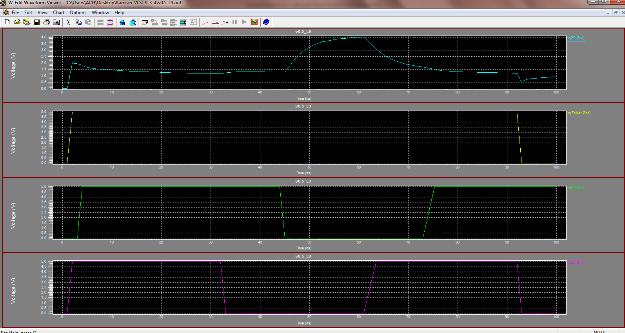

**Submission Declaration by the Student:**

In submitting this lab write-up to the Lab Engineer/Instructor, I hereby declare that:

* I have performed all the practical work myself
* I have noted down actual measurements in this writeup from my own working
* I have written un-plagarised answers to various questions
* I have/have not obtained the desired objectives of the lab.

Reasons of not obtaining objectoves (if applicable):

___________________________________________________________________

___________________________________________________________________

___________________________________________________________________

___________________________

Student’s signature and Date

**Student Evaluation by the Lab Engineer:**

The Lab Engineer can separate this page from the writeup and keep it for his/her own record. It must be signed by the student with date on it.

* **Lab Work:** objectives achieved (correctness of measurements, calculations, answers to questions posed, conclusion) ________/30
* **Lab Writeup:** Neatness, appropriateness, intime submission ________/10
* **Troubleshooting:** Were the student able to troubleshoot his/her work when it was purposedly changed? ________/10
* **TOTAL:** ________/50

**Feedback on student behaviour:**

***Encircle*** your choice. -2 means poorest/worst/extremely inadequate/irrevlevant, 0 gives an average score, and +2 means best/most relevant/most adequate.

* Did the student join the lab at the start/remained in lab? -2 -1 0 1 2
* Did the student remain focused on his/her work during lab? -2 -1 0 1 2
* Rate student's behaviour with fellows/staff/Lab Engineer? -2 -1 0 1 2
* Did the student cause any distraction during the Lab? -2 -1 0 1 2
* Was the student found in any sort of plagiarism? -2 -1 0 1 2

Additional comments (if any) by the Lab Engineer:

__________________________________________________________________

___________________________________________________________________

___________________________________________________________________

___________________________________________________________________

___________________________

Lab Engineer’s signature and Date

**Student's feedback: [Separate this page; fill it; drop in the Drop Box.]**

* Providing feedback for every lab session is optional. No feedback means you are satisified
* The Lab Committee will consider only duly filled forms submitted within one week after the lab
* This feedabck is for LAB session: LAB Number: _____, Date: _____________________
* General (to provide feedback on a persistent practice/ocurrence in LABs).
* Your current CGPA is in the range 4.00 to 3.00/2.99 to 2.00/1.99 to 1.00/0.99 to 0.00

**This feedback is:**

* For a Particular
* Who conducted the LAB? __________________________________________________
* Actual Start time: _______________ Total Duration of Lab: _______________________
* Instruction Duration: _________________ Practical Duration: _____________________
* LAB writeup available before LAB? Yes/No with the Photocopier/in LAB/in SLATE
* Had the theory related to lab been covered in theory class? Yes/No

***Encircle*** your choice. -2 means poorest/worst/extremely inadequate/irrevlevant, 0 gives an average score, and +2 means best/most relevant/most adequate.

|  |  |  |  |  |  |  |  |
| --- | --- | --- | --- | --- | --- | --- | --- |
| **Instruction Session** | Was duration of instruction session adequate? | |  |  |  |  |  | | --- | --- | --- | --- | --- | | **-2** | **-1** | **0** | **+1** | **+2** | |
| How much did you understand about the practical? | |  |  |  |  |  | | --- | --- | --- | --- | --- | | **-2** | **-1** | **0** | **+1** | **+2** | |
| How much content was irrelevant to the practical? | |  |  |  |  |  | | --- | --- | --- | --- | --- | | **-2** | **-1** | **0** | **+1** | **+2** | |
| Did the instructor allowed Q/A and discussion? | |  |  |  |  |  | | --- | --- | --- | --- | --- | | **-2** | **-1** | **0** | **+1** | **+2** | |
| **Practical** | Did you get sufficient time for practical? | |  |  |  |  |  | | --- | --- | --- | --- | --- | | **-2** | **-1** | **0** | **+1** | **+2** | |
| **Lab**  **Engineer** | Presence in lab at all time? | |  |  |  |  |  | | --- | --- | --- | --- | --- | | **-2** | **-1** | **0** | **+1** | **+2** | |
| Ability to convey? | |  |  |  |  |  | | --- | --- | --- | --- | --- | | **-2** | **-1** | **0** | **+1** | **+2** | |
| Readiness to help during practical? | |  |  |  |  |  | | --- | --- | --- | --- | --- | | **-2** | **-1** | **0** | **+1** | **+2** | |
| Readiness to discuss theoretical aspects? | |  |  |  |  |  | | --- | --- | --- | --- | --- | | **-2** | **-1** | **0** | **+1** | **+2** | |
| Helps in troubleshooting? | |  |  |  |  |  | | --- | --- | --- | --- | --- | | **-2** | **-1** | **0** | **+1** | **+2** | |
| Guides hows & whys of troubleshooting? | |  |  |  |  |  | | --- | --- | --- | --- | --- | | **-2** | **-1** | **0** | **+1** | **+2** | |
| **Staff** | How friendly was the lab staff? | |  |  |  |  |  | | --- | --- | --- | --- | --- | | **-2** | **-1** | **0** | **+1** | **+2** | |
| Presence of staff throughout the lab session? | |  |  |  |  |  | | --- | --- | --- | --- | --- | | **-2** | **-1** | **0** | **+1** | **+2** | |
| Impact of availability of staff on your practical? | |  |  |  |  |  | | --- | --- | --- | --- | --- | | **-2** | **-1** | **0** | **+1** | **+2** | |
| **Equipment** | Performance of Electronic Instruments? | |  |  |  |  |  | | --- | --- | --- | --- | --- | | **-2** | **-1** | **0** | **+1** | **+2** | |
| Performance of Breadboard/experiment kit? | |  |  |  |  |  | | --- | --- | --- | --- | --- | | **-2** | **-1** | **0** | **+1** | **+2** | |
| Performance of circuit components esp. ICs? | |  |  |  |  |  | | --- | --- | --- | --- | --- | | **-2** | **-1** | **0** | **+1** | **+2** | |
| **Overall** | Your overall rating for the whole lab session? | |  |  |  |  |  | | --- | --- | --- | --- | --- | | **-2** | **-1** | **0** | **+1** | **+2** | |

Other comments: _________________________________________________________________

_________________________________________________________________

_________________________________________________________________