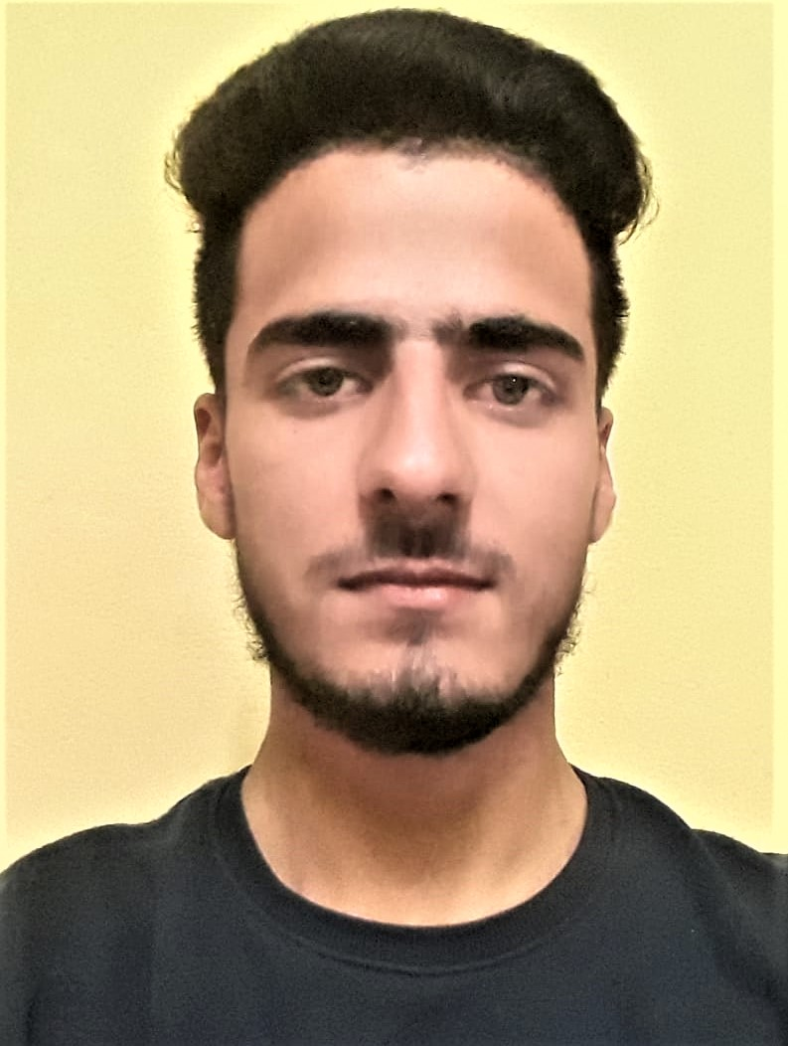

Kamran Riyaz | 0000000000 | xyz@example.com

# About me

I love Coding.

# Work Experience

**FICS** *2021-Present*Computer Instructor

# Skills

* Python
* Java
* C/C++