Project Title
Jasp (A quora styled website for Balochi literature)


Author
Kamiran Umer (GL) 1107801
Sulaman Imdad 1106855
Qambar Arz 1107506

Supervisor
MR. Balach Khan
Lecturer
Department of Computer Science
Faculty of Science and Engineering
University of Turbat
October, 2025

Project Title
Jasp (A quora styled website for Balochi literature)

Author
Kamiran Umer (GL) 1107801
Sulaman Imdad 1106855
Qambar Arz 1107506
Program and Batch 2022/2025
A report submitted in partial fulfillment of the requirements for the degree of
BS Computer Science
Supervised by
MR. Balach Khan
Lecturer
Department of Computer Science
Faculty of Science and Engineering
University of Turbat

Head of The Department Signature: ____________________

Supervisor Signature: ____________________

Department of Computer Science
Faculty of Science and Engineering
University of Turbat
October, 2025

Abstract
Project Title
Jasp(A quora styled website for Balochi literature)
The rapid growth of digital technology has transformed the way knowledge is shared globally; however, Balochi language and literature remain largely confined to physical events and informal social media platforms. These platforms lack structured discussion, academic moderation, and long-term preservation of literary content. This project, Jasp, addresses this gap by providing a dedicated Quora-styled web platform for Balochi literature. Jasp enables writers, readers, researchers, and scholars to ask questions, share knowledge, and engage in structured discussions related to Balochi language and literature. The system supports user registration, question-and-answer functionality, voting, commenting, content moderation, and topic-based search. An AI-assisted feature is integrated to help users detect and correct linguistic errors, supporting new writers and promoting language standardization. The system is developed as a web-based application using a client–server architecture and the MVC design pattern. Emphasis is placed on usability, security, reliability, and maintainability. Jasp aims to contribute to the digital preservation, promotion, and scholarly discussion of Balochi literature by providing a focused, accessible, and moderated online knowledge-sharing platform.
Undertaking
I certify that research work titled “Jasp (A quora styled website for Balochi literature” is my own work. The work has not been presented elsewhere for assessment. Where material has been used from other sources it has been properly acknowledged / referred.

Serial No | Student ID | Student Name | Signature
1 | Kamaran Umer | 1107801
2 | Saleeman Imdad | 1106855
3 | Qambar Arz | 1107506

Acknowledgement
We express our sincere gratitude to Mr. Balach Khan, Lecturer, Department of Computer Science, University of Turbat, for his valuable guidance, continuous support, and constructive feedback throughout the development of this project. His supervision played a crucial role in shaping the direction and quality of this work. We are also thankful to the Department of Computer Science, Faculty of Science and Engineering, University of Turbat, for providing the necessary resources and academic environment required to complete this project successfully. Finally, we acknowledge the encouragement and support of our families and friends, whose patience and motivation helped us remain focused during the completion of this project.

Table of Contents
Abstract iii
Undertaking iv
Acknowledgement v
Table of Contents vi
List of Figures viii
List of Tables ix
List of Abbreviations x
Chapter 1: Introductory Chapter 1
1.1 Introduction 1
1.1.1 Purpose 1
1.1.2 Description 1
1.1.3 Scope 1
1.1.4 Functional Requirements 1
1.1.4.1 User Management 1
1.1.4.2 Content Creation (Q&A & Posts) 2
1.1.4.3 Interaction Features 2
1.1.4.4 Search & Discovery 2
1.1.4.5 Localization (New Feature) 2
1.1.4.6 Notification System 2
1.2 Overall Description 3
1.2.1 Product Perspective 3
1.2.2 Product Features 3
1.2.3 Operating Environments 3
1.2.4 Design Constraints 3
Chapter 2: Literature Review 3
2.1 Context of Balochi Language 3
2.2 Review of Existing Systems 4
2.3 The Quora-Style Model 4
Chapter 3: Methodology 5
3.1 Development Approach 5
3.2 System Architecture 5
3.3 Technology Stack 5
3.4 Database Design 6
3.5 System Design 8
3.5.1 Use Case Diagram 8
3.5.2 Activity Diagram (User Journey) 8
3.5 Functional Module Implementation 11
3.5.1 User Management Module 11
3.5.2 Content Creation Module (Dual Mode) 11
3.5.3 Localization Module (New) 11
3.5.4 Search & Filtering Module 12
3.5.5 Security Measures 12
Chapter 4: Implementation 12
4.1 Introduction 12
4.2 System Overview 12
4.3 User Interface Implementation 12
4.3.1 Home Feed & Navigation 13
4.3.2 Bilingual & RTL Support 13
4.4 Functional Modules 13
4.4.1 User Management & Profiles 13
4.4.2 Content Creation (Modals) 13
4.4.3 Interaction System 14
4.4.4 Search & Discovery 14
4.5 Deployment 14
4.6 Final Interfaces: 14
Chapter 5: Conclusion and Future Work 47
5.1 Conclusion 47
5.2 Future Work 47
References 48

List of Figures
Figure No. | Description | Page No.
Figure 3.1 | Use case Diagram | 8
Figure 3.2 | Activity(User journey) | 10
Figure 3.3 | Sequence Diagram of Voting System | 11
Figure 4.1 | Actor and Action for User Signup Interface | 14
Figure 4.2 | Actor and Action for Log in Interface | 16
Figure 4.3 | Actor and Action for Navigation bar | 18
Figure 4.4 | Actor and Action for Home Feed/Page | 21
Figure 4.5 | Actor and Action for Topic Sidebar | 24
Figure 4.6 | Actor and Action for Dropdown Menu | 25
Figure 4.7 | Actor and Action for Notifications Page | 27
Figure 4.8 | Actor and Action for Q&A Discovery | 29
Figure 4.9 | Actor and Action for Discussion Post Detail | 31
Figure 4.10 | Actor and Action for Localization Feature | 33
Figure 4.11 | Actor and Action for Adding Questions | 34
Figure 4.12 | Actor and Action for Create Post Modal | 37
Figure 4.13 | Actor and Action for Profile Setting | 40
Figure 4.14 | Actor and Action for Profile Page | 42
Figure 4.15 | Actor and Action for Content Management | 44
Figure 4.16 | Actor and Action for Social Engagement | 45

List of Tables
Table No. | Description | Page No.
Table 3.1 | Database Schema: Profiles Table | 6
Table 3.2 | Database Schema: Posts Table | 7
Table 3.3 | Database Schema: Votes Table | 7
Table 4.1 | Actor and Action for User Signup Interface | 15
Table 4.2 | Actor and Action for Log in Interface | 17
Table 4.3 | Actor and Action for Navigation bar | 18
Table 4.4 | Actor and Action for Home Feed/Page | 21
Table 4.5 | Actor and Action for Topic Sidebar | 24
Table 4.6 | Actor and Action for Dropdown Menu | 26
Table 4.7 | Actor and Action for Notifications Page | 27
Table 4.8 | Actor and Action for Q&A Discovery | 29
Table 4.9 | Actor and Action for Discussion Post Detail | 31
Table 4.10 | Actor and Action for Localization Feature | 33
Table 4.11 | Actor and Action for Adding Questions | 34
Table 4.12 | Actor and Action for Create Post Modal | 37
Table 4.13 | Actor and Action for Profile Setting | 40
Table 4.14 | Actor and Action for Profile Page | 42
Table 4.15 | Actor and Action for Content Management | 44
Table 4.16 | Actor and Action for Social Engagement | 45

Chapter 1: Introductory Chapter

1.1 Introduction

1.1.1 Purpose
The aim of this project is to provide an online platform for enthusiasts of Balochi literature—whether writers, readers, researchers, or scholars—where they can access content like poetry, prose, and research1. Unlike social media groups (WhatsApp/Facebook) where discussions are often unstructured and difficult to search2, JASP provides a dedicated, organized repository for long-term knowledge sharing.

1.1.2 Description
JASP is a "Quora-styled" web platform focused on Balochi language and literature3. It serves as a digital library and discussion hub where users can ask questions, share rich-text articles, and engage in scholarly debate. A key feature of JASP is its Bilingual Support, allowing users to toggle between English and Balochi interfaces with full Right-to-Left (RTL) layout adaptation. This ensures the platform is accessible to native speakers while maintaining modern web standards.

1.1.3 Scope
The scope of the project is to provide an easily accessible and reliable online space for Baloch writers and scholars to publish and discuss literary contributions4. It supports two distinct forms of content: Questions for seeking knowledge, and Posts (Articles/Poetry) for sharing creative work using a Rich Text Editor.

1.1.4 Functional Requirements

1.1.4.1 User Management
- The system allows guests to register and create an account securely ^{[5]}.
- The system allows users to log in and maintain a secure session ^{[6]}.
- The system allows users to customize their public profile (Name, Bio, Avatar, Website link).

1.1.4.2 Content Creation (Q&A & Posts)
- Questions: Users can post specific questions tagged with relevant topics (e.g., History, Grammar).
- Posts (Literature): Users can create rich-text articles, poems, or stories with formatting (Bold, Italic, Lists).
- Management: Users can edit or delete their own questions and posts.

1.1.4.3 Interaction Features
- Voting: Users can Upvote or Downvote content to signal quality and relevance.
- Comments: Users can participate in discussions by commenting on posts and questions.
- Following: Users can follow other authors to receive updates in their notification feed.

1.1.4.4 Search & Discovery
- Search: Users can search for specific content using keywords via the navigation bar.
- Topic Filtering: Users can filter the feed by clicking on specific topics (e.g., #BalochiPoetry, #Culture) in the sidebar.
- Content Type Filtering: Users can switch views between "All Questions" and standard "Posts".

1.1.4.5 Localization (New Feature)
- Language Switcher: Users can toggle the entire platform language between English and Balochi.
- RTL Support: Selecting Balochi automatically adjusts the layout to Right-to-Left orientation for correct text rendering.

1.1.4.6 Notification System
- The system notifies users when they receive new followers or interactions (likes/comments) on their content.

1.2 Overall Description

1.2.1 Product Perspective
JASP is designed to be the primary digital archive and discussion space for Balochi literature. Unlike general social media, it separates "Asking" from "Publishing," giving writers a dedicated toolset for poetry and prose while allowing learners to ask questions in a structured format.

1.2.2 Product Features
- User Authentication (Signup/Login/Forgot Password).
- Dual Content Mode: Questions (Plain text) vs. Posts (Rich Text).
- Bilingual Interface (English/Balochi).
- Real-time Voting and Notifications.
- Topic-based Content Filtering.

1.2.3 Operating Environments
- Platform: Web Application (Responsive).
- Browser Compatibility: Chrome, Edge, Firefox, Safari.
- Backend: Supabase (PostgreSQL).
- Frontend: Next.js (React).

1.2.4 Design Constraints
- Internet Dependency: Users must be online to post or interact.
- Authentication: Writing content requires a registered account to prevent spam.

Chapter 2: Literature Review

2.1 Context of Balochi Language
Balochi is a Western Iranian language with a rich oral and written tradition. It is spoken across Pakistan, Iran, and Afghanistan. Historically, the language has faced challenges in maintenance due to a lack of official status in certain regions ^{[1]}. While efforts have been made to digitize books—such as the Balochi Academy's initiatives to provide free online access to over 500 books ^{[2]}—there is a significant lack of interactive platforms. Current digital resources are mostly static repositories or simple dictionaries, which do not foster two-way communication between scholars and learners.

2.2 Review of Existing Systems
To understand the necessity of JASP, we analyzed existing platforms used by the community:
- WhatsApp and Facebook Groups: These are currently the most popular methods for discussion. However, they are inherently "noisy" and unmoderated. Important literary discussions are often lost in a stream of irrelevant messages, and the content is impossible to search or archive for future reference ^{[3]}.
- Static Websites: Several projects like "The Balochi" have built websites for reading short stories and poetry. While valuable, these are "read-only" experiences. They do not allow a user to ask a question about a difficult word or debate the meaning of a poem with the author ^{[4].}
- General Q&A Sites (Quora/StackOverflow): While these platforms are excellent for technical or general knowledge, they do not support the specific cultural context of Balochi literature, nor do they support the Balochi language script (RTL) natively in their interface ^{[5]}.

2.3 The Quora-Style Model
JASP adopts the "Quora"model, which has proven effective for niche communities. This model is superior to standard social media for several reasons:
- Structured Knowledge: Content is organized into Questions and Answers rather than chronological posts. This creates a permanent archive where a single good answer can be read by thousands of people over years ^{[6]}.
- Community Validation: Features like Upvoting ensure that the highest quality and most accurate answers rise to the top, while misinformation is downvoted ^{[7]}.
- Topic Filtering: By tagging content with specific topics (e.g., "History," "Grammar," "Poetry"), users can quickly find exactly what they are looking for, solving the discoverability issue found in unstructured social media groups ^{[8]}.

Chapter 3: Methodology

3.1 Development Approach
The development of JASP followed an Iterative and Incremental Development Model. This approach was selected because the system involves complex interactive features—such as real-time voting, bilingual support, and rich text editing—that required continuous testing and refinement.
Instead of building the entire system in one phase, the project was divided into manageable iterations:
- Phase 1: Setup of Next.js environment and Supabase Database.
- Phase 2: Implementation of User Authentication (Login/Signup).
- Phase 3: Core Features (Posting Questions, Rich Text Articles).
- Phase 4: Advanced Features (Localization, Notifications, Real-time Voting).

3.2 System Architecture
JASP utilizes a Modern Serverless Client-Server Architecture.
- Client (Frontend): Built with Next.js (React), the client handles the user interface, state management (e.g., keeping track of votes), and localization logic (English/Balochi switching).
- Backend Services (BaaS): Supabase acts as the backend-as-a-service, handling Authentication, Database storage, and Real-time subscriptions.
- Database Layer: A PostgreSQL relational database hosted on Supabase stores all user profiles, content, and interaction data.

3.3 Technology Stack
The following modern technologies were used to develop JASP, replacing the traditional PHP/MySQL stack to ensure better performance and scalability:
- Frontend Framework: Next.js 14 (React) – Chosen for its server-side rendering (SSR) capabilities and SEO benefits.
- Styling: Tailwind CSS – Used for responsive design and rapid UI development.
- Icons: Lucide React – For consistent iconography (e.g., bells, vote arrows).
- Backend & Database: Supabase – An open-source Firebase alternative that provides a Postgres database, Authentication, and Edge Functions.
- Deployment: Vercel – Used for hosting the application.
- Development Tools: VS Code, Git/GitHub.

3.4 Database Design
The database is designed using a Relational Model in PostgreSQL. Key entities include:
- Profiles: Stores user details (username, avatar, bio) linked to the Auth ID.
- Questions: Stores questions with title, body, and topic tags.
- Posts: Stores articles/poetry with Rich Text (HTML) content.
- Answers/Comments: Linked to specific questions or posts.
- Votes: Tracks upvotes/downvotes to prevent duplicate voting by the same user.
- Notifications: Logs events (e.g., "User X followed you") for the activity feed.
The database consists of the following key tables:
Table 3.1: Profiles Table
Field Name | Data Type | Description
id | UUID | Primary Key (Links to Auth Users)
username | Text | Unique display handle
full_name | Text | User's real name
avatar_url | Text | URL to profile picture
bio | Text | User biography
Table 3.2: Posts Table
Field Name | Data Type | Description
id | UUID | Primary Key
user_id | UUID | Foreign Key (Profiles)
title | Text | Title of the post
content | HTML/Text | Rich text content
created_at | Timestamp | Date of publication
Table 3.3: Votes Table
Field Name | Data Type | Description
id | UUID | Primary Key
user_id | UUID | Who voted
post_id | UUID | Which post was voted on
vote_type | Integer | 1 (Upvote) or -1 (Downvote)

3.5 System Design
To visualize the system's structure and behavior, standard Unified Modeling Language (UML) diagrams were designed.

3.5.1 Use Case Diagram
The Use Case diagram demonstrates the interactions between the users (Actors) and the JASP system.
- Actors: Guest, Registered User.
- Use Cases: Register, Login, Post Question, Create Posts, Upvote/Downvote, Comment, Follow User, Switch Language.
Figure 3.1
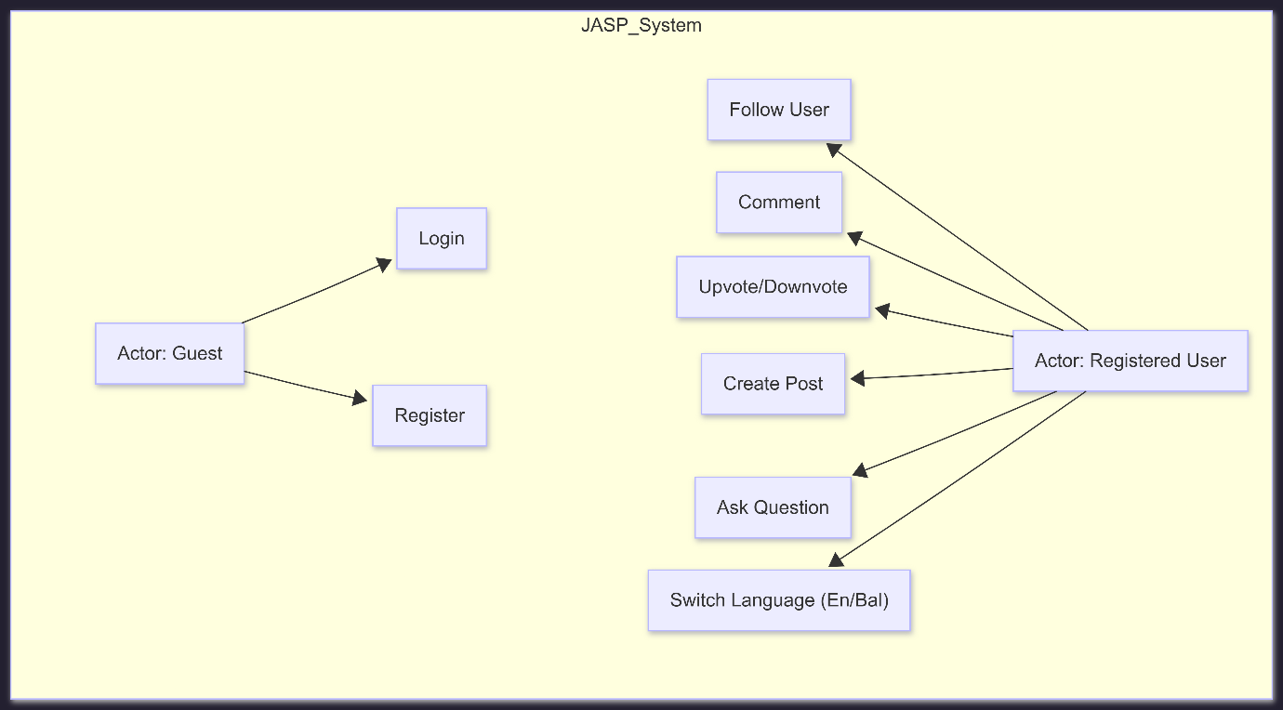

3.5.2 Activity Diagram (User Journey)
This diagram illustrates the complete workflow of a user interacting with the JASP system, starting from registration to accessing core features.
- Start → New User visits JASP.
- Registration → User fills signup form.
- Verification → System sends email; User confirms via Supabase.
- Login → User authenticates.
- Action Selection → User chooses an action:
  - Create Content (Post/Question)
  - Interact (Vote/Comment)
  - Manage Profile (Edit Bio/Avatar)
  - Switch Language (English/Balochi)
- System Update → Database updates and UI reflects changes.
- End.
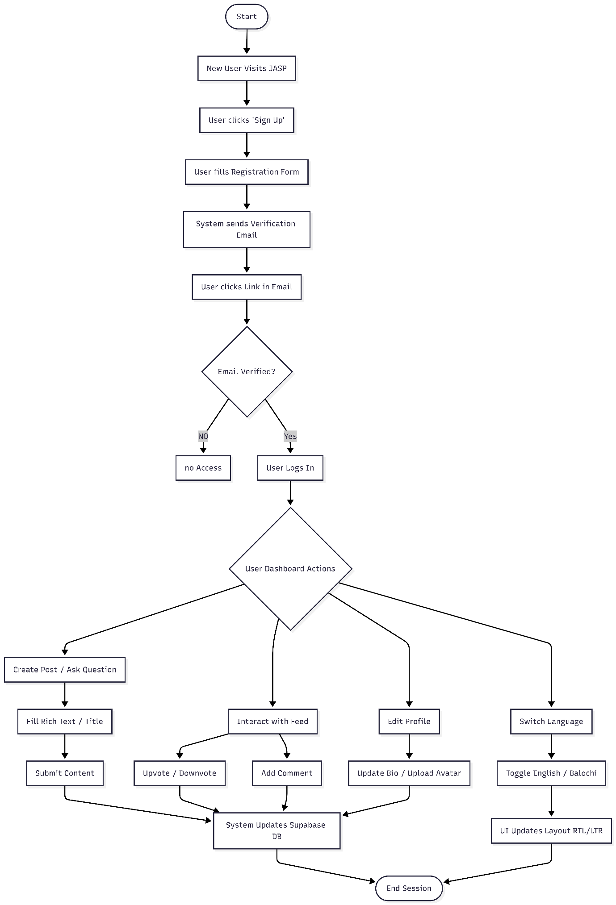
Figure 3.2
Figure 3.3: Sequence Diagram of Voting System
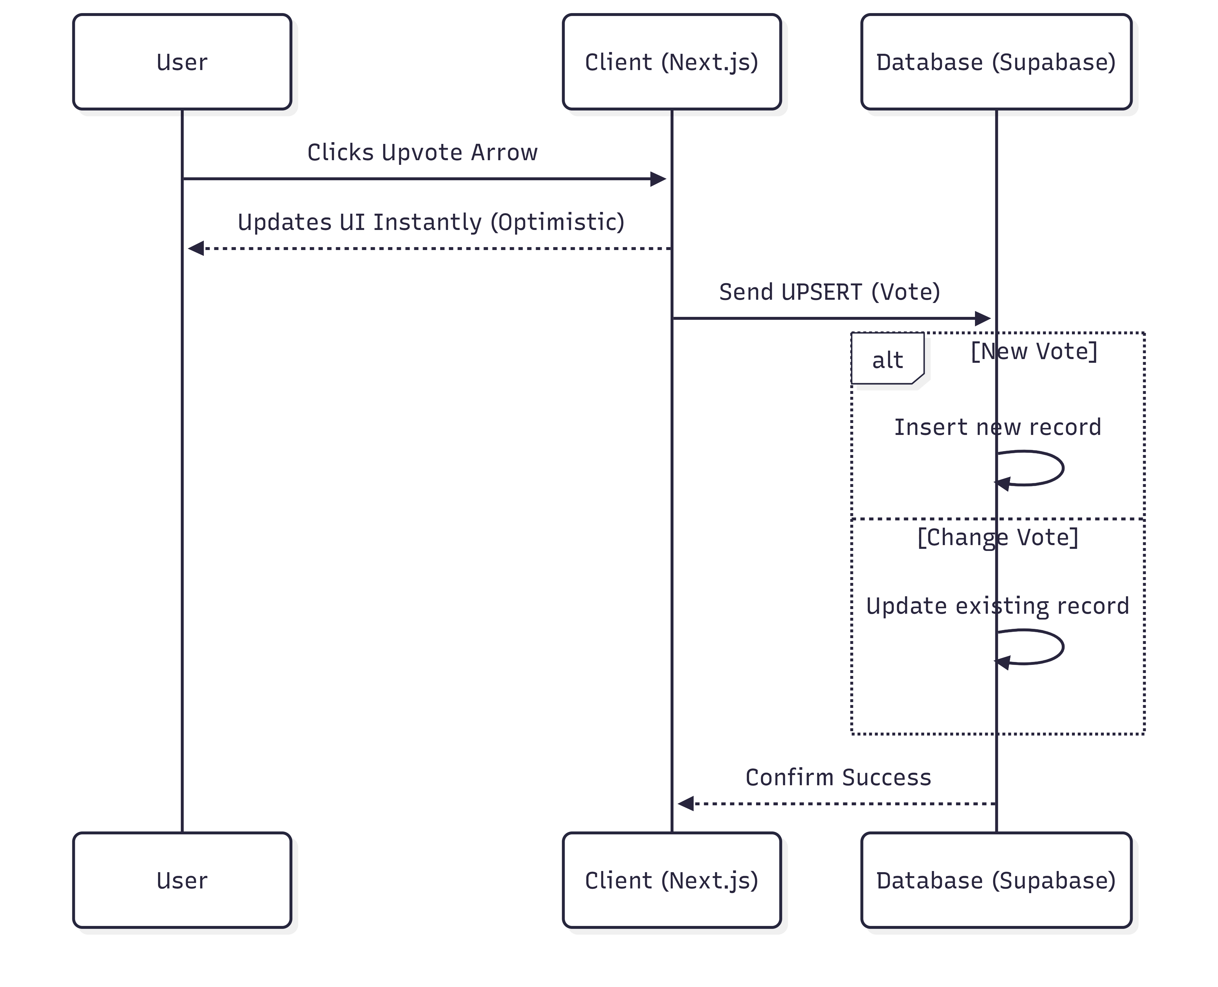

3.5 Functional Module Implementation

3.5.1 User Management Module
This module utilizes Supabase Auth to handle secure sign-up, login, and session management. It supports email/password authentication and includes a "Forgot Password" flow via email magic links.

3.5.2 Content Creation Module (Dual Mode)
- Q&A Mode: A standard text input for asking questions.
- Literature Mode: Integrates a Rich Text Editor that allows users to format text (bold, italics, lists), essential for publishing poetry and literature.

3.5.3 Localization Module (New)
A custom Context API module was built to manage the application's language state.
- Language Toggling: Instantly switches all static text between English and Balochi.
- Directional Support: Automatically updates the CSS direction to RTL (Right-to-Left) when Balochi is selected, ensuring correct script rendering.

3.5.4 Search & Filtering Module
- Sidebar Filtering: Allows users to query the database by specific topic_id.
- Tab Filtering: Separates "Questions" and "Posts" into different views using conditional rendering.

3.5.5 Security Measures
- Row Level Security (RLS): Supabase RLS policies are enforced directly on the database tables. For example, a policy ensures that only the author of a post can edit or delete it.

Chapter 4: Implementation

4.1 Introduction
This chapter details the practical implementation of the JASP web application. It transitions from the theoretical design to the actual software product, highlighting the user interface (UI) components, key modules, and the specific technologies used to build the platform. The implementation focuses on delivering a responsive, bilingual, and interactive environment for Balochi literature.

4.2 System Overview
JASP has been implemented as a Single Page Application (SPA) using Next.js. The application connects to a Supabase backend which manages the database and authentication. The system is divided into several key views: the Home Feed, Question/Post Creation Modals, Profile Pages, and Settings.

4.3 User Interface Implementation
The user interface was built using Tailwind CSS, ensuring a clean, modern, and mobile-responsive design.

4.3.1 Home Feed & Navigation
The main interface consists of a sticky top Navigation Bar and a Sidebar for topic discovery.
- Navigation: Contains the Logo, Home, Notifications (Bell Icon), and "Ask" button.
- Topics Sidebar: A scrollable widget that allows users to filter content by categories such as Balochi Poetry, Culture, History, and Literature.
- Feed Tabs: Users can toggle between "Posts", "Questions", and "Answers" to customize their view.

4.3.2 Bilingual & RTL Support
A key implementation feature is the Language Selection Modal.
- Users can select "Balochi" or "English" from a popup menu.
- Selecting "Balochi" triggers a system-wide state change that translates text labels and mirrors the layout to Right-to-Left (RTL), ensuring proper readability for the Balochi script.

4.4 Functional Modules

4.4.1 User Management & Profiles
- Dropdown Menu: Provides quick access to "My Profile", "Settings", and "Sign Out".
- Profile Page: Displays the user's avatar, stats (followers/following counts), and a history of their contributions (posts and questions).
- Settings: A dedicated form allows users to update their Full Name, Bio, Website URL, and upload a new profile picture.

4.4.2 Content Creation (Modals)
The platform implements two distinct modes for content creation:
- Add Question Modal: A simplified form requiring a "Title" and "Body" text, specifically for asking questions.
- Create Post Modal: A full-featured interface for literature. It includes a Rich Text Editor with a toolbar (Bold, Italic, Lists, Quotes) to support the formatting needs of poetry and articles.
  - Tagging: Users can select up to 3 topics (e.g., #Grammar) to categorize their content.

4.4.3 Interaction System
- Voting: A real-time voting system (Up/Down arrows) allows the community to rate content. The net score is calculated and displayed instantly.
- Management: Content owners have access to a context menu (three dots) to Edit or Delete their own posts.
- Notifications: A dedicated notifications page alerts users when someone follows them or likes/comments on their posts.

4.4.4 Search & Discovery
- Search Bar: Located in the navbar, allowing users to find content by keywords.
- Questions Filter: A specific "All Questions" view filters out general posts, helping users focus solely on answering community queries.

4.5 Deployment
The application is deployed on Vercel, taking advantage of its edge network for fast loading speeds. The database is hosted on the Supabase cloud platform, ensuring data persistence and secure authentication handling.

4.6 Final Interfaces:
Figure 4.1 Sign up
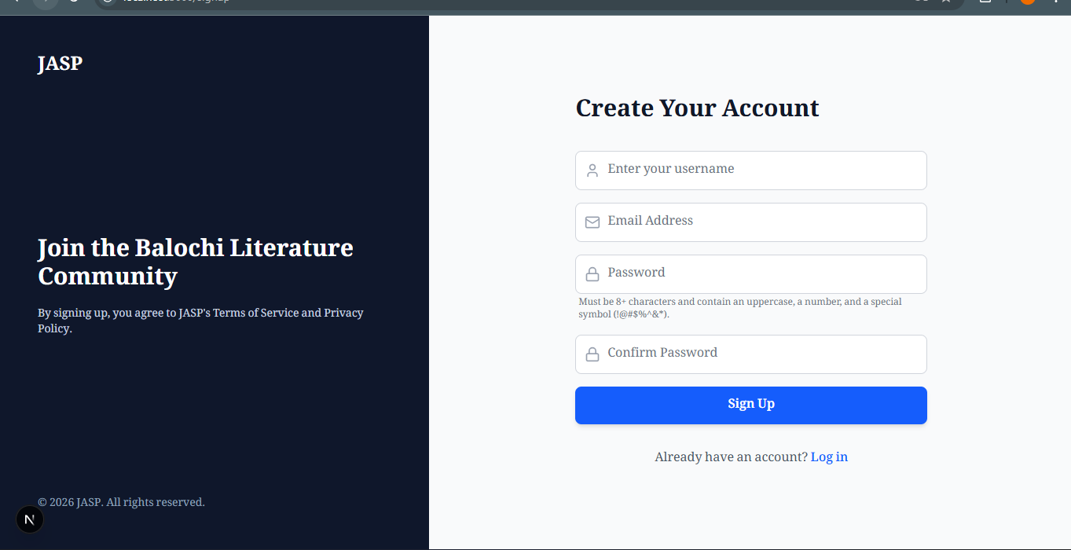
Table 4.1: Sign up

Component | Actor | Action & System Response
Username Field | Guest | Action: The Guest enters a unique display name.  System: Captures the input to be stored in the profiles table as the public identifier.
Email Address Field | Guest | Action: The Guest enters their valid email address.  System: Validates the email format. This will be used as the unique identifier for authentication.
Password Field | Guest | Action: The Guest enters a secure password.  System: Enforces security rules (must be 8+ characters, contain uppercase, number, etc.) to ensure account safety.
Confirm Password Field | Guest | Action: The Guest re-enters the password.  System: Checks if this matches the first password to prevent typing errors.
"Sign Up" Button | Guest | Action: The Guest clicks the blue "Sign Up" button to submit the form.  System: Sends data to Supabase Auth. If successful, creates a new user and redirects them to the Home Feed. If it fails, displays an error message.
"Log in" Link | Guest | Action: The Guest (if they already have an account) clicks the "Log in" link.  System: Redirects the user to the Login Page (/login) instead of creating a new account.

Figure 4.2 Log In
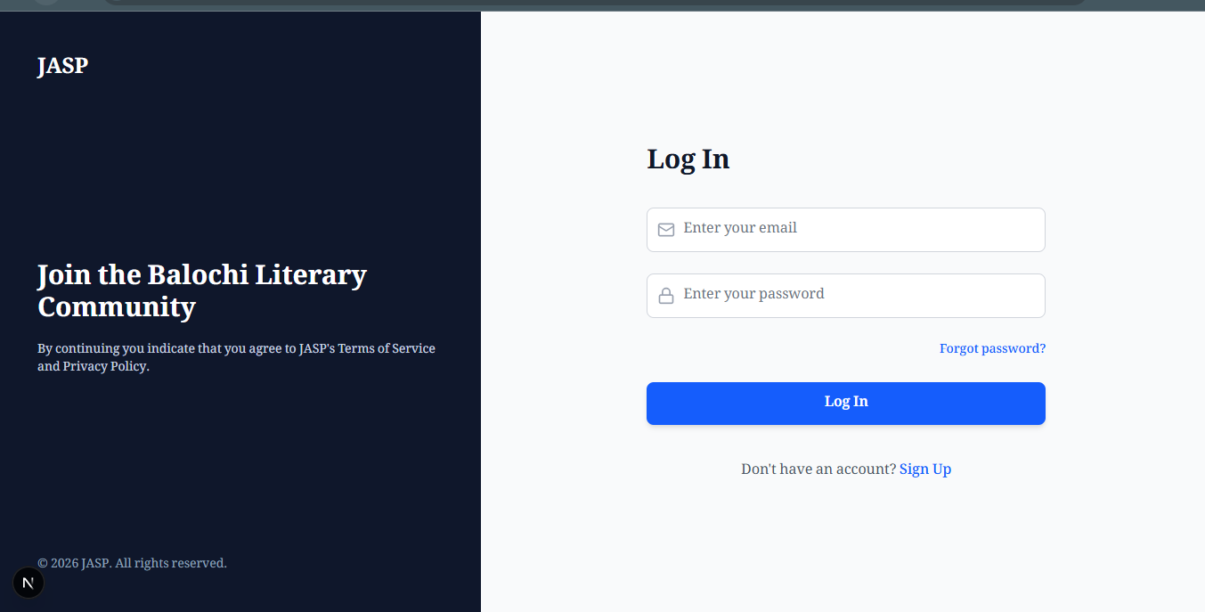
Table 4.2: Log In
Component | Actor | Action & System Response
Email Field | Registered User | Action: The User enters the email address associated with their account.  System: Validates the input format to ensuring it is a proper email address.
Password Field | Registered User | Action: The User enters their secret password.  System: Masks the characters (shows dots) for privacy while typing.
"Log In" Button | Registered User | Action: The User clicks the blue button to submit their credentials.  System: Authenticates data against the Supabase database. If correct, grants access and redirects to the Home Feed. If incorrect, displays an "Invalid login credentials" error.
"Forgot password?" Link | Registered User | Action: The User clicks this link if they cannot remember their credentials.  System: Redirects the user to the Password Recovery page to initiate a reset via email.
"Sign Up" Link | Guest | Action: A Guest (who doesn't have an account yet) clicks this link.  System: Redirects the user to the Signup Page so they can register instead.
Figure 4.3 Navigation Bar
Table 4.3: Navigation Bar
Component | Actor | Action & System Response
JASP Logo | Any User | Action: The User clicks the "JASP" logo text.  System: Redirects the user immediately to the Home Feed, refreshing the content.
Home Icon | Any User | Action: The User clicks the "House" icon.  System: Functions identically to the logo; navigates to the main Home Feed.
Bell Icon | Registered User | Action: The User clicks the "Bell" icon.  System: Redirects to the Notifications Page. It also instantly clears any red "unread" badge count to zero.
Edit Icon | Registered User | Action: The User clicks the "Pencil" icon.  System: Redirects the user to the Questions Feed (the "Answer" section), where they can find questions to answer.
Search Bar | Any User | Action: The User types a keyword (e.g., "Poetry") and presses Enter.  System: Redirects to the Search Results Page, displaying People, Posts, and Questions matching that term.
Globe Icon | Any User | Action: The User clicks the "Globe" icon.  System: Opens the Language Modal, allowing the user to switch between English (LTR) and Balochi (RTL) layouts.
"Ask" Button | Registered User | Action: The User clicks the blue "Ask" button.  System: Opens a popup (Modal) overlay that allows the user to write and submit a new Question or Post.
User Avatar (K) | Registered User | Action: The User clicks their profile circle (Avatar).  System: Opens a dropdown menu providing quick links to My Profile, Settings, and the Sign Out option.

Figure 4.4 Home Feed/Page
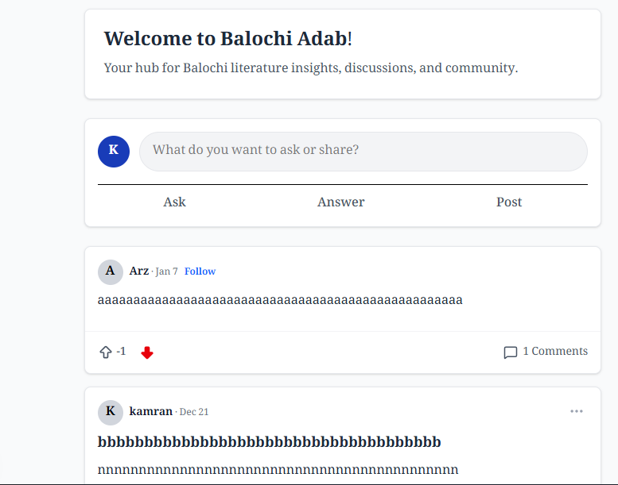
Table 4.4: Home Feed/Page
Component | Actor | Action & System Response
"What do you want to ask..." Input | Registered User | Action: The User clicks on this text field.  System: Opens the Create Post Modal overlay, allowing the user to start typing a new post immediately.
"Ask" Button | Registered User | Action: The User clicks the "Ask" tab.  System: Opens the Create Question Modal, specifically designed for Q&A (requires a Title and Body).
"Answer" Button | Registered User | Action: The User clicks the "Answer" tab.  System: Redirects the user to the Questions Feed (/questions), showing a list of unanswered questions they can help with.
"Post" Button | Registered User | Action: The User clicks the "Post" tab.  System: Opens the standard Create Post Modal for sharing general thoughts or articles.
"Follow" Link | Registered User | Action: The User clicks "Follow" next to an author's name (e.g., beside "Arz").  System: Instantly updates the database to create a relationship. The text changes to "Following" without reloading the page.
Vote Arrows (Up/Down) | Registered User | Action: The User clicks the Up or Down arrow on a post.  System: Highlights the arrow (e.g., Red for Downvote) and updates the vote count instantly (Optimistic UI). It prevents users from voting on their own posts.
Comment Icon | Any User | Action: The User clicks the "Comment" icon or text.  System: Redirects the user to the Post Detail Page (/posts/[id]) to read full comments and add their own reply.
Figure 4.5 Topics Sidebar
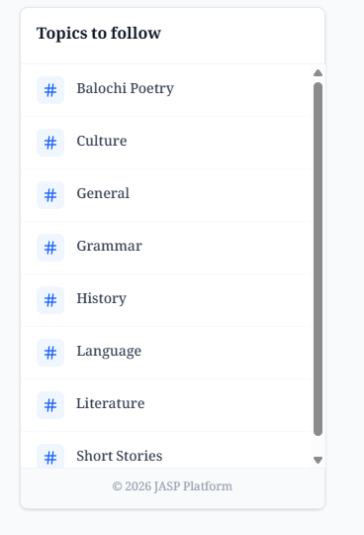
Table 4.5: Topics Sidebar

Component | Actor | Action & System Response
Topic Link (e.g., "Balochi Poetry") | Any User | Action: The User clicks on a specific category name.  System: Redirects the user to a filtered feed page, displaying only Posts and Questions tagged with that specific topic (e.g., filtering the database query by topic_id).
Sidebar Container | Any User | Action: The User views the list of available categories.  System: Fetches the list of predefined topics from the topics database table and renders them in an alphabetical or curated order.
Scrollbar | Any User | Action: The User scrolls down within the widget area.  System: Reveals additional topics that are currently hidden from view, ensuring the main page layout remains clean without stretching too long.
Footer (© 2026 JASP) | Any User | Action: The User views the copyright text.  System: Static display of the current year and platform ownership at the bottom of the navigation area.
Figure 4.6 Dropdown Menu
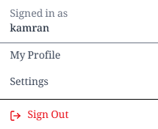
Table 4.6: Dropdown Menu
Component | Actor | Action & System Response
“Signed in as [Name]” | Registered User | Action: The User views their display name.  System: Fetches the current session data to display the correct username, confirming which account is active.
“My Profile” Link | Registered User | Action: The User clicks the “My Profile” link.  System: Redirects the user to their public profile page (/profile/[username]) where they can see their own posts, stats, and followers.
“Settings” Link | Registered User | Action: The User clicks the “Settings” link.  System: Redirects the user to the Settings Page (/settings), allowing them to change their bio, upload a new avatar, or update their website link.
“Sign Out” Button | Registered User | Action: The User clicks the red “Sign Out” button.  System: Terminates the user’s session in Supabase, clears authentication cookies from the browser, and redirects the user back to the Home Page as a Guest.
Figure 4.7Activity Updates (Notifications Page)
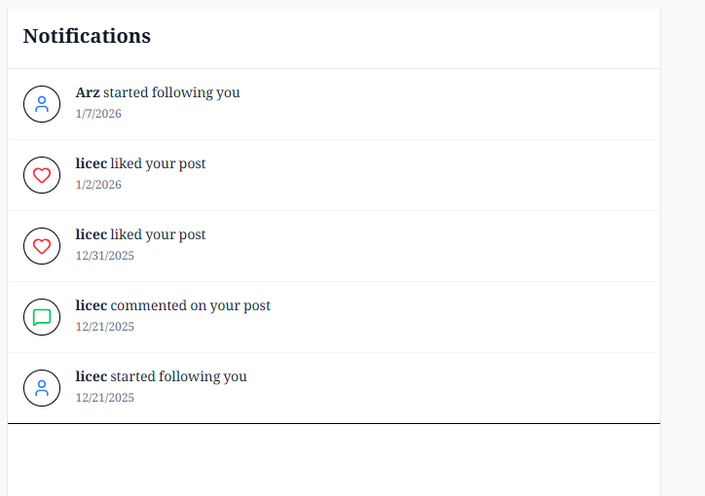
Table 4.7: Activity Updates (Notifications Page)
Component | Actor | Action & System Response
Notification List Item | Registered User | Action: The User views the list of recent alerts.  System: Fetches the latest notifications from the database, ordered by date (newest first).
"Follow" Notification | Registered User | Action: The User clicks a notification saying "[Name] started following you".  System: Redirects the user directly to that follower’s Public Profile page.
"Like/Comment" Notification | Registered User | Action: The User clicks a notification saying "[Name] liked/commented on your post".  System: Redirects the user directly to the specific Post Detail Page (/posts/[id]) so they can see the interaction.
User Avatar Icon | Registered User | Action: The User views the circular icon next to the text.  System: Displays the avatar of the person who performed the action, making it easy to identify friends instantly.
Timestamp | System | Action: System calculates the time elapsed.  System: Displays the exact date (e.g., "1/7/2026") or relative time to give context on when the interaction happened.

Figure 4.8 Q&A Discovery (All Questions Page)
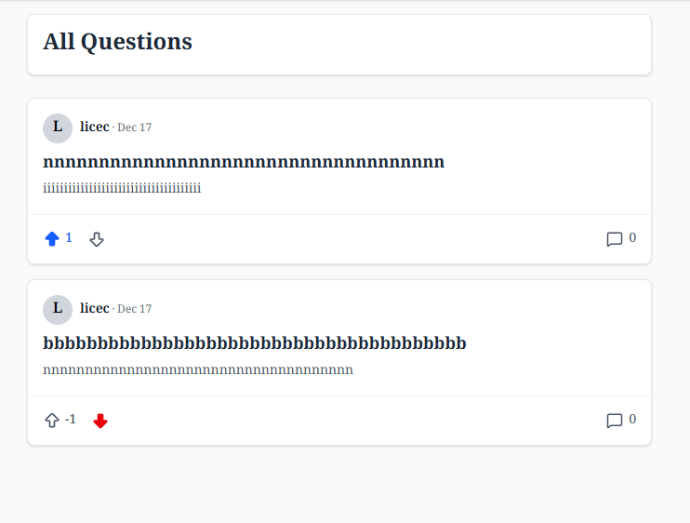
Table 4.8: Q&A Discovery (All Questions Page)

Component | Actor | Action & System Response
"All Questions" Header | Any User | Action: The User views the page title.  System: Confirms that the current view is filtered exclusively for Questions (hiding standard Posts).
Question Title | Any User | Action: The User clicks the bold title text.  System: Redirects the user to the Question Detail Page (/questions/[id]), where they can read the full question and submit an Answer.
Vote Arrows | Registered User | Action: The User clicks the Up or Down arrow.  System: Registers the vote instantly. If Upvoted, the arrow turns blue and the count increases. If Downvoted, it turns red and the count decreases.
Comment/Answer Icon | Any User | Action: The User clicks the speech bubble icon.  System: Redirects to the detail page, focusing on the "Answers" section so the user can contribute.
User Info (Avatar/Name) | Any User | Action: The User clicks the asker's name.  System: Redirects to that user's Public Profile, allowing the viewer to see what else they have asked or posted.

Figure 4.9 Discussion (Post Detail & Comments)
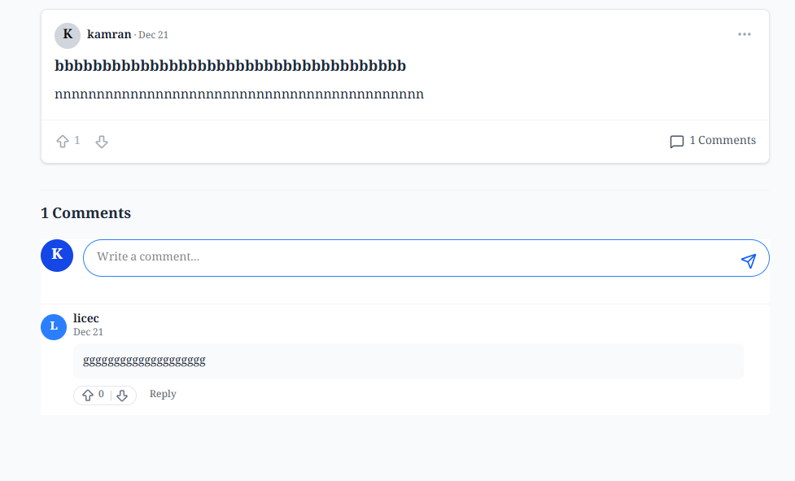
Table 4.9: Discussion (Post Detail & Comments)
Component | Actor | Action & System Response
"Write a comment..." Field | Registered User | Action: User types a response.  System: Captures text input.
Send (Paper Plane) Icon | Registered User | Action: User clicks icon.  System: Submits comment to database and instantly appends it to the list below.
Comment List | Any User | Action: User reads comments.  System: Displays comments chronologically (newest at bottom) with author avatars.
Comment Vote | Registered User | Action: User clicks arrow on a specific comment.  System: Upvotes/Downvotes that specific comment.
Figure 4.10 Localization (Language Selection)
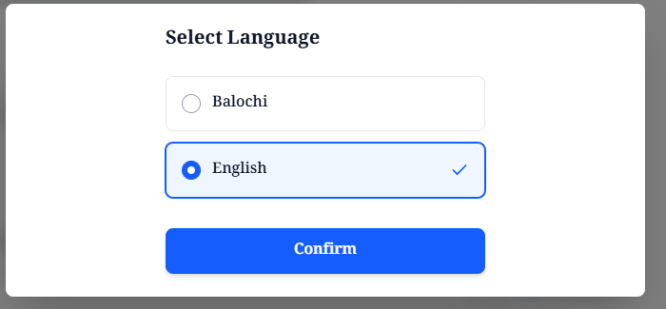
Table 4.10: Localization (Language Selection)
Component | Actor | Action & System Response
“Balochi” Option | Any User | Action: The User clicks the “Balochi” radio button.  System: Selects the option visually. When confirmed, the system will switch the entire interface to Right-to-Left (RTL) layout and translate text to Balochi.
“English” Option | Any User | Action: The User clicks the “English” radio button.  System: Selects the option visually. When confirmed, the system ensures the interface is in standard Left-to-Right (LTR) layout.
“Confirm” Button | Any User | Action: The User clicks the blue “Confirm” button.  System: Saves the preference to the browser (Context/Cookies), instantly applies the new language/layout to the Navbar and Feed, and closes the modal.
Figure 4.11 Content Creation (Add Question Modal)
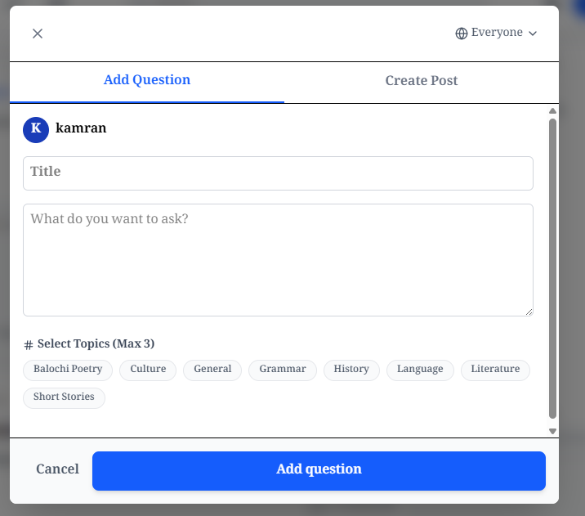
Table 4.11: Content Creation (Add Question Modal)
Component | Actor | Action & System Response
"Add Question" Tab | Registered User | Action: The User views the active tab.  System: Displays the specific form fields required for a Question (Title + Body) rather than a Post.
"Create Post" Tab | Registered User | Action: The User clicks the "Create Post" tab.  System: Switches the form layout to the standard "Post" creation mode (which uses a Rich Text Editor instead of a simple text area).
Title Field | Registered User | Action: The User enters a concise summary of their question.  System: Captures the text. Validation rules usually require this to be at least 10 characters long.
Body Field ("What do you want to ask?") | Registered User | Action: The User types the detailed explanation or context.  System: Captures the main content of the question.
Topic Selectors (e.g., "Culture") | Registered User | Action: The User clicks on a pill button (e.g., "History").  System: Highlights the selected topic and adds its ID to the submission payload. The system enforces a maximum limit (Max 3).
"Add question" Button | Registered User | Action: The User clicks the blue submit button.  System: Validates that Title and Body are not empty. If valid, sends data to the questions table in Supabase, closes the modal, and refreshes the feed to show the new item.
"Cancel" Button / "X" Icon | Registered User | Action: The User clicks "Cancel" or the close icon.  System: Discards any typed text and closes the modal without saving, returning the user to the underlying page.

Figure 4.12 Content Creation (Create Post Modal)
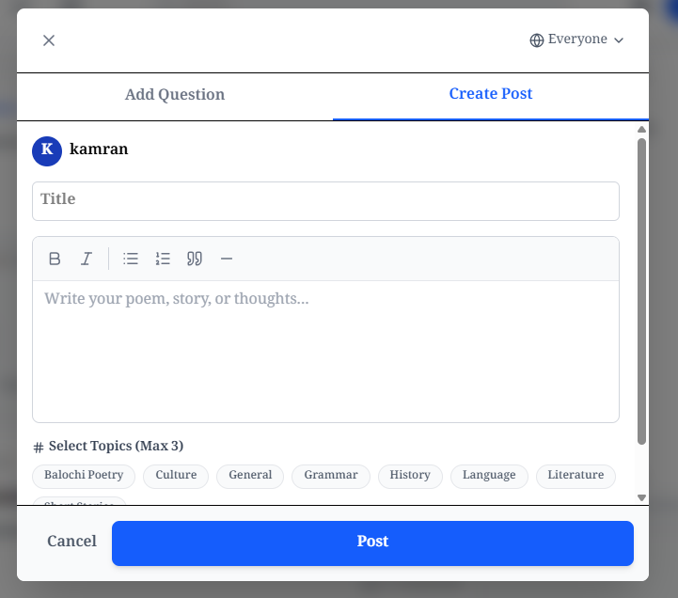
Table 4.12: Content Creation (Create Post Modal)
Component | Actor | Action & System Response
"Create Post" Tab | Registered User | Action: The User views the active tab.  System: Displays the Rich Text Editor interface, allowing for formatted text input suitable for literature.
"Add Question" Tab | Registered User | Action: The User clicks the "Add Question" tab.  System: Switches the form layout to the "Question" mode (simple text area without formatting tools).
Title Field | Registered User | Action: The User enters a headline for their post.  System: Captures the text to be displayed as the main header of the post.
Rich Text Editor (Toolbar) | Registered User | Action: The User clicks icons like B (Bold), I (Italic), or List.  System: Applies formatting to the selected text, essential for styling poetry stanzas or emphasizing prose.
Editor Body ("Write your poem...") | Registered User | Action: The User types their main content.  System: Captures the content and renders it immediately with the applied formatting.
Topic Selectors | Registered User | Action: The User selects relevant tags (e.g., "Balochi Poetry").  System: Highlights the chosen tags to categorize the post in the database (Max 3 allowed).
"Post" Button | Registered User | Action: The User clicks the blue button.  System: Validates that content exists. If valid, inserts the formatted HTML into the posts table and publishes it to the feed.
"Cancel" Button | Registered User | Action: The User clicks "Cancel".  System: Discards the draft and closes the modal.

Figure 4.13 User Customization (Profile Settings)
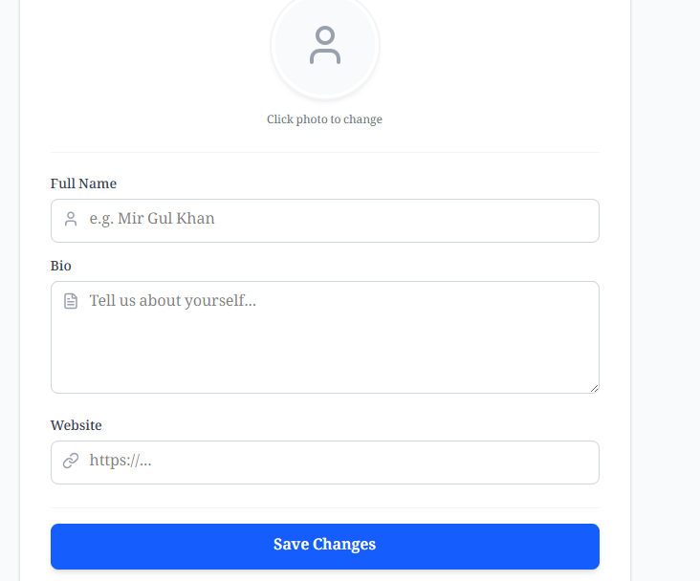
Table 4.13: User Customization (Profile Settings)
Component | Actor | Action & System Response
Avatar Circle ("Click photo to change") | Registered User | Action: The User clicks the circular placeholder or existing photo.  System: Opens the device's file picker. Once a file is selected, the system immediately displays a preview of the new image before saving.
Full Name Field | Registered User | Action: The User enters their real name (e.g., "Mir Gul Khan").  System: Captures the text to display it prominently on their profile page instead of just their username.
Bio Field | Registered User | Action: The User types a short description about themselves.  System: Captures the text (multiline) to be displayed in the "About" section of their profile.
Website Field | Registered User | Action: The User enters a URL (e.g., to a portfolio or blog).  System: Captures the link. On the public profile, this will be rendered as a clickable hyperlink.
"Save Changes" Button | Registered User | Action: The User clicks the blue button.  System: Uploads the new avatar to Supabase Storage (if changed) and updates the profiles database table with the new text. It then reloads the page to show the updated info.

Figure 4.14 User Identity (Profile Page)
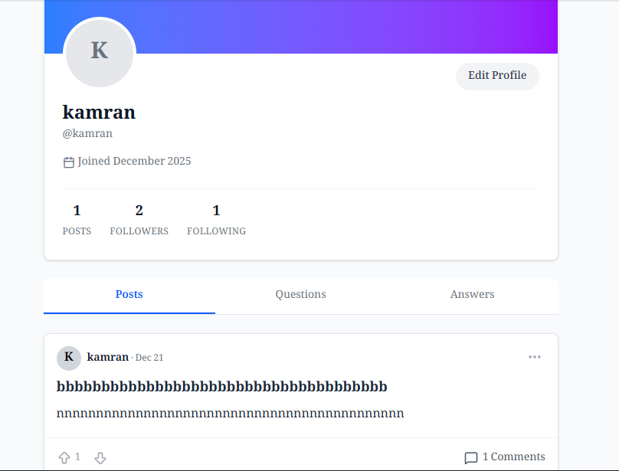
Table 4.14: User Identity (Profile Page)
Component | Actor | Action & System Response
"Edit Profile" Button | Registered User (Owner) | Action: The User clicks the "Edit Profile" button.  System: Redirects the user to the Settings Page (/settings), allowing them to update their bio, avatar, or website since they own this profile.
Profile Stats (Posts, Followers, Following) | System / Any User | Action: The User views the numbers (e.g., "1 Posts", "2 Followers").  System: Automatically queries the database to count the total records associated with this user ID and displays the live statistics.
Activity Tabs (Posts / Questions / Answers) | Any User | Action: The User clicks the "Posts" tab (or Questions/Answers).  System: Updates the list below to show only the content of that specific type. In the screenshot, "Posts" is active, so only standard posts are visible.
Feed Item (Post) | Any User | Action: The User views or interacts with a post in the list.  System: Displays the user's past content chronologically. Users can interact (Vote, Comment) directly from this list without leaving the profile.
Profile Header (Avatar & Name) | Any User | Action: The User views the profile details.  System: Fetches the full_name (e.g., "kamran") and username (@kamran) from the profiles table to confirm identity.

Figure 4.15 Content Management (Edit/Delete Menu)
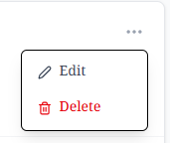
Table 4.15: Content Management (Edit/Delete Menu)
Component | Actor | Action & System Response
"Three Dots" (Menu) Icon | Post Owner | Action: The User clicks the "..." icon on their own post.  System: Opens the dropdown menu. This icon is only visible to the user who created the post (the author).
"Edit" Option | Post Owner | Action: The User clicks "Edit".  System: Re-opens the Create Post Modal, but pre-filled with the existing content. The user can modify text and save, updating the database record without creating a new post.
"Delete" Option | Post Owner | Action: The User clicks "Delete".  System: Usually triggers a "Are you sure?" confirmation. If confirmed, the system permanently removes the post row from the posts table in Supabase and instantly removes it from the UI.
Figure 4.16 Social Engagement (Voting & Comments)
Table 4.16: Social Engagement (Voting & Comments)
Component | Actor | Action & System Response
Upvote Arrow (Up) | Registered User | Action: The User clicks the "Up" arrow icon.  System: Casts a positive vote. If the user had previously downvoted (as shown in the image), the system switches the vote, increasing the total score by +2 (canceling the negative and adding a positive).
Downvote Arrow (Down) | Registered User | Action: The User clicks the "Down" arrow icon (currently red).  System: Casts a negative vote. Since the icon is already red in the screenshot, clicking it again would remove the vote (toggle off), resetting the arrow to gray and increasing the score by +1.
Vote Score ("-1") | Any User | Action: The User views the number between the arrows.  System: Automatically calculates and displays the net score (Upvotes - Downvotes). The negative sign indicates more users have downvoted this content than upvoted it.
Comments Button ("1 Comments") | Any User | Action: The User clicks the comment icon or text.  System: Redirects the user to the Post Detail Page (/posts/[id]), automatically focusing on the comment section so the user can read the existing response or add their own.

Chapter 5: Conclusion and Future Work

5.1 Conclusion
The development of JASP marks a significant step forward in the digital preservation and promotion of Balochi language and literature. By transitioning from informal social media discussions to a structured, "Quora-styled" web platform, we have successfully addressed the core problem of information fragmentation.
The project successfully achieved its primary objectives:
- Centralized Knowledge: We created a unified platform where questions, answers, and literary works are archived and easily searchable, preventing valuable discussions from being lost over time.
- Cultural Accessibility: The implementation of a custom Bilingual System with automated Right-to-Left (RTL) layout adaptation ensures that the platform is truly native-friendly, removing technical barriers for Balochi speakers.
- Modern Technology: By utilizing a cutting-edge tech stack (Next.js and Supabase)
- 33, we delivered a fast, secure, and scalable application that outperforms traditional forum software.
- Quality Control: The integration of community-driven features—such as real-time Voting and Topic Filtering—empowers users to curate content effectively, ensuring that high-quality literature rises to the top.
In conclusion, JASP is not just a website; it is a digital home for the Balochi literary community. It bridges the gap between traditional scholarship and modern digital convenience, ensuring that the rich heritage of the Balochi language thrives in the digital age.

5.2 Future Work
While the current version of JASP is a fully functional product, there are several avenues for future enhancement:
- Mobile Application: Developing a native mobile app (using React Native) would allow for offline access and push notifications, further increasing user engagement in regions with unstable internet.
- Advanced Analytics: Implementing a dashboard for writers to see detailed statistics—such as which regions their readers are from or which topics are trending—would encourage more high-quality contributions.
- Direct Messaging (DM): Adding a private messaging system would allow scholars and students to connect personally for mentorship or detailed discussions outside of the public forum.
- Audio Integration: Adding support for audio posts would allow poets to recite their work, preserving the strong oral tradition of Balochi poetry alongside the written text.

References
- Vercel.
[1](2024). Next.js Documentation: The React Framework for the Web. Retrieved from https://nextjs.org/docs
- Supabase.
[2](2024). Supabase Documentation: The Open Source Firebase Alternative. Retrieved from https://supabase.com/docs
- Facebook Open Source.
[3]( (2024). React: A JavaScript Library for Building User Interfaces. Retrieved from https://react.dev
- Tailwind Labs.
[4]( (2024). Tailwind CSS: Rapidly Build Modern Websites without Ever Leaving Your HTML. Retrieved from https://tailwindcss.com
- Balochi Academy.
[5]( (2024). Digital Initiatives for Balochi Literature. Quetta, Pakistan.
- O'Reilly, T.
[6]( (2005). What Is Web 2.0: Design Patterns and Business Models for the Next Generation of Software. O'Reilly Media.
- Stack Exchange.
[7]( (2024). The Q&A Model: How Community Curation Works. Retrieved from https://stackoverflow.com
- MDN Web Docs. (2024). Right-to-Left (RTL) Styling in CSS. Mozilla Developer Network.

List of Abbreviations
Abbreviation | Full Term
API | Application Programming Interface
CSS | Cascading Style Sheets
DB | Database
DOM | Document Object Model
GL | Group Leader
HTML | HyperText Markup Language
HTTP | Hypertext Transfer Protocol
JASP | Just Another Social Platform (Project Codename)
JSON | JavaScript Object Notation
LTR | Left-to-Right (Text Direction)
MVC | Model-View-Controller
PDF | Portable Document Format
PHP | Hypertext Preprocessor
RTL | Right-to-Left (Text Direction)
SEO | Search Engine Optimization
SPA | Single Page Application
SQL | Structured Query Language
SSR | Server-Side Rendering
UI | User Interface
UML | Unified Modeling Language
URL | Uniform Resource Locator
UUID | Universally Unique Identifier
UX | User Experience

