PROJECT 2.4
The Electronic Gate — NPN Transistor
2N2222 NPN | LDR Voltage Divider | Base Resistor | Proteus ISIS Simulation

1. Project Overview
Component | 2N2222 NPN Transistor
Purpose | Amplify small LDR signal to drive a larger load current
Key Concept | Amplification — Base controls Collector current
Input Signal | Voltage Divider output (LDR + R1 = 10 kΩ)
Base Resistor (Rb) | 10 kΩ — protects the Base pin
Collector Resistor (Rc) | 470 Ω — limits collector current
Load | LED (Vf ≈ 2.1 V)
Supply Voltage (VCC) | 5 V DC
Current Gain (hFE / β) | ≈ 100×

2. Description
This project demonstrates how a tiny signal from the LDR (Light Dependent Resistor) — taken from the voltage divider built in Project 2.3 — can be used to trigger and control a much larger current flowing through the collector circuit. The 2N2222 NPN transistor acts as an electronic switch and amplifier.

3. Core Concept: Amplification
The transistor acts as a bridge (or gate):
- A small current at the Base (B) pin — controlled by the LDR voltage divider — opens the floodgates.
- This allows a much larger current to flow from Collector (C) to Emitter (E), lighting the LED.
- The ratio Ic / Ib is called hFE (current gain, β), approximately 100 for the 2N2222.

Key Formulas
Vmid = Vcc x R1 / (LDR + R1)
Ib = (Vmid - 0.7V) / Rb
Ic = hFE x Ib (hFE ~ 100)
Vled = 2.1V (forward voltage of LED)

4. Proteus Simulation Task
Using Proteus ISIS, assemble the following circuit:
- Place a 2N2222 NPN transistor on the schematic.
- Build the LDR + R1 (10 kΩ) voltage divider connected between VCC and GND.
- Feed the midpoint (Vmid) of the voltage divider through Rb = 10 kΩ into the Base pin.
- Connect an LED in series with Rc = 470 Ω between VCC and the Collector pin.
- Connect the Emitter pin directly to GND.
- Set VCC = 5 V and run the simulation. The LED should illuminate when the LDR detects light.

5. Circuit Diagram (Proteus ISIS Style)
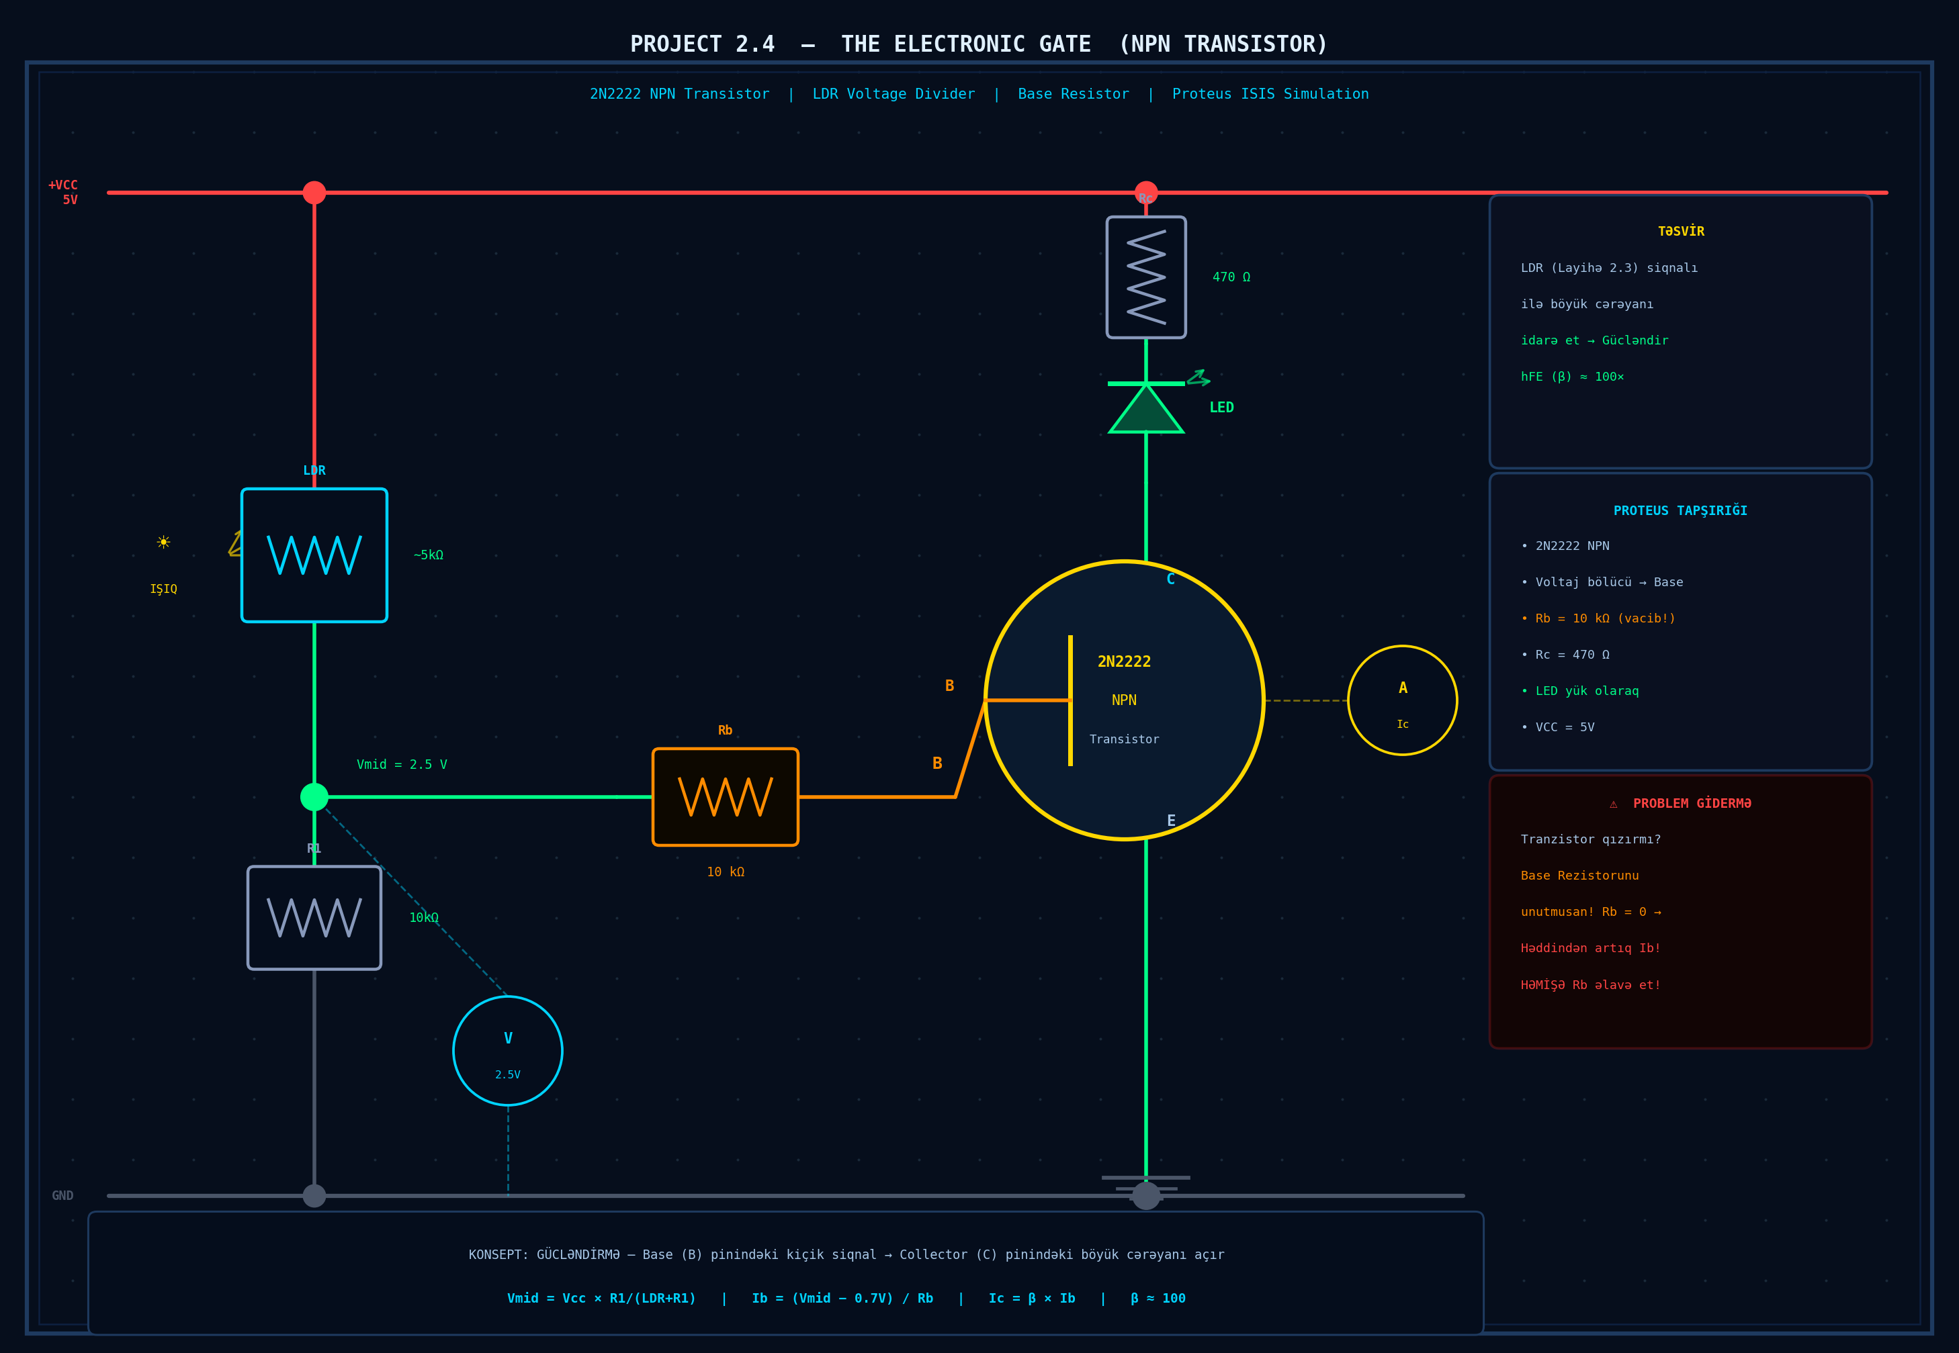
Figure 1 — Project 2.4 Circuit: 2N2222 NPN Transistor Gate with LDR Voltage Divider

6. Component List
Qty | Component | Value / Notes
1 | NPN Transistor | 2N2222
1 | LDR (Photoresistor) | ~5 kΩ in light, ~50 kΩ dark
1 | Fixed Resistor (R1) | 10 kΩ
1 | Base Resistor (Rb) | 10 kΩ (critical!)
1 | Collector Resistor (Rc) | 470 Ω
1 | LED | Any color, Vf ≈ 2.1 V
1 | DC Power Supply | 5 V (VCC)
— | Wires / Breadboard | For connections

7. Transistor Pin Functions (2N2222)
Pin | Name | Function
B | Base | Input control pin — receives Vmid via Rb. Vbe ≈ 0.7 V to turn on.
C | Collector | Main current path — connects to load (LED + Rc) and VCC.
E | Emitter | Output — connected to GND. Current exits here.

8. Troubleshooting
⚠ WARNING: Missing Base Resistor
Is the transistor getting hot? → You likely forgot the Base Resistor (Rb).
Without Rb, the Base draws excessive current, causing thermal runaway and possible component destruction.
Always use Rb = 10 kΩ to limit the trigger current!

Problem | Likely Cause | Solution
Transistor gets hot | No base resistor (Rb) | Add Rb = 10 kΩ at Base pin
LED does not light up | Vmid too low (dark room) | Increase light on LDR or check divider
LED always ON in dark | R1 too small vs LDR | Use larger R1 or reduce LDR value
Transistor stays OFF | Vbe never reaches 0.7 V | Check voltage divider output at Base
LED very dim | Rc too large | Reduce Rc or check LED polarity

9. How It Works — Step by Step
- Step 1: Light hits the LDR: The LDR resistance drops (e.g. from 50 kΩ in dark to ~5 kΩ in light). This changes the voltage at the midpoint of the voltage divider (Vmid).
- Step 2: Vmid rises: As LDR resistance falls, Vmid = Vcc × R1/(LDR+R1) increases toward VCC.
- Step 3: Base current flows: When Vmid exceeds 0.7 V (Vbe threshold), current flows through Rb into the Base: Ib = (Vmid - 0.7) / Rb.
- Step 4: Transistor switches ON: The transistor enters the Active region. Collector current Ic = hFE × Ib ≈ 100 × Ib flows from VCC through Rc and the LED.
- Step 5: LED lights up: The large collector current drives the LED. The transistor has amplified the tiny LDR signal into a useful output.

10. Summary
Project 2.4 demonstrates the fundamental principle of transistor amplification. By feeding a light-sensitive voltage signal from an LDR voltage divider into the Base of a 2N2222 NPN transistor, we can control a much larger current in the Collector circuit — lighting an LED. The Base Resistor (Rb) is critical: it limits the Base current and prevents the transistor from overheating. This circuit is the foundation for countless real-world applications including light-activated alarms, automatic lighting systems, and sensor-controlled devices.

