1.Write a query to report orders which were delayed shipped.

SELECT OrderID FROM Orders WHERE ShippedDate<RequiredDate;

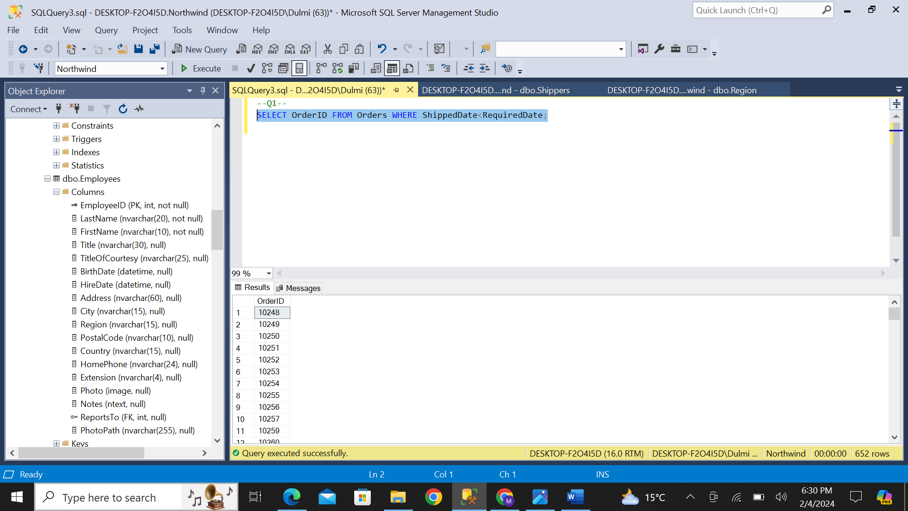

2. Our employees belong to how many countries. List the names.

SELECT Country FROM Employees;

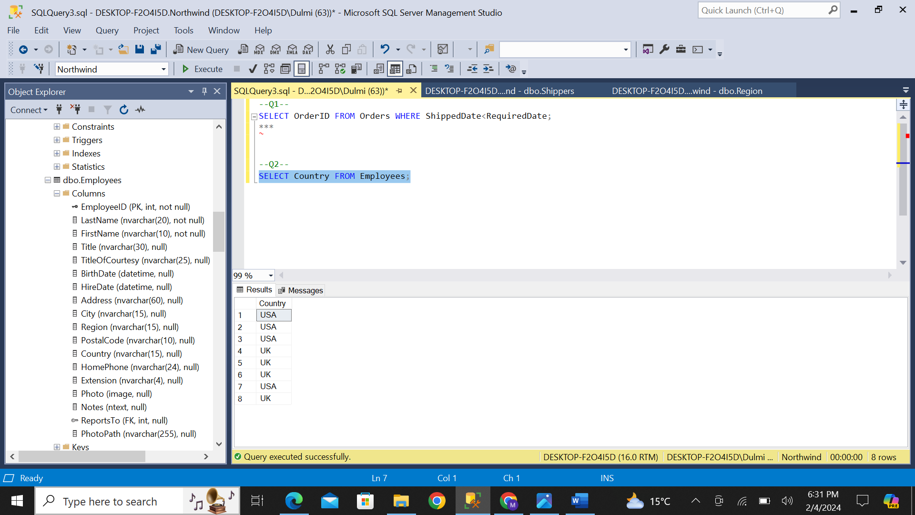

3. Is there any employee who is not accountable?

SELECT FirstName + ' ' + LastName AS ConcatenatedColumn FROM Employees WHERE ReportsTo IS NULL;

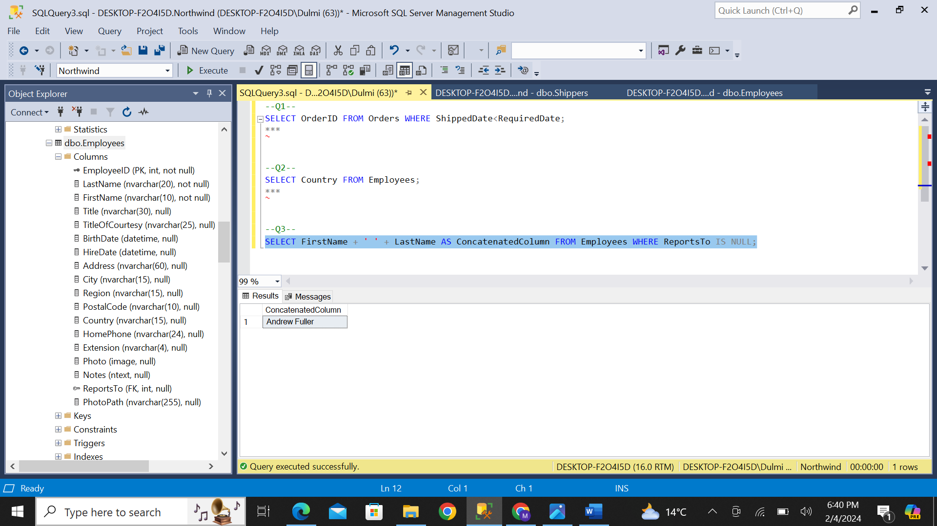

4. List the names of products which have been discontinued.

SELECT ProductName FROM Products WHERE Discontinued='True';

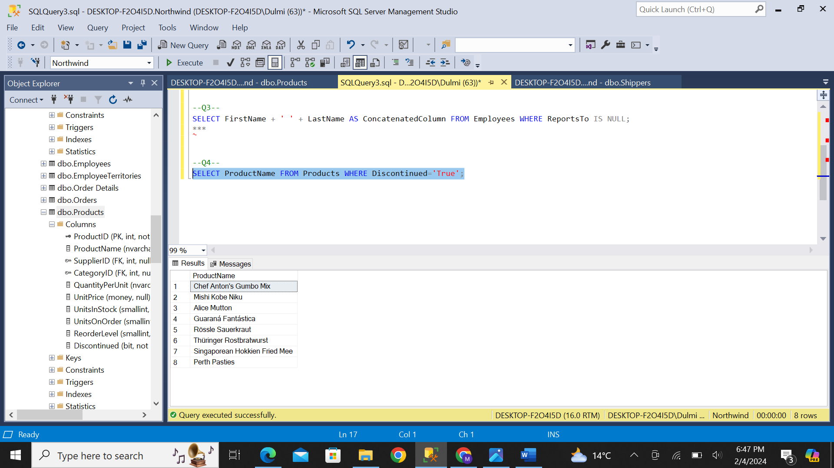

5. List the IDs the orders on which discount was not provided.

SELECT ProductID FROM Products WHERE Discontinued='False';

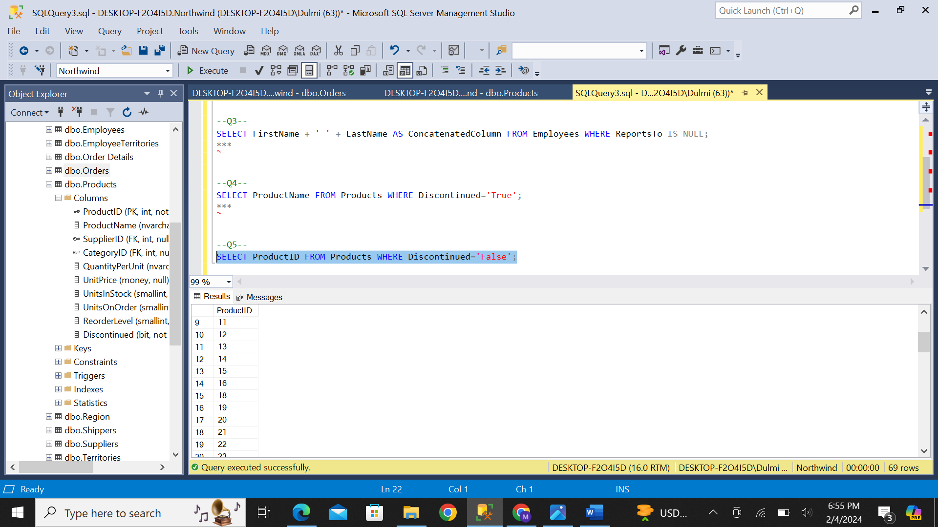

6. Enlist the names of customers who have not specified their region.

SELECT ContactName FROM Customers WHERE Region IS NULL;

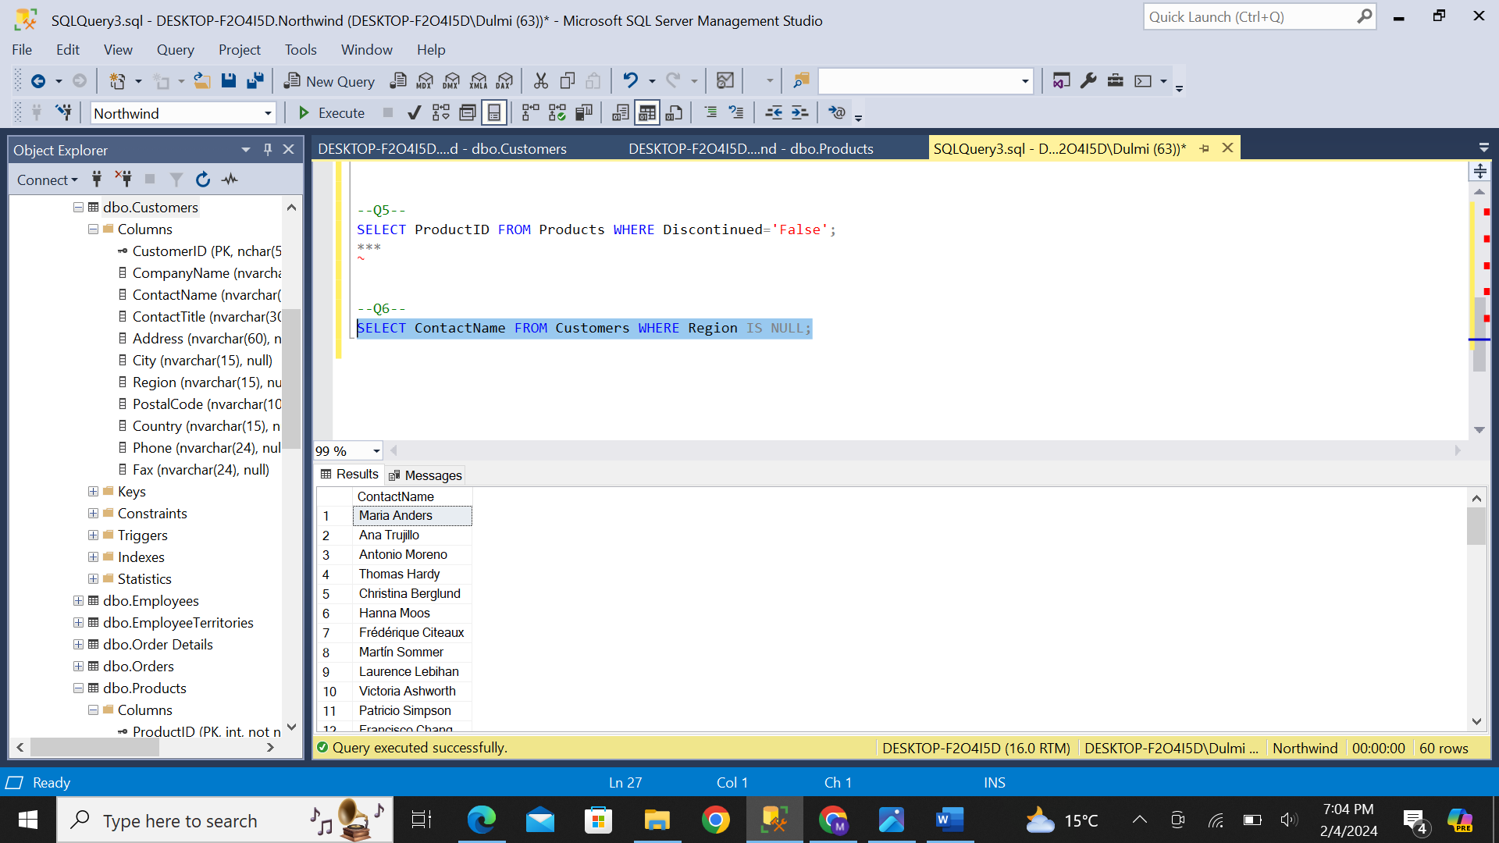

7. Enlist the names of customers along with contact number who either belongs to UK or USA.

SELECT ContactName,Phone FROM Customers WHERE Country='UK' OR Country='USA';

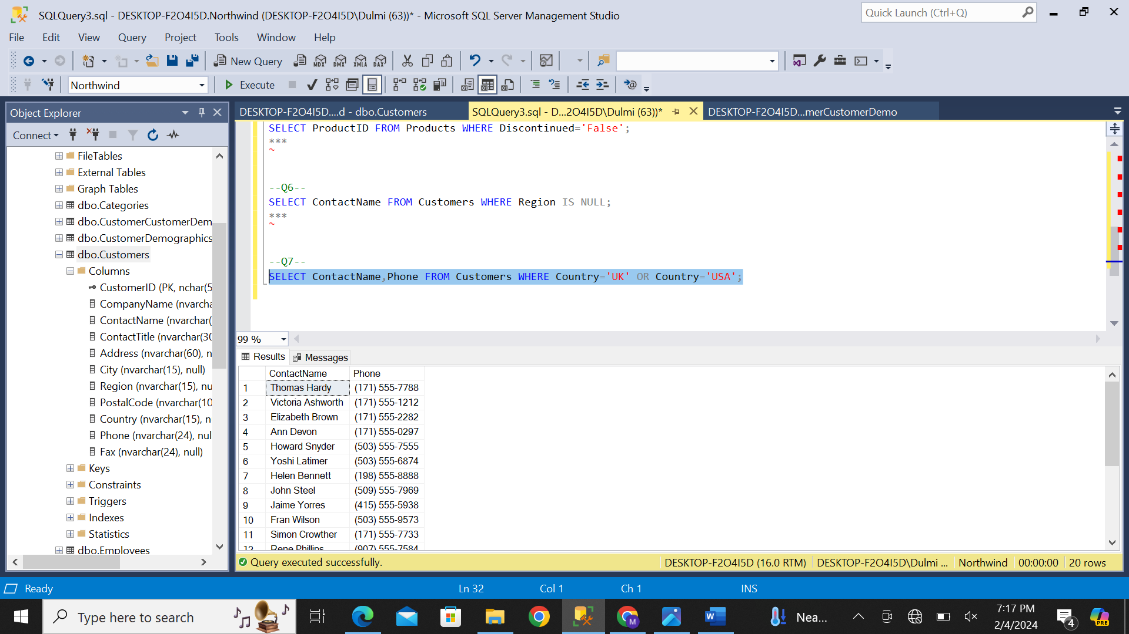

8. Report the names of companies who have provided their web page.

SELECT CompanyName FROM Suppliers WHERE HomePage IS NOT NULL;

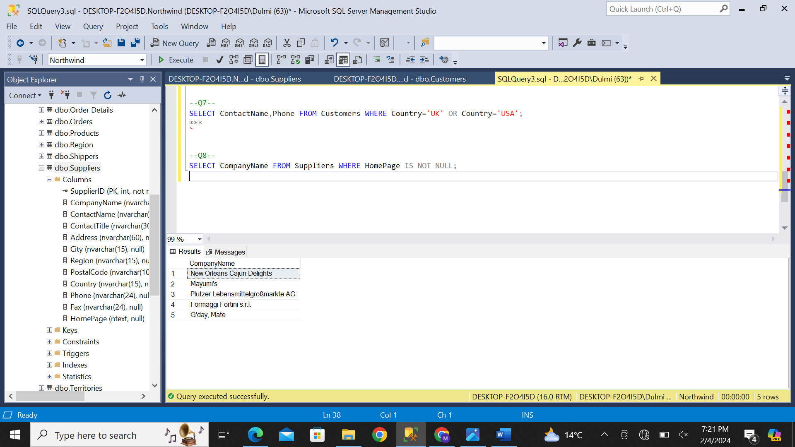

9. In which countries, products were sold in year 1997.

SELECT ShipCountry FROM Orders WHERE OrderDate LIKE '%1997%';

10. List the ids of customers whose orders were never shipped.

SELECT CustomerID FROM Orders WHERE ShippedDate IS NULL;

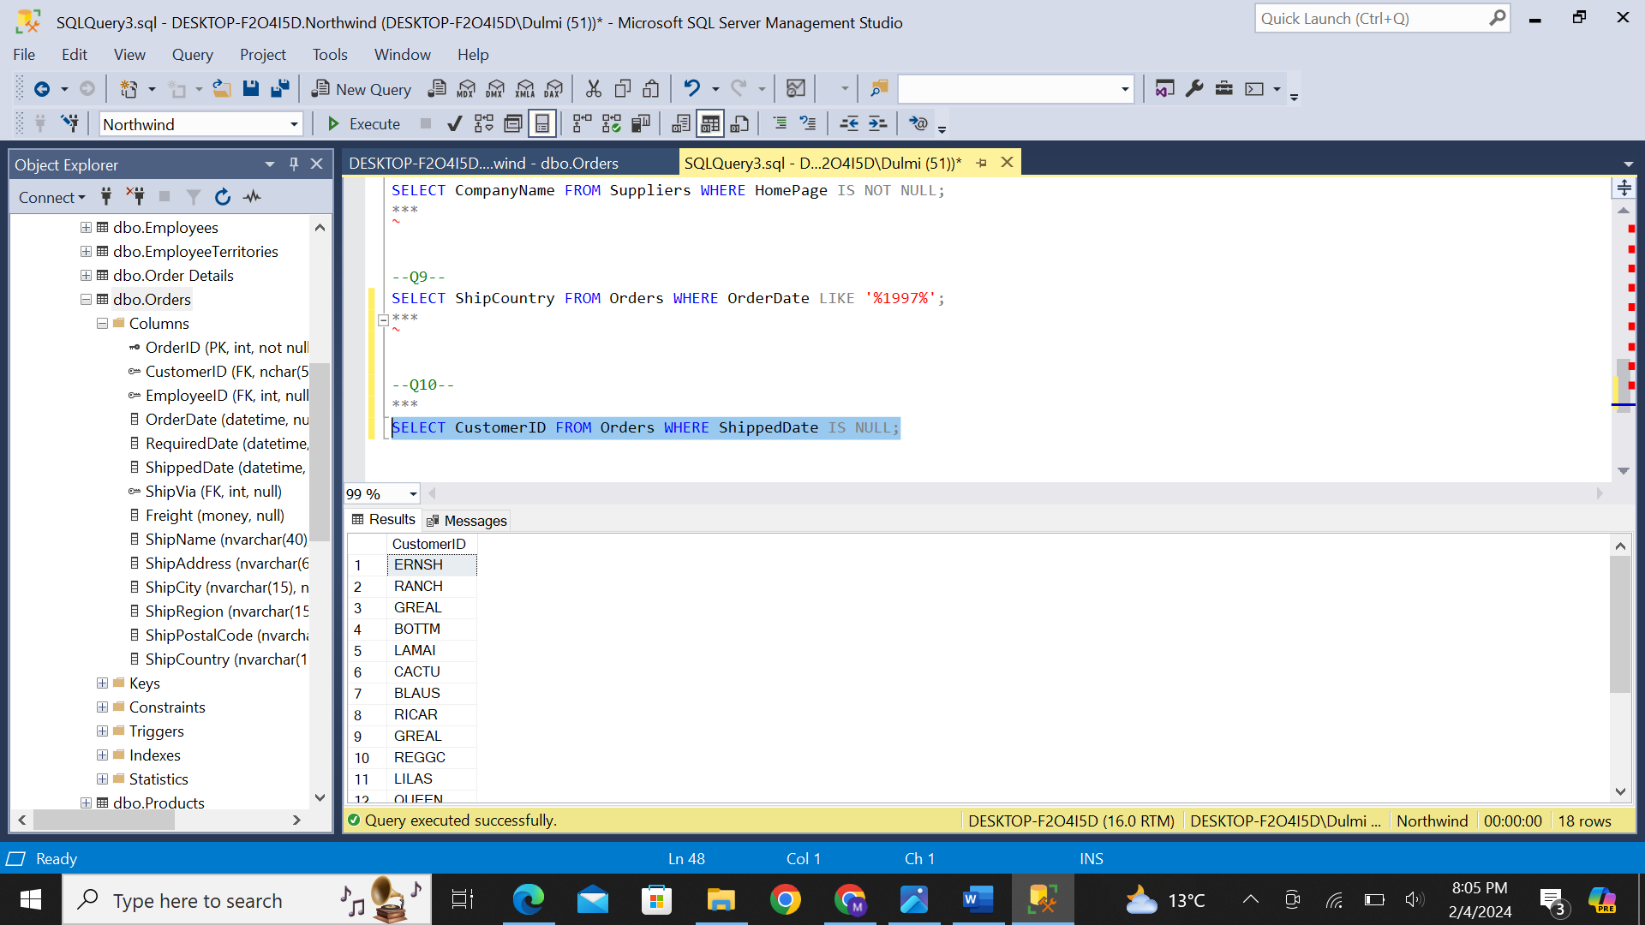

11. Write a query to report suppliers with their id, company name and city.

SELECT SupplierID,CompanyName,City FROM Suppliers;

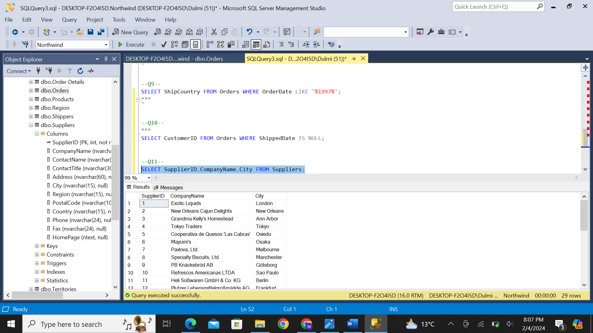

12. Our employees belong to how many countries. List them who are used to live in London.

SELECT COUNT(DISTINCT COUNTRY) AS DifferentCountries FROM Employees;

SELECT FirstName + ' ' + LastName FROM Employees WhERE City='London';

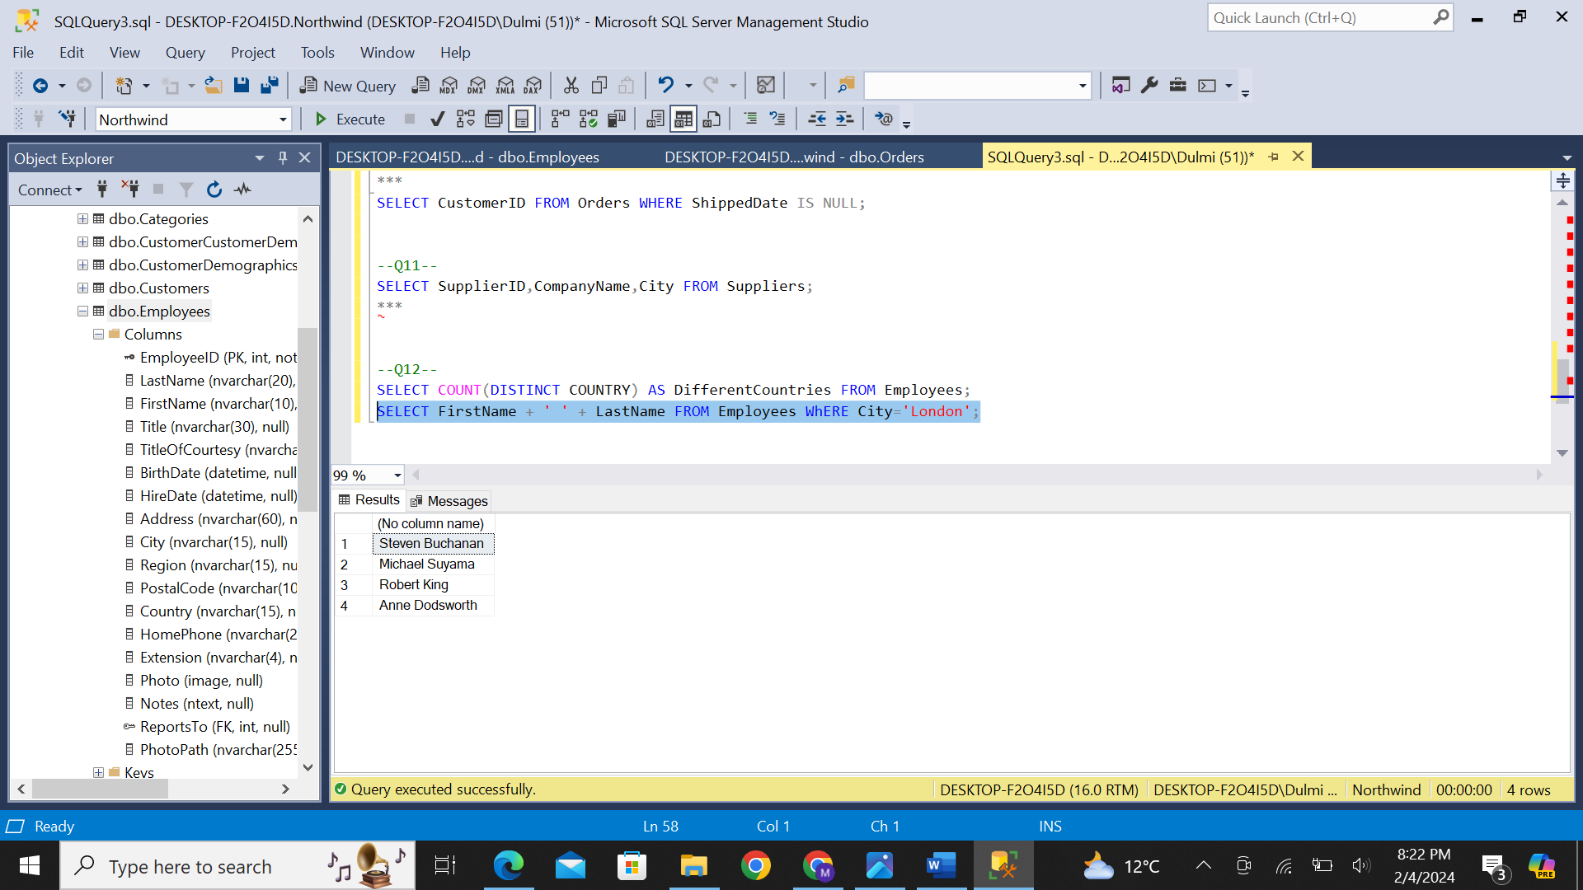

13. List the names of products which have not been discontinued.

SELECT ProductName FROM Products WHERE Discontinued='False';

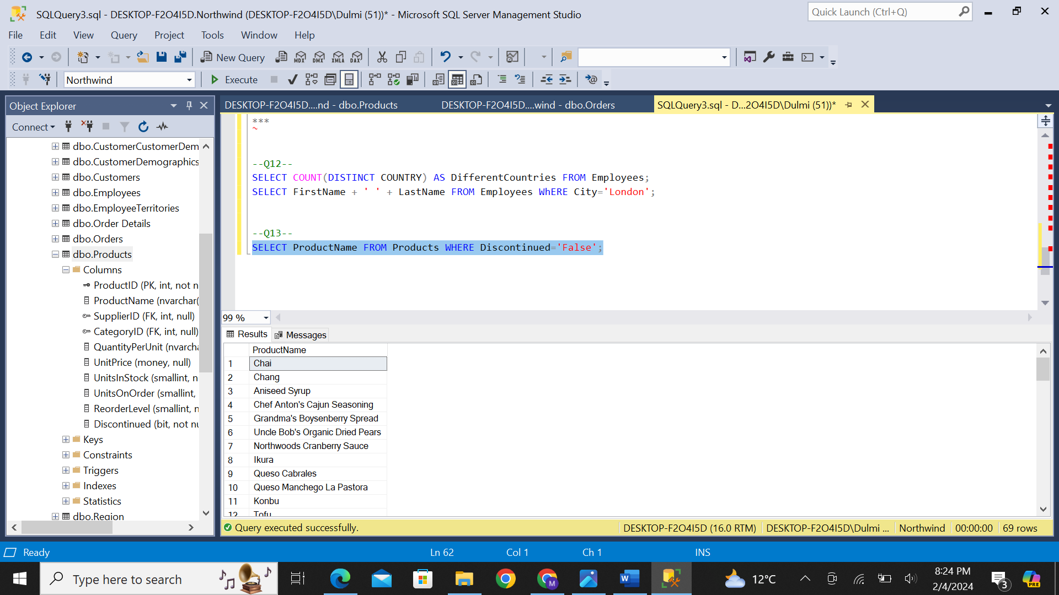

14. List the IDs the orders on which discount was 0.1 or less.

SELECT OrderID FROM [Order Details] WHERE Discount <=0.1;

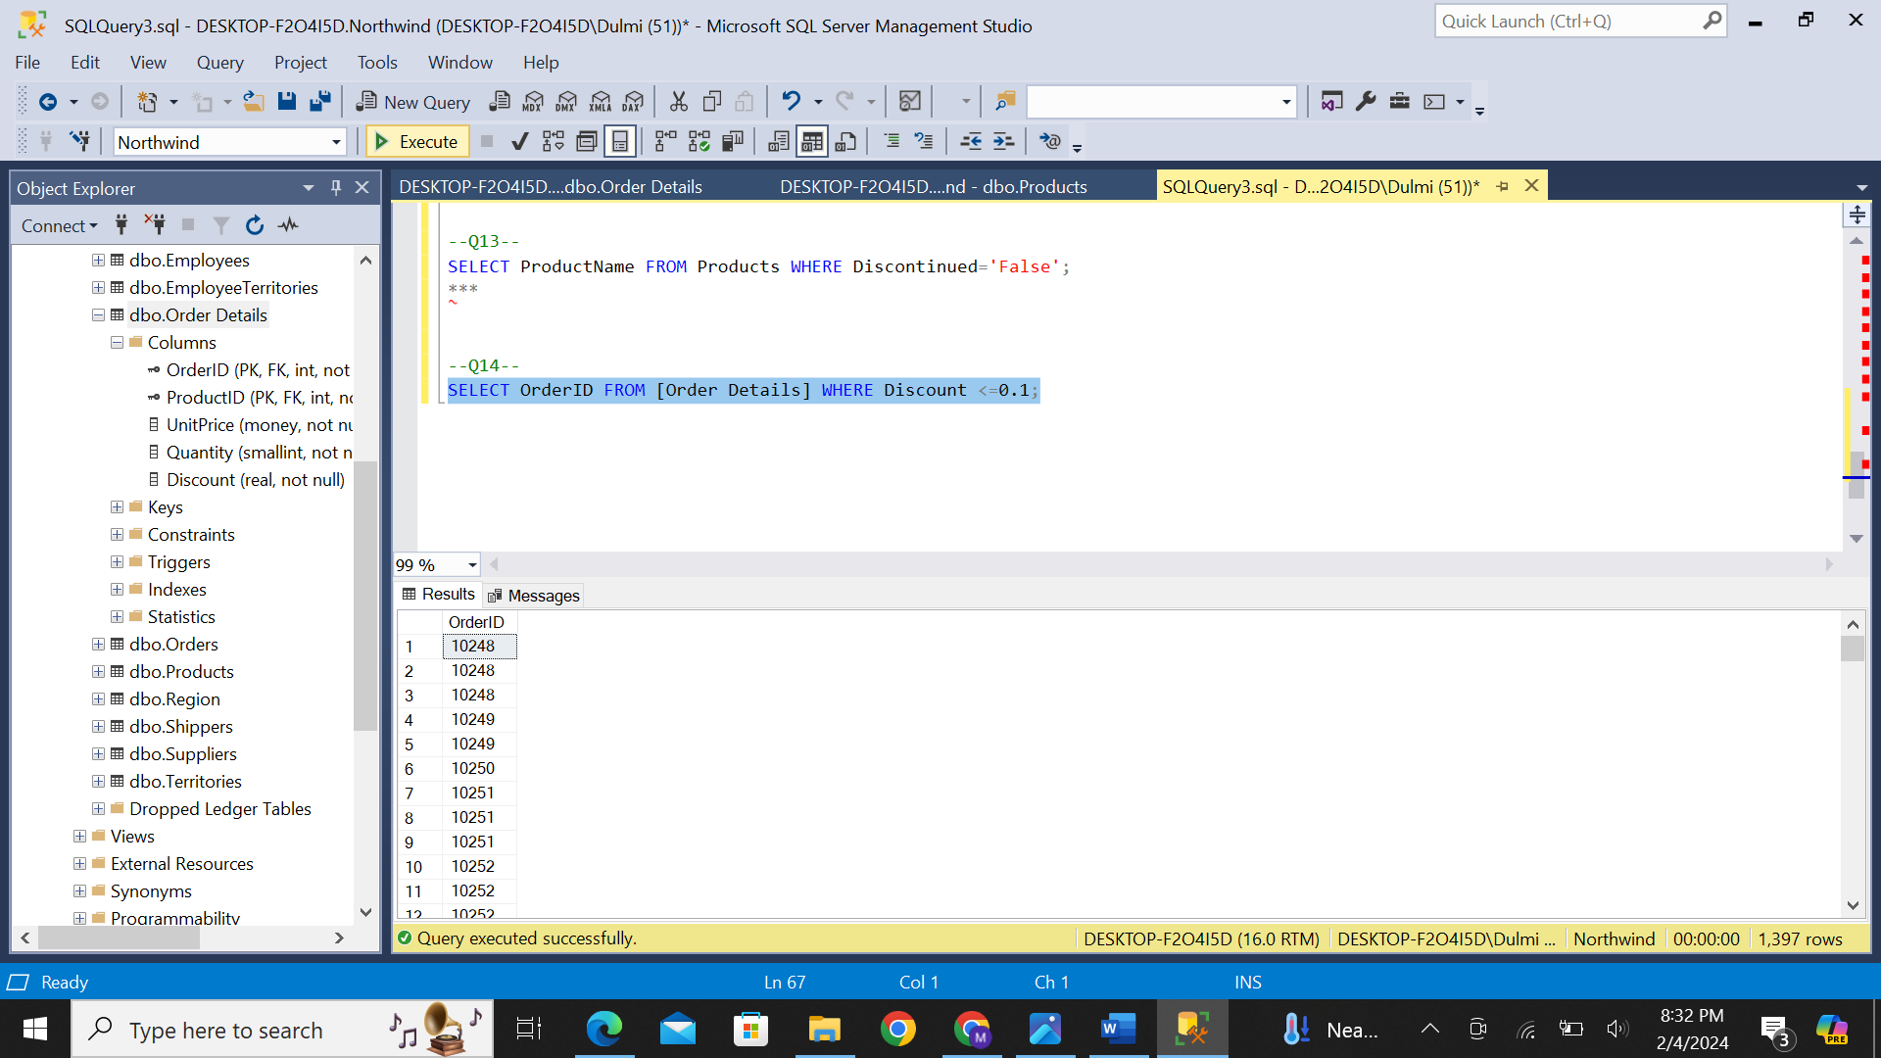

15. Enlist the IDS, names of employees and their contact number with extensions who have not specified their region.

SELECT EmployeeID, FirstName,LastName,HomePhone FROM Employees WHERE Region IS NULL;

