The Kinetics of Enzyme-Catalyzed Reactions
Enzymes act as highly efficient biological catalysts that dramatically accelerate the rate of chemical reactions in living organisms without being consumed in the process. The core principle of enzymatic catalysis relies on the lowering of the activation energy required to convert a substrate into a product. This complex process often follows Michaelis-Menten kinetics, where the reaction rate (v) is proportional to the concentration of the enzyme-substrate complex [ES]. Enzymes act as highly efficient biological catalysts that dramatically accelerate the rate of chemical reactions in living organisms without being consumed in the process. The core principle of enzymatic catalysis relies on the lowering of the activation energy required to convert a substrate into a product. This complex process often follows Michaelis-Menten kinetics, where the reaction rate (v) is proportional to the concentration of the enzyme-substrate complex [ES]. Enzymes act as highly efficient biological catalysts that dramatically accelerate the rate of chemical reactions in living organisms without being consumed in the process. The core principle of enzymatic catalysis relies on the lowering of the activation energy required to convert a substrate into a product. This complex process often follows Michaelis-Menten kinetics, where the reaction rate (v) is proportional to the concentration of the enzyme-substrate complex [ES]. Enzymes act as highly efficient biological catalysts that dramatically accelerate the rate of chemical reactions in living organisms without being consumed in the process. The core principle of enzymatic catalysis relies on the lowering of the activation energy required to convert a substrate into a product. This complex process often follows Michaelis-Menten kinetics, where the reaction rate (v) is proportional to the concentration of the enzyme-substrate complex [ES]. Enzymes act as highly efficient biological catalysts that dramatically accelerate the rate of chemical reactions in living organisms without being consumed in the process. The core principle of enzymatic catalysis relies on the lowering of the activation energy required to convert a substrate into a product. This complex process often follows Michaelis-Menten kinetics, where the reaction rate (v) is proportional to the concentration of the enzyme-substrate complex [ES].

1. Experimental Setup
To investigate the catalytic efficiency of the synthesized enzyme, we performed a series of spectrophotometric assays. The reaction mixture contained 50 mM Tris-HCl buffer (pH 7.4), 100 mM NaCl, and varying concentrations of the substrate. Reactions were initiated by the addition of 5 µL of the purified enzyme solution. The absorbance was monitored continuously at 340 nm using a UV-Vis spectrophotometer at 25°C. To investigate the catalytic efficiency of the synthesized enzyme, we performed a series of spectrophotometric assays. The reaction mixture contained 50 mM Tris-HCl buffer (pH 7.4), 100 mM NaCl, and varying concentrations of the substrate. Reactions were initiated by the addition of 5 µL of the purified enzyme solution. The absorbance was monitored continuously at 340 nm using a UV-Vis spectrophotometer at 25°C. To investigate the catalytic efficiency of the synthesized enzyme, we performed a series of spectrophotometric assays. The reaction mixture contained 50 mM Tris-HCl buffer (pH 7.4), 100 mM NaCl, and varying concentrations of the substrate. Reactions were initiated by the addition of 5 µL of the purified enzyme solution. The absorbance was monitored continuously at 340 nm using a UV-Vis spectrophotometer at 25°C. To investigate the catalytic efficiency of the synthesized enzyme, we performed a series of spectrophotometric assays. The reaction mixture contained 50 mM Tris-HCl buffer (pH 7.4), 100 mM NaCl, and varying concentrations of the substrate. Reactions were initiated by the addition of 5 µL of the purified enzyme solution. The absorbance was monitored continuously at 340 nm using a UV-Vis spectrophotometer at 25°C.

1.1 Data Collection
Here is a graph showing the reaction rate over time:
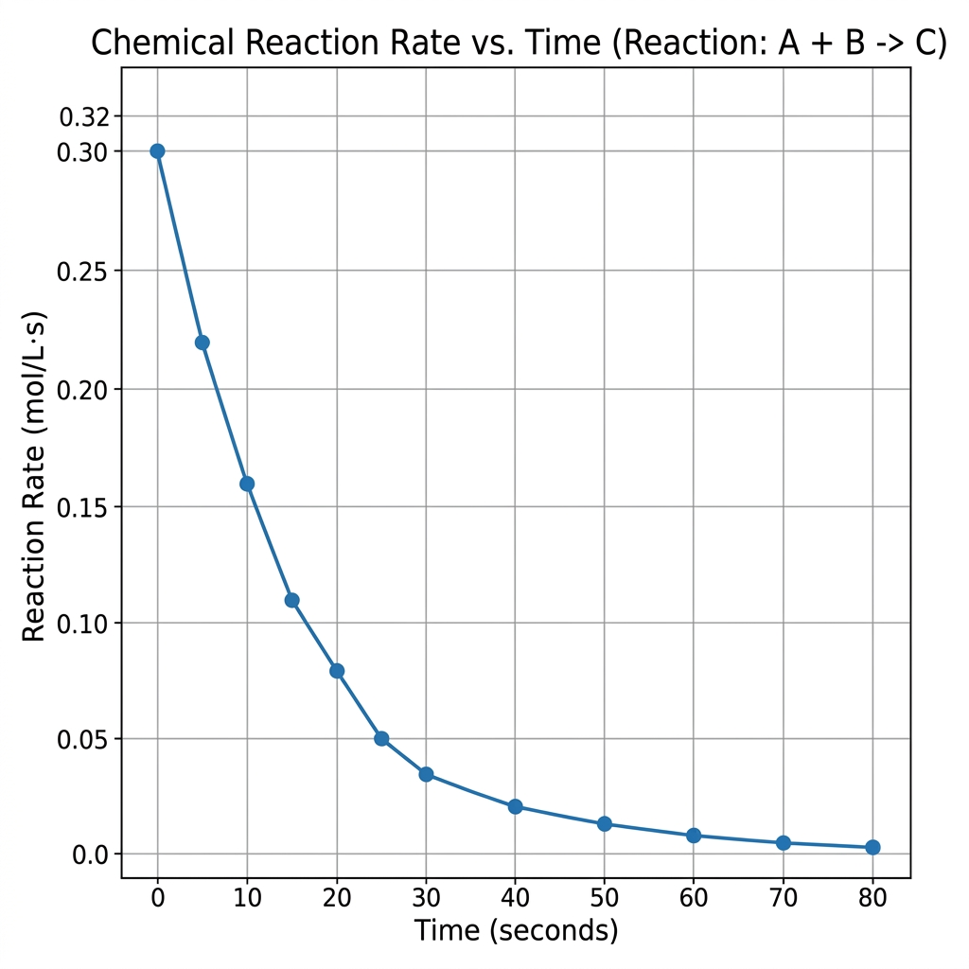
As seen in the figure above, the initial velocity of the reaction increases linearly with substrate concentration until it approaches Vmax, at which point the enzyme becomes fully saturated. As seen in the figure above, the initial velocity of the reaction increases linearly with substrate concentration until it approaches Vmax, at which point the enzyme becomes fully saturated. As seen in the figure above, the initial velocity of the reaction increases linearly with substrate concentration until it approaches Vmax, at which point the enzyme becomes fully saturated.

2. Results and Tables
The following table summarizes the kinetic parameters obtained from the Lineweaver-Burk plot.
Enzyme Variant | Km (mM) | Vmax (µM/min)
Wild-type | 2.5 | 120.4
Mutant A | 1.8 | 95.2
Mutant B | 4.2 | 150.8

The kinetic constants confirm that Mutant A possesses a higher affinity for the substrate (lower Km) compared to the wild-type enzyme, albeit with a reduced maximum velocity. The kinetic constants confirm that Mutant A possesses a higher affinity for the substrate (lower Km) compared to the wild-type enzyme, albeit with a reduced maximum velocity. The kinetic constants confirm that Mutant A possesses a higher affinity for the substrate (lower Km) compared to the wild-type enzyme, albeit with a reduced maximum velocity. The kinetic constants confirm that Mutant A possesses a higher affinity for the substrate (lower Km) compared to the wild-type enzyme, albeit with a reduced maximum velocity. The kinetic constants confirm that Mutant A possesses a higher affinity for the substrate (lower Km) compared to the wild-type enzyme, albeit with a reduced maximum velocity.
According to previous literature ^{[1, 2]}, these kinetic alterations are often attributed to conformational changes in the active site.

3. Conclusion
In conclusion, our comprehensive kinetic analysis elucidates the fundamental mechanisms governing the catalytic cycle of this novel enzyme. The integration of steady-state kinetics and structural modeling provides a holistic understanding of substrate recognition and turnover. Future studies will focus on transient kinetic methods to identify elusive intermediate states. In conclusion, our comprehensive kinetic analysis elucidates the fundamental mechanisms governing the catalytic cycle of this novel enzyme. The integration of steady-state kinetics and structural modeling provides a holistic understanding of substrate recognition and turnover. Future studies will focus on transient kinetic methods to identify elusive intermediate states. In conclusion, our comprehensive kinetic analysis elucidates the fundamental mechanisms governing the catalytic cycle of this novel enzyme. The integration of steady-state kinetics and structural modeling provides a holistic understanding of substrate recognition and turnover. Future studies will focus on transient kinetic methods to identify elusive intermediate states. In conclusion, our comprehensive kinetic analysis elucidates the fundamental mechanisms governing the catalytic cycle of this novel enzyme. The integration of steady-state kinetics and structural modeling provides a holistic understanding of substrate recognition and turnover. Future studies will focus on transient kinetic methods to identify elusive intermediate states. In conclusion, our comprehensive kinetic analysis elucidates the fundamental mechanisms governing the catalytic cycle of this novel enzyme. The integration of steady-state kinetics and structural modeling provides a holistic understanding of substrate recognition and turnover. Future studies will focus on transient kinetic methods to identify elusive intermediate states.

