Here is some text with an inline image: 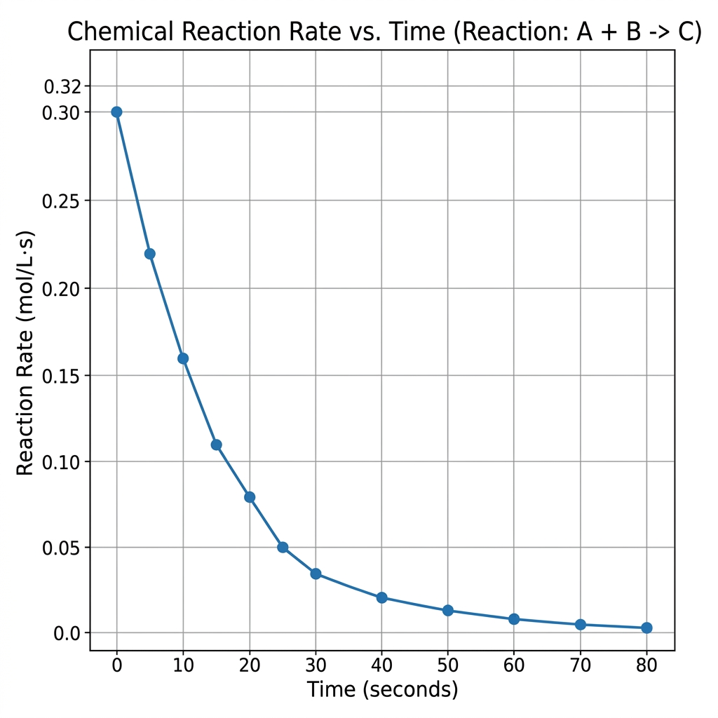 and some more text after it.

